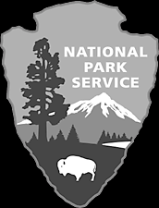
Cowpens
National Park Service
U. S. Department of the Interior

Battlefield Restoration

On January 17, 1781 at the Cow Pens, a well-known pasturing area in the upcountry of South Carolina, Brigadier General Daniel Morgan with his untrained, but experienced militia and 600 Continentals, used the setting to rout the British army under Lieutenant Colonel Banastre Tarleton in the only double envelopment to occur in the American Revolution. This decisive battle led to the British defeat at Yorktown nine months later.

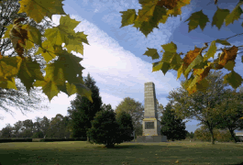
On March 4, 1929, the United States Congress recognized the importance of the battle by creating Cowpens National Battlefield Site on one acre of donated land. In 1972 Congress authorized the purchase of about 845 acres of land and changed the name to Cowpens National Battlefield. The purchase included the entire battlefield and a buffer zone around it so that visitors would be able to explore the battlefield without modern-day intrusions. The Master Plan for the development of Cowpens National Battlefield stated:

"By careful handling of the natural vegetation, the area within the park boundary will eventually come to resemble its appearance in Colonial [sic] times. The pasturelands and woodlands will again be in their historic relationship… The Cowpens National Battlefield of the future, as thus envisioned, will offer a meaningful experience for the visitor, who has come to learn more about the great heritage upon which this Nation [sic] was built."

As a unit of the National Park System, Cowpens National Battlefield protects and preserves the historic scene. Protection means taking care of the battlefield for this and future generations. Preservation means restoring the battlefield to its appearance in 1781.

How Did the Battlefield Look on January 17, 1781?
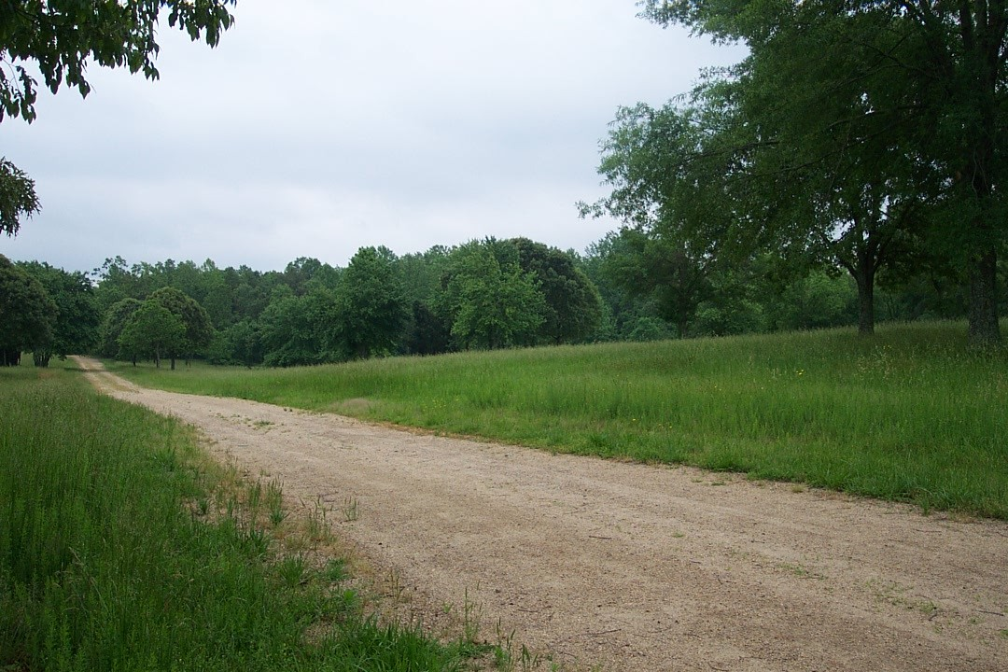
To determine how it looked at the time of the battle, the National Park Service used first hand accounts from the soldiers who fought here that morning.

"…[T]he woods were open and free from swamps…" -- Banastre Tarleton

"The battle was fought early in the morning in the open woods." -- Josiah Martin

"…The battle ground [sic] was part in the woods & part an old field…" -- James Kelly

"…[T]he land was thickly covered with red oak and hickory, with little if any underbrush."
-- Samuel Hammond

“The battle field [sic] was almost a plain with a ravine on both hands, and very little under growth [sic] in front or near us.” -- Thomas Young

Restoration Efforts

In 1972, the area that now comprises the park had two major highways running through it and over 50 structures located on it. After re-routing the highways and removing the structures, park managers concentrated on keeping the core battlefield open as it was in 1781, while letting much of the surrounding land revert to forest. In 2000, Cowpens National Battlefield began a major restoration of the battlefield core. The Palmetto Conservation Foundation partnered with the park to provide research, manpower, and consultation about how best to restore the battlefield.

To return the park to the forage and trees native at the time of the battle, the National Park Service removed early succession trees such as sweetgum and wild cherry along with exotic species, and replaced them with oaks, yellow poplars, and maples. Based on current research, the battlefield core encompasses a larger area than originally thought. To restore these areas, the park clears underbrush between large trees and reintroduces native grasses using various methods of restoration.

Restoration Methods

Mechanical
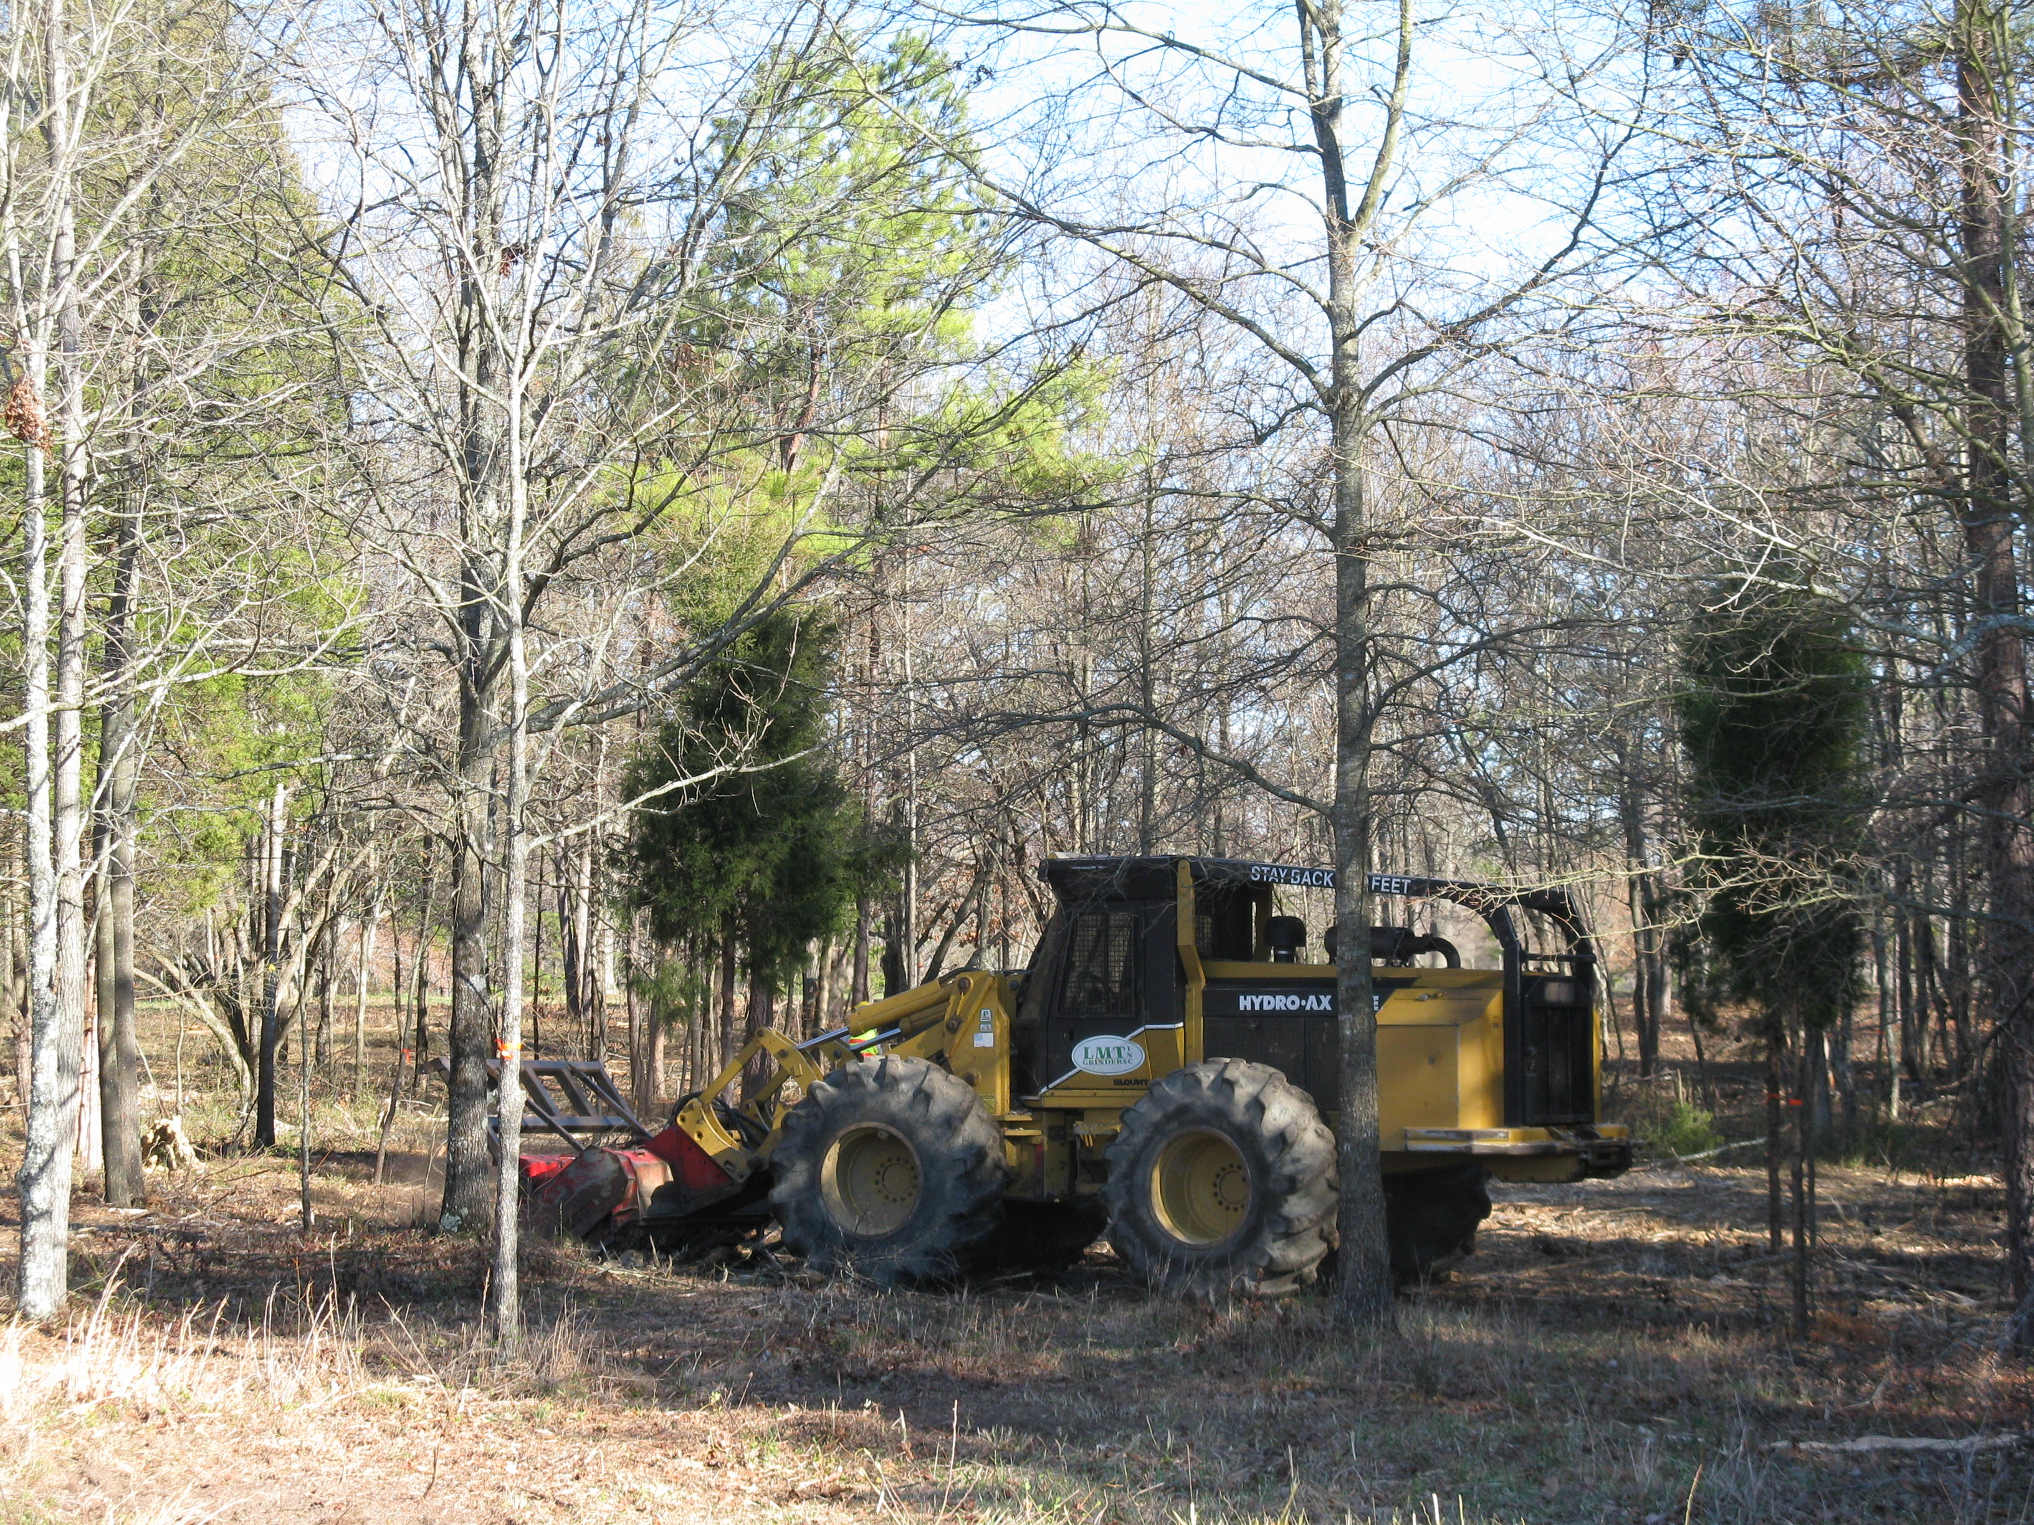
Mechanical restoration uses machinery to selectively thin small trees and underbrush. Cowpens National Battlefield has used traditional mowers, industrial rotary mowers, and contracted for large equipment to remove the underbrush and open up the forest. Mechanical reduction has the advantage of showing immediate results, but it is expensive.

Manual
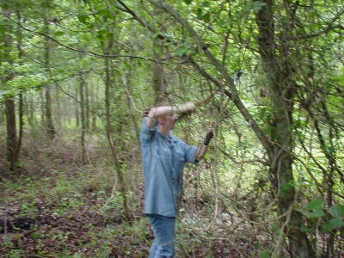
Manual labor includes periodic employment of crews to remove invasive exotic plant species not native to the area in 1781 and which are now prevalent in the park. Hand crews trim trees and undergrowth, and replant native hardwoods. The main benefit of using manual labor for the trimming and planting is that volunteers can do it. Unfortunately, this method is labor intensive and changes are hard to maintain.

Prescribed Fire
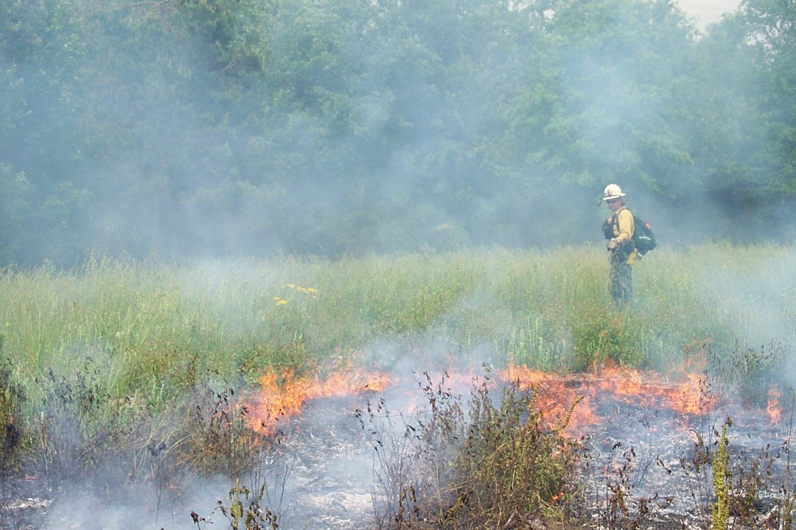
Periodic prescribed burning clears the forest floor, opens up the woodlands, and prevents catastrophic wildfires that could escape from the park. Native Americans and colonial settlers used fire to clear underbrush in heavily wooded areas. Because fire is a natural occurrence, many native plants and animals flourish after a fire. The disadvantages of prescribed burning are that it requires a specialized firefighting team and ideal weather conditions. Also, fires can burn too hot and kill desired species, or not hot enough to accomplish the required restoration.

Preserving Our Heritage

Each restoration method that the National Park Service employs helps restore certain aspects of the battlefield. Battlefield restoration is a long-term, ongoing project, and repetition is the only way to keep the battlefield open, as it would have appeared in 1781.
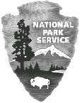
Experience Your America™
The National Park Service cares for special places saved by the American people so that all may experience our heritage.

