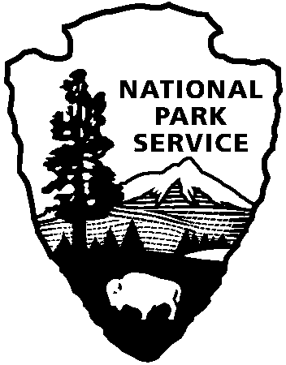 | National Park Service  U.S. Department of the Interior
Summer Jobs for Youth at Cowpens National Battlefield
June 4, 2012 - July 27, 2012

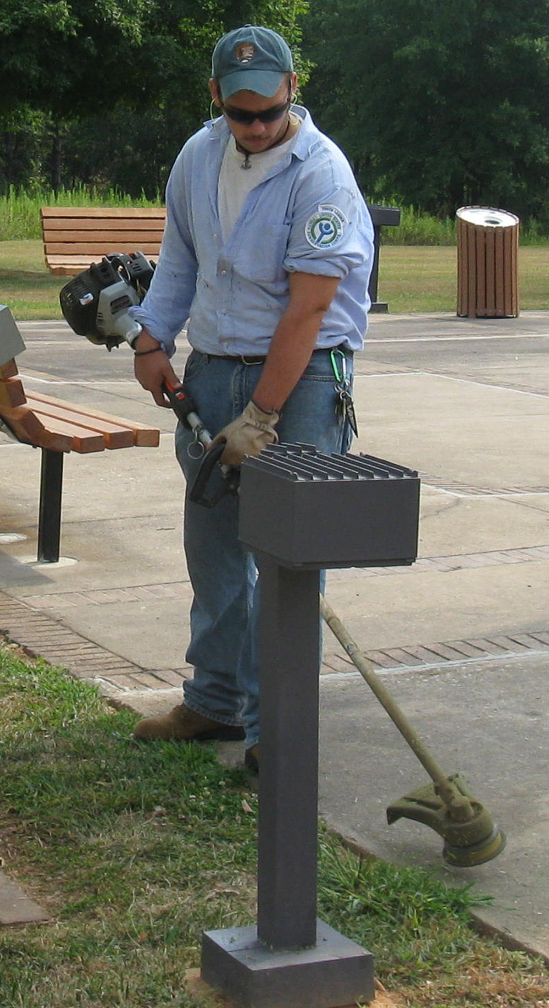
Are you a teenager looking for a challenging summer job? If so you may be interested in working for the National Park Service as a member of the Youth Conservation Corps at Cowpens National Battlefield. The Youth Conservation Corps (YCC) was established by Public Law 93-408 and is a summer employment program for young men and women between the ages of 15-18 who work, learn, and earn together on projects that further the development and conservation of the natural resources of the United States.

This job entails physical work outdoors in temperatures sometimes above 90°. Participants may be exposed to insects, poison ivy, and adverse weather. Previous projects have included removing debris from old home sites and businesses, building bridges and split rail fences, pruning trees, removing exotic plant species, and helping to prepare for the park’s fireworks program. The work this summer will be similar to these previous projects. In addition to these tasks, the park will provide environmental education and field trips to other parks.

Cowpens National Battlefield will have applications available in the Visitor Center from March 15-April 15 or you may download one at http://www.nps.gov/gettinginvolved/youthprograms/upload/ycc_application.pdf. Cut off for accepting applications will be 3:30 pm April 15, 2012. Applicants may return applications to the Visitor Center at 4001 Chesnee Hwy, Gaffney, SC 29341, mail them to Cowpens National Battlefield, PO Box 308 Chesnee, SC 29323, or fax them to 864-461-7795.

The park will randomly draw the names of at least four young people to work this summer, 40 hours per week, Monday through Friday, paid at minimum wage $7.25 per hour. Applicants may pick up an application at the park Visitor Center from 9:00 a.m. to 5:00 p.m. seven days a week. Applicants MUST be available for work from 7:00 a.m. until 3:30 p.m. Monday-Friday, 40 hours a week beginning on June 4th and ending on July 27^{h} with no unexcused absences and NO VACATIONS.

Applicants must be a permanent resident of the United States, have a Social Security card, have a desire and willingness to work outdoors, and have no history of serious crime or anti-social behavior that might create safety problems. In addition, your parent or legal guardian must consent to your working and be able to provide the proper type of work clothing such as long sleeved shirts, jeans and work boots.

For more information you may call the battlefield at (864) 461-2828.

