National Park Service
U.S. Department of the Interior
Cowpens National Battlefield
Overmountain Victory National Historic Trail
338 New Pleasant Road
Gaffney, SC 29341

864-461-2828 Phone
www.nps.gov/cowp
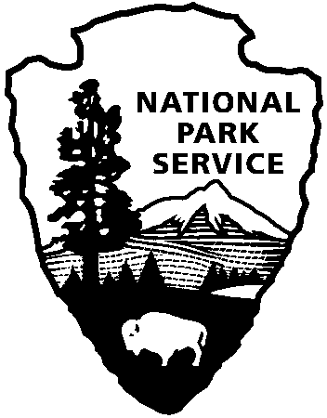
Summer Work for Teens at Cowpens National Battlefield and Overmountain Victory National Historic Trail

Release Date: April 18, 2017
Contact: Katherine Lynn, 864-936-7921, Katherine_lynn@nps.gov

Gaffney, SC –Cowpens National Battlefield and the Overmountain Victory National Historic Trail are accepting applications for the Youth Conservation Corps.
For eight weeks local students will work and play at the NPS sites with Youth Conservation Corps (YCC). As members of the YCC, the students have a personal role in protecting the nation’s precious resources during this summer program. The YCC was established by Public Law 93-408 and is a summer employment program for young men and women between the ages of 15-18 who work, learn and earn together on projects that further the development and conservation of the natural resources of the United States.
Applicants must be a permanent resident of the United States, have a Social Security card, a willingness to work outdoors and the ability to work well with others. Those chosen for employment will be paid minimum wage for a 40-hour work week and must be available to work from June 12 – August 4, 2017.
Previous projects at Cowpens include trail construction and maintenance, brush clearing, weed-eating and erosion control projects. The work this summer for both crews will be similar to these previous projects. In addition to these tasks, the parks will provide environmental education and field trips to other parks, and a working/camping trip in another park.
Applications are available at Cowpens NB Visitor Center, located at 4001 Chesnee Hwy, Gaffney, SC from 9:00 am - 5:00 pm. For more information contact Katherine Lynn at 864-936-7921 or Katherine_Lynn@nps.gov. Applications are due by May 26, 2017.
Cowpens National Battlefield and the Overmountain Victory National Historic Trail are units of the Southern Campaign of the American Revolution Parks Group within the National Park Service. The group mission is to protect, preserve, and interpret the significance of the decisive battles where America earned its freedom. For more information about activities at Cowpens National Battlefield and the Overmountain Victory National Historic Trail, call 864-461-2828 or visit the parks’ webpages at www.nps.gov/cowp/ and www.nps.gov/ovvi/. Like us on Facebook at www.facebook.com/CowpensNationalBattlefield and www.facebook.com/overmountainvictoryNHT.

www.nps.gov

About the National Park Service. More than 20,000 National Park Service employees care for America’s 417 national parks and work with communities across the nation to help preserve local history and create close-to-home recreational opportunities. Learn more at www.nps.gov.

