Cowpens National Battlefield
338 New Pleasant Road
Gaffney, SC 29341

(864) 461-2828 phone
www.nps.gov/cowp/
Cowpens National Battlefield News Release

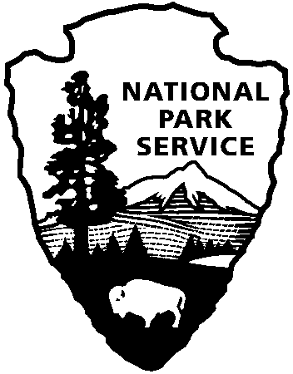
National Park Service
U.S. Department of the Interior

Release Date: September 24
Contact: Virginia Fowler, Virginia_Fowler@nps.gov, (864) 461-2828
Llama on the Lam at Cowpens National Battlefield – CAPTURED!
On September 14, 110 fourth graders from Buffalo Elementary School in Union, SC, visited Cowpens National Battlefield and received more than just one once-in-a-lifetime experience. As the children traversed the Revolutionary War battlefield, they crossed paths with a strange animal. "Ranger, is that a horse?" children called out as they stopped to learn about the differences between continental soldiers and their militia counterparts. Two hundred yards in the distance, a llama was standing in the clearing. For ranger Jonathan Riner, this provided a spontaneous moment to educate the children about safety procedures for animals in National Park Service sites.
Ranger Riner told the children to keep a safe distance and to pay close attention to the llama's reactions to them. The group had the chance to walk by the animal at a safe distance and under close supervision of park staff, teachers, and chaperones. Ranger Riner talked about wildlife protection and preservation and of the challenges of removing the animal from the park.
"Notice how the llama is not afraid of us?" asked Ranger Riner. "Yes,” the children affirmed. "Is that a good thing, or should that make us more concerned about our safety?" The children decided that they should be more concerned with their safety because the animal showed no fear of them even though it did not know them. Riner allowed the children to take pictures, but maintained awareness of their position, and instructed the teachers and children to do the same.
Although it is normal for visitors to encounter wild turkeys, deer, squirrels, and rabbits while walking the battlefield, it is unprecedented for them to come across a llama. These youngsters as well as dozens of other visitors over the course of the weekend had the rare opportunity to see this exotic species while visiting a national battlefield.
George the Llama had sought refuge in the park when a more dominant male llama chased him from his pen near the park’s boundary the night before the children’s field trip. National Park Service officials worked with the park neighbor, who was unable to keep both the young llama and the more dominant one, to find him a new home. Kim and Lynette Melton from Southeast Llama Rescue arrived on September 17 with a female llama to entice George into an enclosure so that they could take him to his new foster home in North Carolina.
Southeast Llama Rescue (SERL) is a non-profit organization that helps find homes for abused, neglected, and unwanted llamas as well as provides basic care information and mentors to new llama owners. For more information about SERL, visit their website at http://www.southeastllamarescue.org.
www.nps.gov

About the National Park Service. More than 20,000 National Park Service employees care for America’s 395 national parks and work with communities across the nation to help preserve local history and create close-to-home recreational opportunities. Learn more at www.nps.gov.

