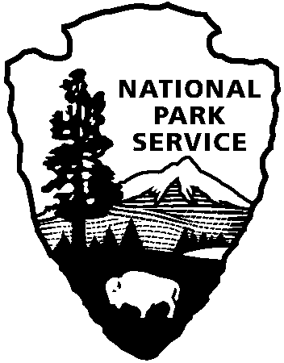 | National Park Service  U.S. Department of the Interior |  | Southeast Region  100 Alabama St. SW  Atlanta, GA 30303  404-507-5612 phone  404-562-3263 fax
National Park Service News Release

FOR IMMEDIATE RELEASE – July 2, 2014
CONTACT – Bill Reynolds - 404-507-5612

Four Revolutionary War Park Units to Consolidate Operations
Kings Mountain National Military Park, Cowpens National Battlefield, Ninety Six National Historic Site, and Overmountain Victory Trail to Share Staff

ATLANTA – Southeast Regional Director Stan Austin announced that four National Park units in North Carolina, South Carolina, Tennessee, and Virginia will begin to consolidate operations on or about September 1. The four units represent significant stories of the American Revolution in the southern United States.

“This action will ensure financial sustainability, provide more efficient use of resources, and help these parks to better serve the visiting public,” Austin said. “The units share historic backgrounds, missions and geographic proximity, and this provides an opportunity to share employees who perform identical or similar functions at each of the parks.”

Kings Mountain National Military Park, Cowpens National Battlefield, and Ninety Six National Historic Site are located in South Carolina. Overmountain Victory Trail spans parts of Tennessee, Virginia, North Carolina and South Carolina. As part of the National Trails Program, it is a partnership entity and does not own land.

The four units will be formed into a “group” under one general superintendent who will manage all four units. The National Park Service has begun the hiring process for a general superintendent. It is expected that the position will be filled by September 1, and the new superintendent will begin the process of combining park functions. The new superintendent will also be responsible to promote the individual identity of each park and build coalitions within each of the parks’ surrounding communities. It has not yet been determined where the new superintendent will be stationed, but it will be at one of the three existing park units.

The new superintendent will work with key leaders in each of the park units to determine the best structure for the new organization. The focus will be on sustainability of operations, efficient and effective use of resources, and finding innovative ways to serve the parks’ visitors. The new structure will be implemented over time.

---more---

Parks Consolidate 2-2-2

The superintendent position at Kings Mountain is vacant because of the retirement of the previous superintendent. The current superintendent of Overmountain Victory National Historic Trail will remain in place under the new structure and will report to the “group” superintendent. He will also be responsible for working with shared partners throughout the “group.” Projects along the trail route will continue to be partially funded through cooperative agreements as opportunities arise and resources and personnel permit.

Consolidating management functions is not unique in the National Park Service, and allows parks to place more staff in the field to serve visitors. For example, the “Outer Banks Group” in North Carolina combines Cape Hatteras National Seashore, Fort Raleigh National Historic Site and Wright Brothers National Memorial under one superintendent.

-NPS-

THE NATIONAL PARK SERVICE IS COMPOSED OF MORE THAN 20,000 RANGERS, BIOLOGISTS, HISTORIANS, GEOLOGISTS AND OTHER PROFESSIONALS WHO CARE FOR AMERICA’S 401 NATIONAL PARKS AND OTHER SPECIAL PLACES SO THAT EVERYONE TODAY AND IN THE FUTURE CAN EXPERIENCE AMERICA’S HISTORY AND BEAUTY.

EXPERIENCE YOUR AMERICATM
The National Park Service cares for special places saved by the American people so that all may experience our heritage.

