Cowpens National Battlefield
338 New Pleasant Road
Gaffney, SC 29341

(864) 461-2828 phone
www.nps.gov/cowp/
Cowpens National Battlefield News Release

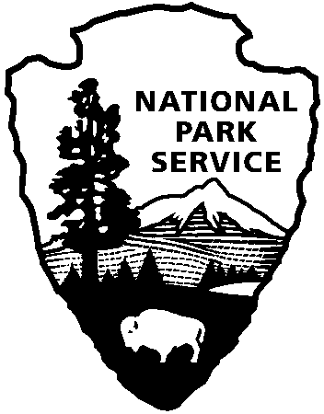
National Park Service
U.S. Department of the Interior

Release Date: December 22, 2012
Contact: Virginia Fowler, Virginia_Fowler@nps.gov, (864) 461-2828

Experience the Sights and Sounds of the American Revolution
To celebrate the 232nd anniversary of the decisive American victory over the British, Cowpens National Battlefield will host a weekend of special events on January 18 - 20, 2013. Visitors who have attended previous anniversary events will recognize some old favorites in the upcoming event: a smoke-filled encampment of over 100 American and British reenactors, a wreath-laying at the US Monument in front of the Visitor Center, 18th century musket, rifle, and cannon firing demonstrations, Revolutionary War cavalry demonstrations, ranger-led battlefield walks, author lectures, and children’s activities.
However, this year, the park is changing things up a little. The commemoration will kick off with a wreath-laying by Sons, Daughters, and Children of the American Revolution at the Daniel Morgan statue in Spartanburg at 2:30 pm on Friday, January 18. That evening, the park is partnering with Wofford College to present a special Revolutionary War Roundtable event. Jim Piecuch will give a talk about his book, The Cavalry of the American Revolution from 6:30 – 8:00 pm in the Multicultural Room of the Burwell Center at Wofford. The dessert-only roundtable costs $5. For reservations, call or email Juanita Pesaro at 864-597-4207 or pesarojb@wofford.edu.
The park is also transforming the annual Saturday evening lantern tours, making them 30-minute Twilight Walks beginning at 5:30. The visitors in each walk will portray couriers carrying an urgent message to General Morgan. For reservations for the free Twilight Walk, call Erica Hass at 864-461-2828 beginning January 2.
For visitors who do not want to miss church on Sunday morning, the park will be offering an 18th century-style church service at 10:30. There will also be a special “reenactor scavenger hunt” for children of all ages to do on both days. Superintendent John Slaughter encourages everyone in the region to help celebrate the anniversary of this pivotal battle, "This is YOUR National Park! What happened here on this simple pasture-land gave all Americans great confidence to take the fight all the way to victory. Our nation's freedom was secured right here in YOUR backyard."
Cowpens National Battlefield is part of the National Park Service and has a Visitor Center, movie, bookstore, and a one-mile trail on the battlefield. There is also a picnic area, nature trail and three mile auto tour loop. Visitor Center hours are 9:00 a.m. – 5:00 p.m. daily, closed on Thanksgiving, Christmas, and New Year’s Day. For more information, call (864) 461-2828 or visit the park’s webpage at www.nps.gov/cowp.
Find us on Facebook at www.facebook.com/CowpensNationalBattlefield.
www.nps.gov

About the National Park Service. More than 20,000 National Park Service employees care for America’s 395 national parks and work with communities across the nation to help preserve local history and create close-to-home recreational opportunities. Learn more at www.nps.gov.

