Cowpens National Battlefield
338 New Pleasant Road
Gaffney, SC 29341

(864) 461-2828 phone
www.nps.gov/cowp/
Cowpens National Battlefield News Release

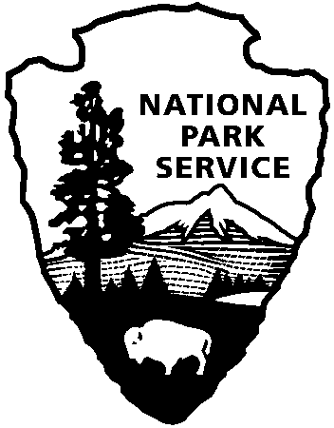
National Park Service
U.S. Department of the Interior

Release Date: December 19, 2013
Contact: Virginia Fowler, Virginia_Fowler@nps.gov, (864) 461-2828

Cowpens National Battlefield Celebrates 233rd Battle Anniversary
January 17-19, 2014

To celebrate the 233rd anniversary of the decisive American victory over the British, Cowpens National Battlefield will host a weekend of special events on January 17 – 19, 2014. Activities include a wreath-laying, 18th century weapons firing demonstrations, Revolutionary War cavalry demonstrations, ranger-led battlefield walks, author and historian talks, and a Saturday evening guided lantern walk.

The commemoration will kick off with a wreath-laying by Sons, Daughters, and Children of the American Revolution at the Daniel Morgan statue in Spartanburg at 2:30 pm on Friday, January 17, the anniversary of the battle. That evening, Scott Hodges will portray the battle’s militia commander, Andrew Pickens at 7:00pm at Wofford College; social time with dessert and coffee will be from 6:30 – 7:00. Tickets for the performance and dessert and coffee are $5.00. The park will continue the annual Saturday evening lantern tours beginning at 5:30. In addition, there will be a special “reenactor scavenger hunt” for children of all ages to do while the reenactors are in their camps. For visitors who do not want to miss church on Sunday morning, the park will be offering an 18th century-style church service at 11:00 am. In addition, visitors can experience what it was like for Morgan’s “Flying Army” to arrive at the Cow Pens by registering for Morgan’s Victory March. Led by author and Rutherford County teacher Robert W. Brown who worked at Cowpens National Battlefield this past summer, the 25-mile walk/ride retraces the route that Daniel Morgan’s men took to the Cow Pens, a well-known landmark in 1781. Participants will arrive at the park on Sunday afternoon at 1:30.

Acting Superintendent Chris Revels encourages everyone in the region to visit and join in the celebration of the American victory, led by General Daniel Morgan. “This battle will forever be recognized as a pivotal battle during the Southern Campaign of the American Revolution.”

For reservations for the January 17 Scott Hodges performance at Wofford College, email Juanita Pesaro at pesarojb@wofford.edu.

For reservations for the January 18 lantern tour, email Erica Hass at erica_hass@nps.gov.

For information about Morgan’s Victory March, January 18 – 19, email or call Jane Waters at jane.waters@cherokeecountyhistory.org or 864-489-3988.

Cowpens National Battlefield is part of the National Park Service and has a Visitor Center, movie, bookstore, and a one-mile trail on the battlefield. There is also a picnic area, nature trail and three mile auto tour loop. Visitor Center hours are 9:00 a.m. – 5:00 p.m. daily; closed on federal holidays except for Memorial Day, Independence Day, and Veterans Day. For more information, call (864) 461-2828 or visit the park’s webpage at www.nps.gov/cowp.
Find us on Facebook at www.facebook.com/CowpensNationalBattlefield.

www.nps.gov

About the National Park Service. More than 20,000 National Park Service employees care for America’s 401 national parks and work with communities across the nation to help preserve local history and create close-to-home recreational opportunities. Learn more at www.nps.gov.

