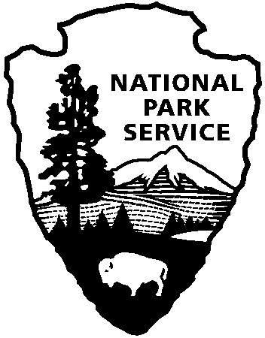 | National Park Service  U.S. Department of the Interior
National Park Service News Release

FOR IMMEDIATE RELEASE – DATE: October 18, 2013
CONTACT: Virginia Fowler, (864) 461-2828

Cowpens National Battlefield to Complete Delayed Paving Project in October

Park Superintendent John Slaughter announced today that contractors will be onsite to pave and repair parking lots the week of October 27 – November 1, 2013. During this period, pedestrian access in the Picnic Area, vehicular access to the Trailhead Parking Lot, and pedestrian and vehicular traffic to the Visitor Center will be restricted periodically.

To minimize visitor inconvenience, as much as possible of the work will be completed after 5 pm while the park is closed. The park will post unscheduled closures that may occur due to inclement weather.
Scheduled closures for paving are as follows:
- Visitor Center Parking Lot - Monday, October 28. On that day, visitors can either park on the loop road and walk to the Visitor Center and interpretive trail, or park at Battlefield Overlook #2 (Morgan’s Camp parking lot) and be shuttled to the Visitor Center.
- Picnic Area – Wednesday and Thursday, October 30 and 31
- Trailhead Parking Lot – as needed

Visitors can learn about the Battle of Cowpens at the Visitor Center and museum, where an 18-minute movie about the battle shows on the hour between 9:00 and 4:00. A fiber-optic map explains the battlefield strategy and troop movements, and museum exhibits highlight the opposing soldiers who fought here. The one mile interpretive battlefield trail starts at the Visitor Center.

Cowpens National Battlefield is part of the National Park Service and has a Visitor Center, movie, bookstore, and a one-mile trail on the battlefield. There is also a picnic area, nature trail and three mile auto tour loop. Visitor Center hours are 9:00 a.m. – 5:00 p.m. daily, closed on Thanksgiving, Christmas, and New Year’s Day. For more information, call (864) 461-2828 or visit the park’s webpage at www.nps.gov/cowp. Find us on Facebook at www.facebook.com/CowpensNationalBattlefield, and follow us on Twitter @CowpensNB.

About the National Park Service. More than 20,000 National Park Service employees care for America’s 401 national parks and work with communities across the nation to help preserve local history and create close-to-home recreational opportunities. Learn more at www.nps.gov.

