

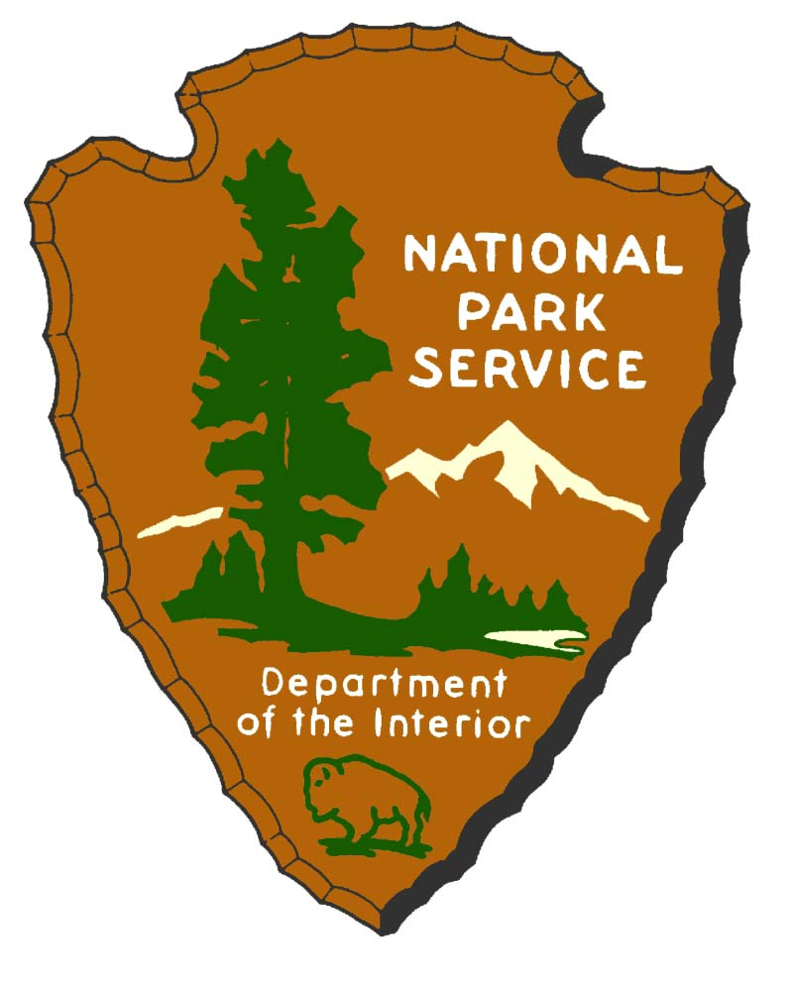

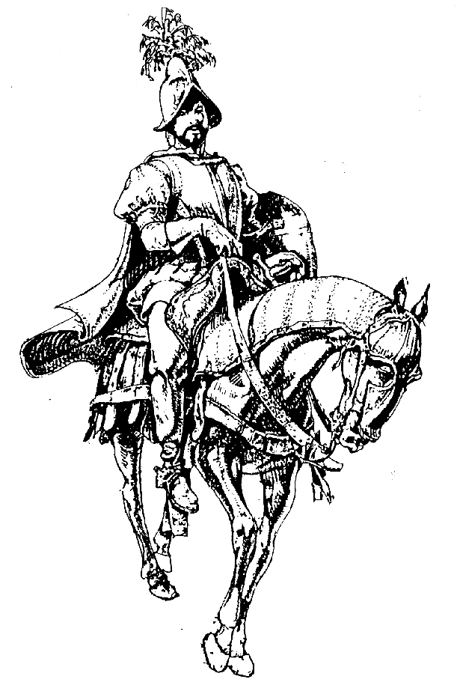

Coronado National Memorial

History Education Program

Activity Guide

Included in this guide are activities based on the Coronado Expedition and Native Americans. They are all designed for the 4th grade class curriculum in several subjects such as math, art, geography, language, etc. Please use this guide to introduce your students to Coronado and his expedition. It is a fun and educational way to prepare your students for the field trip. Your students must have a good base knowledge of the Coronado Expedition before coming to the park to get the most out of the park-based section of the program. You may find some activities too easy or difficult for your class. Please feel free to adjust the activities to make them more useful.

Table of Contents
Social Studies
Activity 1- Your epidermis is showing! 3
Activity 2- Build a Pueblo 4
Activity 3- Pictographs 6
Math
Activity 4- What would you take on an expedition? 8
Activity 5- Learn to be a step counter 9
Geography
Activity 6- The trek of Coronado 11
Activity 7- Charting a map 13
Communications
Activity 8- Be a reporter 15
Activity 9- Sign Language 16
Language
Activity 10- Journal writing 19
Activity 11- Poems 20
Activity 12- Crossword puzzle 21

Activity 1- Your Epidermis is Showing!

Applicable Arizona State Standards (Social Studies):

SS04-S1C2-02 SS04-S1C3-03
SS04-S2C5-03 SS04-S4C2-01

What one word describes why all humans wear clothes? PROTECTION! We protect our heads from cold and sun, our skin from scratches, and our feet from rocks and thorns.

Have students feel fabric samples of wool, cotton, and linen. Discuss which fibers are natural and which ones are man-made. Compare the clothing and fabrics we have now with those of the time of the Expedition as to care, comfort, etc. Have students check the labels in the clothes they have on as to fiber content.

- Natural fibers are wool, cotton, silk, and linen. Discuss how they occur in nature: wool comes from sheep; cotton grows as plants (here in Arizona); linen is made from flax, a plant that looks like wheat; silk is the fiber from which the silkworm spins its cocoon.
- Wool was widely used in the Old World for clothing. Only the wealthy could afford luxury fabrics such as silk and linen. Some Old World types of cotton had been grown in India and the Near East for centuries, but only very small quantities of it ever reached Europe. That cotton was not only expensive, but weak and difficult to weave because of its short strands. In Europe the Old World cotton served primarily for padding jerkins under the coats of mail worn in battle. The long-stranded cotton of the American Indians so surpassed in quality the puny cotton of the Old World that the Spaniards mistook American Indian cloth for silk and interpreted its abundance as yet further proof that these lands lay close to China. For thousands of years before the European conquest of America, the Indians had been using this carefully developed cotton to weave some of the finest textiles in the world.
- Leather and skins from a variety of animals are also natural materials commonly used for clothing by both the Spaniards and Indians.
- Man-made fibers are nylon, Dacron, polyester, spandex, etc. all of which were manufactured in the past 75 years.
- Discuss how clothing was laundered in 1540; compare this method with today’s laundering procedures. Ask the students: If you had to do all of your laundry by hand, would you wash your clothes as often as you do today? The Indians used soap made from yucca.

Activity 2- Build a Pueblo

Applicable Arizona State Standards (Art and Social Studies):

A04-S1C1-01 A04-S1C1-02 A04-S1C1-03 A04-S1C2-01
A04-S1C2-02 A04-S1C4-02 A04-S1C5-01 A04-S1C5-02
A04-S2C1-06 A04-S2C2-01 A04-S2C2-02 A04-S2C3-01
A04-S2C4-02 A04-S2C4-03 A04-S2C5-02 A04-S3C2-02
A04-S3C5-02 SS04-S1C2-01 SS04-S1C2-02 SS04-S1C2-03
SS04-S4C5-01

This activity is designed for students to view and understand the Zuni way of life by discussing Zuni culture and building a model pueblo. First, discuss as a class how tasks were performed in the Zuni culture. How were they different from what we do today?
- The men did the clothing construction, sewing and knitting clothes for themselves and the women using needles of bone.
- Men laid the foundations, built the walls and placed the beams for the pueblos, while the women and girls mixed the mortar and plastered the houses.
- It was common to find several families living under the same roof in a pueblo society.
- The girls had little time for play because they cared for the younger children and imitated all that their mothers did, making pottery, weaving belts, and making bread.

Building the pueblo is probably best done in small groups. It may be completed as a single unit, or materials could be laid out in one corner of the classroom for students to use after they have finished their other assignments.

Materials Needed
- flat piece of heavy cardboard (at least 18” X 24”)
- small, empty cardboard boxes- shoe, tissue, cracker, etc.
- twigs, string, clay
- glue, paint
- cloth scraps

Instructions
Use a large piece of heavy cardboard as the base and paint it earth colored. Arrange the cardboard boxes using the picture on the following page as a guide, but be creative and use your imagination. After deciding on the basic design of the pueblo, glue the boxes to each other but do not attach them to the base at this time. Cut square openings in the roofs as trap doors and cut doors and small windows on the upper floors. Remember there are no doors or windows on the ground floor for protection, and outside ladders were used to climb from one level to another. Using a pointed object such as a pen or sharp pencil, make small round holes slightly below the roof lines on each box. Paint the outside of all the boxes the color of adobe and insert short pieces of twigs into the holes. Leave approximately ½” sticking out to resemble the wooden “rafters” typical of southwestern architecture. With additional twig pieces and glue, construct ladders for outside doors and trap doors. Cut small cloth scraps to use as window and door coverings. Students may use their imaginations to personalize the pueblo by constructing human and animal figures out of clay and landscaping it with sand, small rocks and pebbles. Although most pictures show “beehive” ovens on the roof tops, these were actually a technology acquired from the first Spanish missionaries and settlers which replaced the cook fires.
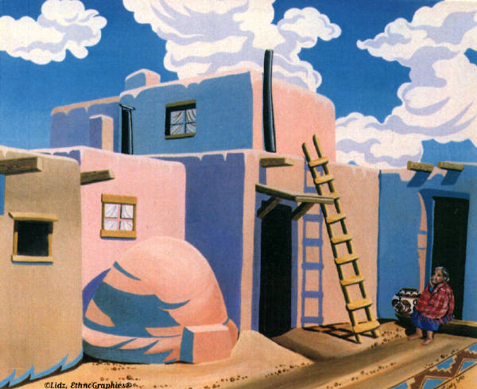
Activity 3- Pictographs

Applicable Arizona State Standards (Art):

A04-S1C1-01 A04-S1C1-02 A04-S1C1-03 A04-S1C2-01
A04-S1C2-02 A04-S1C3-01 A04-S1C4-01 A04-S1C4-02
A04-S1C5-01 A04-S1C5-02 A04-S2C1-01 A04-S2C1-02
A04-S2C1-03 A04-S2C1-06 A04-S2C2-01 A04-S2C2-02
A04-S2C3-01 A04-S2C4-01 A04-S2C4-02 A04-S2C4-03
A04-S2C5-01 A04-S2C5-02 A04-S2C5-03 A04-S3C1-01
A04-S3C1-02 A04-S3C2-01 A04-S3C2-02 A04-S3C3-01
A04-S3C4-01 A04-S3C5-02 A04-S3C5-03

Discuss with students what a pictograph is. Tell them that Native Americans used pictographs to record events and tell stories. Using the symbols provided on the next page or by making your own, draw a pictograph telling a short story about something that has happened to you. Making an overhead to project onto the wall is a good method for presenting the pictographs. Have students trade pictograph pages to try to figure out the stories of their classmates. Discuss how it is difficult to figure out pictographs without a translation sheet. Discuss why today we don’t know what many of the symbols mean because the translation has been lost.

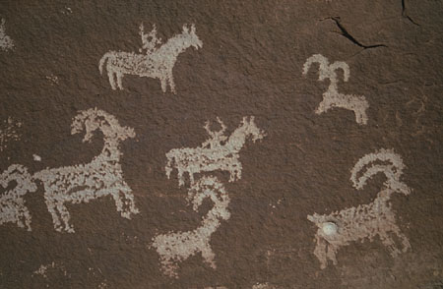
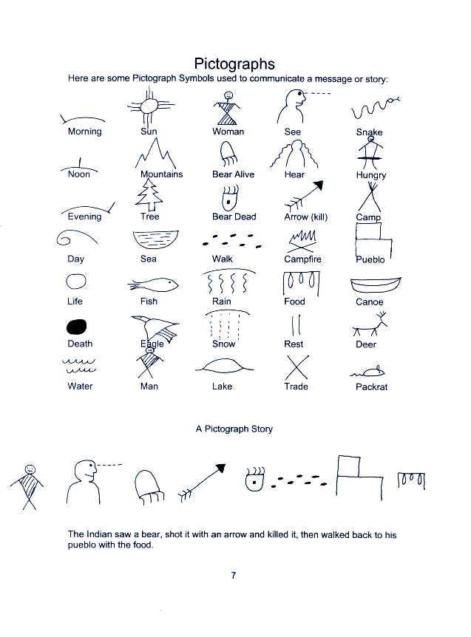
Activity 4- What Would You Take on an Expedition?

Applicable Arizona State Standards (Math):

M04-S1C1-01 M04-S1C1-02 M04-S1C1-10 M04-S1C2-01
M04-S1C2-02 M04-S1C2-03 M04-S1C2-04 M04-S1C2-05
M04-S1C2-06 M04-S1C2-07 M04-S1C2-08 M04-S1C2-09
M04-S2C1-01 M04-S2C1-05 M04-S2C1-06

Imagine being one of the soldiers on Francisco Vazquez de Coronado’s expedition. What sort of items would you need to bring along? How would you carry them with you? Make a list of ten items you would need on the trip. How much does each item weigh? If a horse can carry 100 pounds, can one horse carry all your things?

There were 339 soldiers on the Coronado Expedition. If each soldier brought along two pieces of armor for himself, how many pieces of armor were carried on the expedition?

If each piece of armor weighed ten pounds, how many tons of armor were carried? (one ton = 2000 pounds)

We need to eat!

There were approximately 1,400 people including Spanish horsemen and footmen, and Indian allies, guides, and servants on the expedition. They took over 1,500 horses, mules, cattle, and sheep, travelling for two years.

How many days were they gone?

If a side of beef fed 100 people, how many people would one cow feed? (two sides= one cow)

How many cows would need to be killed in order to feed the whole group for the evening supper?

If there were 500 head of cattle, how many nights could the entire group eat beef for dinner?

One sheep would provide food for 30 people. How many people could eat by killing five sheep?

Teachers- make up more questions relating to the amount of items necessary for the expedition. Impress upon the students what a huge amount was necessary to create such an expedition.
Activity 5- Learn to be a Step Counter

Applicable Arizona State Standards (Math):

M04-S1C3-01 M04-S1C3-02
M04-S1C3-03 M04-S1C3-04

Explain to the students how Coronado’s Expedition had a step counter. This person knew how many of his steps made up one league, the unit of measure used by the Spaniards. He counted his steps all day long to then calculate how far the Expedition had gone each day. This was a very important job because the distance traveled each day was used to figure out where the Expedition was on the map. Have your students pretend to be step counters. Their job is to figure out how many of their steps equals one mile, one league, and one kilometer.

Because the main body of the Expedition was traveling on foot with so many animals, they often went only a few leagues each day. However, Indians might travel 10 leagues per day on foot. How many of the students think they would be able to walk even a few leagues per day for weeks and months on end, with few if any days of rest?

Materials
Large tape measure
Chalk
Sidewalk or playground area 50 ft. long

Mark off 50 ft. on a sidewalk or playground area with chalk. Have each student walk the 50 ft. section and count the number of steps it takes him/her to walk the distance. Using the table on the next page, each student will calculate how many steps they would have to take to walk a mile, a kilometer, and a league (3 miles).

Example: A student walks the 50 ft. section and counts 33 steps. From the chart the student learns that they would have to walk 3485 (after rounding) steps to go a mile. The student then divides that number by 1.6 to get 2178 steps per kilometer (students can also multiply by .62). And he multiplies the number by 3 to get 10455 steps per league.

Step Counting Table
Number of steps: |  |  | Number of steps:
in 50 feet | per mile |  | in 50 feet | per mile
20 | 2112 |  | 41 | 4329.6
21 | 2217.6 |  | 42 | 4435.2
22 | 2323.2 |  | 43 | 4540.8
23 | 2428.8 |  | 44 | 4646.4
24 | 2534.4 |  | 45 | 4752
25 | 2640 |  | 46 | 4857.6
26 | 2745.6 |  | 47 | 4963.2
27 | 2851.2 |  | 48 | 5068.8
28 | 2956.8 |  | 49 | 5174.4
29 | 3062.4 |  | 50 | 5280
30 | 3168 |  | 51 | 5385.6
31 | 3273.6 |  | 52 | 5491.2
32 | 3379.2 |  | 53 | 5596.8
33 | 3484.8 |  | 54 | 5702.4
34 | 3590.4 |  | 55 | 5808
35 | 3696 |  | 56 | 5913.6
36 | 3801.6 |  | 57 | 6019.2
37 | 3907.2 |  | 58 | 6124.8
38 | 4012.8 |  | 59 | 6230.4
39 | 4118.4 |  | 60 | 6336
40 | 4224

Activity 6- The Trek of Coronado

Applicable Arizona State Standards (Social Studies):

SS04-S4C1-01 SS04-S4C1-02 SS04-S4C1-03 SS04-S4C1-04
SS04-S4C1-05 SS04-S4C1-06 SS04-S4C1-07 SS04-S4C2-03
SS04-S4C2-04 SS04-S4C2-05 SS04-S4C4-03 SS04-S4C6-01
SS04-S4C6-03

Imagine walking from your home to school and back. Now imagine walking back and forth from home to school to home to school all day long. Now imagine walking back and forth from home to school day after day for two years. Would you get worn out? Would you get tired of walking?

Look at a map as a group and discuss how far the people on the expedition had to walk. Some soldiers had horses, but most people walked the whole way. Discuss some of the place names along the route the travelers passed by. Hand out a copy of the map on the next page to each student. Have them match up place names with the letters on the map.

Answers:
- L
- I
- N
- G
- K
- M
- F
- B
- E
- R
- Q
- P
- O
- A
- H
- C
- D
- J
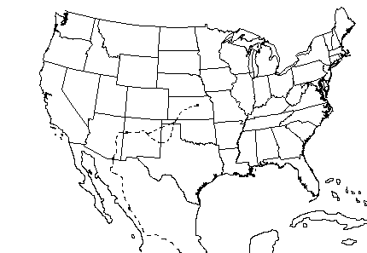
1. _____ Mexico City
2. _____ Rio Grand River
3. _____ Quivera
4. _____ Gulf of California
5. _____ Compostela
6. _____ Kansas
7. _____ US/Mexico border
8. _____ Grand Canyon
9. _____ Coronado National Memorial

10. _____Gulf of Mexico
11. _____ Mexico
12. _____ Texas
13. _____ Oklahoma
14. _____ Pacific Ocean
15. _____ Hawikuh (pueblo in Cibola)
16. _____ Arizona
17. _____ San Pedro River
18. _____ New Mexico

CORONADO’S ROUTE

L
K
Q
A
G
C
B
E
D
F
I
J
H
P
O
M
N
R
Activity 7- Charting a Map

Applicable Arizona State Standards (Social Studies and Art):

SS04-S4C1-01 SS04-S4C1-02 SS04-S4C1-03 SS04-S4C1-04
SS04-S4C1-05 SS04-S4C1-06 SS04-S4C1-07 A04-S3C1-01
A04-S3C1-02

Make an overhead of the map below and project it onto a wall. Using a copy of the grid provided on the next page, students will draw the map of the United States and Mexico onto their paper. Students use the grid to help them draw the map. Then have the students:

- Draw the Expedition route in red.
- Label all the states in green.
- Underline the states Coronado passed through in yellow.
- Color the Gulf of California, Gulf of Mexico, and Pacific Ocean blue.

Activity 8- Be a reporter

Communication: Listening and Speaking Activity

Applicable Arizona State Standards (Language Arts):

LA04-S1C1-02 LA04-S1C1-03

Invite students to answer this question: If you could talk with any person on the Coronado Expedition, who would you talk to? What questions would you ask that person? Write five good questions.

After students have written their interview questions, have them group up with one other student. The students can then interview each other, taking on the role of the person to be interviewed. Have the students role-play to construct the answers as well as they can using the information they have learned about the Expedition and life in the 1500's.

Activity 9- Sign Language

Communication: Listening and Speaking Activity

Applicable Arizona State Standards (Language Arts):

LA04-S1C1-01 LA04-S1C1-02 LA04-S1C1-03

Explain that the Spaniards and the Zunis could not speak to each other when they first met. They spoke different languages. To communicate they used Native American interpreters that knew a common sign language.

Use the following sheet to teach some of the Native American sign language signs to your students. Your students will need to know this for the encounter during the field trip. After practicing the signs, have the students find a partner. Have the students practice saying different simple sentences to each other. Have them make up simple sentences and sign them, without speaking to each other. Is it easy to understand each other when signing?

Sample sentences:
- I am angry.
- I want to eat.
- You and I (me) are friends.
- Everyone wants to camp.
- Everyone is hungry and wants to camp.

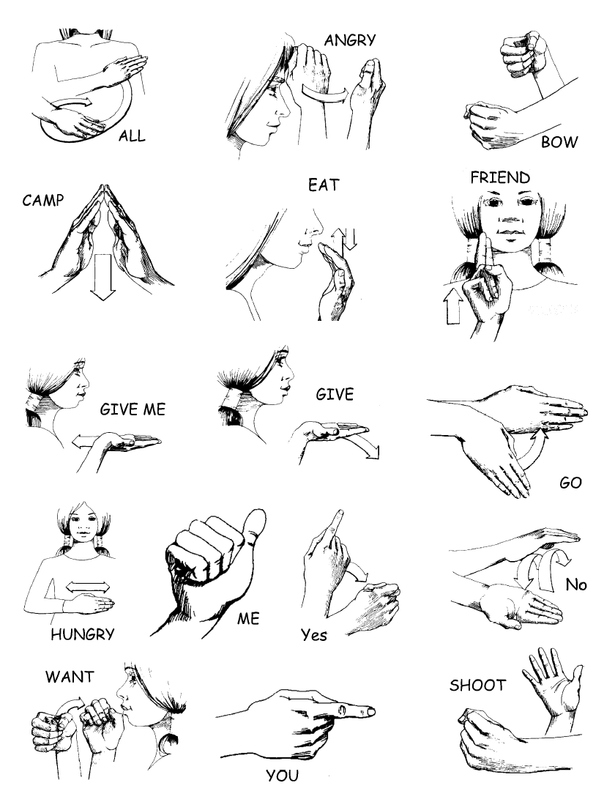

Eat: Cup fingers near mouth. Move hand up and down three times.

Hungry: Start with open palm in front of stomach. Move it from side to side a few times as if cutting something in half.

Give: Hold out flat right hand with palm up at shoulder level. Extend hand out and down as if offering something.

Give Me: Sign Give, then pull hand into chest.

All: From your left shoulder move your hand palm down in a circle.

Me: Point to yourself with your thumb.

You: Point to person with your index finger.

Friend: Hold hand in front of neck, with palm out and index and middle fingers pointing up. Raise hand to right side of face. (meaning growing
up, together)

Angry: Put fist to forehead, then move hand out a little while twisting wrist slightly. (Meaning: Mind twisted)

Camp: (To set up camp) Hold fingers up to form Tipi. Then lower hands a few inches.

Go: Point flat right hand down in front of you. Then with wrist, swing hand up and ahead.

Bow: Close left hand in front of you as if holding a bow. Draw right fist back as if pulling bowstring.

Shoot: Sign Bow. Then snap right hand open as if letting go of arrow.

Want: Bring hand to mouth, as if holding cup. With head still, tilt hand, as if drinking.

Yes: Hold hand in front of right chest with index finger pointing up. Move your hand slightly down and to the left while closing your index finger over your thumb.

No: Hold your flat hand out, palm down, with fingers pointing left. Swing your hand to the right, so palm is up. Return to original position.

Activity 10- Journal Writing

Applicable Arizona State Standards (Writing):

W04-S1C1-01 W04-S1C1-02 W04-S1C1-03 W04-S1C1-04
W04-S1C1-05 W04-S1C1-06 W04-S1C2-01 W04-S1C2-02
W04-S1C3-01 W04-S1C3-02 W04-S1C3-03 W04-S1C3-04
W04-S1C3-05 W04-S1C3-06 W04-S1C3-07 W04-S1C4-01
W04-S1C4-02 W04-S1C4-03 W04-S1C4-04 W04-S1C5-01
W04-S1C5-02 W04-S1C5-03 W04-S1C5-04 W04-S2C1-01
W04-S2C1-02 W04-S2C1-03 W04-S2C2-01 W04-S2C2-02
W04-S2C2-03 W04-S2C2-04 W04-S2C2-05 W04-S2C2-06
W04-S2C3-01 W04-S2C3-02 W04-S2C4-01 W04-S2C4-02
W04-S2C4-03 W04-S2C4-04 W04-S2C5-01 W04-S2C5-02
W04-S2C5-03 W04-S2C5-04 W04-S2C6-01 W04-S2C6-02
W04-S2C6-03 W04-S2C6-04 W04-S2C6-05 W04-S2C6-06
W04-S2C6-07 W04-S2C6-08 W04-S2C6-09 W04-S2C6-10
W04-S2C6-11 W04-S2C6-12 W04-S2C6-13 W04-S3C1-01
W04-S3C1-02 W04-S3C2-01 W04-S3C2-02 W04-S3C2-03

Have each student take on the identity of a person on Coronado’s Expedition. Some examples of characters are: a soldier, a shepherd, a priest, a boy traveling with his father, an Indian servant, the wife of a soldier, a scout, etc. Students will write a journal entry for their character. Tell the students to imagine they are traveling through this area (along the San Pedro River) and tell them to express what they see and do. The children can write a single entry or the assignment can be ongoing, students writing an entry every day for several days. The students can then create a journal cover from cardboard and bind the entries into a book they can take home to show their family.
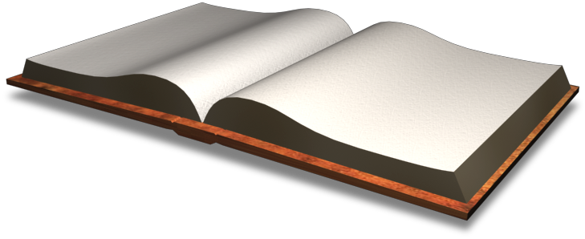
Activity 11- Poems

Applicable Arizona State Standards (Writing):

W04-S1C1-01 W04-S1C1-02 W04-S2C1-03 W04-S2C3-01
W04-S2C3-02 W04-S2C4-01 W04-S2C4-02 W04-S2C4-03
W04-S2C4-04 W04-S2C6-03 W04-S2C6-05 W04-S2C6-06
W04-S2C6-07 W04-S2C6-09 W04-S2C6-10 W04-S3C1-02

After studying the Coronado Expedition for several days, have your students write a poem about the trip taken through this area. Tell the students to be creative. They don’t have to write specifically about Coronado himself; they can write about walking through the desert, being in a new place, the difficulty of being hungry, sights (mountains, fall colors, animals) seen along the trip, or anything that has to do with the Expedition.

Coronado
In 1535, Francisco Coronado did arrive
In Mexico. Then he said he'd go
To the Seven Cities of Gold
Which was said to hold
A lot of gold.
But to his surprise, he found Zuni and Hopi houses that were old.
In 1554 Francisco was alive no more
So he could no longer roam
So this is the end of the poem.

Students can write a rhyming poem like the above poem, or you can make it into a class activity by having all the students write a Diamante poem. This type of poem is good for practicing different elements of grammar. See the example below.

- Line 1 = Initial topic (noun)
- Line 2 = Two descriptive words (adjectives)
- Line 3 = Three action words (verbs)
- Line 4 = Four nouns
- Line 5 = Three action words (verbs)
- Line 6 = Two adjectives
- Line 7 = Ending noun

Man
Long, tiring
Walked, ran, drank
Horses, dogs, men, women
Hiked, ran, walked
Old, pretty
Coronado
Activity 12- Crossword Puzzle

Applicable Arizona State Standards (Writing):

W04-S3C3-01
W04-S3C3-02

Have the students define each of the words below or do it as a group. Discuss how each word would pertain to the Coronado Expedition. Then have the students put the words in alphabetical order. To complete the activity, give them the crossword puzzle on the next page and have them complete it. They can either have the list of vocabulary words to use for reference, or have them put it away so they have to remember the words.

Lances

Navigation

Trek

Metate

Pictographs

Gestures

Ceremonies

Endure

Vegetation

Exaggerate

Flint

Mano

Caravan

Arid

League

Expedition

Translate

Yucca

Provisions

Flock


Coronado's Expedition

Across
2. hard stone that can be flaked and shaped
3. a hand sized stone used on the metate to grind
5. supplies such as clothing and food
6. a measure of distance, about 3 miles
11. formal acts or customs
15. to think, speak, or write something greater than it really is
17. change to a different language
18. weapons with long shafts and sharp points
19. large stone used for grinding corn

Down
1. ancient pictures painted on a rock surface
4. finding one's way with a compass or by using the stars
7. a group or herd of sheep
8. group of people traveling together
9. lacking enough water to grow things
10. a journey with a definite purpose
12. a trip or journey
13. growing plants
14. a plant with sword shaped leaves
15. survive hardships or trials
16. body movements with meaning

