Pre-visit Activity Questions Student Worksheet
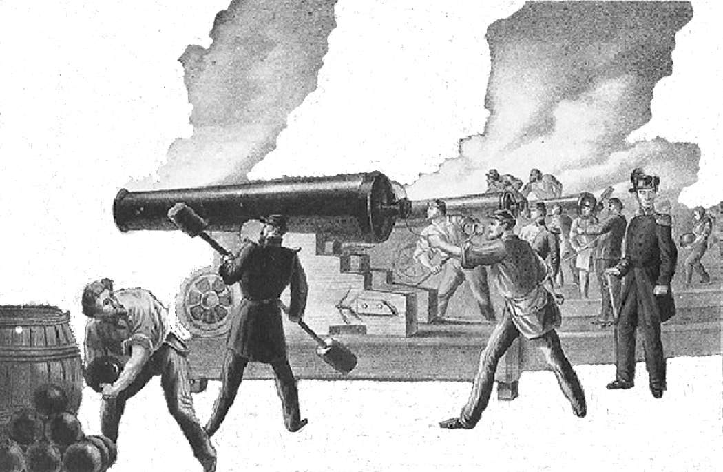
- Savannah, Georgia is a port on the

River.

- When Fort Pulaski was built, ships were made of

.

- Fort Pulaski was built with 25 million

.
- Fort Pulaski is located on Island.
- Count Casimir Pulaski was a War hero.

- On 10, 1862, Fort Pulaski was fired upon by Union cannons.

- Confederate Colonel he was there to defend the fort, not surrender it.
would not surrender Fort Pulaski, stating

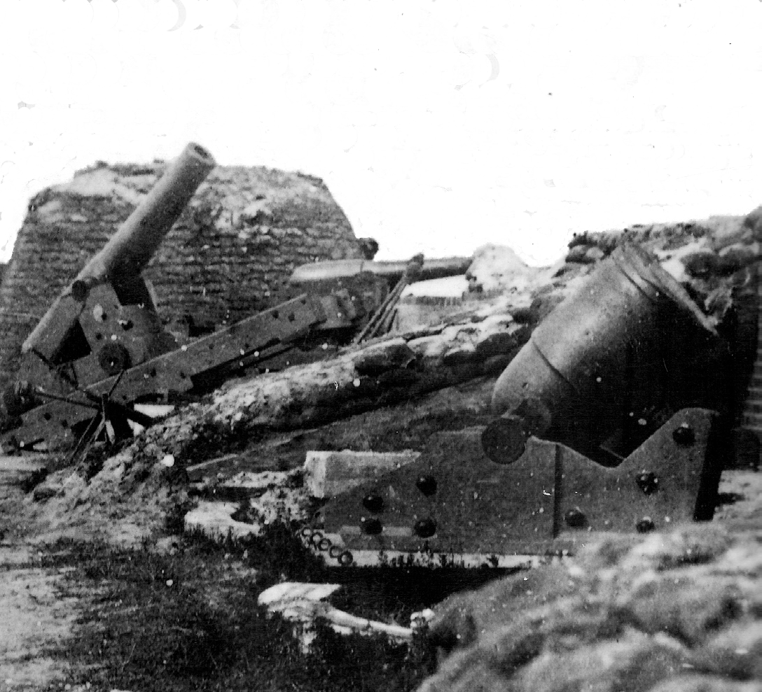
- When the Battle of Fort Pulaski started, of the fort.
- In 1924, Fort Pulaski was named a National .
were in control

- Fort Pulaski was on April 11, 1862.
- The cannon (new

technology) could fire with greater distance and accuracy.
- It required 18 to build Fort Pulaski.

Pre-visit Activity Questions Student Worksheet
- Savannah, Georgia is a port on the Savannah
River.

- When Fort Pulaski was built, ships were made of

wood .

- Fort Pulaski was built with 25 million
bricks .

- Fort Pulaski is located on Island.
- Count Casimir Pulaski was a
Cockspur

Revolutionary

War hero.

- On
April

10, 1862, Fort Pulaski was fired upon by Union cannons.

- Confederate Colonel
Olmstead
would not surrender Fort Pulaski, stating

he was there to defend the fort, not surrender it.

- When the Battle of Fort Pulaski started, of the fort.
Confederates

were in control

- In 1924, Fort Pulaski was named a National
Monument .

- Fort Pulaski was

on April 11, 1862.
surrendered

- The
rifled

cannon (new

technology) could fire with greater distance and

accuracy.

- It required 18
years

to build Fort Pulaski.

