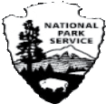
U.S. Department of the Interior National Park Service
Fort Pulaski
Fort Pulaski National Monument

Pre-visit Background for Fort Pulaski
This is information that you can share with your students prior to your visit to Fort Pulaski. A pre-visit question sheet and crossword puzzle is also available for your students. The answers for the question sheet and crossword puzzle are in this backgrounder. The answers are capitalized.

- 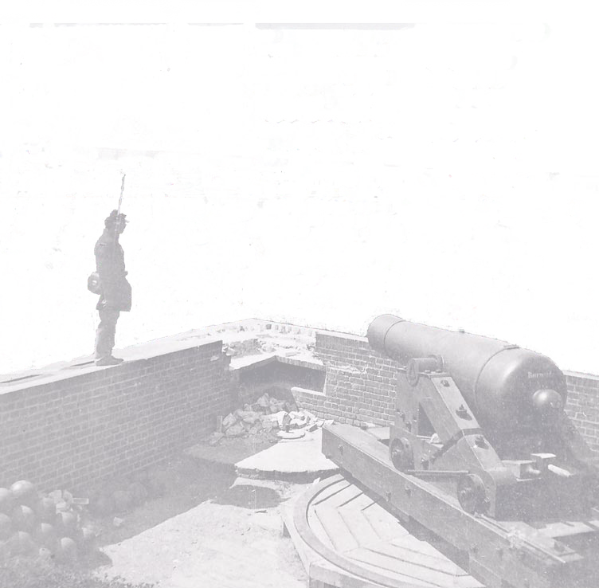The U.S. government has the responsibility to protect its citizens.

- After the War of 1812 against the British, the
U.S. government decided to build brick and stone forts to protect its coastal cities.

- Savannah, Ga., is a coastal city. Ships traveled up and down the SAVANNAH River carrying supplies and cargo to and from the port of Savannah.

- Ships at time were made of WOOD.

- The U.S. government built Fort Pulaski on COCKSPUR Island at the mouth of the Savannah River. All ships traveling to and from Savannah passed by Cockspur Island.

- The building of Fort Pulaski was begun in 1829 and completed in 1847, so it took 18 YEARS.

- Twenty-five million BRICKS were used to build the fort at a cost of one million dollars.

- Cannons were placed in the fort facing the river ready to fire at enemy ships in the river.

- The fort was named for Count Casimir Pulaski, a REVOLUTIONARY War hero.

- In early 1861, before the Civil War began, soldiers from Georgia took over Fort Pulaski. Only two U.S. soldiers had been left to protect the fort.
- Once the Civil War started, the CONFEDERATES in control of the fort prepared the fort for battle, knowing that the Union (North) wanted to take it back. The Confederates mounted 48 cannons in the fort.

- The Union prepared for the battle by placing 37 cannons on Tybee Island, some of them more than one mile away.

- On APRIL 10, 1862, the Union Army demanded that Confederate Colonel Charles OLMSTEAD, fort commander, surrender the fort. He refused, stating he was there “to defend the fort not to surrender it.”

- Immediately afterwards, General Quincy Gillmore (Union) gave the order to begin firing cannons at Fort Pulaski from Tybee Island.

- The Union army on Tybee Island was using a new technology, the RIFLED cannon. Due to its design, the rifled cannon was able to fire with greater distance and accuracy.

- After 30 hours of cannon shots hitting the fort, a corner of the fort was destroyed.

- Col. Olmstead SURRENDERED the fort to the Union on April 11, 1862.

- For the rest of the Civil War, Fort Pulaski saw little military action.

- In 1924, Fort Pulaski was declared a national MONUMENT.

