Adaptation 3: Fortune Teller Adaptations Worksheet 1
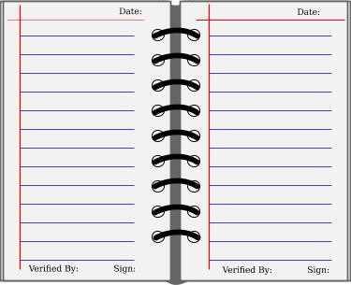
Name of Biologist:

Birth (and Death) Date:

Location of Research:

Why is he/she famous?

Why is he/she famous?

Name of Biologist:

Birth (and Death) Date:

Location of Research:

