Grand Canyon Geology
Video Worksheet

Today, you are the investigator looking for evidence that explains how the Grand Canyon landscape was formed! As you explore Grand Canyon, use this worksheet to take notes of the pieces of evidence that you find. By the end of this video, you will have discovered evidence explain the forces that shape the Grand Canyon landscape.

Directions: Answer the following questions on this worksheet as you watch the video. The video will have built in pause points that give you time to answer the questions.

Worksheet Pause 1
What I Know.
Based on what you know, what forces do you think are shaping Grand Canyon?
Answers will vary.

What I Want to Know.
What do you want to know about the forces that shape Grand Canyon?
Answers will vary.

*Revisit this question, at the last pause of the video
Worksheet Pause 6
What I Learned.
After you discovered evidence of the forces that shape Grand Canyon, write about what you learned. What force was the most interesting? What did that force do to shape the Canyon?
Answers will include various forms of evidence/cause relationships.
Ex: Rock towers are evidence of breaking/falling rock from the rim. These towers are created by freezing water expanding inside rocks.

Worksheet Pause 2 – Small Evidence
Green/orange crust on rock | Small craters in rock | Chert lump in rock
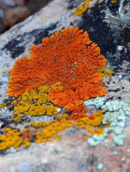 | 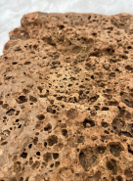 | 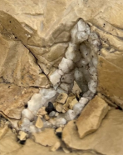
How does this evidence shape Grand Canyon?  Lichen anchors itself to the rock. Over time, this weakens the rock. Lichen expands and contracts based on the season, further weakening the rock it lives on. | How does this evidence shape Grand Canyon?  Acid in rainwater breaks down the rock, forming holes. Over time, these rocks erode more and more from monsoon rain. | How does this evidence shape Grand Canyon?  Chert is a harder rock then the limestone that it is embedded in. When the limestone wears away the chert is exposed. This is an indicator that erosion is occurring.

Worksheet Pause 3 – Big Evidence
Red rust on rock | Rock Tower | Side Canyons
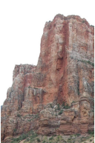 | 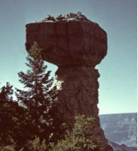 | 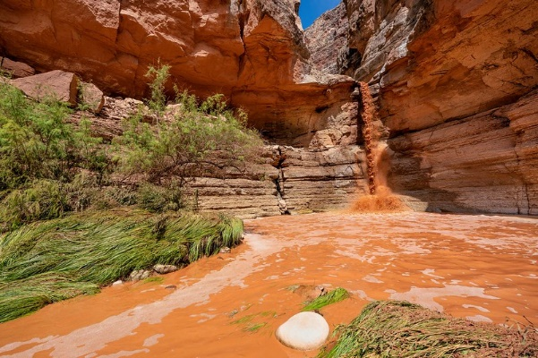
How does this evidence shape Grand Canyon?  Water wearing away at the rocks with a special mineral that turns the cliff face red. This is an indicator that weathering is occurring. | How does this evidence shape Grand Canyon?  Towers form when water changes into ice. Ice builds and expands, forcing the rock to break. Rocks will break from the canyon rim into the canyon. Over time these rock towers will erode and break into the canyon. | How does this evidence shape Grand Canyon?  Creeks flow downhill into the Colorado River. These creeks flow over rock, breaking them down to carve out new areas of the canyon.

Worksheet Pause 4 – Human Evidence
Recreation - Trails | Transportation – Vehicles/Mules | Land Development - Damns
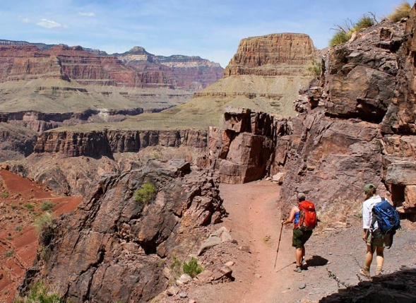 | 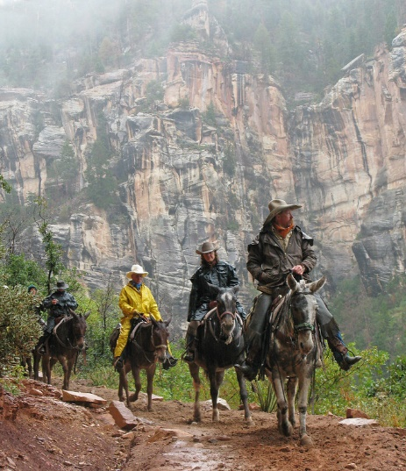 | 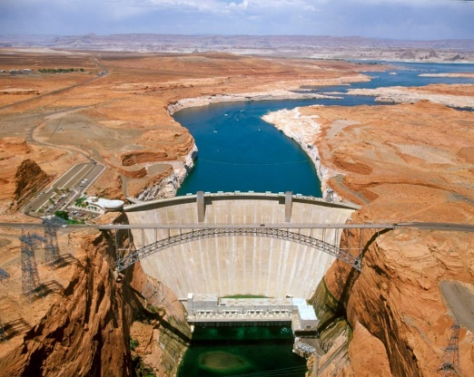
How does this evidence shape Grand Canyon?  When many people walk the same path, the soil and rocks wear away faster. This is a form of human-caused erosion that, over time, can significantly alter the landscape. | How does this evidence shape Grand Canyon?  Mules on trails and vehicles on dirt roads causes erosion. Increased trail erosion forms deeper paths and sometimes changing the course of water runoff. | How does this evidence shape Grand Canyon?  Dams slow down the flow of Colorado River, reducing the ability to carry sediment. This change has slowed the erosion of the canyon and causes low-lying areas to erode more quickly.

Worksheet Pause 5 – River Evidence
Slope | Force | Dry Environment
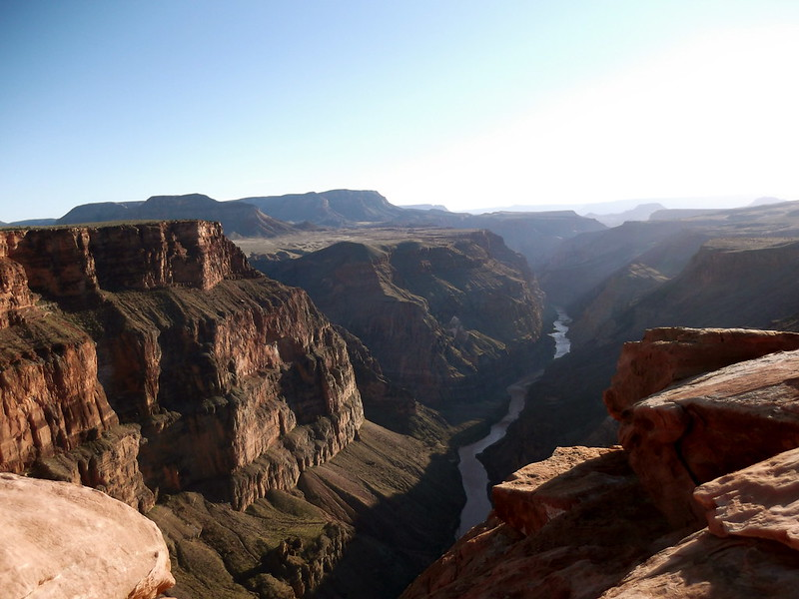 | 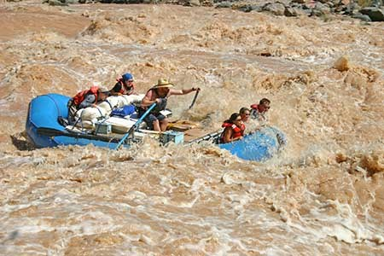 | 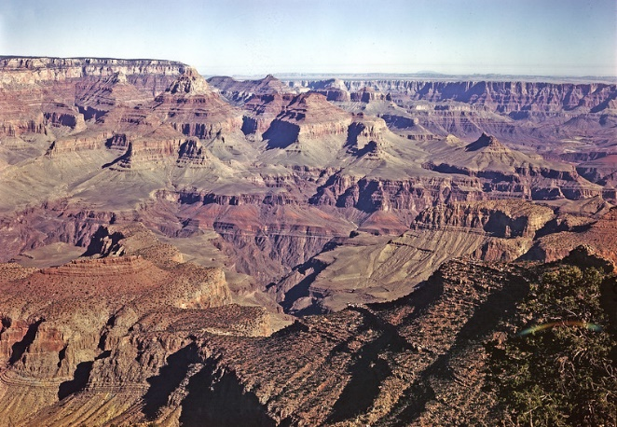
How does this evidence shape Grand Canyon?  Steep slopes gives the river a tremendous amount of speed and the ability to transport big rocks during floods. | How does this evidence shape Grand Canyon?  Fast-moving water of the Colorado River helps break down and remove rock material from the river's path. | How does this evidence shape Grand Canyon?  Due to the dry desert environment, the erosion process increases because there isn’t as much vegetation slowing the movement of rock and sediment.

Worksheet Pause 6 – Return to the first page and complete the “What I Learned” section.

