“By 1275 thousands of people lived in Tonto Basin. Archeologists refer to this mixed-cultural phenomenon as Salado. During the early 1300s climate favored the people of the basin. Moisture increased farming potential, and plant and animal populations flourished. Then around 1330 a dramatic change occurred. The region became more arid -lowering water tables. The changing climate decreased farming and increased hunting and gathering, severely impacting the ecosystem. Important plants and animals declined or disappeared.

Competition for dwindling resources created stress among the villagers. As tensions grew, people left their smaller villages and crowded into communities on the valley floor. At the same time people aggregated in the Tonto cliff dwellings. Some built defensive walls around villages, while others built on defensible hilltops and in caves. During the late 1300s resource depletion intensified, and populations declined.

The 1300s were also marked by catastrophic flooding of the Salt River that destroyed lowland farms and villages. When the waters receded, many of the 100-year-old irrigation canals were undermined or destroyed, and hundreds of acres of farmland were useless. By 1450 those struggling to maintain their way of life gave up -and another migration began. Oral histories say this migration from Tonto Basin took their ancestors in many directions, guiding each to the place their descendents now call home.

The cliff dwellings at Tonto National Monument are but two of hundreds of once-thriving communities in Tonto Basin. Preserved and protected by the National Park
Service, they stand as icons of people who flourished and struggled as their world changed.”

“The people farmed in the Salt River Valley and supplemented their diet by hunting and gathering native wildlife and plants. They were fine craftsmen, producing some of the most exquisite polychrome pottery and intricately woven textiles to be found in the Southwest. Many of these objects are on display in the Visitor Center museum.

The monument is located in the Upper Sonoran ecosystem, known primarily for its characteristic saguaro cactus. Other common plants include cholla, prickly pear, yucca, agave, ocotillo, and an amazing variety of colorful wildflowers.”

Source: National Park Service, Tonto National Monument http://www.nps.gov/tont/learn/historyculture/index.htm

What is Trade?
Trade occurs when one thing is exchanged for another. Today, we trade money for things. We earn money by trading our time and effort for a paycheck. Then we trade the paycheck for money and the money for things like food and clothing.
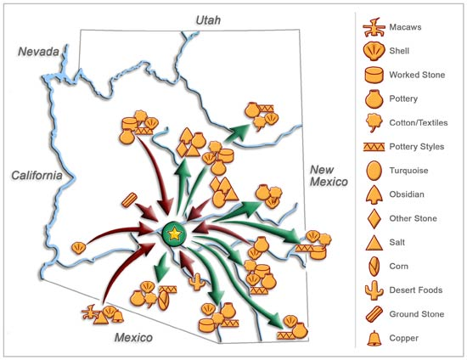
The Hohokam established extensive trade routes.
What was exchanged?
The ancient people of the Sonoran Desert didn't have money. Instead, they used items they had created or collected to trade for things they didn’t have. Many things were unavailable in the Sonoran Desert, so they traded extensively throughout the Southwest. From the west, they acquired seashells, either from the Pacific Ocean or the Gulf of California. From the North, they traded for raw materials like obsidian for making arrowheads. And from the south, where Mexico is now located, they traded for copper bells, macaws, parrots, and seeds for their crops.

Exchanging Goods and Ideas
The ancient Sonoran Desert people exchanged goods and ideas, made long-distance expeditions to procure exotic raw materials, and produced prestige items such as carved shell, for exchange. These activities occurred within the Sonoran Desert culture and with other cultural areas. Interaction with other groups is indicated by the presence of macaws, copper bells, and pottery from sometimes very distant regions.
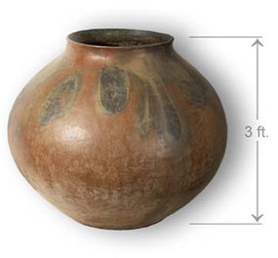
NPS Photo
Large pottery vessels were used for water and food storage and for cooking.
When different types of temper were added, a vessel became more porous and acted as an evaporative cooler, producing chilled water.
This olla was found near the Great House and is 3-ft. tall.
The ancient Sonoran Desert people had to have something to exchange, so they produced and traded large storage jars, pottery with intricate designs, and even jewelry made from seashells. The exchange systems they established reached their maximum extent between AD 800 and 1000, and items they created have been found hundreds of miles from their homeland.

Hohokam Pottery and Jewelry
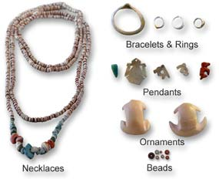
The ancient Sonoran Desert people created beautiful shell jewelry including necklaces, bracelets, rings, earrings and pendants. Some of the shells were inlaid with turquoise and others had beautiful designs. To create raised designs on the shells, they used a technique called etching. They would paint a pattern on the shell with sap from a tree (the sap is very sticky and doesn’t dissolve in water.) After the sap was dry, they would submerge the entire shell in fermented cactus juice. The cactus juice is slightly acidic and the acid in the juice would eat away the unpainted portion of the shell. After it had been in the juice long enough, they would remove it, scrape off the sap and it would leave a raised design.
Examples of Hohokam jewelry. NPS Photo 1

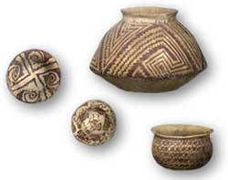
Items the ancient Sonoran Desert people created have been found hundreds of miles from their homeland. They didn’t have wagons or horses, so in order to move their stuff from one place to another they had carry it on foot. It is over 350 miles to the Pacific Ocean from Casa Grande Ruins National Monument. Can you imagine how long it would take and how tired you would be if you had to walk all that way and back again?
Examples of fine Hohokam pottery.
NPS Photo-Dave Winchester

