# Climate Change & Bird Range Virtual Investigation Activity Student Worksheet

## Tule Springs Expedition Research Learning Center

## Introduction:

Twice per year, Tule Springs Expedition Research Learning Center partners with our local Audubon Society Chapter to participate in the Audubon Climate Watch bird survey citizen science project. Citizen scientists across North America report the data they collected during these surveys to help document how bluebirds and other bird species are responding to climate change and shifting their ranges. This activity explores how different climate change scenarios may affect bird populations at Tule Springs Fossil Beds National Monument in Clark County, Nevada.

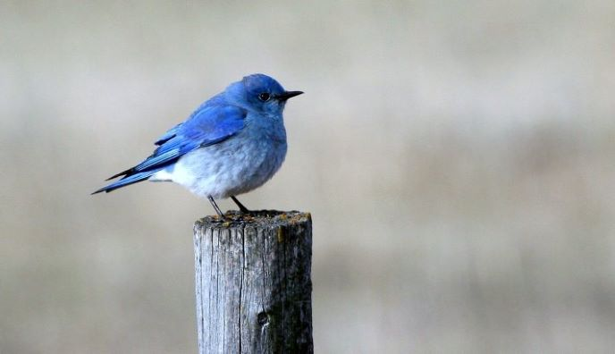

A mountain bluebird sitting on a wooden post. National Park Service Photo

## Essential Questions:

1. How will climate change affect populations of mountain bluebirds locally and nationwide?
2. How does community science inform species conservation?

## Objectives:

1. Students will compare the effects of climate change on different bird species.
2. Students will propose possible solutions to climate change.

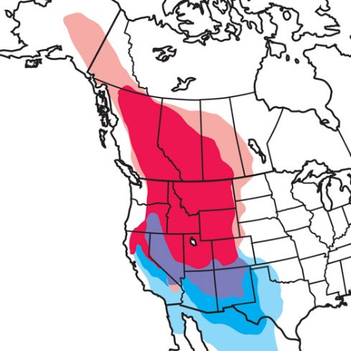

The winter (blue), breeding (red), and year-round (purple) ranges for the mountain bluebird. Audubon Society Image.

## Activity:

* On a web browser, open the Audubon “[Survival By Degrees Birds and Climate Visualizer](https://www.audubon.org/climate/survivalbydegrees/visualizer-1).” Input the Zip Code 89124 to the “Search by Zip Code” box, which is the Zip Code for Tule Springs Fossil Beds National Monument. Click “Search” or press the enter key to start your search.
* You should see the heading “Vulnerable Birds in Clark County”. Below this, set the *Warming Scenario* to “+1.5ᵒC” and *Season* to “Summer”.

1. If the temperature were to rise by 1.5ᵒC (2.7ᵒF), how many birds in Clark County would be:
   1. High Vulnerability? _________
   2. Moderate Vulnerability? ________
   3. Low Vulnerability? ________
   4. A stable species? ________
2. Click +ᵒ2ᵒC and +3ᵒC. Record your observations about what is happening to the number of birds in each category as temperature increases:

* Scroll down to the heading **How Will the Mountain Bluebird's Range Be Affected in Clark County?** Below this, set the *Warming Scenario* to “Current” and *Season* to “Summer”.

1. Click through the +1.5ᵒC, +2ᵒC, and +3ᵒC buttons. What do you observe happening to the Mountain Bluebird range as temperatures increase?
2. Zoom out on the map. Where do you see the Mountain Bluebird gaining range as temperatures increase? Identify the State.

* Scroll down to the heading **Climate Threats Facing Birds and People in Clark County.** Below this, set the Warming Scenario to “+3ᵒC”.

1. Scroll over the map and list the climate threats to birds and people around Las Vegas:

* Go back to the Audubon Birds and Climate Visualizer. Input YOUR Zip Code, or a family member or friend’s zip code if yours is very close to Tule Springs.

1. Write a paragraph comparing and contrasting the vulnerable bird populations and climate threats to Tule Springs Fossil Beds National Monument and where you live:

## Adapting to Climate Change:

* Read the “[Climate Change in National Parks](https://www.nps.gov/subjects/climatechange/upload/2023-03-03-UPDATE-CC-Unigrid-compliant.pdf)” brochure.

1. Fill out this 3-2-1 Chart to organize your ideas and share with your peers:
   1. **3 Things I have learned:**
   2. **2 Things I Found interesting:**
   3. **1 Thing I have a question about:**