Prepare for Cold Air!

Directions & Worksheet
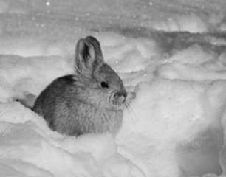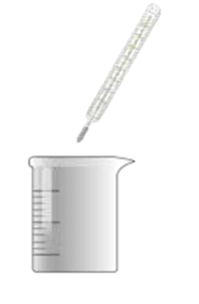

Prepare for a SnowSchool visit to Craters of the Moon by learning about insulation, an important animal adaptation for winter survival. Observe the difference in heat loss between a well-insulated object and a poorly insulated object. Afterwards you will know how to prepare for a winter snowshoe hike.

Directions
- Prepare the cans. Remove labels and rinse out, if necessary. Place one can on the table with the open end down.

- Add insulation. Place sock on can or glue cotton balls, quilt batting, or other insulation onto the surface. If using cotton balls, fluff them out once the glue has dried.

- Fill the cans with warm water. Try to start with water that is close to normal human body temperature, about 98° to 100°F. Use water from the same container or faucet to fill both cans so the starting temperature is the same for each. Fill each can with an equal amount of water.

- Measure the water temperature. Measure and record the initial water temperature without letting the thermometer touch the side of the can.

- Place the cans outside. The cans can be placed anywhere (sun, snow, shade, pavement, etc.) as long as both cans are in the same location.

- Record the water temperatures for 30 minutes. Measure and record the temperature on the table on page 3 for each can every 5 minutes. Use the graph on page 6 or make your own to show the change in temperature for each can.

- Answer the questions on page 4.
Source: Ogden Nature Center

- Write the type of insulation you are using for each can, as well as the environmental conditions for each can (example: sun, shade, grass, concrete).
Can 1:_______________________________________________________________________

Can 2:_______________________________________________________________________

- Using a clock to keep time, record the water temperature for each can in the chart below.
Time (Minutes)
Temperature (°F) | 0 5 10 15 20 25 30  Can 1  Can 2

3. Graph each can’s temperature. Make a dot on the grid for each temperature reading for Can 1. Then connect the dots with a crayon or pen. Do the same for Can 2, but use a different color to connect the dots.
120
110
100
Temperature (°F)

90
80
70
60
50
40
30
0 5 10 15 20 25 30
Time (Minutes)

- Did one can cool faster than the other? Why?

- If your class used different types of insulation for each can, which one did the best at insulating the can? Why?

- If you had to live outside during winter, what types of clothing would you use to insulate yourself from the cold?

