Four types of teeth: incisors, canines, premolars, molars

Instructions: Circle and label each of the 3 main tooth types: using I for incisors, C for canines, M for molars

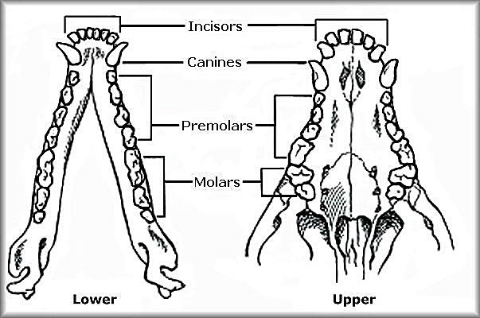

Each tooth type is shaped to reflect a specific function.

Match the functions with the appropriate tooth type (below).

Incisors

Molars

Canines

Crushing and Grinding

Cutting and Breaking

Tearing and Ripping

Omnivore, Herbivore or Carnivore? Compare the teeth of the following three mammals. Describe the most prominent diagnostic feature that supports your hypothesis. Which tooth type (incisors, canines, modified premolars, molars) are most specialized (reflecting diet)?



Omnivore, Herbivore or Carnivore? _______________________________________

Diagnostic Feature(s): _________________________________________________

Hypothesized diet: ______________________________________________________

Animal Guess:



Omnivore, Herbivore or Carnivore? _______________________________________

Diagnostic Feature(s): _________________________________________________

Hypothesized diet: ______________________________________________________

Animal Guess:



Omnivore, Herbivore or Carnivore? _______________________________________

Diagnostic Feature(s): _________________________________________________

Hypothesized diet: ______________________________________________________

Animal Guess:

Compare the teeth of the following three omnivores. Omnivore molars have large flat surfaces for grinding food. Canines can be equal in size to other teeth or slightly larger depending on diet.

Which skull belongs to whom? Identify the skull of the bear, dog and pig.



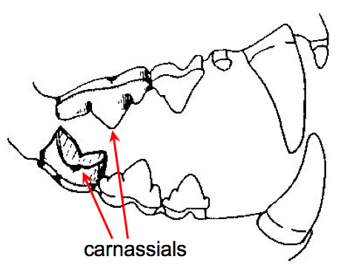**____________ _____________ ____________**

**Carnivores (meat eaters) have specially adapted teeth for cutting and shearing meat, called *carnassial teeth.*** Which of the three mammals uses carnassial teeth for cutting apart their prey? Carnassial teeth are especially prominent in one of the animals above. Circle the teeth.

Carnassials are odified pre-molars. Elongated like scissor blades.

Four types of teeth: incisors, canines, premolars, molars

Instructions: Circle and label each of the 3 main tooth types: using I for incisors, C for canines, M for molars



Each tooth type is shaped to reflect a specific function.

Match the functions with the appropriate tooth type (below).

Incisors

Molars

Canines

Crushing and Grinding

Cutting and Breaking

Tearing and Ripping

Omnivore, Herbivore or Carnivore? Compare the teeth of the following three mammals. Describe the most prominent diagnostic feature that supports your hypothesis. Which tooth type (incisors, canines, modified premolars, molars) are most specialized (reflecting diet)?



Omnivore, Herbivore or Carnivore? ______CARNIVORE__________________

Diagnostic Feature(s): SHARP TEETH, LARGE CANINES, JAW FOR RIPPING AND TEARING

Hypothesized diet: SMALL RODENTS, BIRDS, BERRIES, CARRION, LIZARDS, SNAKES, ETC.

Animal Guess: SKUNK



Omnivore, Herbivore or Carnivore? ______OMNIVORE__________________________

Diagnostic Feature(s): _LARGE INCISORS, NO CANINES, FLAT MOLARS FOR GRINDING

Hypothesized diet: ___WILD GRASSES, BERRIES, INSECTS, SMALL MAMMALS, NUTS_

Animal Guess: WOODCHUCK (GROUNDHOG)



Omnivore, Herbivore or Carnivore? ____HERBIVORE (BROWSER)_________________

Diagnostic Feature(s): __NO CANINE TEETH, FLAT MOLARS FOR GRINDING_______

Hypothesized diet: WILLOW AND BIRCH SHOOTS, AQUATIC PLANTS, GRASSES, LEAVES

Animal Guess: MOOSE

Compare the teeth of the following three omnivores. Omnivore molars have large flat surfaces for grinding food. Canines can be equal in size to other teeth or slightly larger depending on diet. Note the modified premolar carnassial teeth in the dog and bear.

Which skull belongs to whom? Identify the skull of the bear, dog and pig. Circle the prominent carnassial teeth.

Which of the three mammals uses carnassial teeth for shearing and cutting meat?



**Bear Dog Pig**