Dr. & Mrs. Debutts
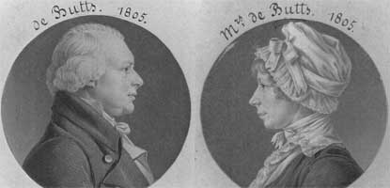
Dr. Samuel DeButts, his wife, Mary Welby owned the Mount welby property from 1805 to 1843.
Artist: St. Memin. Courtesy of the National Portrait Gallery.

Samuel DeButts was born in Ireland in 1756. He began his career as a doctor in England and there he met and married his wife, Mary Welby, in 1785. Samuel's practice was difficult, unprofitable, and kept the couple apart for weeks. Like hundreds of thousands of other European families, Samuel and Mary decided to immigrate to the United States to make a better life for their family.
Twenty years after the DeButts family arrived in America, Samuel signed a deed for a 206 acre land that is known today as Oxon Hill Farm. Samuel, however, named the new family home Mount Welby, in honor of his wife's family, and spent the rest of his days there. Samuel's grandchildren sold the property in 1843.

War Comes to Mount Welby
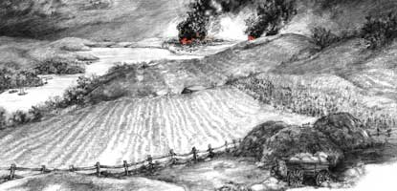
The DeButts family, owners of the Mount Welby property, could see the city in flames from a high bluff on the Mount Welby property. The picture above is an artist's conception of the burning of Washington seen from Mount Welby.
Artist: Billy Rash, 2002

During the War of 1812, British troops fought a battle with American Soldiers near Bladensburg, Maryland. The battleground was about ten miles from Mount Welby, the 19th century name of the Oxon Hill Farm property, just east of the current boundaries of Washington D.C.
The British routed the American defenders and marched into the city. By 9 p.m. the U.S. Capitol was ablaze. Two hours later, British soldiers reached the White House and set it afire, along with the Treasury Building next door. Even closer, the Navy Yard in southwest Washington was put to the torch about 8 p.m. to keep ships, ammunition, sails, rope, and other supplies from the British. President James Madison, First Lady Dolly Madison, and many Washingtonians has fled the city only a few hours before.
In 1815, Mrs. DeButts related in a letter to her brother, Richard, her fears of being so close to the scene of the battle.
"The termination of the war has cheered the Hearts of thousands but its bitter consequences will long be severely felt. I cannot express to you the distress it has occasioned at the Battle of Bladensburg. We heard every fire (that place being not more than 5 or 6 miles from us). Our house was shook repeatedly by the firing upon forts & bridges, & illuminated by the fires in our Capital."

