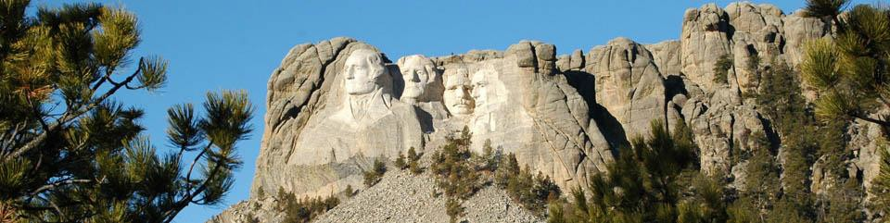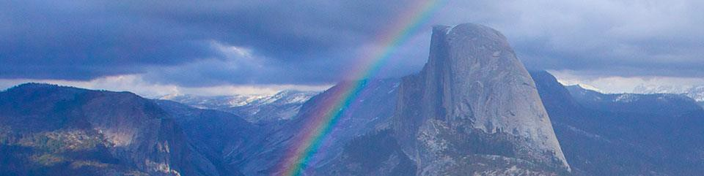

4. This national historic trail extends through Texas and Louisiana along the Spanish colonial “royal road”. Along the trail, you will experience 300 years of history.

2. During the month of March 2014, dog sled teams were used to remove used oil barrels from a wilderness area in this national park and preserve.

1. To reach this national park in the early 1900’s, passengers were brought by railroad and then loaded onto stagecoaches.

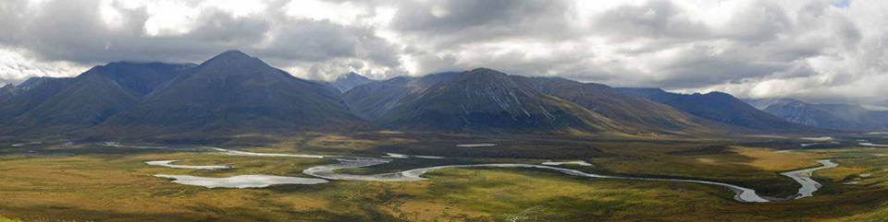

3. Ninety percent of this national memorial was carved using dynamite moving 450,000 tons of rock.

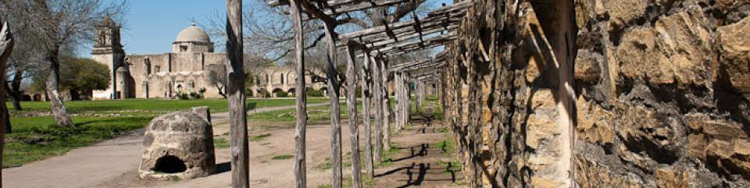

7. This site was established in 1972 as the first national river. For 135 miles, it flows freely and undammed.

6. No one is allowed in this national monument wearing any clothes worn in a cave east of the Rocky Mountains in order to prevent the spread of white-nose syndrome in the bat population.

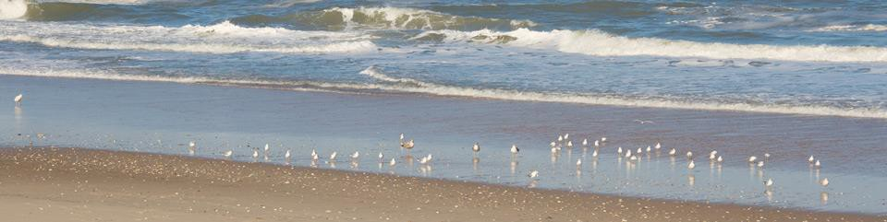

5. This national seashore has three light stations. Some lighthouses were built to warn of danger and some were built to show safety.

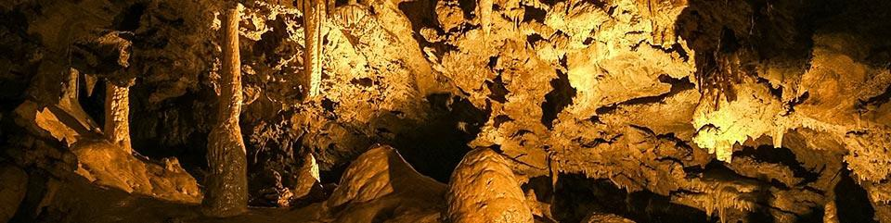

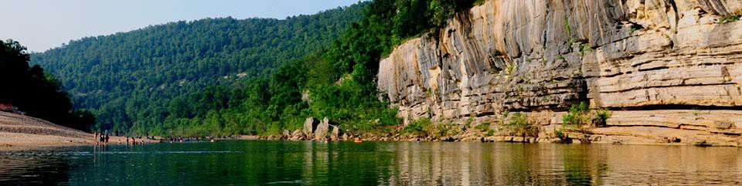

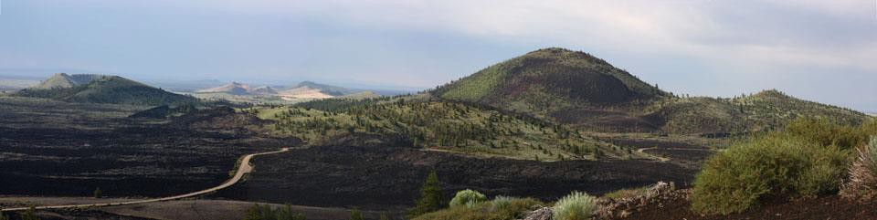

8. Apollo astronauts visited this national monument and preserve to learn volcanic geology before their trip to the moon.

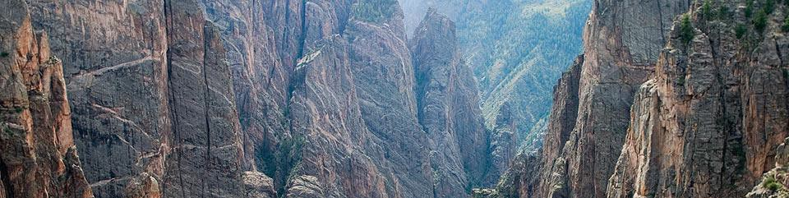

9. The river that runs through this national park drops at the rate of 95 feet per mile. For comparison, the Colorado River flowing through the Grand Canyon drops at the rate of 7.5 feet per

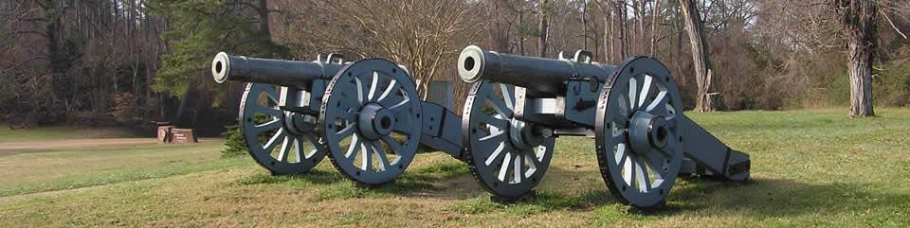

10. This national historical park was the site of the last major battle of the Revolutionary War.

11. This national expansion memorial was constructed to commemorate the opening of the West under Thomas Jefferson’s direction.

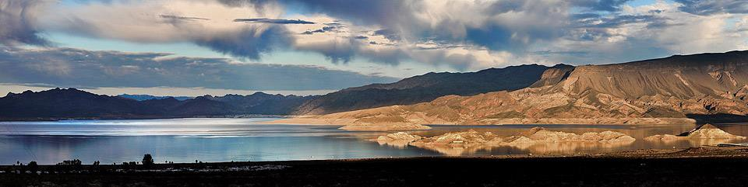

12. This national recreation area was created in the 1930’s when Hoover Dam was constructed on the Colorado River.

16. Francis Scott Key wrote the “The Star Spangled Banner” at this national monument and historic shrine in 1814.

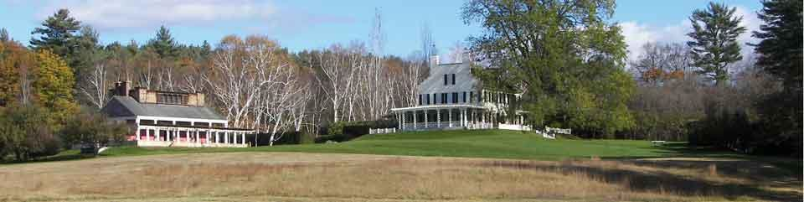

13. The designer for the famous 1907 Twenty Dollar Gold Piece lived at this national historic site. He is one of America’s greatest sculptors. He also helped to redesign the mall in Washington DC.

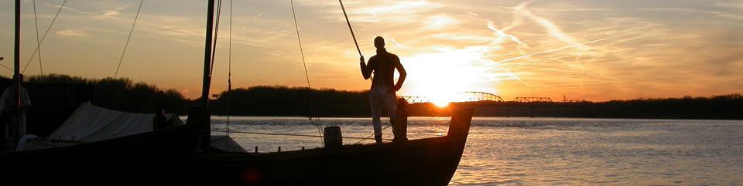

14. Thirty-one men, one woman, and one baby traveled along this national historic trail in search of a water route to the Pacific Ocean.

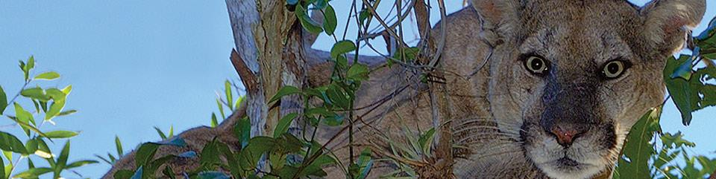

15. This national preserve has over 729,000 acres of swamp vital to the health of the neighboring Everglades National Park.

