Adaptations 2: Plant Adaptation Card Game Name

Worksheet 1 Date

Period
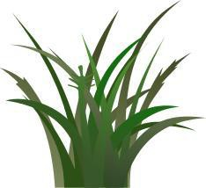
Four characteristics of Grassland Plants:
1.

2.

3.

4.

Think about animals that graze in grasslands—what part of the plant do they eat? Think about fires that spread across the grasslands—what part of the plant burns?

Explain how the plants of the grasslands have adapted to survive grazing by animals and fire in their environment.

Four characteristics of Tundra Plants:
1.

2.

3.

4.

Four characteristics of Tropical Rainforest Plants:
1.

2.

3.

4.

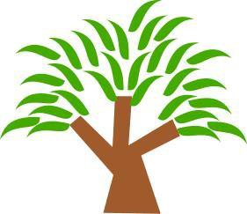

Rainforests have very poor soil which lacks nutrients due to the large amount of rainfall. Plants must be able to get nutrients either on the surface of the ground or before they reach the ground.

Explain how the plants of the tropical rainforest have adapted to survive by getting their nutrients from the surface of the ground or even before the nutrients get absorbed into the ground.

Four characteristics of Deciduous Forest Plants:
1.

2.

3.

4.

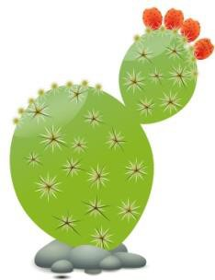
Four characteristics of Desert Plants:
1.

2.

3.

4.

All deserts share one characteristic: they are very dry. Not all deserts are hot and not all are composed of sand. Some are cold, some are covered with pebbles and some with cracked mud. Plants living in the desert must be able to absorb and store water.

Explain how the plants of the desert have adapted to survive by absorbing and storing water during long dry periods.

Four characteristics of Taiga Plants:
1.

2.

3.

4.

