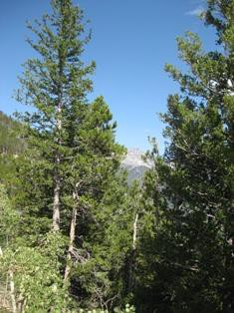

TAIGA

Evergreen trees make food right away

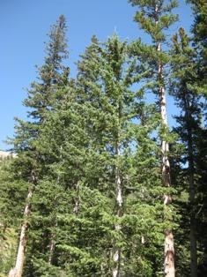

TAIGA

Needle-like leaves lose less water

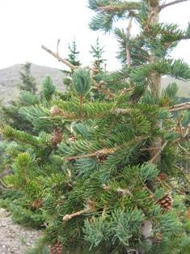

TAIGA

Waxy coating prevents water loss

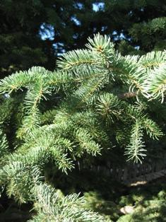

TAIGA

Dark colored needles absorb solar heat

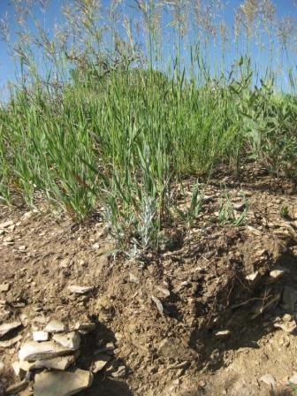

GRASSLAND

Deep roots absorb water

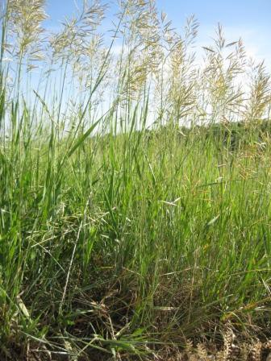

GRASSLAND

Narrow leaves lose less water

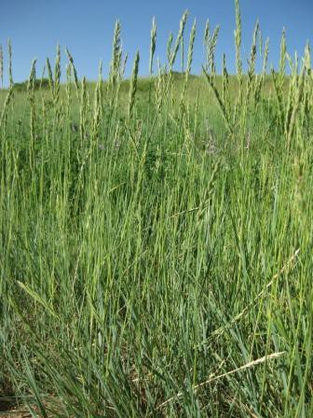

GRASSLAND

Soft stems bend in the wind

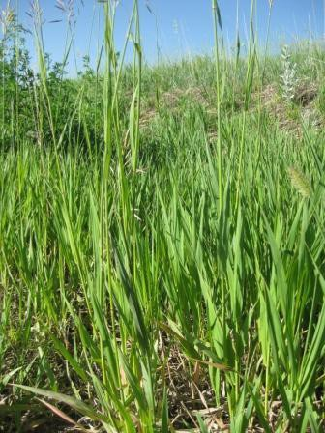

GRASSLAND

Grasses grow from base not tip

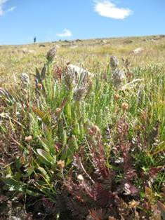

TUNDRA

Small and low keep from freezing

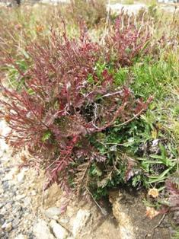

TUNDRA

Plants dark in color absorb solar heat

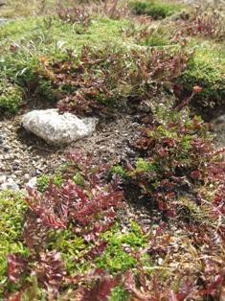

TUNDRA

Grows in clumps to protect-wind and cold

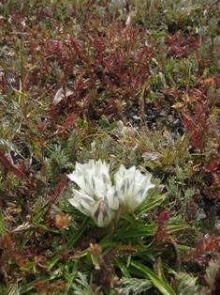

TUNDRA

Flowers follow the sun for solar heat

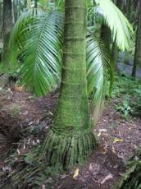

TROPICAL RAINFOREST

Buttresses and prop roots in shallow soil

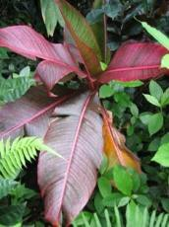

TROPICAL RAINFOREST

Waxy surfaces allow water to run off

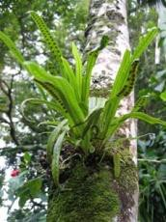

TROPICAL RAINFOREST

Plants grow on each other to reach sun

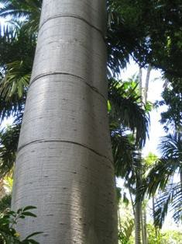

TROPICAL RAINFOREST

Smooth bark speeds water run off

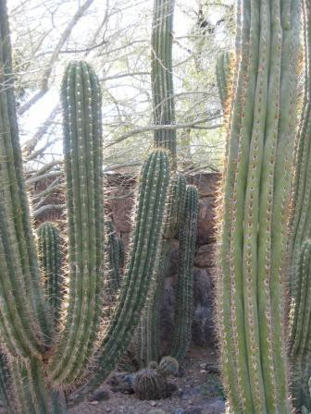

DESERT

Spines keep animals from eating

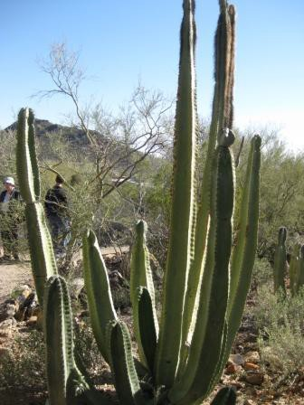

DESERT

Waxy coating on leaves and stems

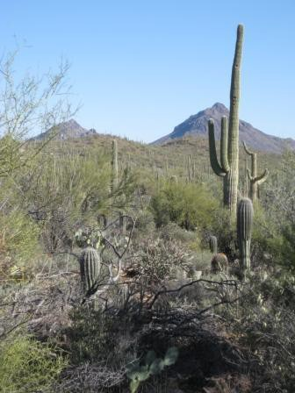

DESERT

Spread out and deep roots absorb water

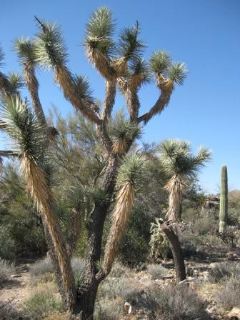

DESERT

Store water in stems or leaves

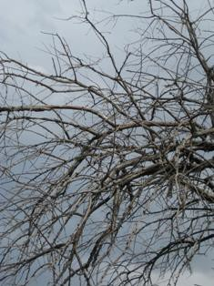

DECIDUOUS FOREST

Trees drop their leaves in the fall

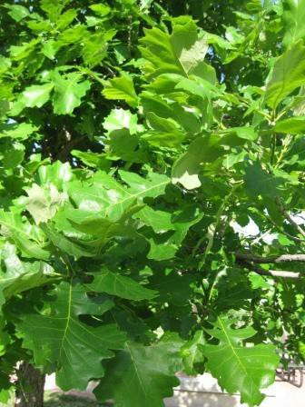

DECIDUOUS FOREST

Thin, broad, leaves capture sunlight

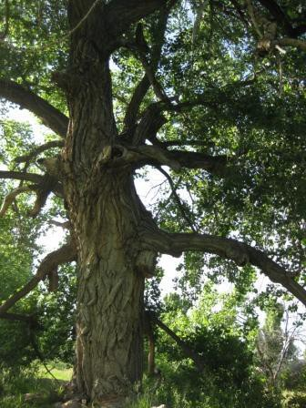

DECIDUOUS FOREST

Thick bark protects in winter

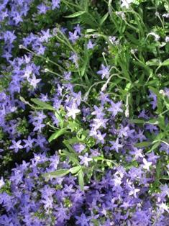

DECIDUOUS FOREST

Wildflowers bloom early in spring