Trading Card Template
- Example
Title/Name _________________________  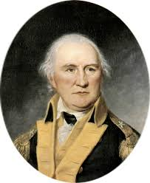 | Major facts and interesting information such as-  Nickname:  Importance to revolution:  Battle(s)  Interesting Facts:

If not access to computer: print and allow for kids to draw pictures on the front

________________________________ | Major facts and interesting information:

Must Pick 12 of the following in trading cards the following associated with the Southern Campaign

Kings Mountain Overmountain men
Cowpens Andrew Pickens
Siege at Ninety-Six Yorktown
Daniel Morgan Nathanael Greene
Banastre Tarleton George Washington
Guilford’s Courthouse Sir Henry Clinton
Overmountain men William Washington
Patrick Ferguson John Howard
Horatio Gates
Battle of Camden

Directions for Battles: Example
Places:_____________________________  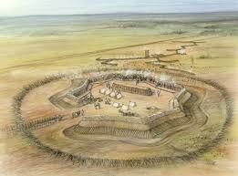 | Major Facts and Interesting Information  Leaders:  Facts/Information:  Outcome:

