Name _____________________________ Date ____________________
Directions: Research your animal using the Internet or books. Draw a picture of the animal in the box and write its name. Answer the questions in complete sentences.
Animal (Draw and color a picture of it, and write its name)  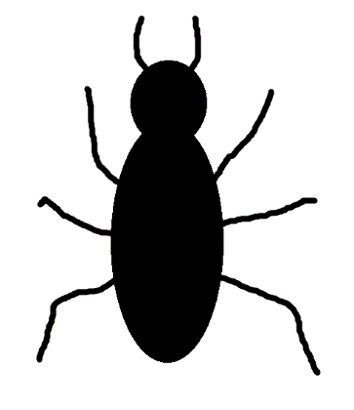  Pinacate Beetle (also known as Stinkbug) | Habitat (Where in the desert does it live? Sand? Mountains? Water?)  The Pinacate Beetle can live in many different places in the desert. It can live in rocky areas, sand dunes, in the mountains, and in places with lots of plants.
Circle One:  Diurnal Nocturnal Both  Circle One:  Herbivore Omnivore Carnivore | Food (What do they eat? List only things that are in the desert.)  Pinacate Beetles mostly eat decaying leaves, plants, and grasses. It is a decomposer.
Physical Adaptations  (What parts of the animal’s body help it live in the desert?)  Pinacate Beetles have a bad smell and taste on the hind end of their body. This helps protect them against predators, such as birds. | Behavioral Adaptations  (What does the animal do that helps it live in the desert?)  Pinacate Beetles spend the hottest part of the day in cool places, such as rodent burrows and under rocks.
Sources Used (What site or book did you use?)
“Insects of the Southwest” by Floyd Werner, Ph.D. ____________________________________________________________________________________________________________________________________________

