National Park Service
U.S. Department of the Interior

Ninety Six National Historic Site
1103 Highway 248, Ninety Six, South Carolina 29666
www.nps.gov/nisi 864-543-4068

PARKS AS CLASSROOMS

Colonial Trade
  - Traveling Trunk
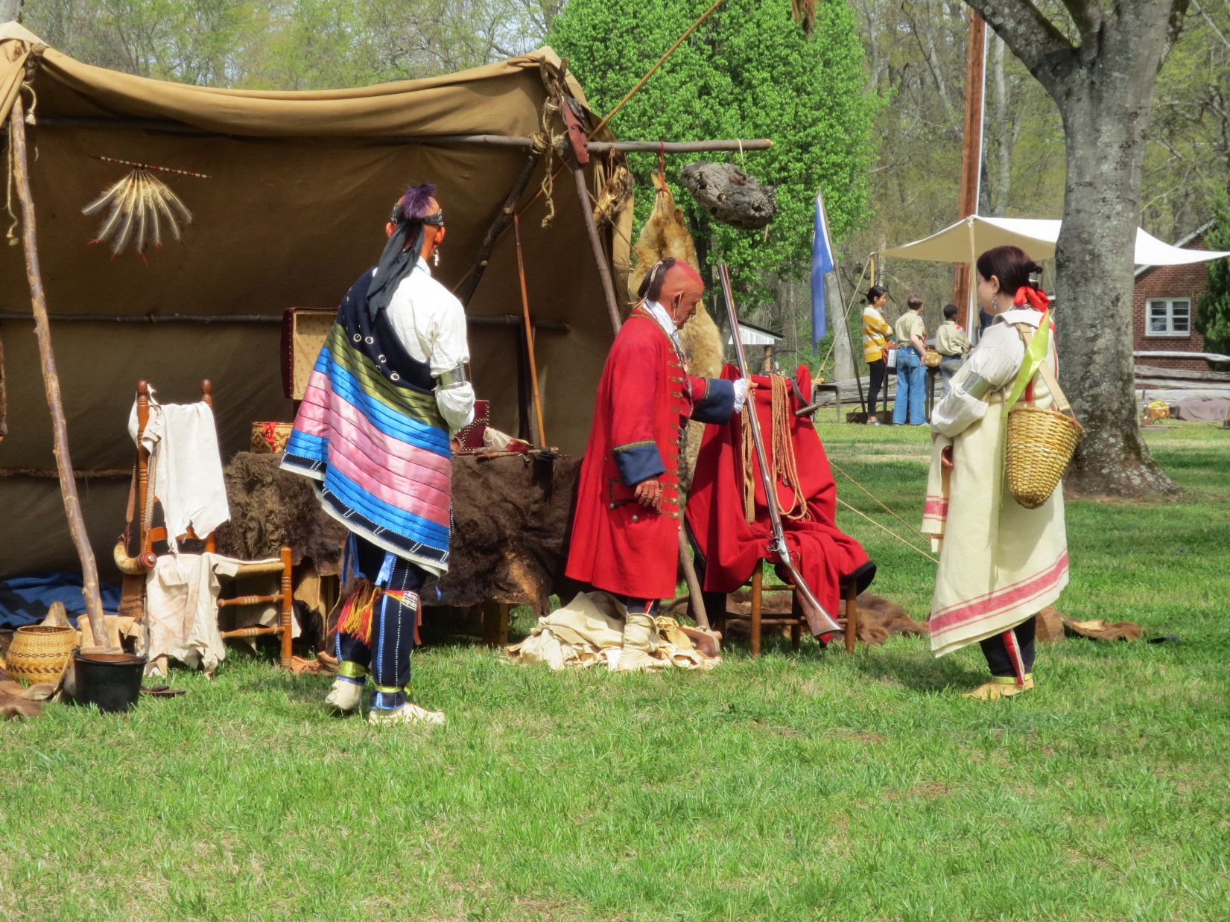

Cherokees & Trade at Ninety Six

Language Barriers
The English occupants in the Carolina region had trouble communicating with their Native American neighbors. The barrier was not solely derived from language but also from a difference in customs. However, Native Americans and settlers adapted to these difficulties.
During the mid to late 1700’s in the Carolina region, one dominate Native American tribe was the Cherokee. However, the region was also home to several other tribes: Creek, Congaree, Catawba, and Wateree. Each tribe had their own language which derived from broader native language families. The European settlers who traded and trapped in Cherokee country faced a problem with understanding the native language of the area. The Cherokee language was not consistent within the tribe, as it varied from region to region. Even today people experience problems much similar to the one that the settlers faced. Take the United States for instance. The dominant language is English, but a variation from the English dialect one would hear in England. However, even within the various regions of the United States, people say words differently and also use different phrases for certain situations. Even on an international level, in some countries, a “thumbs up” is a negative gesture, while in the United States, it is a sign of a job well done.
When Native Americans and settlers interacted, communication was often an obstacle. Initially, Indians did not know the settlers’ language nor the settlers know native languages. How, then, did these people communicate? Gestures and body language were used as an early form of communication. With an increase in contact, some traders, trappers, and Native Americans evolved into translators as they learned the language of one another. Another obstacle in communication was the manner in which the two groups respected others as they spoke. The Cherokee did not speak over one another, rather they waited on whomever was speaking to finish before commenting. Cherokee leader Skiagunsta had this to say at a conference with South Carolina Governor James Glen: “…I have something to say, for it is not our custom like the white people to talk altogether, but when one is done another begins. When they are all quiet, I shall begin to speak.”
Crossing the language divide was likely a frustrating and difficult task for all people involved. This task, however, was especially important in the colonization of the United States. Interaction and relationships between Natives and colonists was absolutely necessary, as the groups came together and learned to cooperate. Until a language was shared, it was necessary for someone to translate – someone to bridge the language divide.

Robert Gouedy’s Trading Post
The Cherokee Path was once a direct route for traders and trappers, Native Americans, and settlers, to exchange merchandise between the backcountry and the Carolina coast. The path stretched from the lower Cherokee town of Keowee (near Clemson, SC) to the Congaree River. The path then forked north to the Catawba Nation and south to Charles Towne (Charleston) and became increasingly important because of its connection to the developing trade economy in the Carolinas.
In the early 1750s Robert Gouedy, an Indian trader moved his trading operation from the Eastern Mountains of Tennessee to the Ninety Six District. He became the first permanent settler in this area, establishing a thriving trading post, and soon became a dominant figure on the frontier. His trading post would have had items such as cloth, beads, needles, tools, gunpowder, lead, rum, & other articles that settlers and Indians in the area would have used.
Trade between Cherokees and settlers was gradual. However, once it was embedded in to Cherokee society, trade became a necessity. Out of necessity for a continuous supply of goods, Cherokees began to stray from their traditional hunting culture. The Cherokee ventured from subsistence hunting to hunting purely for the profits of backcountry trade. Their reliance on the English for barter of important goods, like guns and farm implements, pushed them farther and farther away from traditional Cherokee lifestyle and hunting ethic.
As trade continued in the backcountry the relationship between the Cherokee and the Settlers became stressed. As tensions grew the Cherokee began to attack. In 1759 a stockade fort was built around one of Gouedy’s barns to offer protection from these attacks. Over the course of two months Fort Ninety Six survived two attacks by the Cherokee on February 3 and March 3, 1760. Despite the fact the Cherokee were driven off in both attacks they managed to destroy the Gouedy’s home during their first strike.

Cherokee Attacks on Fort Ninety Six
Trespassing and encroachment are two actions that can bring about much anger and territoriality. In the mid-18th century South Carolina backcountry, Native American tribes, namely the Cherokee, displayed much anger as colonists moved near and on to Indian lands to create settlements. Backcountry colonization, tension and misunderstanding constructed a web of death, blood revenge, and pacification between settlers and Cherokees. Fear escalated in the years leading up to 1760 when two Cherokee war parties attacked the small backcountry defense, Fort Ninety Six, along the Cherokee Path.
The Cherokee were a hunting people with a warrior instinct, especially among the young men. Even with this emphasis on violence, colonists’ relations with their Native American neighbors were not always tense. In fact, trade with Indians was very important in the early 18th century, and the Cherokee were dependent on the English to supply them with goods like woolens, guns, and farm implements. South Carolina Governor James Glen negotiated with the Cherokee several times in efforts to establish peaceful relations. On one occasion, Governor Glen met with Cherokee Chiefs Connecorte and Attakullakulla in hopes that they would show loyalty to the British against France and Spain. In 1753, the Cherokee granted Governor Glen permission to build forts on their land. Three years later, in 1756, William Henry Lyttleton became governor of South Carolina. Lyttleton’s appointment prompted a change in how Cherokee relations were handled, as Glen was adamant about maintaining positive relations while Lyttleton was less concerned. Eventually, colonist and Cherokee relations broke down. Cherokee raids ensued.
Mistrust and misunderstanding mounted tensions leading up to the first attack on Fort Ninety Six. As a Cherokee war party returned from their raid in the Pennsylvania backcountry to aid the British in the French and Indian War, they went through the colony of Virginia. In the Virginia backcountry these Cherokee raiders took some supplies from a local farm. The farmer and his neighbors countered by shooting and killing a number of the warriors. This single event renewed Cherokee resistance against their colonist neighbors, and caused an eruption of raiding parties in the Carolina and Virginia colonies, starting the Anglo-Cherokee War. In return, the colonies offered a bounty on Cherokee scalps. This bounty erupted into a scalping frenzy and led to increased raids in the backcountry. The bloody and sporadic raids resulted in mass killings of both settlers and Native Americans. Settlers, once hearing of the massacre that occurred at Long Cane Creek, rushed for their lives to the small wooden defense of Fort Ninety Six for refuge.
The garrison at Fort Ninety Six contained “33 resolute White Men and 12 Stout Negroes, all armed,” according to the South Carolina Gazette. As the men prepared for the eminent attack, they sent out daily patrols. On February 2, 1760, a patrol captured two young Cherokee warriors. The following day February 3, forty Cherokees launched an attack on the Ninety Six defenses. For two hours, the Cherokee fired from the wooded forest with little effect. The Cherokee eventually retreated. However, as the raiders retreated they burned the town, except for Robert Gouedy’s Barn, to the ground.
After a month of reinforcing the Ninety Six garrison, another Cherokee war party rekindled the fire and set out towards the backcountry and the town. On March 3, 1760, an estimated 250 Cherokee warriors attacked Fort Ninety Six, which was infected with a smallpox epidemic at the time. Under constant fire for 36 hours, the fort’s defenses remained intact. Aided by a hard rain and a relief column under Major Lloyd approaching the fort, the war party retreated again with six deaths. According to the South Carolina Gazette, Major Lloyd’s arrival “…raised the spirit of the Garrison a good deal” even with the knowledge that two of the men were injured. Along a twenty-two mile expanse, the warriors killed cattle and burned homes as they retreated from the backcountry fort.
In retribution for the attacks on Fort Ninety Six and the raids in the backcountry, the Provincial Government appealed to British commander Sir Jeffrey Amherst to subdue Cherokee resistance. Colonel Archibald Montgomery was sent to quell Cherokee opposition. Montgomery burned most of the lower towns. He was later ambushed by Cherokees along the Little Tennessee River at Tassantee. Although Montgomery commanded the field, he was forced to retreat due to casualties. Assuming the Cherokee were defeated he withdrew. However, the Cherokee were not defeated and they captured Fort Loudon in modern day Tennessee. The capture of this Fort then led to renewed resistance by Lieutenant Colonel James Grant and the Indian Corps. This armed group forced the Cherokees to negotiate a treaty in December 1761. With this treaty the Cherokee War ended.
Ninety Six was a stopping place for both Colonels Montgomery and Grant en route to the Cherokee villages in their respective campaigns. When Grant decided to use Ninety Six as a resting place, Major William Moultrie of the Provincial Regiment was sent with his men to construct supply sheds and cow pens and to expand the fort around Gouedy’s barn. In light of the Cherokee treaty, Grant said of the stored supplies at Ninety Six which contributed to his successful campaign: “…if I had not made a very large Provision for the Campaign I should not have been able to do it.”
During the American Revolution Cherokees sided with the British. The Patriots, however, pacified them into compulsory neutrality. After the Revolution, Cherokee Indians had to live with the demands of the new American government. Even when forced of off their native lands years later for the sake of wealth and gold discovery, the Cherokees never again committed to armed conflict against the American government.

Cherokee Storytelling
"The world is full of stories, and from time to time they permit themselves to be told."
Ancient Cherokee Saying

How the Red Bird Got His Color, retold by Barbara Shining Woman Warren
Cherokee Words: wolf wa-ya, raccoon gv-li, bird tsi-s-qua, brown u-wo-di-ge, red gi-ga-ge, red bird to-tsu-wa
Raccoon loved to tease Wolf. One day Raccoon teased Wolf so much that Wolf became very angry. Wolf began to chase raccoon through the woods. Raccoon, being the clever animal that he is, kept ahead of Wolf. Raccoon came to a river. Instead of jumping in the river, he quickly climbed a tall tree and peered over a branch to see what Wolf would do next.
When Wolf came to the river, he saw the reflection of Raccoon in the water. Thinking that it was Raccoon, Wolf jumped in and tried to catch him. Wolf continued to search for Raccoon for such a long time that he became so tired he nearly drowned. Finally, tired and exhausted, Wolf climbed up the river bank and fell fast asleep. After a while, Raccoon quietly climbed down the tree and slipped over to the sleeping Wolf. While Wolf slept, Raccoon began to plaster the eyes of Wolf with mud. Then when he had finished, Raccoon ran off through the woods laughing to himself thinking of the clever trick he had played.
Later, Wolf woke up. He began to whine, "Oh, someone please help me. I can't see. I can't open my eyes." But no one came to help him. At long last, Brown Bird heard the cries of Wolf. He flew over to Wolf and landed on his shoulder. He said, "What's the matter Brother Wolf? Can I help you?" Wolf cried, "I can't open my eyes. Oh, please help me to see again." Brown Bird said, "I'm just a little brown bird but I will help you if I can." Wolf said, "Brown Bird, if you can help me to see again, I will take you to a magic rock that oozes red paint. We will paint your feathers red." Brown Bird began pecking away at the dried mud on the eyes of Wolf. Soon Wolf could open his eyes again. True to his promise Wolf said, "Thank you, my brother; now jump up onto my shoulder." Away they ran through the woods to the rock that oozed red paint. When they came to the rock, Wolf reached up and plucked a twig from a tree branch. He chewed the end of the twig until it was soft and pliable like the end of a paint brush. Then he dipped the end of the twig into the red paint and began to paint the feathers of Brown Bird.
When all of his feathers were red, Red Bird flew off to show his family and friends how beautiful he was. That is why, from that day to this, you can see Red Bird flying around the woods in Cherokee country.

Why the Rabbit Has a Short Tail, retold by Barbara Shining Woman Warren
Cherokee Words: Rabbit tsi-s-du, Fox tsu-la, Fish a-tsa-di
Back when the world was young, rabbit had a very long bushy tail. In fact, his tail was longer and bushier than the tail of fox. Now rabbit was very proud of his tail and he was constantly telling all the other animals about how beautiful his tail was. One day fox became so tired of hearing Rabbit brag about his tail that he decided to put an end to the boasting once and for all.
The weather was getting colder. One day it finally became so cold that the waters in the lake and streams froze. A few days later, fox went down to the lake carrying four fish. When he got to the lake, he cut a hole in the ice. He tied those four fish to his tail, then sat down and waited for rabbit to come.
Soon rabbit came hopping over the top of the ridge. When fox saw rabbit, he quickly dropped his tail into the cold water. Rabbit hopped right up to fox and said, "What are you doing, Fox?" fox answered, "I'm fishing". And rabbit asked, "With your tail?" fox replied, "Oh yes, that's the very best way to catch the most fish."
Rabbit said, "How long you been a fishing?" Fox lied and said, "Oh, only about fifteen minutes." Rabbit asked, "Have you caught any fish yet?" Then Fox pulled up his tail, and there were those four fish hanging on it. Rabbit asked, "What do you plan to do with the fish you catch?" Fox said, "Well, I figure I'll fish until I catch enough fish to take to the Cherokee Village and then trade them in for a pair of beautiful tail combs. There is only one set of tail combs left and I really want them." Fox could see that Rabbit was thinking. Rabbit thought to himself, "If I fished all night long, I bet I would have enough fish by morning to trade at the Cherokee Village. Then I could get those tail combs for myself."
Fox said, "It's getting late and I'm cold. I think I'll come back and fish some more in the morning. See ya, Rabbit." Then Fox loped off over the top of the ridge. As soon as Fox was out of sight, Rabbit dropped his tail down into the icy water of the lake. Brrrrr, it was cold! But Rabbit thought, "Oh, no. I want those tail combs more than anything." So he sat down on the hole in the ice and fished all night long.
Soon after the sun came up, Fox loped over the top of the ridge. He ran right up to Rabbit. He said, "What are ya doing there, Rabbit?" The teeth of Rabbit began to chatter. "I'm ffffissshing, Fffox." Fox asked, "Well have you caught any fish?" Rabbit started to get up but he found he couldn't budge. He said, "Fffox you've ggott to helppp me. I'mmm ssstttuck." So Fox, with a big smile on his face walked behind Rabbit. He gave Rabbit one mighty big shove. Rabbit popped out of that hole and landed clear across the other side of the lake. But his tail was still stuck in the frozen water. And that's why from that day to this, Rabbit has such a very short, short tail.
What do you think each tale teaches children? What were children supposed to learn after hearing each story? Why do you think some of the animals in these stories are called tricksters? How does this tale explain why rabbits have short tails now? How does this tale explain why some birds are red now?
Share your own story by telling your personal memory of a place or person to which you feel especially connected. Think about a place where you have had a wonderful experience. Think about all your senses. Remember what you heard, saw, felt, touched, and maybe even tasted there. Think about a person who you have experienced a special time with. Share your story with a partner or the whole group. Give your complete attention to each storyteller as they tell their story. When you get back to school, write and illustrate the story you created here today.

Robert D. Bass, Ninety Six: The Struggle for the South Carolina Back Country (Orangeburg: Sandlapper Publishing, 1978), 41.
Jerome A. Greene, Ninety Six: A Historical Narrative (Denver: Denver Service Center, 1978), 2.
Vicki Rozema, Footsteps of the Cherokees (Winston-Salem: John F. Blair Publisher, 2007), 265-266.
Robert M. Dunkerly and Eric Williams, Old Ninety Six: A History and Guide (Charleston: History Press, 2006), 14-16.
South Carolina Gazette as cited in Marvin L. Cann, Ninety Six: A History of the Backcountry 1700-1781. N.D. Unpublished, 10.
Dunkerly and Williams, 16.
South Carolina Gazette, March 15, 1760, as cited in Cann, 10.
Dunkerly and Williams, 16.
South Carolina Gazette, March 15, 1760, as cited in Dunkerly and Williams, 17.
Dunkerly and Williams, 16-17.
Duane H. King, “A Powder Horn Commemorating: The Grant Expedition against the Cherokees,” Journal of Cherokee Studies I, no I (1976): 23-40.
Lower Cherokee towns were located at the headwaters of the Savannah River in Northwest South Carolina and Northeast Georgia. http://www.palmettohistory.org/exhibits/cherokee/2a-CHEROKEEPEOPLE.htm. Accessed 5 July 2012.
Grant to Amherst, September 3, 1761, War Office, Amherst Papers, as cited in Cann, 15.
http://www.cherokee.org/AboutTheNation/History/Facts/24449/Information.aspx. Accessed 5 July 2012.

