Castillo de San Marcos:

Solving Word Problems-Volume & Area

1. What is the total area of the wall section of the South East Bastion of the Castillo?

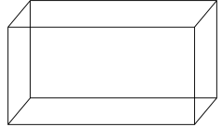

14 ft.

5 ft.

2 ft.

1. Today, the cost of coquina is $150 per cubic foot. A segment of wall with the dimensions 3 ft. x 2 ft. x 4 ft. needs to be replaced. How much will it cost to replace this segment?

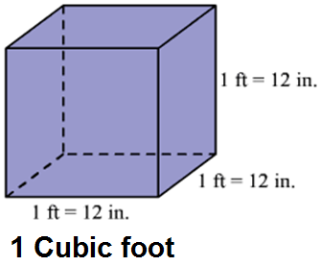

1. When you enter the Castillo, after walking over the second drawbridge, you enter the area known as Sally Port. The flooring of the room needs to be resurfaced. The area is 34 feet by 17 feet. What is the total square footage you will need to resurface?

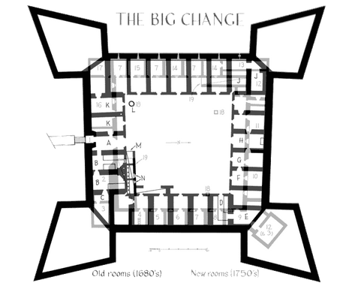

1. During a two month siege in 1702 approximately 1,500 townspeople were brought to the Castillo for safety. Today, the courtyard measures 116 ft. by 109 ft. What is the total area of the courtyard?
2. There are 4 bastions located at the Castillo de San Marcos. Find the area of the NW Bastion. Please estimate your lengths to the nearest foot.

