Name ___________________________________________ Date ________________
Topographic Maps
Directions: Circle the highest point and the lowest point on the map. Then fill in the blanks below.
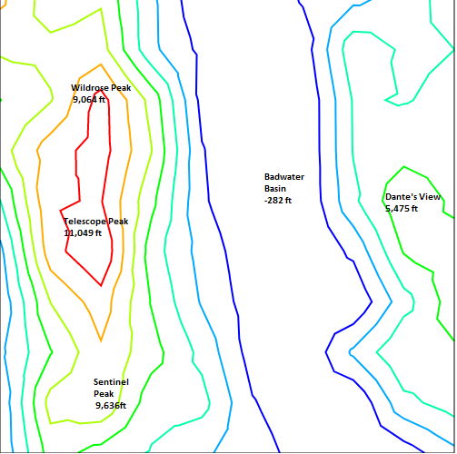
Map created with http://contourmapcreator.urgr8.ch/
The highest point is _______________________. It is ________________ feet _____________ sea level.
The lowest point is _______________________. It is ________________ feet _____________ sea level.

