Attachment 1, “Biodiversity 2: Open Your Eyes” Numbered Organism Cards

CARD #

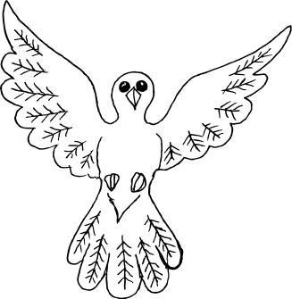

CARD #

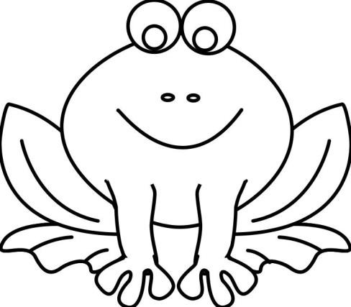

BIRD Letter

AMPHIBIAN Letter

CARD #

CARD #

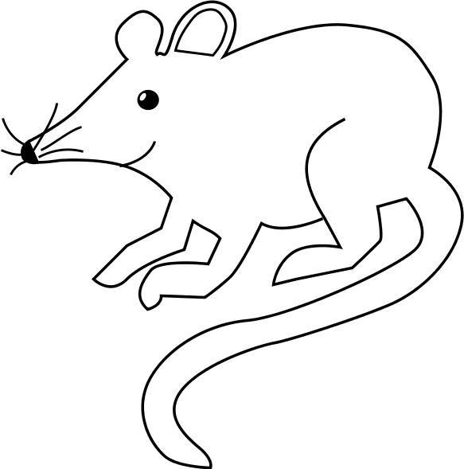

MAMMAL Letter

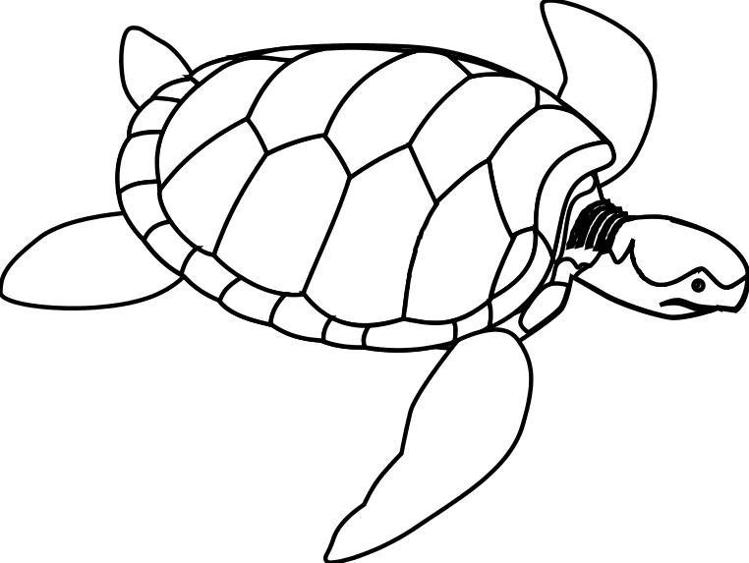

REPTILE Letter

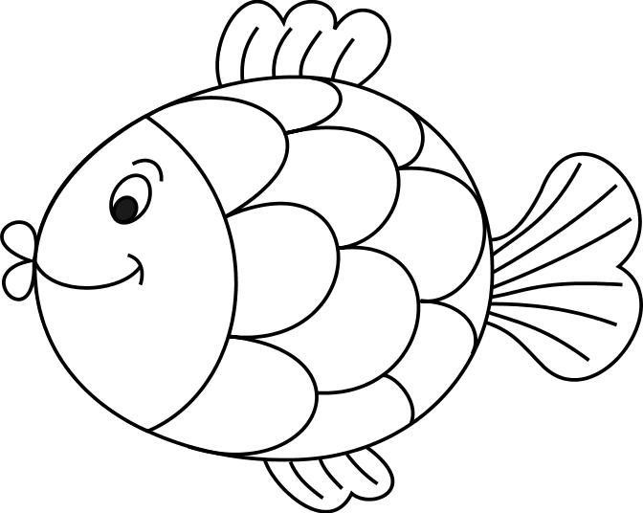CARD #

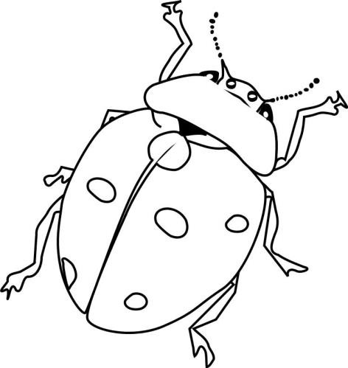

CARD #

FISH Letter

INSECT Letter

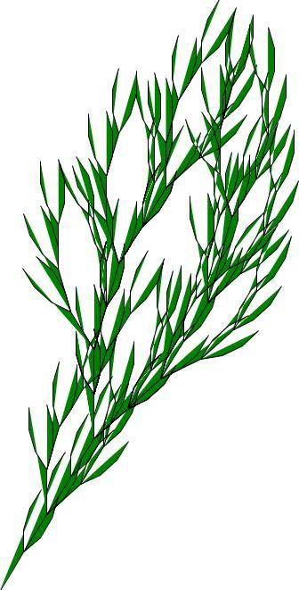CARD #

BUSH Letter

CARD #

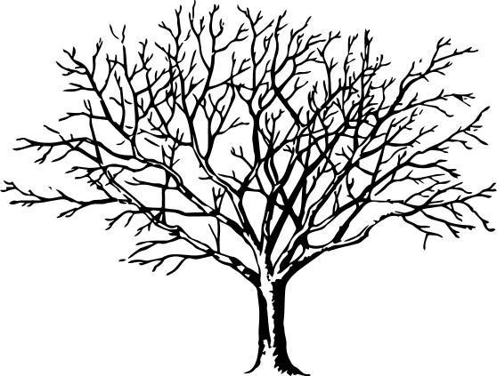

TREE Letter



CARD #

ALGAE Letter

CARD #

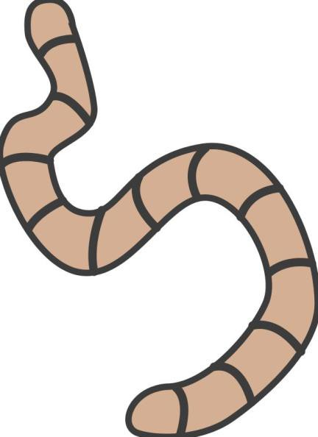

CARD #

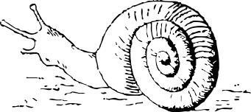

WORM Letter SNAIL Letter

CARD #

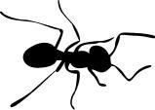

ANT Letter

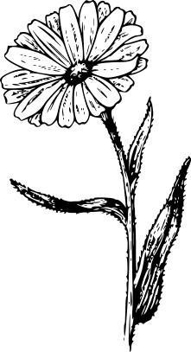CARD #

CARD #

FLOWER Letter GRASS Letter

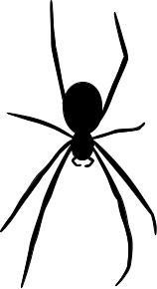CARD # CARD #

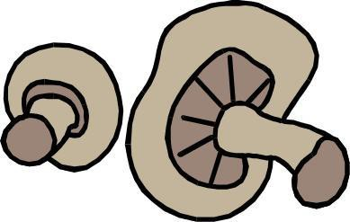

SPIDER Letter FUNGI Letter