A Worn Path
A Short Story Set on the Natchez Trace
Grade Levels: 6-8 Grade
Subject Area: Language Arts
Duration: 1 Class Period

Vocabulary: metaphor, simile, allusion, allegory, pullets, Natchez Trace, phoenix, myth, lye, commemorate, loess soil
Summary: “A Worn Path” is a short story written by Eudora Welty in 1940. The story is set on the Natchez Trace and the town of Natchez, MS. The protagonist is Phoenix Jackson an elderly African-American woman who goes on a heroic quest to procure medicine for her ill grandson.
Mississippi Objectives: English 8th Grade:
1. The student will use word recognition and vocabulary (word meaning) skills to communicate.
2. The student will apply strategies and skills to comprehend, respond to, interpret, or evaluate a variety of texts of increasing length, difficulty, and complexity.
3. The student will express, communicate, evaluate, or exchange ideas effectively.
4. The student will apply Standard English to communicate.

Teacher Set: Students will read “A Worn Path,” complete a comprehension quiz, discuss the layers of metaphor, simile, allusion, and allegory utilized by Welty.
Learning Objectives: The student will be able to read for content and answer 10 quiz questions. The student will be able to differentiate between a simile and metaphor given an example. The student will be able to name at least one allegorical folktale. The student will be able to describe and define an allusion. The student will be able to identify 5 images relative to the Natchez Trace in the short story “A Worn Path.”
Teacher Overview: “A Worn Path” is a story that is set on the old Natchez Trace and the southern Mississippi town of Natchez. The Natchez Trace is an ancient trail that served as a main artery for commerce, war, exploration, mail, lawlessness, and westward expansion. Many of the slaves imported to the cotton belt were marched down the Natchez Trace from the eastern plantations. It is inferred that Phoenix Jackson was emancipated by the civil war, settled near the Natchez Trace and uses it, as many did, as a country road to get to ‘town,’ in this case Natchez. The part of the trace that Phoenix is walking through is unique for the loess soil that eroded to many feet deep. She would have been surrounded by 500 year-old live oak trees covered in spanish moss, long-leaf pine barrens, shallow bayous, and abandoned plantations. She is travelling to Natchez to a clinic to get medicine for her grandson who suffers from lye poisoning, a common ailment in those days in that part of the country. Children would mistakenly drink lye dissolved in water (a cleaning agent). The caustic liquid would destroy the lining of the esophagus, often leading to a slow and painful death from malnutrition. A physician of the day, Chevalier Jackson, fought congress to pass a law making lye manufacturers print a warning label on their product. It is possible that Welty named Phoenix Jackson after this man. Some interesting facts to discuss in class are:
How do people refer to Phoenix? ‘Grandma’ was a term white skinned people used as a term of respect for dark-skinned old women. ‘Aunt ___,’ however was a term African-Americans used as a term of respect for elders. Does this mean the nurse at the clinic was African-American?
Below are several pictures of the Natchez Trace taken around the time “A Worn Path” was written. Have the class imagine the scenes Welty describes, then show the pictures. Does their imagination match the images? What’s the same? What’s different?
Eudora Welty was a Mississippi author who was born and died in Jackson, MS. She wrote extensively about the Natchez Trace, living near the ‘Old Trace’ for most of her life. She has been awarded the Pulitzer Prize, Presidential Medal of Freedom, a National Book Award, National Medal of Arts, and is a member of the French Legion of Honor, among many other awards. She claimed to have written “A Worn Path” after seeing a women walking down the Natchez Trace near Jackson. She imagined the life of the woman, where she might be going, and why.
See an interview with the author here:
http://www.youtube.com/watch?v=W2fh37fzsOg
More Resources:
http://www.eudorawelty.org/

Student Instruction:
For homework, read the short story “A Worn Path” by Eudora Welty. Read specifically for imagery, what pictures does Welty draw? If you were an artist, what scenes from the story would you want to paint?
Complete a classroom Quiz based on the reading.
Participate in class discussion
Complete the metaphor/simile chart
Write a short essay

Lesson:
The class period begins with a quiz on the reading:
Quiz
- What color was the rag Phoenix Jackson wore in her hair?
- The path ran “...up through __________(trees?) ,” “and down through _____________(trees?).”
- What was the ‘ghost’ Phoenix passed?
- In what season did Phoenix see a two headed snake?
- What town was Phoenix’s destination?
- What month was it?
- A lady ties Phoenix’s shoe, what is one color of the packages the lady carried?
- What two names did characters call Phoenix?
- How many nickels does Phoenix have at the end of the story?
- At the end of the story is she walking up or down stairs?

Answers
- Red
- Pines, Oaks
- A Scarecrow
- Summer
- Natchez
- December
- Red/Green/Silver
- Grandma/Aunt Phoenix
- 2
- Down stairs

General Discussion
Let us begin with a general discussion about the story. Who liked the story? What was their favorite part? Who didn’t like the story? Why not? Who was Phoenix Jackson? Where was she going? What is the Natchez Trace?
The Natchez Trace is a trail that is several thousand years old and 450 miles long. From the late 1700s to the mid-1800s it was used as a main thoroughfare through Mississippi. It starts in Natchez, on the Mississippi River and winds Northeast through Port Gibson, Jackson, Kosciusko, Tupelo, into NW Alabama, then through central Tennessee, ending in Nashville. Many travelers used it after floating down the Mississippi to Natchez to walk home in Tennessee, Ohio, Kentucky, Illinios, etc… But, by the mid to late 1800s most people who used the Trace were locals who lived in the country and were getting to town, or vice versa. Today the Trace is still used for that purpose. Old Canton Road in Jackson, MS, Broadway in Nashville, Jackson St in Houston, MS are sections of Natchez Trace still used today. The Natchez Trace Parkway is a National Park that was built to commemorate the Natchez Trace. The National Park Service land stills preserves sections of the old trace that are not used as roads today. Many of these preserved sections of trail can be walked. In fact, these trails are part of the Natchez Trace National Scenic Trail, one of only 11 National Scenic Trails in the United States.
Phoenix says “I never did go to school, I was too old at the Surrender.” What do you think this means and based on this when do you think the story is set?
The doctor calls Phoenix’s situation a “charity case.” Do you think of saving a life as charity? Do you think the doctor made a good decision? What does this tell you about Natchez in the 1930s?

Technical Discussion
A metaphor is one thing used to describe something else. Metaphors are a powerful way to discuss personal experiences.
Can anyone give an example of a metaphor? (often pop songs often use metaphor).
- “You ain’t nothin’ but a hound dog” – Elvis Presley
- “You’ll be the prince and I’ll be the princess, It’s a love story” –Taylor Swift
- Sport metaphors – blind side, line of scrimmage, travelling, home plate
Do not confuse metaphor with simile. A simile is when one thing is described as being “like” something else.

Activity
Option 1
Ask the student to call out metaphors from the story and write their answers on the board. Draw a vertical line with “Narrator” on one side and “Phoenix” on the other. Identify if the metaphor/simile comes from Welty or Phoenix.
Let’s chart the metaphors and similes in the story based on who uses them, the narrator or Phoenix.
Examples of metaphors:
- ’Something always take a hold of me on this hill-pleads I should stay.’
- ’Now comes the trial.’
- ’the time come around.’
- Phoenix sees a bird and exclaims that “God watching me the whole time.”
- Have the class find as many as they can. Mark a hash line in the appropriate column for each.
Similes:
- Her umbrella made a grave and persistent noise in the still air, that seemed meditative like the chirping of a solitary little bird.
- Her skin had a pattern all its own of numberless branching wrinkles and as though a whole little tree stood in the middle of her forehead…”
- The lids stretched down over her eyes, as if she were doing this in her sleep.
- ‘Lying on my back like a June-bug waiting to be turned over…’
- The shadows hung from the oak trees to the road like curtains.
Option 2
Have the students fill out the activity sheet. Then discuss their answers.
As it turns out, almost all of the similes are used by the narrator and almost all of the metaphors are used by Phoenix. What can we conclude about this?
Discussion-expanded
Metaphors, however, are not always just a few words. Metaphors can be sentences, paragraphs, or whole novels. Let’s look at the story again and try to find some more complex metaphors.
- The story is set in December. This metaphor refers to the end of Phoenix’s life. Is December symbolic of anything else? Are the images of Winter/December contrasting in the story? Is there a contrast between the wintery weather on the Trace and the Christmas time in Natchez?
- The path Phoenix is walking on has hills, creeks, swamps, thorns, fences, and other obstacles. What do these difficulties represent? How does Phoenix deal with them? What is her attitude? What words does she use to describe them? What are some other obstacles/metaphors along the path?
- Phoenix meets a few characters along the way, such as the hunter, the dog, the bobwhite quail, and the scarecrow. What do these characters represent? Are these obstacles that you have met in your life? What metaphor would you have used to describe them? Why did Welty choose the metaphors that she did?
An allusion is like a metaphor that refers to another story. Allusions are complicated because you have to be familiar with both stories to grasp the idea. Allusions can be a powerful way to say a lot with only a few words. The clearest allusion in “A Worn Path” is Phoenix’s name.
- The phoenix is a Greek mythological creature. It is a bird with powerful healing abilities. At the end of its life the phoenix spontaneously bursts into flames. In the ashes that are left it is reborn as a chick.
- Phoenix’s grandson is ill because he drank lye, a common cleaning chemical in the 30s. Lye was made by poor Mississippians by filtering water through ashes.
- It is mentioned a few times that Phoenix makes the trip to Natchez regularly. She gets medicine and is thereby reborn.
- Phoenix’s journey down the path (Natchez Trace) resembles a hero’s journey through mythology. Can you think of any other heroes in stories that went on a journey? What people did they meet? How did they overcome their difficulties or defeat their enemies? Do any similarities(allegories) exist between them and “A Worn Path”? Could Phoenix’s dance with the scarecrow represent an escape from an enemy? An escape from death?
Don’t forget the story’s title. Metaphors and allusions can almost always be found within a title.
An allegory is a story that is entirely a metaphor. Sometimes, in order to express something that is hard to describe it is best to tell a story that illustrates the intent. For example, Aesop’s Fables make complicated lessons easy for children to understand. The story of Brer Rabbit is an allegory for the way people trick each other to get what they want. It serves to illuminate the human condition. People connect with allegories emotionally because they help us to understand ourselves. What are some allegories in popular culture?
- Most movies
- Challenge students to name their favorite fictional story and discover the allegory. The more abstract the fiction then the more defined the allegory (eg: Finding Nemo is an allegory for parents’ devotion to their child)
“The Worn Path” can be seen as an allegory for the difficulties all people face through the course of life. Relative to her condition, the trials Phoenix faces on the Natchez Trace are metaphors for life-altering troubles all people encounter. The seemingly simple goal of getting medicine for her grandson is a metaphor for the responsibility we all have to protect and nurture the things we value.
But this is not an end-all description. Encourage students to parallel their own trials and tribulations with those of Phoenix.

Assignment
Choose one, or any combination of essays. 1 Page
1) There are many reasons someone would put themselves through a hardship, such as Phoenix Jackson did in “A Worn Path.” Think of something in your life that you struggle through in order to achieve something. Write an essay describing this hardship and the reasons you endure it.
2) “A Worn Path” can be seen as an allegory for a universal human experience. On your own, deduce an experience that Eudora Welty had in mind. Make an argument for this, citing examples from the story.
3) Many critics of “A Worn Path” have argued that Phoenix Jackson’s grandson is dead and that Phoenix is suffering from a delusion. Choose a side and make an argument, citing examples from the story, whether or not her grandson is dead.
4) In Eudora Welty’s “A Worn Path” Phoenix Jackson is suffering from near blindness. Write an essay describing how she copes with her blindness. Be sure to cite examples from the story.
5) In “A Worn Path” Eudora Welty alludes to many stories from mythology (eg: Phoenix, The blind man who can see, Ulysses tricking the Cyclops, two headed snakes, etc...). Write an essay expanding on an allusion.
6) Many myths use the ‘hero’s journey’ as a framework to describe an adventure and successful encounter. Some examples include Ulysses in the Illiad, Jack and the Beanstalk, Orpheus in the underworld, Harry Potter. Describe Phoenix Jackson’s hero’s journey. Citing examples, what was her goal, what ‘monsters’ did she defeat and how? What was her success?

Follow Up
Visit the Natchez Trace Parkway. Coordinate with a ranger to walk a section of the Natchez Trace. Imagine Phoenix Jackson’s journey, read excerpts from the story, act out a skit, find sections of trail that look like you imagined from the story.

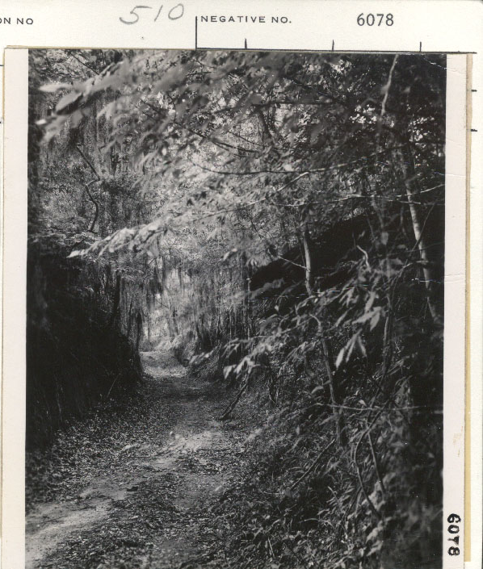

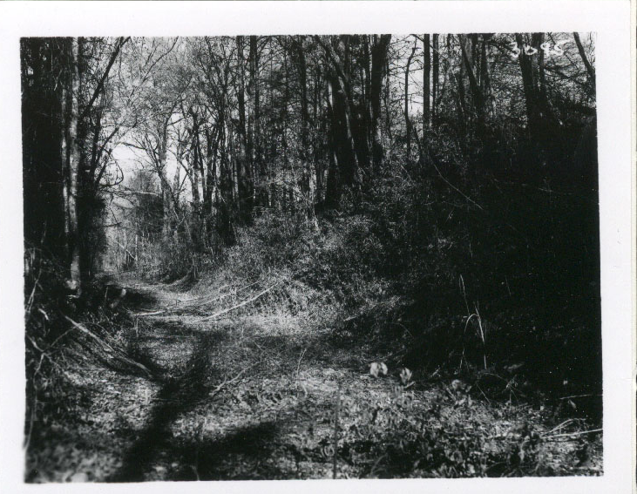
Name:__________________________________________________________Date:_________________
“A Worn Path” -Eudora Welty
Instructions: Read through “A Worn Path” when you find a metaphor or simile write it down in the right column. Identify if it is a metaphor or simile in the first column. Identify if it was said by the narrator or by Phoenix Jackson in the second column. The first line is an example.

Metaphor | Phoenix | “Now comes the trial”

