Colorado
National Monument

National Park Service
U.S. Department of the Interior

Colorado National Monument Fruita, Colorado

WHAT IS THE COLORADO PLATEAU?

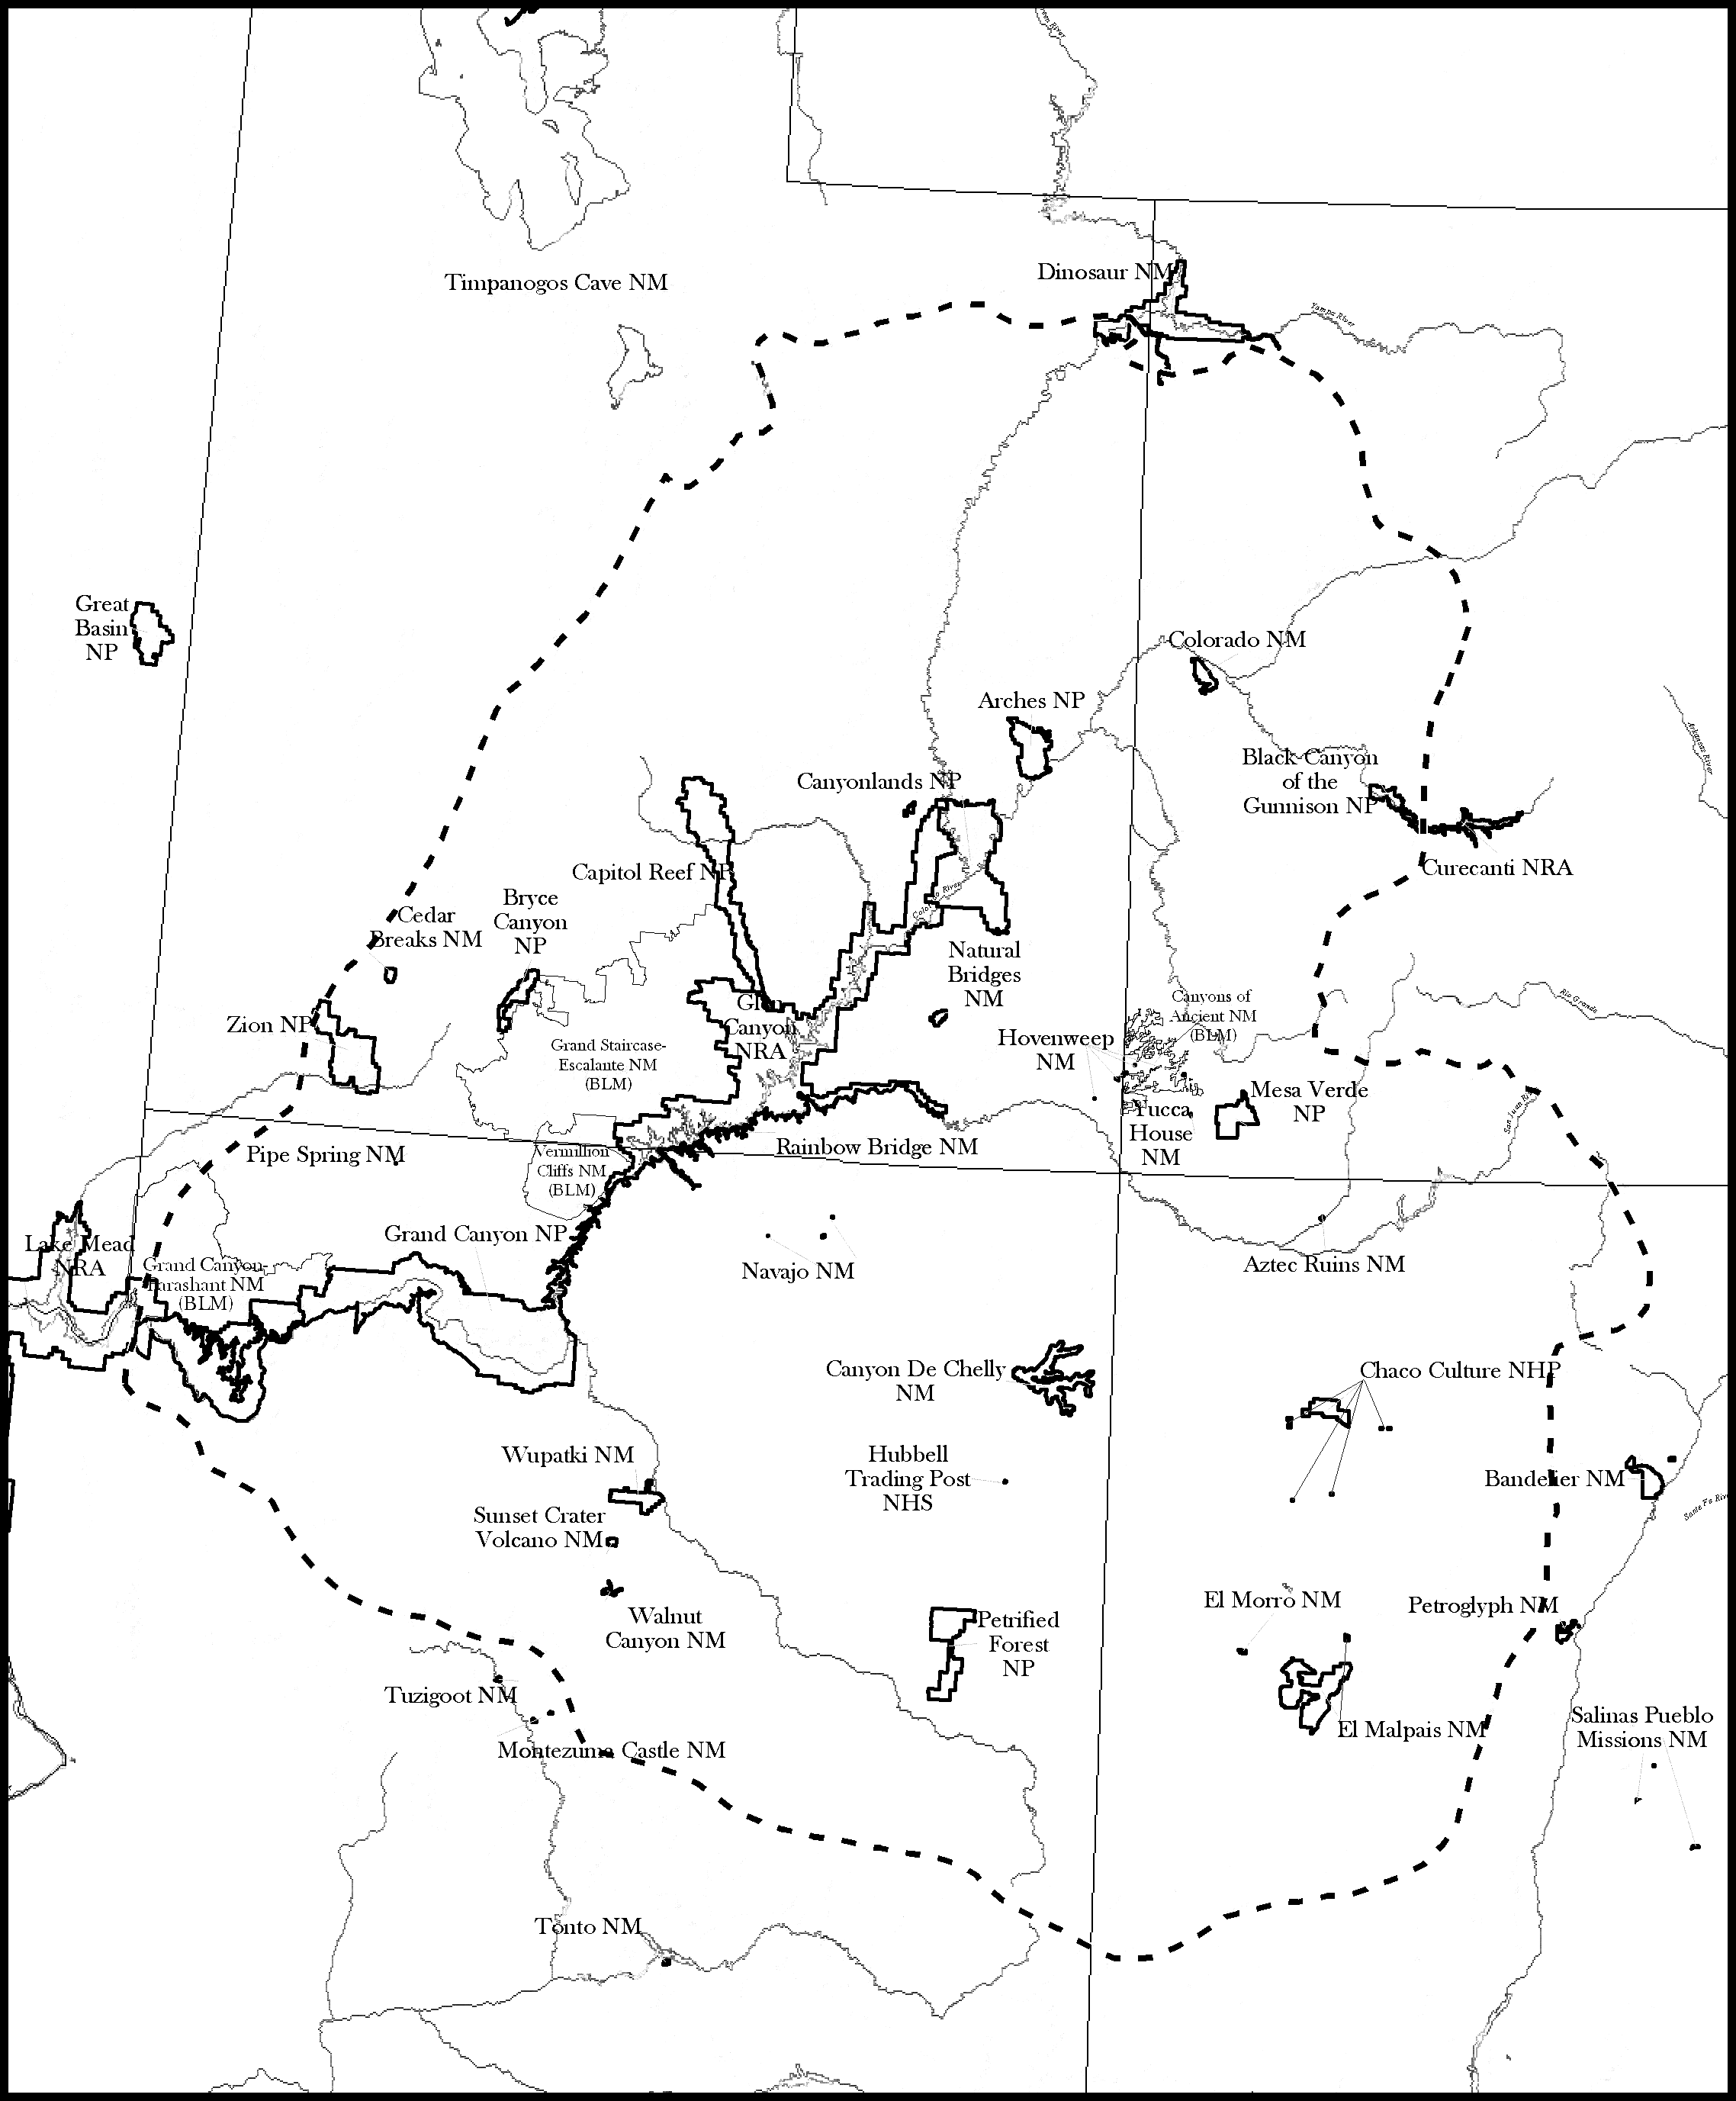
Utah
Colorado
Arizona
New Mexico

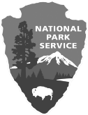
OVERVIEW

The Colorado Plateau is a vast land of relatively horizontal rock layers situated between the Rocky Mountains and the Great Basin of Nevada. Encompassing 150,000 square miles (492,000 km), an area the size of Montana, the Plateau is centered around the four corners of Utah, Arizona, New Mexico, and Colorado and includes

Colorado National Monument.
The Colorado Plateau consists of mesas, pinnacles, and arid tablelands.
This land is deeply etched and dissected by the incredible canyons of the Colorado River and its tributaries.

PHYSICAL GEOGRAPHY This diverse land is a semi-arid desert that
generally, lies above 5,000 feet (1524 m),
punctuated by volcanic peaks and igneous- cored mountains that rise as high as

12,000 feet (3657 m). The spectacular Colorado Plateau is mostly public lands, including 27 units of the National Park Service.

ENVIRONMENT
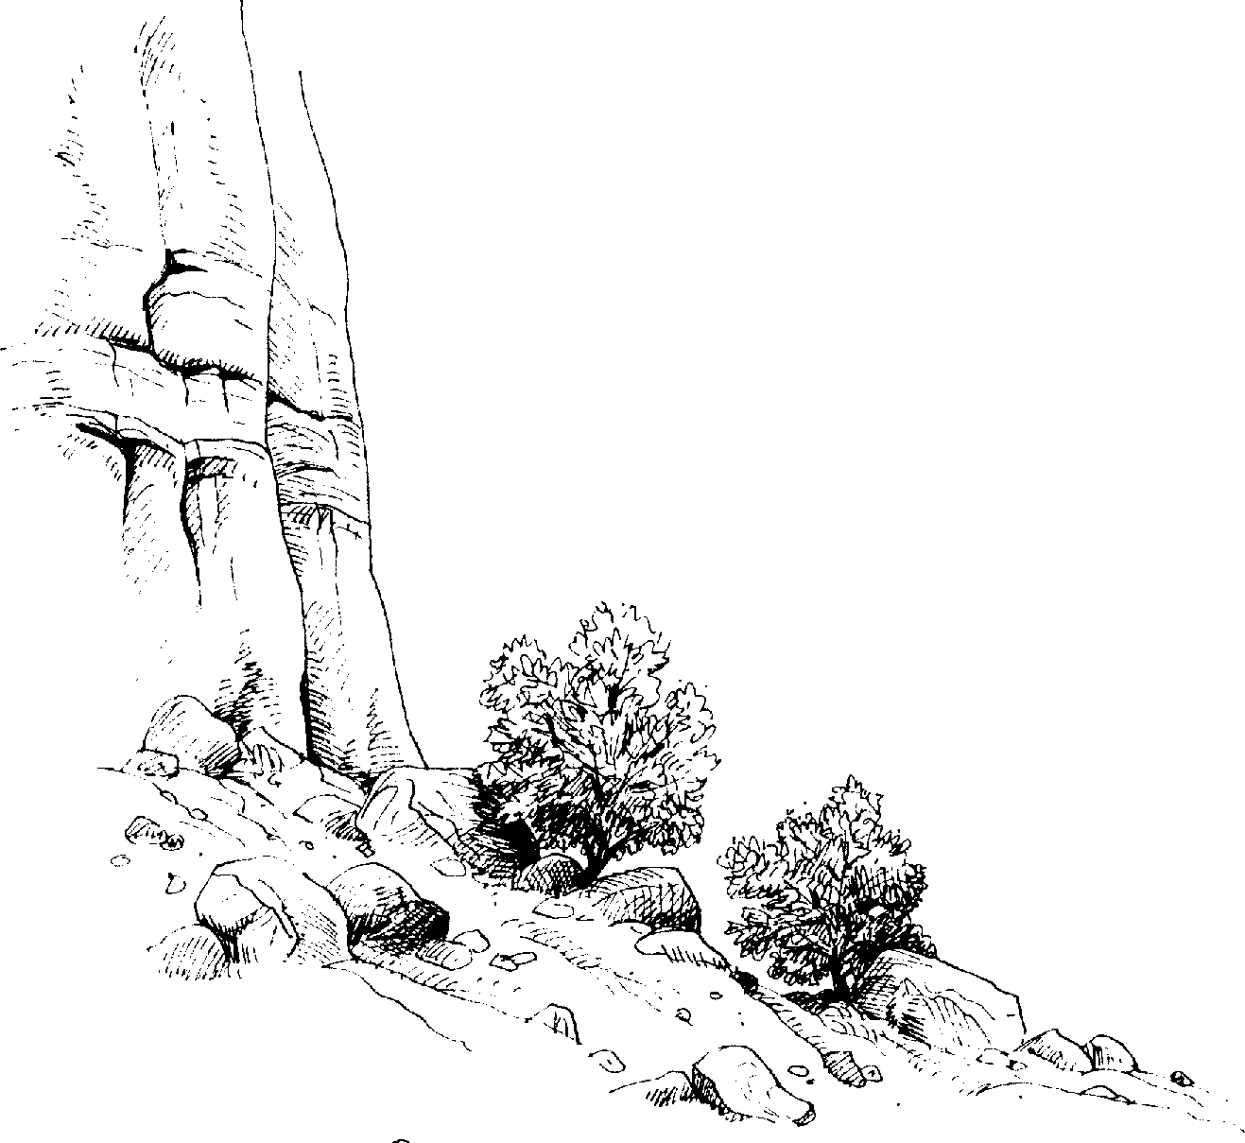

GEOLOGY

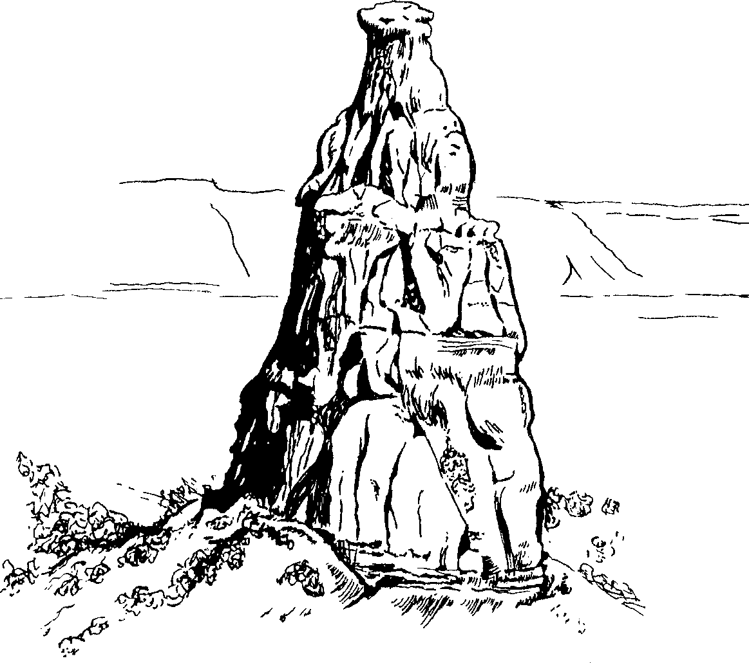

HUMAN HISTORY

To many, the Colorado Plateau is a bleak and threatening region. It is very hot in summer, very cold in winter, and it seems as though water is nowhere. However, when one ventures onto roads and trails that go “nowhere”, the excitement begins.

Red rock badlands are everywhere. Pinnacles, buttes, and mesas of spectacular proportions dominate the landscape. An amazing assortment of canyons, large
and small, abound. Beauty reigns with

The Colorado Plateau is a geologic entity that constitutes a large part of the drainage basin of the Colorado River and its many tributaries. Its boundaries are defined by broad transition zones between the high desert Plateau and bordering lowlands and mountain ranges.

Major fractures or faults in the Earth’s crust have uplifted the Plateau thousands of feet over the last 10 million years. Uplift has allowed rivers like the Colorado, the Green,

Today, the Colorado Plateau is one of the most sparsely populated regions of the United States. In many areas, there were greater populations during the time of ancient Indian civilizations than there are today. Amazing cliff dwellings like those of Mesa Verde National Park remain as monuments to the ancient inhabitants of the region.

unbelievable shapes and colors!

Despite a climate that can be quite harsh, the Colorado Plateau has a rich and diverse population of flora and fauna, including mammals, reptiles, birds and abundant plant-life. Colorful flowers can make spring an especially wonderful time to visit the plateau country. As an ancient Navajo ritual concludes: “Beauty all around us. With it I wander.”

and the San Juan to rapidly carve through the relatively soft rocks, revealing the spectacular red rock canyons we see today. Fracture zones were initiated in the 1.8-billion-year-old basement rocks, sometimes seen deep in the canyons. They have been reactivated repeatedly throughout time. Fractures and faults control the location and orientation of major geological features of the Colorado Plateau, its canyons, river valleys and mesas.

Visiting the Colorado Plateau is an enriching experience. Local American Indians consider the land sacred and believe it is
the center of the universe. Preserving this land’s beauty, both natural and cultural, is the proud responsibility not only of our public land’s managers, but of each and every one of us.

