Types of Rocks

Igneous | Metamorphic | Sedimentary
Rock formed from liquid magma that cools and solidifies deep beneath the Earth’s surface, finally makes its way out of the surface through volcanoes. | Rock that has been changed from its original igneous, sedimentary, or earlier metamorphic form and has been subjected to high heat and pressure. | Rock is formed from pre-existing rocks or pieces of once-living organisms.
Examples:  - Granite  - Lava  - Pumice  - Rhyolite  - Basal | Examples:  - Gneiss  - Marble  - Mica schist  - Slate  - Quartzite (Quartz) | Examples:  - Conglomerate (mixture)  - Limestone  - Sandstone  - Shale  - Dolomite

Cut along dashed lines
Directions: With the help of an adult, cut along the dashed lines. Using tape or glue, secure cut-out onto your egg carton.
Igneous |  | Metamorphic |  | Sedimentary
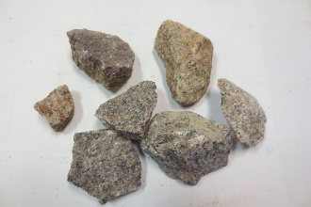  Granite |  | 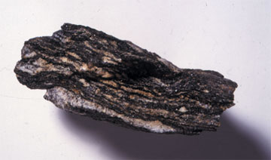  Gneiss |  | 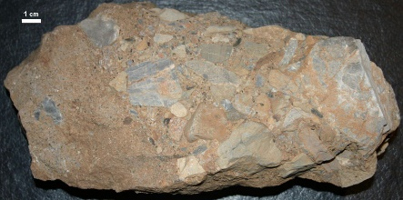  Conglomerate (mixture)
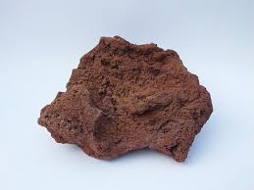  Volcanic rock |  | 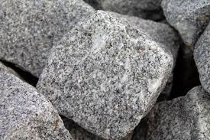  Marble |  | 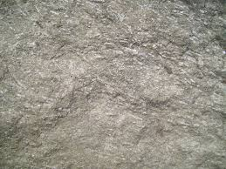  Limestone
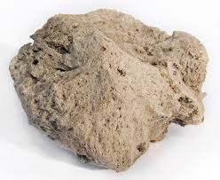  Pumice |  | 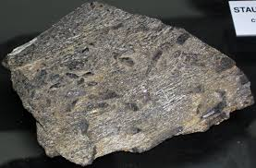  Mica schist |  | 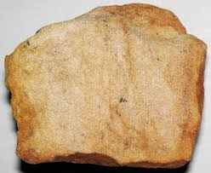  Sandstone
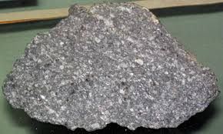  Rhyolite |  | 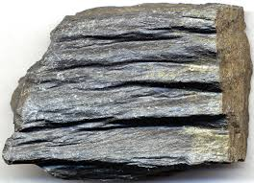  Slate |  | 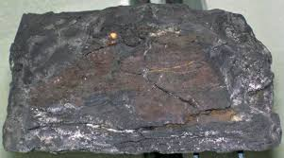  Shale
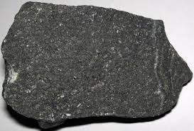  Basalt |  | 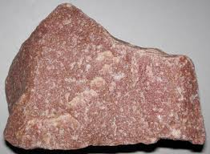  Quartzite (Quartz) |  | 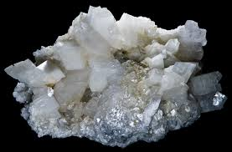  Dolomite

Source: Public domain images from Wikimedia Commons under the Creative Commons License.
Document created by: NPS/Raisa Barrera

