ELEMENTARY LEARNING SERIES

Dr. Carter G. Woodson Home
National Historic Site
National Park Service Educational Project

By La Vonne I. Neal, Ph.D. & Sarah Militz-Frielink, Ph.D.

The same educational process which inspires and stimulates the oppressor with the thought that he is everything and has accomplished everything worth while, depresses and crushes at the same time the spark of genius in the Negro by making him feel that his race does not amount to much and never will measure up to the standards of other peoples. –CARTER G. WOODSON

Purpose of Learning Series
The purpose of this learning series is to give elementary students an opportunity to investigate the importance of collecting, preserving, and teaching the history of diverse people and cultures, especially African Americans.
The Carter G. Woodson Home National Historic Site
The Carter G. Woodson Home National Historic Site highlights the contributions of Dr. Carter Godwin Woodson, "the Father of Black History." Dr. Woodson worked to educate the public about the history of African Americans and their profound impact on American society.
Born on December 19, 1875 in New Canton, Virginia, Woodson had few educational or employment opportunities during his youth. He did not receive a formal education until age 20. Woodson's thirst for knowledge led him to complete a high school diploma, two bachelor's degrees, and a master's degree. In 1912, he became the second black American and the only person of enslaved parentage to earn a Ph.D. from Harvard University.

Woodson was the first professionally trained historian to devote his career to advancing black history. He believed that spreading knowledge about black history was an important part of the struggle for black equality. He spent many years as an educator at various institutions, including the prestigious Armstrong Manual Training School, M Street School, and Howard University.
On July 18, 1922, Woodson purchased his home at 1538 9th Street, N.W. for $8,000. This home served as the headquarters for the organizations that Woodson founded: the Association for the Study of Negro Life and History, Inc. and the Associated Publishers, Inc.
Dr. Carter G. Woodson: The Father of Black History
Dr. Carter G. Woodson, "the Father of Black History," was an educator and historian of African American life and culture. His book The Miseducation of the Negro (1933) challenged histories of the United States that did not recognize the role of Africans and their descendants. Dr. Woodson founded the Association for the Study of Negro Life and History (ASNLH) in 1915, now called the Association for the Study of African American Life and History (ASALH).
In 1916, Dr. Woodson launched The Journal of Negro History. It was the nation’s first major historical journal on the black American experience. By 1919, the Journal had reached 4,000 people. Woodson also established Associated Publishers to ensure that black history was more readily available. Woodson's ground-breaking work, The Negro in Our History, was published by the Associated Publishers in 1922. It would go on to serve as the foundational textbook for teaching black history.
Woodson also founded the federal celebration of Negro History Week in 1926, which was expanded to Black History Month in 1976. In 1937 Dr. Woodson, with the encouragement of the first female president of ASNLH—Mary McLeod Bethune—co-founded the The Negro History Bulletin to teach young people about their cultural heritage. The Negro History Bulletin, now called the Black History Bulletin, publishes and disseminates peer-reviewed information about African Americans in U.S. History, the African Diaspora, and the peoples of Africa to inform the practice of middle and high school teachers.
If These Walls Could Talk: 1538 Ninth Street, N.W. and The People who Assisted in the Creation of the Black History Movement

Dr. Carter G. Woodson’s home played a vital role in his mission to promote the study of black history. The first floor housed the Associated Publishers, The Journal of Negro History, The Negro History Bulletin, and the Association for the Study of Negro Life and History. Important figures of the early black history movement either worked for or visited this intellectual space. It also functioned as an important mentoring center. Woodson either employed or counseled budding historians like Rayford Logan, Charles Wesley, Lorenzo Johnston Greene, and John Hope Franklin here. During the 1920s, both Langston Hughes and Zora Neale Hurston worked at the home.
Vital to ASNLH's success was the work and support of African American women. Black women were important grassroots organizers, officeholders, and participants in ASNLH chapters throughout the country. Some of these women included Nannie Helen Burroughs, Mary Church Terrell, Lois Mailou Jones, and Dorothy Porter. Out of all of Woodson’s relationships, one of his closest friendships was with renowned educator Mary McLeod Bethune. In 1936, Bethune was elected the first female president of ASNLH. Bethune brought money and prestige to the association, and Woodson thought very highly of Bethune, calling her “one of the most distinguished personages of her time.”
While the second floor of Woodson's home housed his office and library, the basement served as a make-shift archive. Woodson preserved rare artifacts and collections that documented the experiences of people of African descent. He housed manuscripts from important individuals of African American history like Francis J. Grimke, Charles Young, Frederick Douglass, and Booker T. Washington. Woodson passed away of a heart attack in his home on April 3, 1950. His efforts continue to be an invaluable resource for scholars today.

Multi-Week Unit

Dr. Carter G. Woodson Home
National Historic Site
National Park Service Educational Project

Connections to Elementary School
This learning series addresses the overall purposes and goals of the high quality embedded technology standards developed by the District of Columbia Office of the State Superintendent of Education. Additionally, adaptations for children who have disabilities are included. The series also incorporates the District of Columbia PreK through Grade12 Social Studies Standards, which examine complex themes and concepts such as:

- The evolution of the concepts of personal freedom, individual responsibility, and respect for human dignity over time.
- The struggles that men and women have faced in overcoming political oppression, economic exploitation, religious persecution, and racial injustice
- The growth and impact of centralized state power through time.
- The birth, growth, and decline of civilizations.
- The influence of economic, political, religious, and cultural ideas as human societies move beyond regional, national, or geographic boundaries.
- The historical patterns and relationships within and among world nations, continents, and regions — economic competition and interdependence; age-old ethnic, racial, and religious enmities; political and military alliances; peacemaking and war making — that serve as a backdrop to and explain contemporary policy alternatives with national and worldwide implications.
- The effects of geography on the history of civilizations and nations.
- The effects of the interactions between humans and the environment through the ages.
- The growth and spread of free markets and industrial economies.
- The development of scientific reasoning, technology, and formal education over time and their effect on people’s health, standards of living, economic growth, government, religious beliefs, communal life, and the environment.

Objectives
At the end of this unit students will be able to investigate multiple perspectives across many content areas about African American history—connecting to museum collections, primary documents, and historical places related to Dr. Carter G. Woodson, the Association for the Study of African American Life and History, and his mentees. Students will be able to design, engage with, and present products that display an accurate portrayal of historical people, places, and collections.

District of Columbia Social Studies Standards:
2.4. Students understand the importance of individual action and character, and they explain, from examining biographies, how people who have acted righteously have made a difference in others’ lives and have achieved the status of heroes in the remote and recent past.

2.5. Students describe the human characteristics of familiar places and varied backgrounds of U.S. citizens and residents in those places.

3.4. Emphasizing the most significant differences, students describe Washington, DC, at the end of the 18th, 19th, and 20th centuries.

This series incorporates the thematic structure of the National Curriculum Standards for Social Studies developed by the National Council for Social Studies (NCSS).

CULTURE

Social studies programs should include experiences that provide for the study of culture and cultural diversity.

Human beings create, learn, share, and adapt to culture. The study of culture examines the socially transmitted beliefs, values, institutions, behaviors, traditions and way of life of a group of people; it also encompasses other cultural attributes and products, such as language, literature, music, arts and artifacts, and foods. Students come to understand that human cultures exhibit both similarities and differences, and they learn to see themselves both as individuals and as members of a particular culture that shares similarities with other cultural groups, but is also distinctive. In a multicultural, democratic society and globally connected world, students need to understand the multiple perspectives that derive from different cultural vantage points.
Cultures are dynamic and change over time. The study of culture prepares students to ask and answer questions such as: What is culture? What roles does culture play in human and societal development? What are the common characteristics across cultures? How is unity developed within and among cultures? What is the role of diversity and how is it maintained within a culture? How do various aspects of culture such as belief systems, religious faith, or political ideals, influence other parts of a culture such as its institutions or literature, music, and art? How does culture change over time to accommodate different ideas, and beliefs? How does cultural diffusion occur within and across communities, regions, and nations?
Through experience, observation, and reflection, students will identify elements of culture as well as similarities and differences among cultural groups across time and place. They will acquire knowledge and understanding of culture through multiple modes, including fiction and non-fiction, data analysis, meeting and conversing with peoples of divergent backgrounds, and completing research into the complexity of various cultural systems.
In schools, this theme typically appears in units and courses dealing with geography, history, sociology, and anthropology, as well as multicultural topics across the curriculum. Young learners can explore concepts of likenesses and differences among cultural groups through school subjects such as language arts, mathematics, science, music, and art. In social studies, learners interact with class members and discover culturally-based likenesses and differences. They begin to identify the cultural basis for some celebrations and ways of life in their community and in examples from across the world. In the middle grades, students begin to explore and ask questions about the nature of various cultures, and the development of cultures across time and place. They learn to analyze specific aspects of culture, such as language and beliefs, and the influence of culture on human behavior. As students progress through high school, they can understand and use complex cultural concepts such as adaptation, assimilation, acculturation, diffusion, and dissonance that are drawn from anthropology, sociology, and other disciplines to explain how culture and cultural systems function.
Embedded Technology Standards:
2.2.1 – Science and Technology Give examples of how our lives would be different without such technologies as automobiles, computers, and electric motors.

3.1.8 – Science and Technology Appropriately use simple tools – such as clamps, rulers, scissors, and hand lenses, as well as other technology (e.g., such as calculators and computers) – to help solve problems.

4.M.1 – Reading/English Language Arts/ Media Compare stories in print with their filmed adaptations, describing the similarities and differences in the portrayal of characters, plot, and settings.

4.M.2 – Reading/English Language Arts/Media Create presentations using audio recordings of poems and/or stories.

Common Core State Standards for Reading Informational Text Grade 4
- Refer to details and examples in a text when explaining what the text says explicitly and when drawing inferences from the text.
- Determine the main idea of a text and explain how it is supported by key details; summarize the text.
- Explain events, procedures, ideas, or concepts in a historical, scientific, or technical text, including what happened and why, based on specific information in the text.
- Determine the meaning of general academic and domain-specific words or phrases in a text relevant to a grade 4 topic or subject area.
- Describe the overall structure (e.g., chronology, comparison, cause/effect, problem/solution) of events, ideas, concepts, or information in a text or part of a text.
- Compare and contrast a firsthand and secondhand account of the same event or topic; describe the differences in focus and the information provided.
- Interpret information presented visually, orally, or quantitatively (e.g., in charts, graphs, diagrams, time lines, animations, or interactive elements on Web pages) and explain how the information contributes to an understanding of the text in which it appears.
- Explain how an author uses reasons and evidence to support particular points in a text.
- Integrate information from two texts on the same topic in order to write or speak about the subject knowledgeably.

Common Core Standards for Math
Grade 4 Overview

Operations and Algebraic Thinking
• Use the four operations with whole numbers to solve problems.
• Gain familiarity with factors and multiples.
• Generate and analyze patterns.

Number and Operations in Base Ten
• Generalize place value understanding for multi-digit whole numbers.
• Use place value understanding and properties of operations to perform multi-digit arithmetic.

Number and Operations—Fractions
• Extend understanding of fraction equivalence and ordering.
• Build fractions from unit fractions by applying and extending previous understandings of operations on whole numbers.
• Understand decimal notation for fractions, and compare decimal fractions.

Measurement and Data
• Solve problems involving measurement and conversion of measurements from a larger unit to a smaller unit.
• Represent and interpret data.
• Geometric measurement: understand concepts of angle and measure angles.

Geometry
• Draw and identify lines and angles, and classify shapes by properties of their lines and angles.

Mathematical Practices
1. Make sense of problems and persevere in solving them.
2. Reason abstractly and quantitatively.
3. Construct viable arguments and critique the reasoning of others.
4. Model with mathematics.
5. Use appropriate tools strategically.
6. Attend to precision.
7. Look for and make use of structure.
8. Look for and express regularity in repeated reasoning.

Learning Goals: Products

- Integrate the information presented from reading and listening to a recording of Frederick Douglass’ chapter 1 of the Narrative of the Life of Frederick Douglass (an excerpt from the true story of his life). Speak and write about the barriers Douglass overcame to accomplish great feats in his lifetime.

- Learn vocabulary from Frederick Douglass’ autobiography and make inferences about the meaning of a passage from his book that starts with, “I was broken in body, soul, and spirit.” Then make parallels to the Black Lives Matter Movement.

- Listen to a recording about Carter G. Woodson’s life and learn about historical events related to Carter G. Woodson and Black History.

- Tweet sentences about Carter G. Woodson’s life.

- Play an interactive vocabulary game that teaches students important historical vocabulary words, engages the senses through acting and artwork, and requires students to discuss Dr. Woodson’s life.

- Gifted activity: Complete a timeline of Frederick Douglass’ life—sequencing events in the correct order.

- Write original song lyrics on what it means to be Miseducated based on Dr. Woodson’s text and Lauryn Hill’s song—The Miseducation of Lauryn Hill.

- Learn about becoming a forensic historian and find key archive documents in Dr. Woodson’s collection or online.

- Virtually engage with the location of Dr. Woodson’s home on a Google map as well as other pertinent locations in Washington DC, which are relevant to Woodson’s legacy.

- Learn about feminist figures in Black history who climbed the staircase in Woodson’s house. The same house that could no longer contain the Association for the Study of African American Life and History as it expanded over time. Make inferences about this complex concept. Tweet the historical legacies of their lives.

- Complete mathematic activities related to the architecture of Dr. Woodson’s house.

Day 1
Activity 1: Learning about Dr. Carter G. Woodson
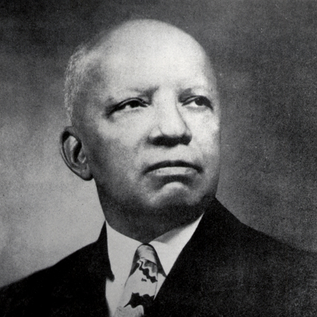

• Today we are going to learn some vocabulary words that are relevant to the life of Dr. Carter G. Woodson, his legacy, and the organization he started—the Association for the Study of African American Life and History. Then we are going to listen and read a short biography about Dr. Carter G. Woodson and play a game in the museum.

NOTE: Depending on the resources available in the museum—the vocabulary pre-teaching would be ideal as a program on a computer screen that introduces the words or phrases from Dr. Woodson’s biography, defines the words and phrases, reviews them, etc. for the children to see if possible.

Adaptations for children who have disabilities (*not an exhaustive list for all disabilities, but a start): Create semantic maps for each vocabulary word. Create power cards for each vocabulary word. Pair appropriate words with a video that explains the meaning. Pair words with pictures that help visual learners. Enlarge the text for students with visual impairments or provide text in braille for students who use braille in the classroom. Provide all vocabulary words in audio format with accompanying definitions in audio format for students who need auditory supports.

Vocabulary word or phrase | Definition
Publisher | A person or company who produces books, journals, or software
Historian | A person who accurately writes about the facts, events, and social conditions of the past.
Forebears | An ancestor; someone who died a long time ago.
Accomplished | Having many talents and skills
Citizens | Someone who has the right to live in a country
Society | People who are bound together by similar institutions, communities, and structures.
Scholarly | Showing a great deal of knowledge
Negro History Week | Federally initiated by Carter G. Woodson in 1926 to celebrate the accomplishments of African Americans in the United States and across the world.
Heritage | Something someone is born into, the status or conditions established by one’s family or social class.
Compromise | To negotiate and reach a deal or agreement.
Principle | One’s ethical standard, values, or beliefs
Carpenter | A builder who works with wood
Fundamentals | The basics of something
Miner | Someone who works with coal in the mines
Diploma | A certificate that says one has graduated from an institution of learning (e.g. high school, college, graduate school).
Philosophy | A way of thinking and a way of life
social conditions | The circumstance in which one was born into or was subjected to may be beyond one’s control (e.g. access to income, education, etc.).
period | A time in history
Association for the Study of Negro Life and History | Founded in 1915 by Dr. Carter G. Woodson to preserve, disseminate, and generate the study of Black History, the Association for the Study of Negro Life and History is now called the Association for the Study of African American Life and History
journals | A magazine or periodical that is published by a professional body for its members (such as the Journal of African American History) for people who are interested in History
Journal of Negro History | Founded by Dr. Woodson in 1917, now called the Journal of African American History
The Negro History Bulletin | Co-founded by Dr. Woodson and Mary McLeod Bethune in 1937 to increase the knowledge of secondary education teachers who were teaching Black History. Now called the Black History Bulletin
legitimate | Something that is valid
integral | Vital to the survival of something
research | Investigate or make an inquiry
profound | Sincere
inquiry | Research or make an investigation

Adaptations for children who have disabilities (*not an exhaustive list for all disabilities, but a start):
Enlarge the text for students with visual impairments or provide text in braille for students who use braille in the classroom. Provide biography in audio format for students who need auditory supports. This lesson already suggests that the biography should be read to students in an audio format since the reading level is above 4th grade. For museum settings: the audio format should be used in addition to any visual format as it is ideal for the lesson.

Short Biography: Dr. Carter G. Woodson
These are the words of Dr. Carter Godwin Woodson, distinguished Black author, editor, publisher, and historian (December 1875 – April 1950). Carter G. Woodson believed that Blacks should know their past in order to participate intelligently in the affairs in our country. He strongly believed that Black history – which others have tried so diligently to erase – is a firm foundation for young Black Americans to build on in order to become productive citizens of our society.
“Those who have no record of what their forebears have accomplished lose the inspiration which comes from the teaching of biography and history”
Known as the “Father of Black History,” Carter G. Woodson holds an outstanding position in early 20th century American history. Woodson authored numerous scholarly books on the positive contributions of Blacks to the development of America. He also published many magazine articles analyzing the contributions and role of Black Americans. He reached out to schools and the general public through the establishment of several key organizations and founded Negro History Week (precursor to Black History Month). His message was that Blacks should be proud of their heritage and that other Americans should also understand it.
Carter G. Woodson was born in New Canton, Buckingham County, Virginia, to former slaves Anne Eliza (Riddle) and James Henry Woodson. Although his parents could neither read nor write, Carter G. Woodson credits his father for influencing the course of his life. His father, he later wrote, insisted that “learning to accept insult, to compromise on principle, to mislead your fellow man, or to betray your people, is to lose your soul.”
His father supported the family on his earnings as a carpenter. As one of a large and poor family, young Carter G. Woodson was brought up without the “ordinary comforts of life.” He was not able to attend school during much of its five-month term because helping on the farm took priority over a formal education. Determined not to be defeated by this setback, Carter was able “largely by self-instruction to master the fundamentals of common school subjects by the time he was seventeen.” Ambitious for more education, Carter and his brother Robert Henry moved to Huntington, West Virginia, where they hoped to attend the Douglass High School. However, Carter was forced to earn his living as a miner in Fayette County coal fields and was able to devote only a few months each year to his schooling. In 1895, a twenty-year-old Carter entered Douglass High School, where he received his diploma in less than two years.
From 1897 to 1900, Carter G. Woodson began teaching in Winona, Fayette County. In 1900, he returned to Huntington to become the principal of Douglass H.S.; he finally received his Bachelor of Literature degree from Berea College, Kentucky. From 1903 to 1907, he was a school supervisor in the Philippines. Later he traveled throughout Europe and Asia and studied at the Sorbonne University in Paris. In 1908, he received his M.A. from the University of Chicago, and in 1912, he received his Ph.D. in history from Harvard University.
During his lifetime, Dr. Woodson developed an important philosophy of history. History, he insisted, was not the mere gathering of facts. The object of historical study is to arrive at a reasonable interpretation of the facts. History is more than political and military records of peoples and nations. It must include some description of the social conditions of the period being studied.
Woodson’s work endures in the institutions and activities he founded and promoted. In 1915, he and several friends in Chicago established the Association for the Study of Negro Life and History. The following year, the Journal of Negro History appeared, one of the oldest learned journals in the United States. In 1926, he developed Negro History Week and in 1937 published the first issue of the Negro History Bulletin.
Dr. Woodson often said that he hoped the time would come when Negro History Week would be unnecessary; when all Americans would willingly recognize the contributions of Black Americans as a legitimate and integral part of the history of this country. Dr. Woodson’s outstanding historical research influenced others to carry on his work. Among these have been such noted historians as John Hope Franklin, Charles Wesley, and Benjamin Quarles. Whether it’s called Black history, Negro history, Afro-American history, or African American history, his philosophy has made the study of Black history a legitimate and acceptable area of intellectual inquiry. Dr. Woodson’s concept has given a profound sense of dignity to all Black Americans.

Activity 2: Comprehension Activity through Social Media

Adaptations for children who have disabilities (*not an exhaustive list for all disabilities, but a start): Depending on the child, a parent, paraprofessional or peer mentor may need to assist student with this activity.

Use the following hash tags. Fill in the sentence on your twitter feed.

I learned #CarterGWoodson____________________________________
Go NPS#

You can use the following vocabulary words or phrases for ideas!

Publisher
Historian
Author
Father of Black History
Society
Scholarly
Black History Bulletin
Journal of African American History
Berea College
University of Chicago
Harvard University Ph.D.
Washington DC
Research
Association for the Study of African American Life and History (ASALH)

Activity 2.5
History, Maps, Places

Show students the following locations on a Google map: Dr. Carter G. Woodson’s home, the current location of the Association for the Study of African American Life and History, and Howard University.

- Dr. Carter G. Woodson’s Home National Historic Site: https://www.google.com/maps/place/Carter+G.+Woodson+Home+National+Historic+Site/@38.9108206,-77.0263962,17z/data=!3m1!4b1!4m5!3m4!1s0x89b7b7ee6584eae1:0xc17b04268f5fcc94!8m2!3d38.9108164!4d-77.0242075
- Howard University: https://www.google.com/maps/place/Howard+University/@38.9226885,-77.0216264,17z/data=!3m1!4b1!4m5!3m4!1s0x89b7b7fc56b4cef9:0x32dcc71fc8db77c2!8m2!3d38.9226843!4d-77.0194377
- Association for the Study of African American Life and History, located in the Howard Center: https://www.google.com/maps/place/Howard+Center,+2225+Georgia+Ave+NW+%23331,+Washington,+DC+20059/@38.9195061,-77.0237472,17z/data=!3m1!4b1!4m5!3m4!1s0x89b7b7fb54071ccb:0x3b0360f2f5551867!8m2!3d38.9195019!4d-77.0215585

- Go over each location again, delete (X out) the red pin which shows the students the spot for each exact location on the map of each designated location as you go through the maps.

- Have students locate the places on the map without the red pins first as a group, then individually or in pairs.

- See if students can identify two locations at once without the red pins (e.g. located ASALH and Howard University). Zoom the map out and see if students can located all three locations.

Inferential and Critical Thinking about Maps:

- How do you think the map looked in the 19th century as compared to how it looks today?
- Can you provide some examples of how life would be different in 1922 when Dr. Carter G. Woodson bought this house and had ASNLH meetings here? How would the streets be different? How would the city of Washington DC be different? Why?

Activity 2.6
Mathematical Activity:
Using the Google map as a tool, figure out the miles it takes to drive to the following locations today in Washington DC:
- Drive from ASALH to Dr. Carter G. Woodson’s House, how many miles?
- Drive from Dr. Carter G. Woodson’s House to Howard University, where he taught college classes. How many miles?
- Round-trip, how many miles did Dr. Carter G. Woodson commute when he taught at Howard University?

Activity 3 Materials Needed:
Paper, pencils, dice, clear container filled with vocabulary words from Dr. Woodson’s bio, vocabulary sheets with activities (see example from below).

Use a clear container to hand-select the pre-taught vocabulary words and phrases out of the container from Dr. Woodson’s short biography. Then direct the children to roll the dice on their vocabulary boards. Read the word, and then have children (in pairs) roll the dice and take turns completing the vocabulary activities. Then have them match the chosen vocabulary word to the short biography about Dr. Woodson.

Vocabulary Game: Draw a vocabulary word from the clear container. Roll the dice on the sheet. Complete the vocabulary activity in groups or in pairs. Repeat until the jar is empty.

Define the word or vocabulary phrase. | Draw a picture of the word or phrase on a piece of paper using your imagination.
What does the word or vocabulary phrase remind you of? | How does the word make you feel?
Use the word in a sentence. Act it out with a partner. | What do you remember about Dr. Woodson when you hear the word? Discuss this with your partner.

Day 2

Adaptations for Children Who Have Disabilities (*not an exhaustive list for all disabilities, but a start):
Enlarge the text for students with visual impairments or provide text in braille for students who use braille in the classroom. Provide Douglass’ biography in audio format for students who need auditory supports. This lesson already suggests that the biography should be read to students in an audio format since the reading level is above 4th grade. For museum settings: the audio format should be used in addition to any visual format as it is ideal for the lesson.

Learning about Frederick Douglass

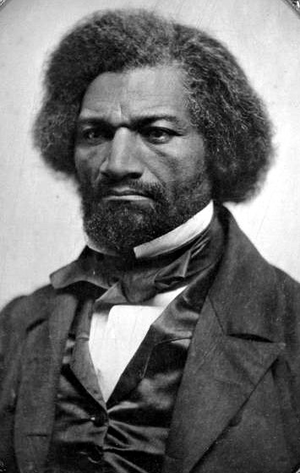

Warm up (Anticipatory Set):

• First let’s talk about Frederick Douglass. Can anyone tell me who he is and some of the great deeds he accomplished in history?

•Does anyone remember how Dr. Carter G. Woodson is connected to Frederick Douglass?

•Dr. Carter G. Woodson kept original manuscripts that Frederick Douglass wrote in this library.

• Listen to a recording of Chapter 1 from one of Frederick Douglass’ books The Narrative of the Life of Frederick Douglass, written in 1845. Then we are going to watch a short biography of Douglass.

• This way we can start to understand the historical context and the insurmountable barriers that both Woodson and Douglass had to overcome as African American men who were born in the 18th and 19th centuries.

Activity 2
Pause for brief questions after the recording of Frederick Douglass’ Chapter 1 from The Narrative of the Life of Frederick Douglass

First, let’s learn a new word that you may not know. The correct word for slavery is enslavement. A person is not born a slave; they become enslaved by another human being who has chosen to misuse and abuse their power.

We have seen the words slave and slavery used a lot in books because those are the words that people used back then to describe the conditions of the times. However, today we choose to replace those derogatory terms with vocabulary words that more accurately reflect the true nature of what happened in history.

So when you read or hear certain historical words in our texts today, remember the context for how and when they were used.

- Identify: What did Frederick Douglass’ true story about being enslaved (being a slave) teach you about enslavement?
- Identify: How did his true story make you feel? What did you hear?
- Identify: What did you notice, but not expect?
- Compare: How does Frederick Douglass’ Chapter 1 compare to other books you have read about enslavement?
- Infer: Why do you think Frederick Douglass’ true story is so important?
- Infer: What would we think about enslavement if we only read certain history books and we did not read true accounts of what really happened, such as stories like Frederick Douglass’?

Activity 3
CCSS
- Describe the overall structure (e.g., chronology, comparison, cause/effect, problem/solution) of events, ideas, concepts, or information in a text or part of a text.

Listen: Now we are going to listen to the biography of Frederick Douglass’ life (what he accomplished after enslavement and recall the timeline of Douglass’ triumphant life).

Given what you learned about Frederick Douglass from his narrative, I want you to try to imagine the period of time during the late 1800s and what Frederick Douglass had to overcome to become one of the most successful self-educated people in history.

Short Biography: Frederick Douglass
Frederick Augustus Washington Bailey was born into slavery in Talbot County, Maryland, around 1818. The exact year and date of Douglass' birth are unknown, though later in life he chose to celebrate it on February 14.

Douglass initially lived with his maternal grandmother, Betty Bailey. At a young age, Douglass was selected to live in the home of the plantation owners, one of whom may have been his father. His mother, an intermittent presence in his life, died when he was around 10.
Learning to Reading and Write
Defying a ban on teaching slaves to read and write, Baltimore slaveholder Hugh Auld’s wife Sophia taught Frederick Douglass the alphabet when he was around 12.

When Auld forbade his wife to offer more lessons, Douglass continued to learn from white children and others in the neighborhood.

It was through reading that Douglass’ ideological opposition to slavery began to take shape. He read newspapers avidly and sought out political writing and literature as much as possible.

In later years, Douglass credited The Columbian Orator with clarifying and defining his views on human rights.

Douglass shared his newfound knowledge with other enslaved people. Hired out to William Freeland, he taught other slaves on the plantation to read the New Testament at a weekly church service. Interest was so great that in any week, more than 40 slaves would attend lessons. Although Freeland did not interfere with the lessons, other local slave owners were less understanding. Armed with clubs and stones, they dispersed the congregation permanently.

With Douglass moving between the Aulds, he was later made to work for Edward Covey, who had a reputation as a "slave-breaker.” Covey’s constant abuse nearly broke the 16-year-old Douglass psychologically. Eventually, however, Douglass fought back, in a scene rendered powerfully in his first autobiography. After losing a physical confrontation with Douglass, Covey never beat him again. Douglass tried to escape from slavery twice before he succeeded.

Abolitionist
After settling as a free man with his wife Anna in Bedford in 1838, Frederick Douglass was eventually asked to tell his story at abolitionist meetings, and he became a regular anti-slavery lecturer. Founder of The Liberator, William Lloyd Garrison, was impressed with Douglass’ strength and rhetorical skill, and wrote of him in his newspaper. Several days after the story ran, Douglass delivered his first speech at the Massachusetts Anti-Slavery Society's annual convention in Nantucket. Crowds were not always hospitable to Douglass. While participating in an 1843 lecture tour through the Midwest, Douglass was chased and beaten by an angry mob before being rescued by a local Quaker family.

Following the publication of his first autobiography in 1845, Douglass traveled overseas to evade recapture. He set sail for Liverpool on August 16, 1845, and eventually arrived in Ireland as the Potato Famine was beginning. He remained in Ireland and Britain for two years, speaking to large crowds on the evils of slavery. During this time, Douglass’ British supporters gathered funds to purchase his legal freedom. In 1847, the famed writer and orator returned to the United States a free man.

Upon his return, Douglass produced some abolitionist newspapers: The North Star, Frederick Douglass Weekly, Frederick Douglass' Paper, Douglass' Monthly and New National Era. The motto of The North Star was "Right is of no Sex – Truth is of no Color – God is the Father of us all, and we are all brethren."

Women’s Rights
In addition to abolition, Douglass became an outspoken supporter of women’s rights. In 1848, he was the only African American to attend the first women's rights convention at Seneca Falls, New York. Elizabeth Cady Stanton asked the assembly to pass a resolution stating the goal of women's suffrage. Many attendees opposed the idea. Douglass stood and spoke eloquently in favor, arguing that he could not accept the right to vote as a black man if women could not also claim that right. The resolution passed.

Civil War and Reconstruction
By the time of the Civil War, Douglass was one of the most famous black men in the country. He used his status to influence the role of African Americans in the war and their status in the country. In 1863, Douglass conferred with President Abraham Lincoln regarding the treatment of black soldiers, and later with President Andrew Johnson on the subject of black suffrage.
President Lincoln's Emancipation Proclamation, which took effect on January 1, 1863, declared the freedom of all slaves in Confederate territory. Despite this victory, Douglass supported John C. Frémont over Lincoln in the 1864 election, citing his disappointment that Lincoln did not publicly endorse suffrage for black freedmen. Slavery everywhere in the United States was subsequently outlawed by the ratification of the Thirteenth Amendment to the Constitution.
Douglass was appointed to several political positions following the war. He served as president of the Freedman's Savings Bank and as chargé d'affaires for the Dominican Republic. After two years, he resigned from his ambassadorship over objections to the particulars of U.S. government policy. He was later appointed minister-resident and consul-general to the Republic of Haiti, a post he held between 1889 and 1891.

In 1877, Douglass visited one of his former owners, Thomas Auld. Douglass had met with Auld's daughter, Amanda Auld Sears, years before. The visit held personal significance for Douglass, although some criticized him for the reconciliation.

Vice Presidential Candidate
Douglass became the first African American nominated for vice president of the United States as Victoria Woodhull's running mate on the Equal Rights Party ticket in 1872. Nominated without his knowledge or consent, Douglass never campaigned. Nonetheless, his nomination marked the first time that an African American appeared on a presidential ballot.

When Did Frederick Douglass Die?
Frederick Douglass died on February 20, 1895 of a massive heart attack or stroke shortly after returning from a meeting of the National Council of Women in Washington, D.C. He was buried in Mount Hope Cemetery in Rochester, New York.

For museum presentation, it would be ideal to have a computer screen with moving choice icons that students could manipulate with their fingers into the correct order. The computer could give an alert if the choices are placed in the incorrect sequence.

Challenge Activity

Directions:
- Study: Here are copies of the Frederick Douglass’ Biography. (Distribute copies of the biography that the students just listened to in the museum or classroom. (Or provide a giant visual on a screen that students can see.)

2. Describe: Get together in pairs and renumber the following events of Frederick Douglass’ life in the correct order.

Choices:

- Became First African American to be nominated for vice-president in 1872.
- Died of Heart Attack or Stroke.
- After settling as a free man with his wife Anna in Bedford in 1838, Frederick Douglass was eventually asked to tell his story at abolitionist meetings.
- Delivered his first speech at the Massachusetts Anti-Slavery Society's annual convention in Nantucket.
- Appointed minister-resident and consul-general to the Republic of Haiti, a post he held between 1889 and 1891.
- Born to parents who were enslaved.
- Spoke at the Seneca Falls convention in 1848.
- Published five abolitionist newspapers.
- Started educating himself as a child.
- In 1863, Douglass conferred with President Abraham Lincoln regarding the treatment of black soldiers, and later with President Andrew Johnson on the subject of black suffrage.
- Published his first book in 1845.

Activity 3, part 2: Let’s Make Inferences
“We are going to talk about how to make inferences, or how to make our best guess based on previous knowledge we may have or what we think the author is leading us to believe based on clues or hints given in the story. Inferences can also be described as “drawing conclusions from what we learned in the story or the informational text we read. When we make inferences, we use our critical and creative thinking skills to generate information ourselves. This means we provide answers to questions our teachers ask us that we did not find directly in the story or text itself.

Using your critical and creative thinking skills, I want you to study the following text and make an inference (make your best guess) about what Frederick Douglass meant when he stated the following in his autobiography:
“I was broken in body, soul, and spirit. My natural elasticity was crushed, my intellect languished, the disposition to read departed, the cheerful spark that lingered about my eye died; the dark night of slavery closed in upon me; and behold a man transformed into a brute”

Teachers, pre-teach the following vocabulary words to go with the above passage. The vocabulary definitions were written to match the context of Douglass’ autobiography.

Adaptations for children who have disabilities (*not an exhaustive list for all disabilities, but a start): Create semantic maps for each vocabulary word. Create power cards for each vocabulary word.

•Pair appropriate words with a video that explains the meaning. Pair words with pictures that help visual learners.

•Enlarge the text for students with visual impairments or provide text in braille for students who use braille in the classroom.

•Provide all vocabulary words in audio format with accompanying definitions in audio format for students who need auditory supports.

Vocabulary Words | Definitions
Elasticity | Flexibility or ability to go along with and overcome life’s difficulties.
Intellect | A person’s mind
Languished | Left to spoil, decompose, weaken
disposition | One’s natural state of being. For example, Susan has a natural disposition to read at the library seven days a week.
Lingered | Stayed; remained
Behold | Look; pay attention to; See that!
Transformed | Completely changed from one way to another way. For example, The caterpillar was transformed into a butterfly.
Brute | Someone who becomes dehumanized, or less than human due to enslavement

Inferential Questions:

- Accessing prior knowledge: Have you ever heard the phrase, “dark night of the soul?” If so what do you think it means?
- Infer: What do you think Frederick Douglass meant when he said “the dark night of slavery closed in upon me?”
- Infer: What do you think Frederick Douglass meant when he said, “I was broken in body, soul, and spirit?”
- Making Connections:
Watch this video, which re-enacts what Black Americans are facing today with respect to police brutality and the killing of innocent Black people. https://www.youtube.com/watch?v=qrDJfxIDmJk
Black Lives Mannequin Challenge on Police Brutality

What connections can you make from what Frederick Douglass wrote in this passage to what Black Americans are facing today with respect to police brutality and the killing of innocent Black people, which has led to the Black Lives Matter Movement?

Activity 5
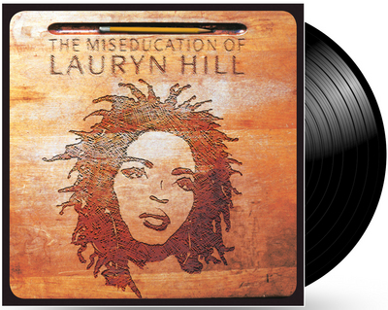 Lauryn Hill branched out and released her solo debut album after the Fugees disbanded in 1997. It was both a critical and commercial success, shooting to number one on the Billboard 200 upon its release. To this day, it remains a landmark record for both hip-hop and neo-soul. Hill later won five Grammys (including Album of the Year) for the LP.

Warm-up:
We are going to learn about an important song artist who was inspired by the work of Dr. Carter G. Woodson, specifically his book The MisEducation of the Negro in 1933. The song artist we are going to learn about today is Lauryn Hill who released an album in 1998 titled “The Miseducation of Lauryn Hill.”

Does anyone know what the prefix “mis” means? “Mis” means wrongly. What does mis mean? So to be miseducated means to be educated wrongly. When Carter G. Woodson wrote his famous book The MisEducation of the Negro in 1933 in this very house, he wrote about the ways in which schools can lie to Black people and tell them that they are not equal to white people through the teachers, books, and treatment of African Americans in schools, and also that the ways in which students are taught can actually remove the passion and desire to learn. So this is part of the miseducation of African Americans. Here is a quote from Dr. Woodson’s book, the Miseducation of the Negro that explains his idea of what it means to be wrongly educated:

“When you control a man’s thinking you do not have to worry about his actions.” –CARTER G. WOODSON

Intro the MisEducation of Lauryn Hill
Teacher in the album taking attendance is Ras Baraka
Please respond when I call your name...
Alright, Kevin Charles... (here)
Jaris Boykins... (here)
Alicia Simmons... (here)
Phillip Valdez... (here)
Gabrielle Salado... (here)
Latoya Bradberry... (right here)
Antawn Mitchell... (here)
Shaquan Sutton... (here)
Cory Thomas... (here)
Tyron Lucas... (here)
Kennia Codwell...(here)
Tanika Marshall... (here)
Lauryn Hill...
Lauryn Hill...
Lauryn Hill...
Walton Spates... (here)
(music fades)

The MisEducation of Lauryn Hill—Lyrics

My world it moves so fast today
The past it seems so far away
And life squeezes so tight that I can't breathe
And every time I try to be, what someone else has thought of me
So caught up, I wasn't able to achieve
But deep in my heart, the answer it was in me
And I made up my mind to define my own destiny
I look at my environment
And wonder where the fire went
What happened to everything we used to be
I hear so many cry for help
Searching outside of themselves
Now I know his strength is within me
And deep in my heart, the answer it was in me
And I made up my mind to define my own destiny
And deep in my heart...
And deep in my heart, the answer it was in me
And I made up my mind to define my own destiny

Answer the following questions in complete sentences. (written or orally).
You may complete this activity on a tablet or with a chaperone in a discussion circle.

Analyzing Order and Juxtaposition
Artists, film directors, and songwriters often choose to use events, voice-overs, and on-screen text to present their point of view (even when factual).

- Analyze: How did Lauryn Hill accomplish this through the use of Ras Baraka at the beginning of her album taking attendance and then including the rest of the lyrics later in the album?
- Infer (or draw a conclusion): What did it mean when the teacher kept saying the artist’s name and she did not answer?

Analyze Lauryn Hill’s Point of View
Hi, this is Lauryn Hill, and I want to tell you guys a little bit about a song that means a great deal to me. The song is called, “The Miseducation of Lauryn Hill,” and it has a lot to do with how I figured out some things from my life. It doesn’t necessarily mean miseducation like I didn’t do well in school– as I did well in school– but it has a lot to do with finding out about your own aspirations and your own dreams, and not those dreams and those aspirations that some might have for you. It’s a song about movement and growth and inspiration.
- Identify: What is the main idea that Lauryn Hill is trying to express through her song (as stated in her own words)?
- Infer (or draw a conclusion): How does this contribute to Lauryn Hill’s idea of what it means to be miseducated?

Compare Lauryn Hill’s Lyrics to the selected passages from Woodson’s Miseducation of a Negro that we listened to earlier:
- Compare and contrast: Is her idea about what it means to be miseducated similar or different to Carter G. Woodson’s idea of being miseducated in his book The Miseducation of the Negro that he published in 1933?
- Express: Draw a picture of what you think it means to be miseducated.

Activity 6
4.M.2 – Reading/English Language Arts/Media Create presentations using audio recordings of poems and/or stories.

Create: Using your recorders on your smart phone and some of the words in the optional word bank, create your own lyrics about what it means to be miseducated.

• heart
• own
• dreams
• someone else
• my
• Miseducation
• destiny
• steal
• equality
• oppress

Tweet one line of your new song with the following hash tags: #NPS #CarterGWoodson

Activity 7
Learning about Carter G. Woodson’s Education

Berea College
Divide the class into small groups of 3-4 students.

We are going to watch a video from Berea College and learn about the important history surrounding the founding of that institution. Watch the video on YouTube here:
https://www.youtube.com/watch?v=5Xvl8ceFoR4

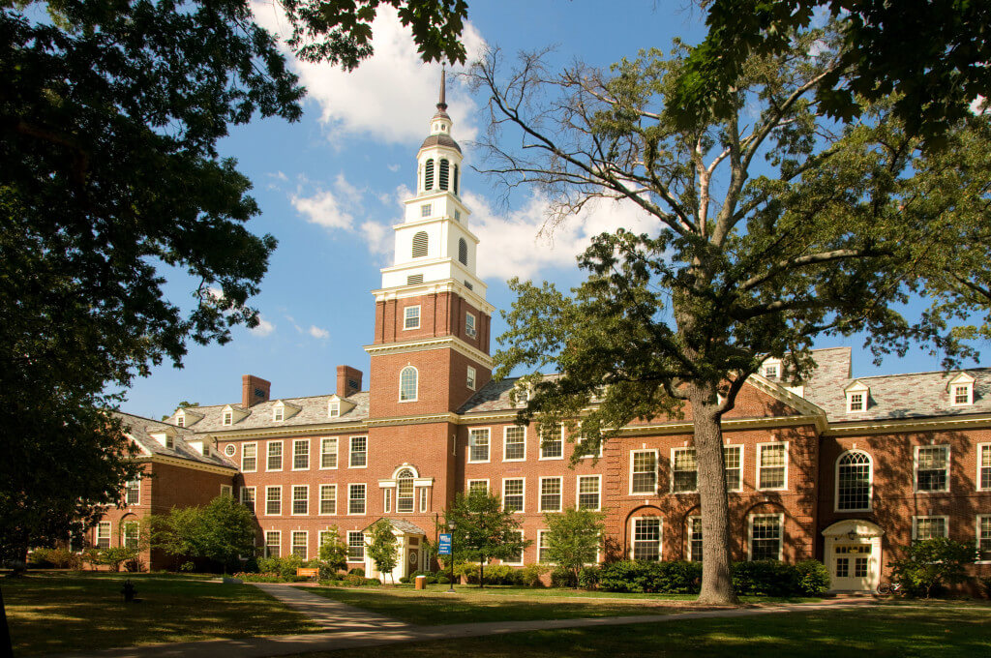

Originally founded in 1855 by abolitionist John Gregg Fee, Berea College was the first co-educational and racially integrated higher learning institute in the South.

Dr. Carter G. Woodson obtained his bachelor’s degree in literature from Berea College in 1903. Complete the chart about Woodson’s education.

Berea College  Founded in 1855 as interracial and coeducational | What was happening in history when Dr. Woodson attended Berea College? | What made Berea College different from other colleges during that time? | What kind of environment do you think Berea College was for Dr. Woodson? (friendly, racially hostile, neutral, none of the above) Why?

Encourage students to consult other primary and secondary sources on the internet to make connections between the histories of African Americans during the time Carter G. Woodson attended Berea College.

Reflective Activity (Whole Group): Written and Oral

- Document your main findings about the history of African Americans and their experience in college during the early 1900s.
- Imagine you were going to college as an African American during that time.
- What do you think it would be like?

Activity 8
Becoming a Forensic Historian in Dr. Carter G. Woodson’s Library
First pre-teach the following words, using visuals in Dr. Woodson’s library when/if possible. If not, use visuals in the classroom to go with the vocabulary definitions.

Pre-teaching vocabulary Words
Artifacts | Objects made by a human being that has cultural or historical interest
Archives | Collection of documents, letters, official papers, photographs, recorded material
Collections | Groups of writing, music, books, and other objects that are together

Activity 7 continued
Scavenger Hunt:
“Today we are going to locate some specific documents, important journals, and publications that Dr. Carter G. Woodson co-founded, created, or started during his life.”

Adaptions for the Classroom:
Find a partner and conduct a digital search on the internet for the following artifacts. It may help to click on images when you do your search and also check the ASALH website.

Adaptions for Woodson Home:
Find a partner and search the archives in Dr. Woodson’s house for the following artifacts:

Forensic historian artifact hand-outs
Directions: Make an X on the visual representation of the artifact when you locate it in Dr. Woodson’s house or on the internet.

- Journal Cover: The Journal of Negro History
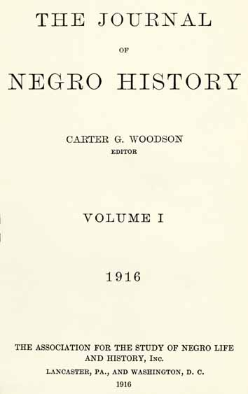

2. Publishing Company: The Associated Publishers, Inc.
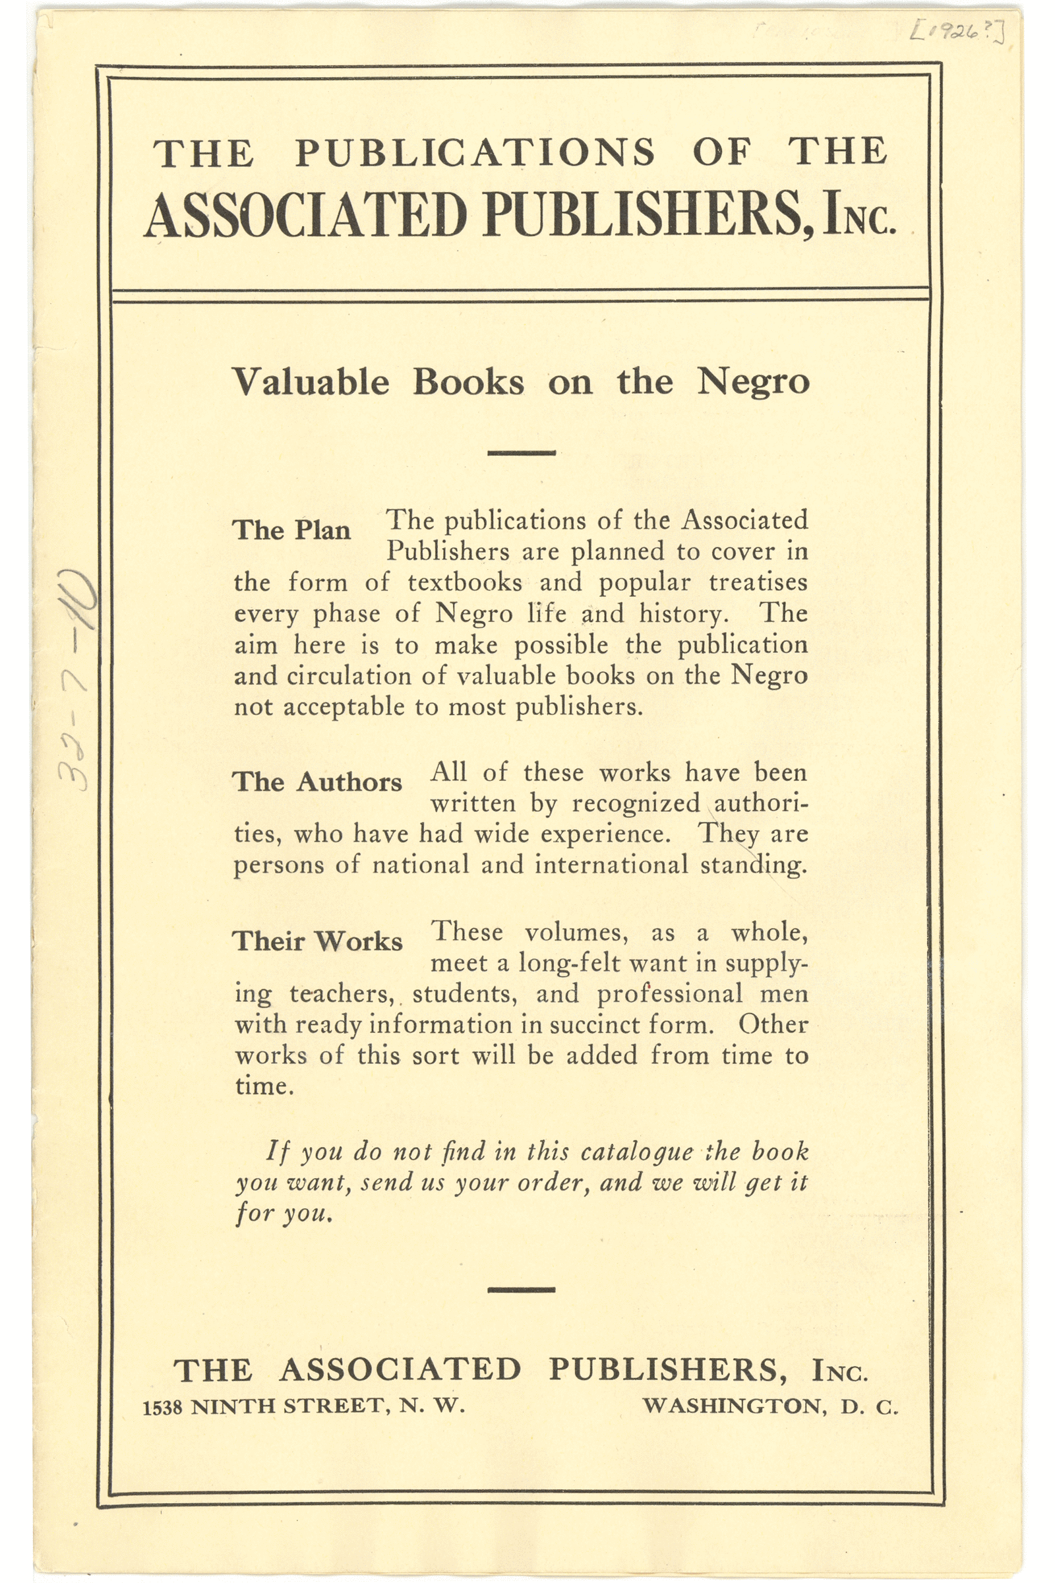

3.Book cover: The Negro in Our History

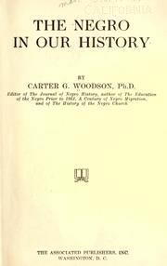

4.Book cover: The History of the Negro Church

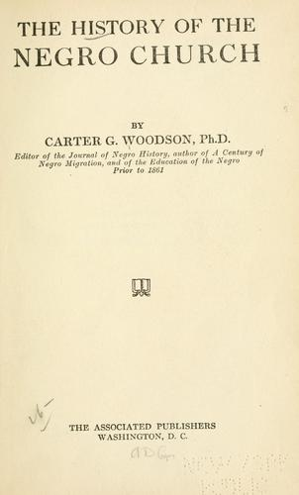

5.Organization: The Association for the Study of Negro Life and History

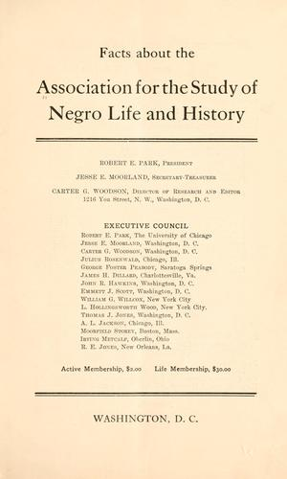

6.Federally recognized celebration: Negro History Week, established in 1926
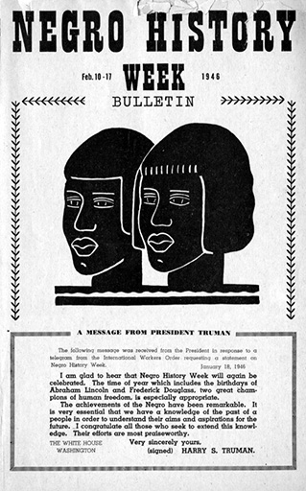

7.Federally recognized celebration: Black History Month, established in 1976

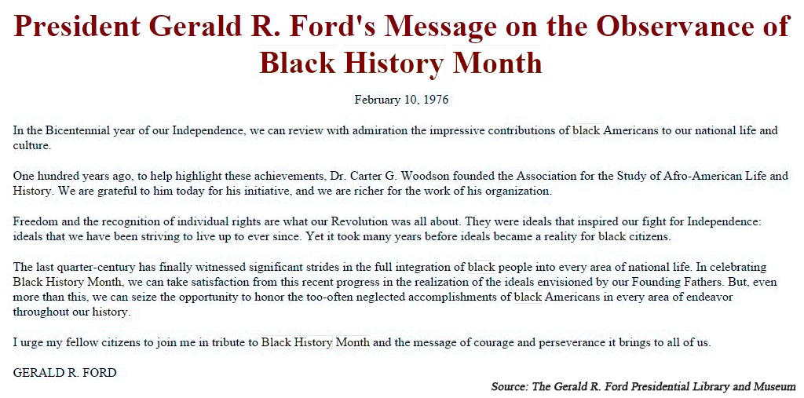

Activity 8: Historical Architecture

Becoming a restorative architect at Carter G. Woodson’s house

Study this fireplace, which was completely restored to the original one from 1922 using the bricks from the original house. Teachers should provide buckets with manipulatives to represent the actual number of bricks Dr. Woodson’s fireplace has in his original model that the restorative architects used to update the fireplace.

- Study the picture of the fireplace or the actual fireplace. Estimate how many bricks the original fireplace had (which are shown here in this picture) or shown at the actual location in the museum. 2. Count the bricks used to restore the fireplace, using the laminated pieces or manipulatives provided at the museum. 3. Calculate the difference. (How close were you to estimating the correct amount? Maybe you guessed the exact amount?

Estimate | Count | Calculate | How many?

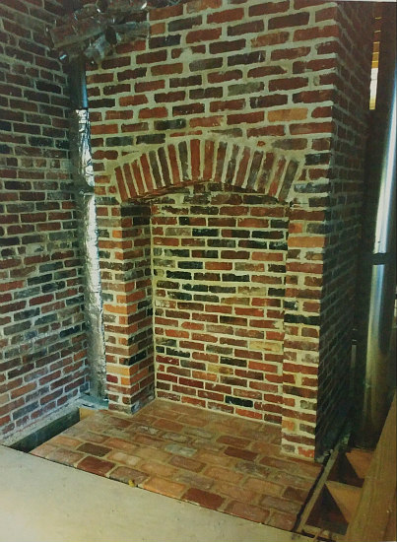

Activity 11

Influential Women who climbed the stairs in Woodson’s home.

Connections to Middle School and High School:

- The struggles that men and women have faced in overcoming political oppression, economic exploitation, religious persecution, and racial injustice.

Common Core State Standards for Reading Informational Text Grade 4
- Refer to details and examples in a text when explaining what the text says explicitly and when drawing inferences from the text.
- Determine the main idea of a text and explain how it is supported by key details; summarize the text.
- Explain events, procedures, ideas, or concepts in a historical, scientific, or technical text, including what happened and why, based on specific information in the text.

Mary McLeod Bethune
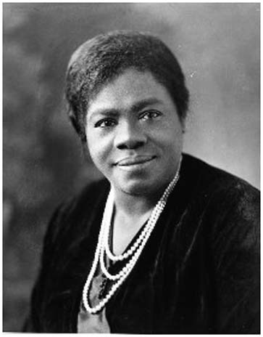
Mary McLeod Bethune had a vision for teachers across the United States that they could access the true history of African Americans in the United States; thus co-founding the Black History Bulletin with Dr. Carter G. Woodson in 1937, which celebrated its 80th year anniversary in 2017. Bethune’s work in the Association for the Study of African American History was key in the movement for racial justice. She was the first female president of ASALH from 1936 to 1951 “and is one of the most outstanding women role models in our history,” (ASALH, 2018).

She also had several noteworthy contributions to humanity. Here are just some of the highlighted outstanding ones:

- Florida Chapter President of the National Association of Colored Women from 1917-1925
- President of the Southeastern Association of Colored Women’s Clubs.
- Founder of the National Council of Negro Women
- First African American female division head of the National Youth Administration, federal agency created under Roosevelt’s Works Progress Administration.
- In 1994, the National Park Service acquired Bethune's last residence, the NACW Council House at 1318 Vermont Avenue. The former headquarters was designated as the Mary McLeod Bethune Council House National Historic Site.

Investigative Report:

Use the internet on your smart phone or device and the panels, pick your favorite contribution of Mary McLeod Bethune’s to humanity, write a 1-3 page investigative report on Mary McLeod Bethune’s contribution or do research on another achievement not included on the list. Be sure to include at least one other scholar who has written about your favorite contribution that Mary McLeod Bethune has accomplished for the entire human race.

Modification and accommodations for children who have special needs: Reduce this requirement to one to three paragraphs or sentences depending on the level of need for the student(s).

Twitter activity
Tweet 280 characters or less about Mary McLeod Bethune’s achievements with the hash tags: #NPS #McLeodBethune

Zora Neale Hurston
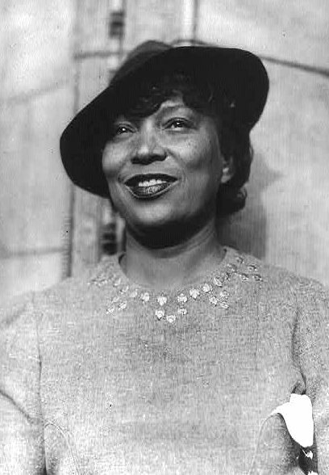
Zora Neale Hurston’s was born in Eastonville Florida, which is the home of the Zora Neale Hurston Museum of Fine Arts. She was one of the women who was influenced by Dr. Carter G. Woodson and climbed his stairs, was a feminist thinker who developed spiritual overtones in her books and essays. Gnostic, religious and existential spiritual themes have proliferated in Zora Neale Hurston’s writings. For example Janie, the main character in Their Eyes Were Watching God often describes divine aspects of the natural world.

Here are some of the novels she published in her lifetime. She also wrote a play called Mule Bone: A Comedy of Negro Life with Langston Hughes (1930).

• Jonah’s Gourd Vine (1934)
• Mules and Men (1935)
• Their Eyes were Watching God (1937)
• Moses, Man on the Mountain (1939)
• Dust Tracks on a Road (1942)
• Seraph on a Suwanee (1948)
• The Sanctified Church (1981)

Investigative Report
Read a chapter from your favorite novel by Zora Neale Hurston. Write a one to three paragraph book report on her novel. Modification for children with learning disabilities: read a passage of one of her books and write one- three sentences about the best part of the book.

Twitter activity
Tweet 280 characters or less about your favorite book by Zora Neale Hurston with the hash tags #NPS #NealeHurston

Books by Carter G. Woodson:

- The Education Of The Negro Prior To 1861: A History of the Education of the Colored People Of The United States From The Beginning of Slavery to the Civil War (New York: Putnam’s, 1915. Repr. Ayer Co., 1968 LC2741.W7).

- A Century Of Negro Migration. (Washington, D.C.: ASNLH., 1918) Repr. Russell, 1969. E185.9.W89).

- The History Of The Negro Church. (Washington, D.C.: Associated Publishers, 1921 BR563.N9W6).

- THE Negro In Our History. (Washington, D.C.: Associated Publishers, 1922. E185.9 .W89 1970).

- FREE Negro Owners Of Slaves In The United States In The United States In 1830: Together With Absentee Ownership Of Slaves In The United States In 1830, ed. (Washington: ASNLH., 1924; Repr. Negro Univ. Press. E185.W8873).

- FREE Negro Heads Of Families In The United States In 1830: Together With Brief Treatment Of The FREE Negro. (Washington: ASNLH., 1925. F185.W887125).

- Negro Orators And Their Orations, ed. (Washington: Associated Publishers, 1926. Repr. Russell, 1969. PS663.N4.W6).

- The Mind Of The Negro As Reflected In Letters Written During The Crisis, 1800-1860, ed. (Washington: ASNLH., 1926. Repr. E185.W8877 1969b).

- Negro Makers Of History. (Washington: Associated Publishers, 1928. E185.W85).

- African Myths Together With Proverbs: A Supplementary Reader Composed Of Folk Tales From Various Parts Of Africa. Adapted to use of children in the public schools. (Washington: Associated Publishers, 1928. PE1127.G4 W7).

- The Negro As A Businessman, joint author with John H. Harmon, Jr. and Arnett G. Lindsay. (Washington: Associated Publishers, 1929. E185.8.H251).

Books by Carter G. Woodson continued…

• The Negro Wage Earner, joint author with Lorenzo J. Greene. (Washington: ASNLH., 1930. Repr. AMS Press. E185.G79).

- The Rural Negro. (Washington: ASNLH., 1930. Repr. Russell, 1969. E185.86.W896).

- THE Mis-education Of The Negro. (Washington: Associated Publishers, 1933. Repr. AMS Press, 1972. LC2801.W6 1977).

- The Negro Professional Man And The Community: With Special Emphasis On The Physician And The Lawyer. (Washington: ASNLH.,1934 Repr. Negro University Press, 1969. Johnson Reprints E185.82.W88).

- THE Story of the Negro Retold. (Washington: Association Publishers, 1935. E185.W898).
- THE African Background Outlined. (Washington: ASNLH., 1936. DT351.W89.

- African Heroes And Heroines. (Washington: Associated Publishers, 1939. DT3525.W66).

Teacher Resources:
- Library of Congress’ Teacher’s Guide: Analyzing Photographs & Prints: http://www.loc.gov/teachers/usingprimarysources/resources/Analyzing_Photographs_and_Prints.pdf.
- Library of Congress’ Teacher’s Guide: Analyzing Primary Sources:
http://www.loc.gov/teachers/usingprimarysources/resources/Analyzing_Primary_Sources.pdf

- Guidebook to African American History in the National Parks http://www.eparks.com/store/product/92424/Guidebook-to-African-American-History-in-the-National-Parks/
- National Curriculum Standards for the Social Studies https://www.socialstudies.org/standards

- District of Columbia Embedded Technology Standards https://osse.dc.gov/sites/default/files/dc/sites/osse/publication/attachments/Embedded_Technology_Standards_into_other_Content_Standards.pdf.

Lauren Hill, “The MisEducation of Lauren Hill,” Lyrics https://genius.com/Lauryn-hill-the-miseducation-of-lauryn-hill-lyrics.

NAACP History: Carter G. Woodson, http://www.naacp.org/oldest-and-boldest/naacp-history-carter-g-woodson/.

Frederick Douglass, Narrative of the Life of Frederick Douglass, an American Slave (New York: Barnes & Noble Books, 2003).

Association for the Study of African American Life and History (ASALH) https://asalh.org.

Notes:

Brittany Omoleye-Hall, “Overview of Dr. Carter G. Woodson: The Carter G. Woodson Home National Historic Site,” Panel 1, National Park Service.
Brittany Omoleye-Hall, “The Journal of Negro History, Negro History Week, and The Negro History Bulletin,” Panel 2, National Park Service.
Brittany Omoleye-Hall, “If These Walls Could Talk: 1538 Ninth Street, N.W. and The People who Assisted in the Creation of the Black History Movement,” Panel 3, National Park Service.
District of Columbia, “Social Studies, PreK through Grade 12 Standards,” accessed August 15, 2017, https://osse.dc.gov/sites/default/files/dc/sites/osse/publication/attachments/DCPS-horiz-soc_studies.pdf, 4.
Ibid., p. 12.
Ibid., p. 13.
Ibid.
National Curriculum Standards for the Social Studies, accessed February 21, 2017, https://www.socialstudies.org/standards/strands.
District of Columbia, “Embedded Technology Standards,” DC Office of the Superintendent, accessed August 15, 2017, https://osse.dc.gov/sites/default/files/dc/sites/osse/publication/attachments/Embedded_Technology_Standards_into_other_Content_Standards.pdf, 9
Ibid.
Ibid., p. 6
Ibid.
Common Core State Standards, “Reading Standards for Informational Text K-5,” accessed August 15, 2017, http://www.corestandards.org/wp-content/uploads/ELA_Standards1.pdf, 14.
Common Core State Standards, “Math Standards Grade 4 Overview,” accessed August 29, 2017, http://www.corestandards.org/wp-content/uploads/Math_Standards1.pdf, 27.
Definitions of vocabulary words were written with the assistance of the Encarta Dictionary: English (North America) available through Microsoft Word.
NAACP History: Carter G. Woodson, accessed August 17, 2017, http://www.naacp.org/oldest-and-boldest/naacp-history-carter-g-woodson/.
Biography, “Frederick Douglass,” accessed August 17, 2017 https://www.biography.com/people/frederick-douglass-9278324.
Frederick Douglass, Narrative of the Life of Frederick Douglass, an American Slave (New York: Barnes & Noble Books, 2003), 63. (Originally published in 1845 by the Anti-Slavery Office.)
Lauren Hill, “The MisEducation of Lauren Hill,” Lyrics, accessed February 22, 2018, https://genius.com/Lauryn-hill-the-miseducation-of-lauryn-hill-lyrics.
Ibid.
District of Columbia, “Social Studies, PreK through Grade 12 Standards,” accessed August 15, 2017, https://osse.dc.gov/sites/default/files/dc/sites/osse/publication/attachments/DCPS-horiz-soc_studies.pdf.
Common Core State Standards, “Reading Standards for Informational Text K-5,” accessed August 15, 2017, http://www.corestandards.org/wp-content/uploads/ELA_Standards1.pdf, 14.
ASALH, Mary McLeod Service Bethune Service Award, accessed February 19, 2018, https://asalh.org/awards/mary-mcleod-bethune-service-award/.
Wikipedia, Mary McLeod Bethune, accessed February 19, 2018, https://en.wikipedia.org/wiki/Mary_McLeod_Bethune.
Sarah Militz-Frielink, “Toward a Liberatory Pedagogy: A Genealogy of Black Feminist Pedagogy,” Black History Bulletin 77, no. 2, (Fall, 2014): 17.

