Carlsbad Caverns National Park
3225 National Parks Highway
Carlsbad, New Mexico 88220
575-785-2232

www.nps.gov/cave
Carlsbad Caverns National Park News Release

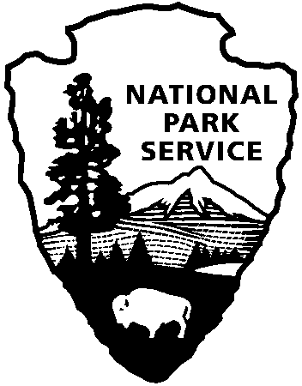
National Park Service
U.S. Department of the Interior

For Immediate Release - August 7, 2017
Contact: Valerie Gohlke - 575-236-1420

Elevator Contract Awarded for Carlsbad Caverns National Park

CARLSBAD, NM – A contract for the complete modernization of the primary elevators at Carlsbad Caverns National Park was awarded to Tutor Perini Corporation, California, for the amount of $4,752,709. The larger primary elevators went out of service in November 2015 when a 6” motor shaft unexpectedly sheared off, leaving the empty elevator car hanging in the hoistway 600 feet down.
The demolition part of the modernization will begin almost immediately, followed by installation of two new motors, elevator cars, sheaves, cables and controllers. This $4-million project is expected to be completed by summer of 2018.

“We are extremely excited to begin this project that will result in a brand new, extremely reliable elevator system at the park,” said Carlsbad Caverns National Park Superintendent Doug Neighbor. “We are eager to serve the visiting public more safely, efficiently and reliably.”

For more information about park hours, tours and programs, visit www.nps.gov/cave or call 575-785-2232.

-www.nps.gov-

About the National Park Service: More than 22,000 National Park Service employees care for America’s 417 national parks and work with communities across the nation to help preserve local history and create close-to-home recreational opportunities. Learn more at www.nps.gov

