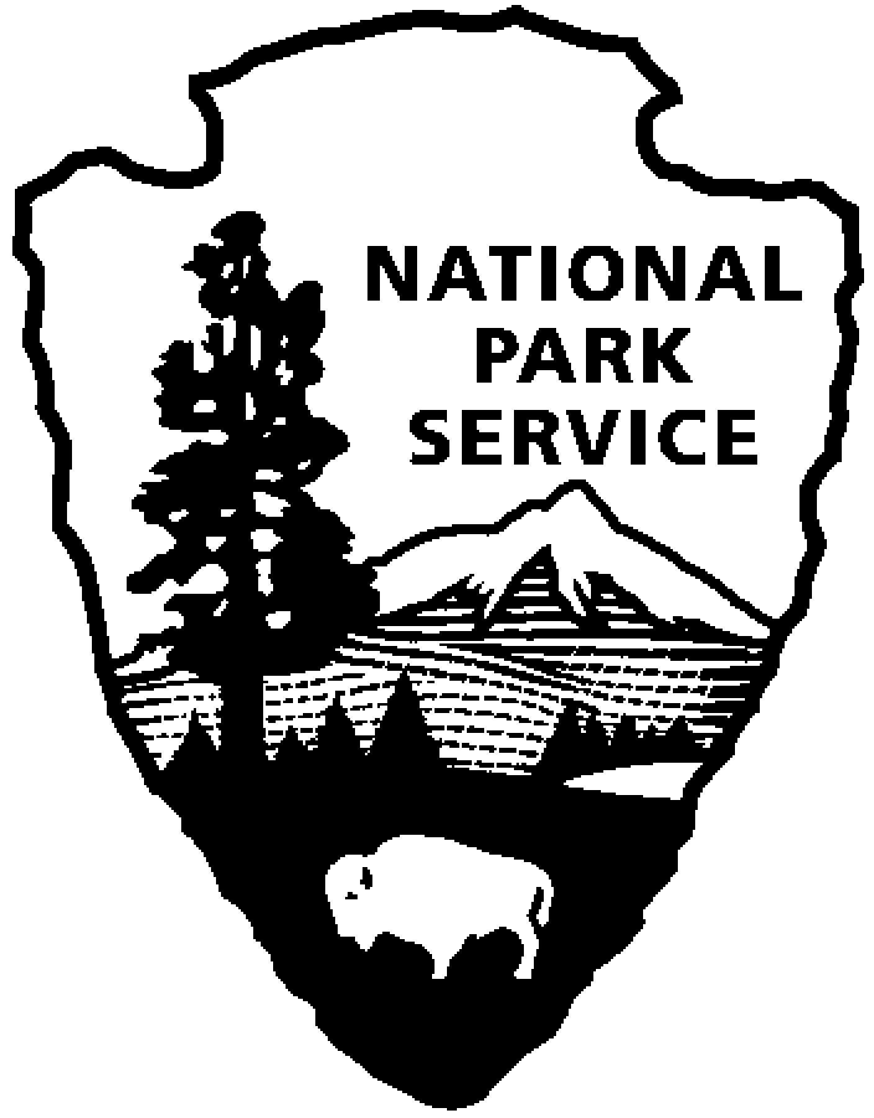 National Park Service  U.S. Department of the Interior |  |  | Catoctin Mountain Park  6602 Foxville Road  Thurmont, MD 21788  (301) 663-9388 phone  (301) 271-2764 fax  www.nps.gov/cato

Catoctin Mountain Park News Release

FOR IMMEDIATE RELEASE: March 7, 2018
Contact: Becky Loncosky (301) 416-0536, Becky_Loncosky@nps.gov

Catoctin Mountain Park announces 2018 Youth Conservation Corps Program

THURMONT, Md. - The National Park Service is pleased to announce that applications are now being accepted for the 2018 Youth Conservation Corps (YCC) program at Catoctin Mountain Park. This is an exciting opportunity for high school students to spend the summer doing meaningful work in a National Park. The YCC program is scheduled to last for eight weeks beginning on June 18, 2018 and ending on August 10, 2018.

The program is open to teens 15 through 18 years of age. All applicants who meet the eligibility requirements listed on the application will be considered. The position will require daily outdoor labor, working in heat, and using a variety of hand tools. The work projects include trail maintenance and construction, exotic plant control and removal, monitoring of rare plant populations, gypsy moth monitoring, painting and rehabilitation projects. Enrollees will be selected through a random drawing. Previous enrollees may only be considered in the event that an insufficient number of new applications are received. The rate of pay will be $9.25 per hour and increase to $10.10 per hour after July 1, 2018, to match the state minimum wage in Maryland.

Applications may be obtained at the Catoctin Mountain Park Visitor Center at 14707 Park Central Road, Thurmont, MD 21788, or by contacting Becky Loncosky at Becky_Loncosky@nps.gov.

Completed applications may be emailed to Becky_Loncosky@nps.gov or mailed to Becky Loncosky, Catoctin Mountain Park, 6602 Foxville Road, Thurmont, MD 21788. The deadline to apply is April 15, 2018. If you have questions concerning this program, please contact Ms. Loncosky by email or at (301) 416-0536M.

-NPS-

Catoctin Mountain Park is one of 417 national parks cared for by the National Park Service, U.S. Department of the Interior. Correspondence should be addressed to: Superintendent, Catoctin Mountain Park, 6602 Foxville Road, Thurmont, MD 21788. General information can be obtained through the park website at www.nps.gov or by calling the Visitor Center at (301) 663-9388.

EXPERIENCE YOUR AMERICA™
The National Park Service cares for special places saved by the American people so that all may experience our heritage.

