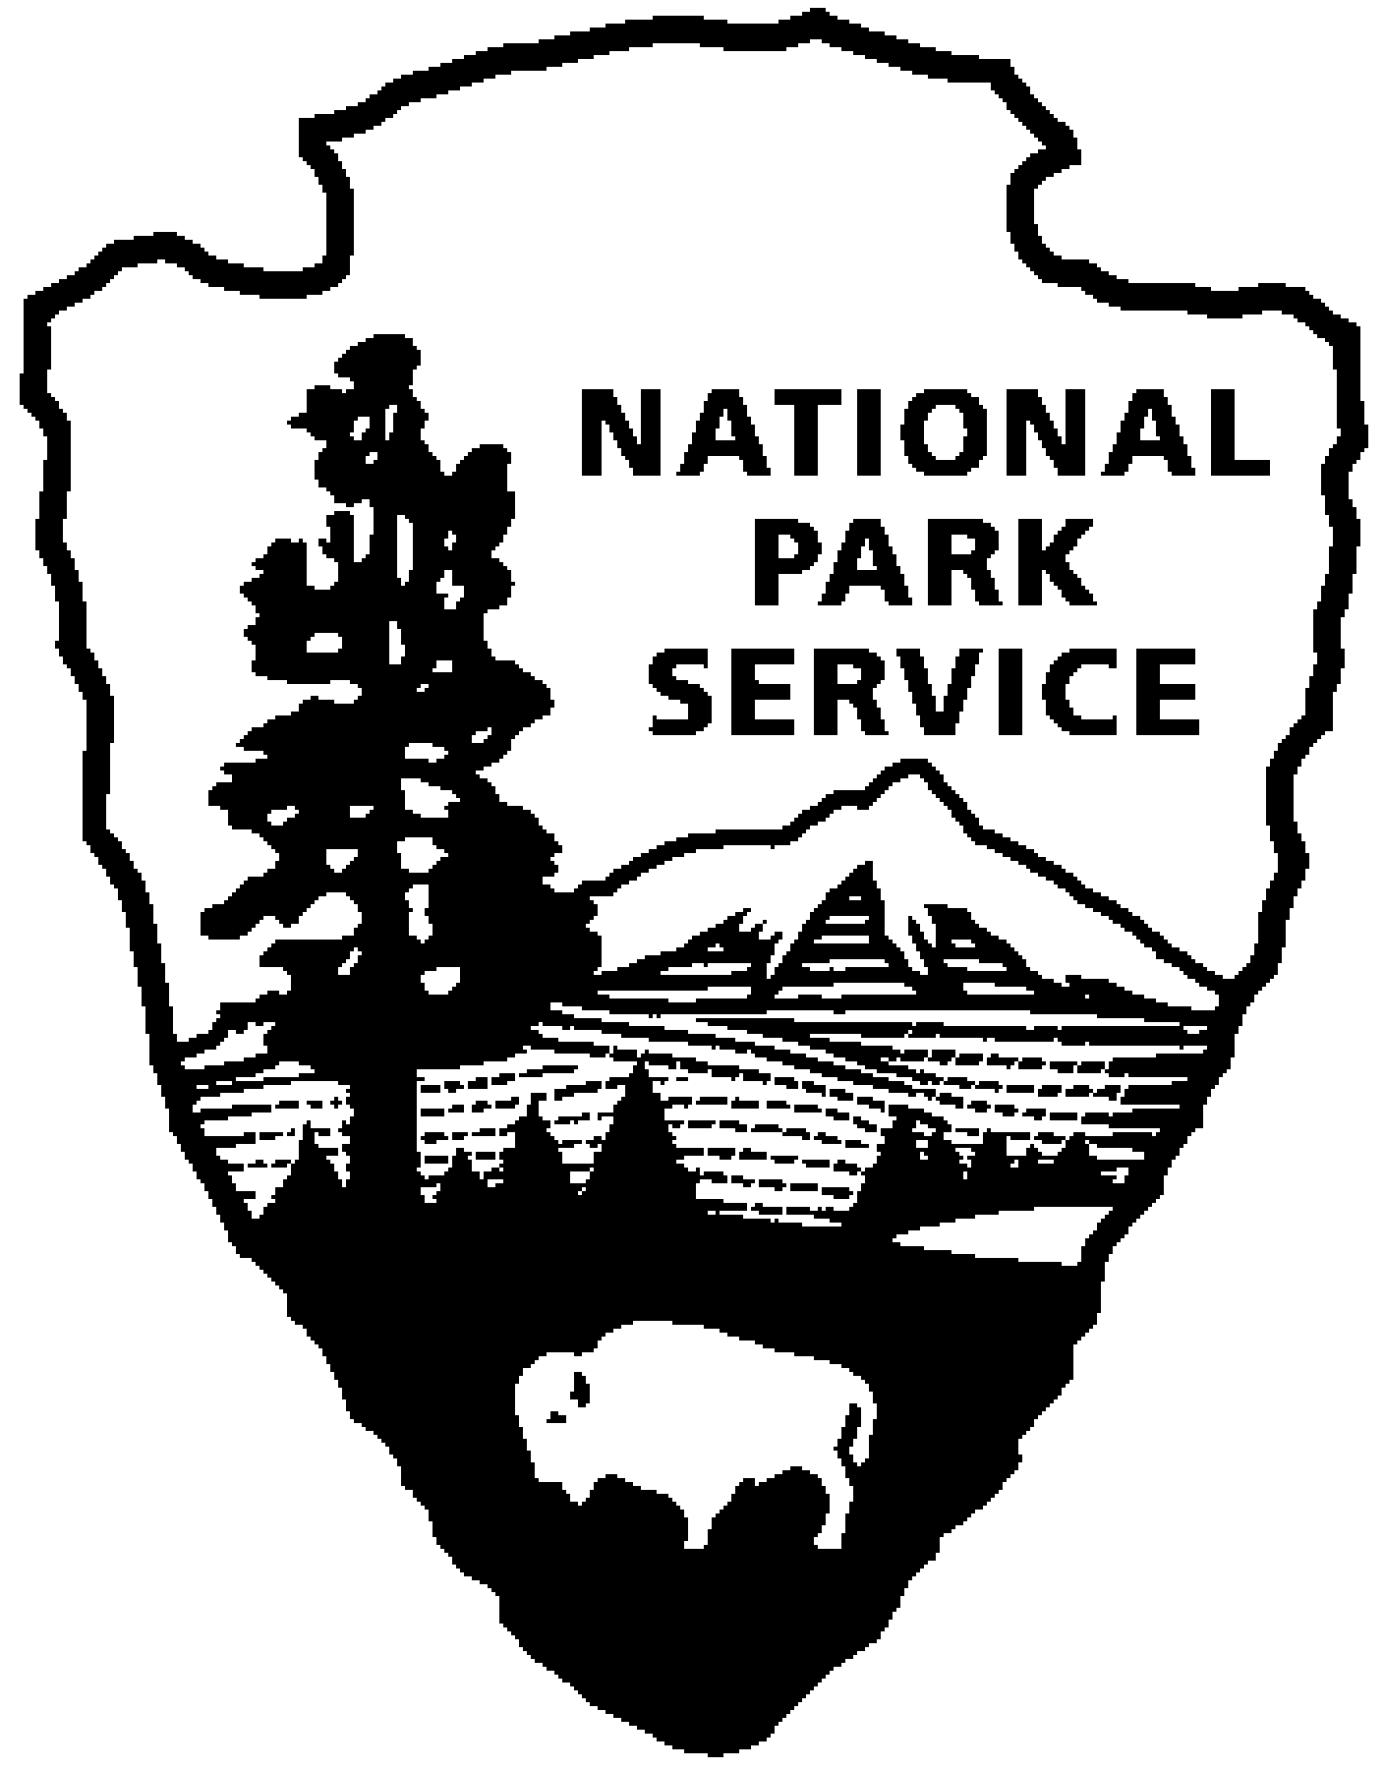  National Park Service  U.S. Department of the Interior | Catoctin Mountain Park |  | 6602 Foxville Road  Thurmont, MD 21788  (301) 663-9388 phone  (301) 271-2764 fax

Catoctin Mountain Park News Release

June 23, 2014
For Immediate Release
Debra Mills

Catoctin Mountain Park Ranger Lindsey Donaldson Wins Regional Director’s Award for Natural Resource Management

Catoctin Mountain Park Biologist Lindsey Donaldson has received the National Capital Region’s Director’s Award for Natural Resource Management. The Director’s Award is presented to an individual who goes above and beyond in performance of their duty as a Natural Resource Manager. Honorees are nominated by their peers in the National Park Service.

Ms. Donaldson has made significant contributions to natural resource management at Catoctin Mountain Park. She has worked on protecting brook trout populations from threats imposed by climate change, land use and invasives in addition to her work leading the park’s white-tail deer management program. In 2013, she helped establish a partnership with neighboring Cunningham Falls State Park and the Maryland Department of Natural Resources to address riparian degradation caused by vegetation loss and to improve brook trout habitat. Lindsey led a team of volunteers to plant and protect hemlock trees from the non-native pest, hemlock wooly adelgids, in the headwaters of Big Hunting Creek. She has led efforts to obtain critical baseline temperature and water quality data in park streams since 2011.

Lindsey Donaldson is an emerging leader in the community of natural resource managers in the National Capital Region, National Park Service. Lindsey served as Secretary of the NCR Natural Resource Advisory Team (NCR NAT) from 2010-2011. She effectively managed communications and supported the NAT Chair during his interactions with the Office of the Regional Director and other regional advisory teams.

Lindsey began working for the NPS as part of the Youth Conservation Corps at the Antietam National Battlefield in Sharpsburg, MD in 1998 while still a high school student. She worked at Antietam as a seasonal employee while attending college, receiving a Bachelor's degree in Environmental Studies from Shepherd University and a Master's degree in Forest Resource Management and Watershed Stewardship from Penn State University. She began her tour of duty at Catoctin Mountain Park in November, 2009.

Catoctin Mountain Park is one of over 400 units administered by the National Park Service, U.S. Department of the Interior. The park Visitor Center, located on State Route 77 three miles west of Thurmont, Maryland, is open daily from 9:30 a.m. until 5:00 p.m., and until 7:00 p.m. on Fridays and Saturdays. Correspondence should be addressed to: Superintendent, Catoctin Mountain Park, 6602 Foxville Road, Thurmont, MD 21788. Our website address is www.nps.gov/cato. General information can be obtained by calling the Visitor Center at (301) 663-9388.

EXPERIENCE YOUR AMERICA™
The National Park Service cares for special places saved by the American people so that all may experience our heritage.

