Catoctin Mountain Park
6602 Foxville Road
Thurmont, MD 21788

(301) 663-9330 phone
(301) 271-2764 fax
www.nps.gov/cato
Catoctin Mountain Park News Release

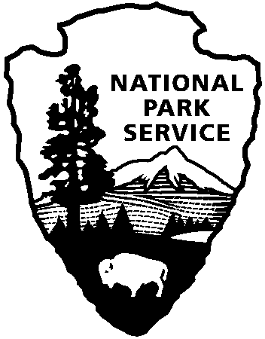
National Park Service
U.S. Department of the Interior

FOR IMMEDIATE RELEASE: November 29, 2017
Contact: Peggie Gaul, 301-663-9388, peggie_gaul@nps.gov

Catoctin Mountain Park Visitor Center to close December 11-13, 2017

THURMONT, Md. – Catoctin Mountain Park Visitor Center will be temporarily closed December 11-13, 2017 while the National Park Service replaces insulation in public areas of the building. The building will be thoroughly cleaned before it reopens at 9 a.m. Thursday, December 14. This work was originally scheduled to take place in November but could not be completed at that time.
During the closure, public restrooms and a contact station will be available at park headquarters. The headquarters phone number is 301-663-9330, and the street address is 6602 Foxville Road, Thurmont MD 21788. Public restrooms are also available at the Hog Rock Parking Area if Park Central Road is open for traffic. Trail maps will be available at trailheads throughout the park and at park headquarters.
For additional information please contact the visitor center at 301-663-9388.
—NPS—

About the National Park Service. More than 20,000 National Park Service employees care for America's 417 national parks and work with communities across the nation to help preserve local history and create close-to-home recreational opportunities. Visit us at www.nps.gov, on Facebook www.facebook.com/nationalparkservice, Twitter www.twitter.com/natlparkservice, and YouTube www.youtube.com/nationalparkservice.

