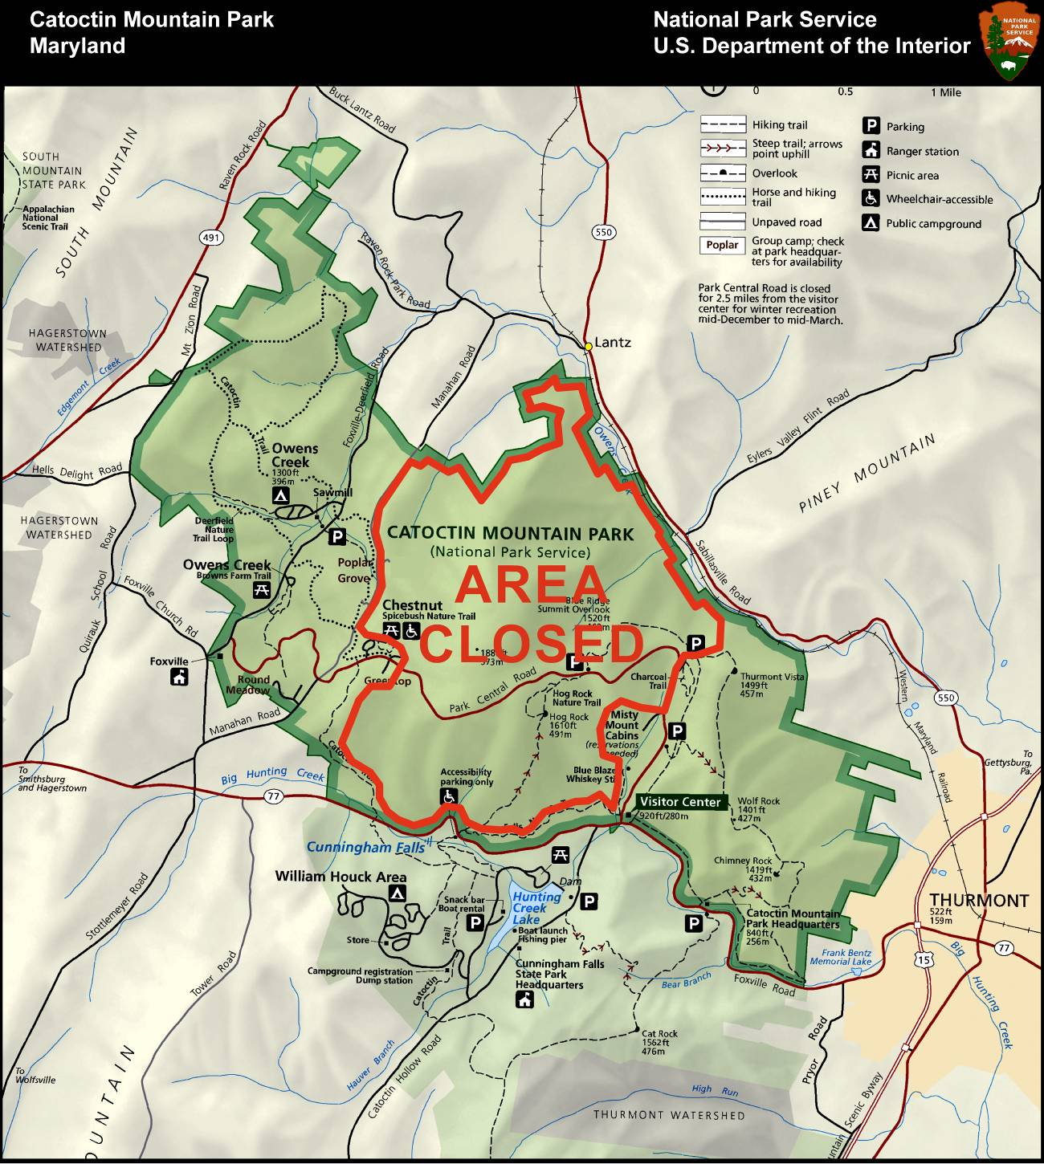
AREA  CLOSED | Saturday, May 2, 2015 at approximately 8:00 AM  Through  Sunday, May 3 at approximately 2:30 PM | APPROVED:  DATE: 4-30-15

