Catoctin Mountain Park
6602 Foxville Road
Thurmont, MD 21788

(301) 663-9330 phone
(301) 271-2764 fax
www.nps.gov/cato
Catoctin Mountain Park News Release

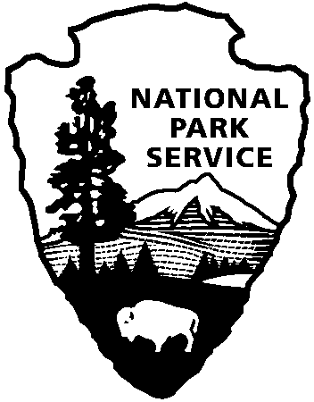
National Park Service
U.S. Department of the Interior

FOR IMMEDIATE RELEASE: September 29, 2016
Becky Loncosky, 301-416-0536, becky_loncosky@nps.gov

Catoctin Mountain Park to Remove Hazardous Trees From Park
THURMONT, Md. – Catoctin Mountain Park has contracted with Excel Tree Experts from Jessup, MD to remove and/or trim approximately 300 hazardous trees throughout the park. The first stage of operations will focus on hazardous trees along roadways, and then removal will begin in the camp areas. The tree work will continue intermittently through December and may result in periodic lane closures along Park roads and periodic closures of parking lots. As work is being completed near roadways, flagmen will direct traffic around the operations.
A hazardous tree is one that has the potential to threaten people or resources. Trees along the trails will remain the responsibility of park staff and volunteers. If visitors see a tree that may be a hazard to others, they are encouraged to report it at the visitor center at 301-663-9388.

—NPS—

Catoctin Mountain Park is one of 413 national parks cared for by the National Park Service, U.S. Department of the Interior. Correspondence should be addressed to: cato_superintendent@nps.gov or you can write to Superintendent, Catoctin Mountain Park, 6602 Foxville Road, Thurmont, MD 21788. General information is available by visitng our website at www.nps.gov/cato, by visiting the Visitor Center at 14707 Park Central Road, Thurmont, MD 21788 (open 9-5 daily), or by calling us at (301) 663-9388.

