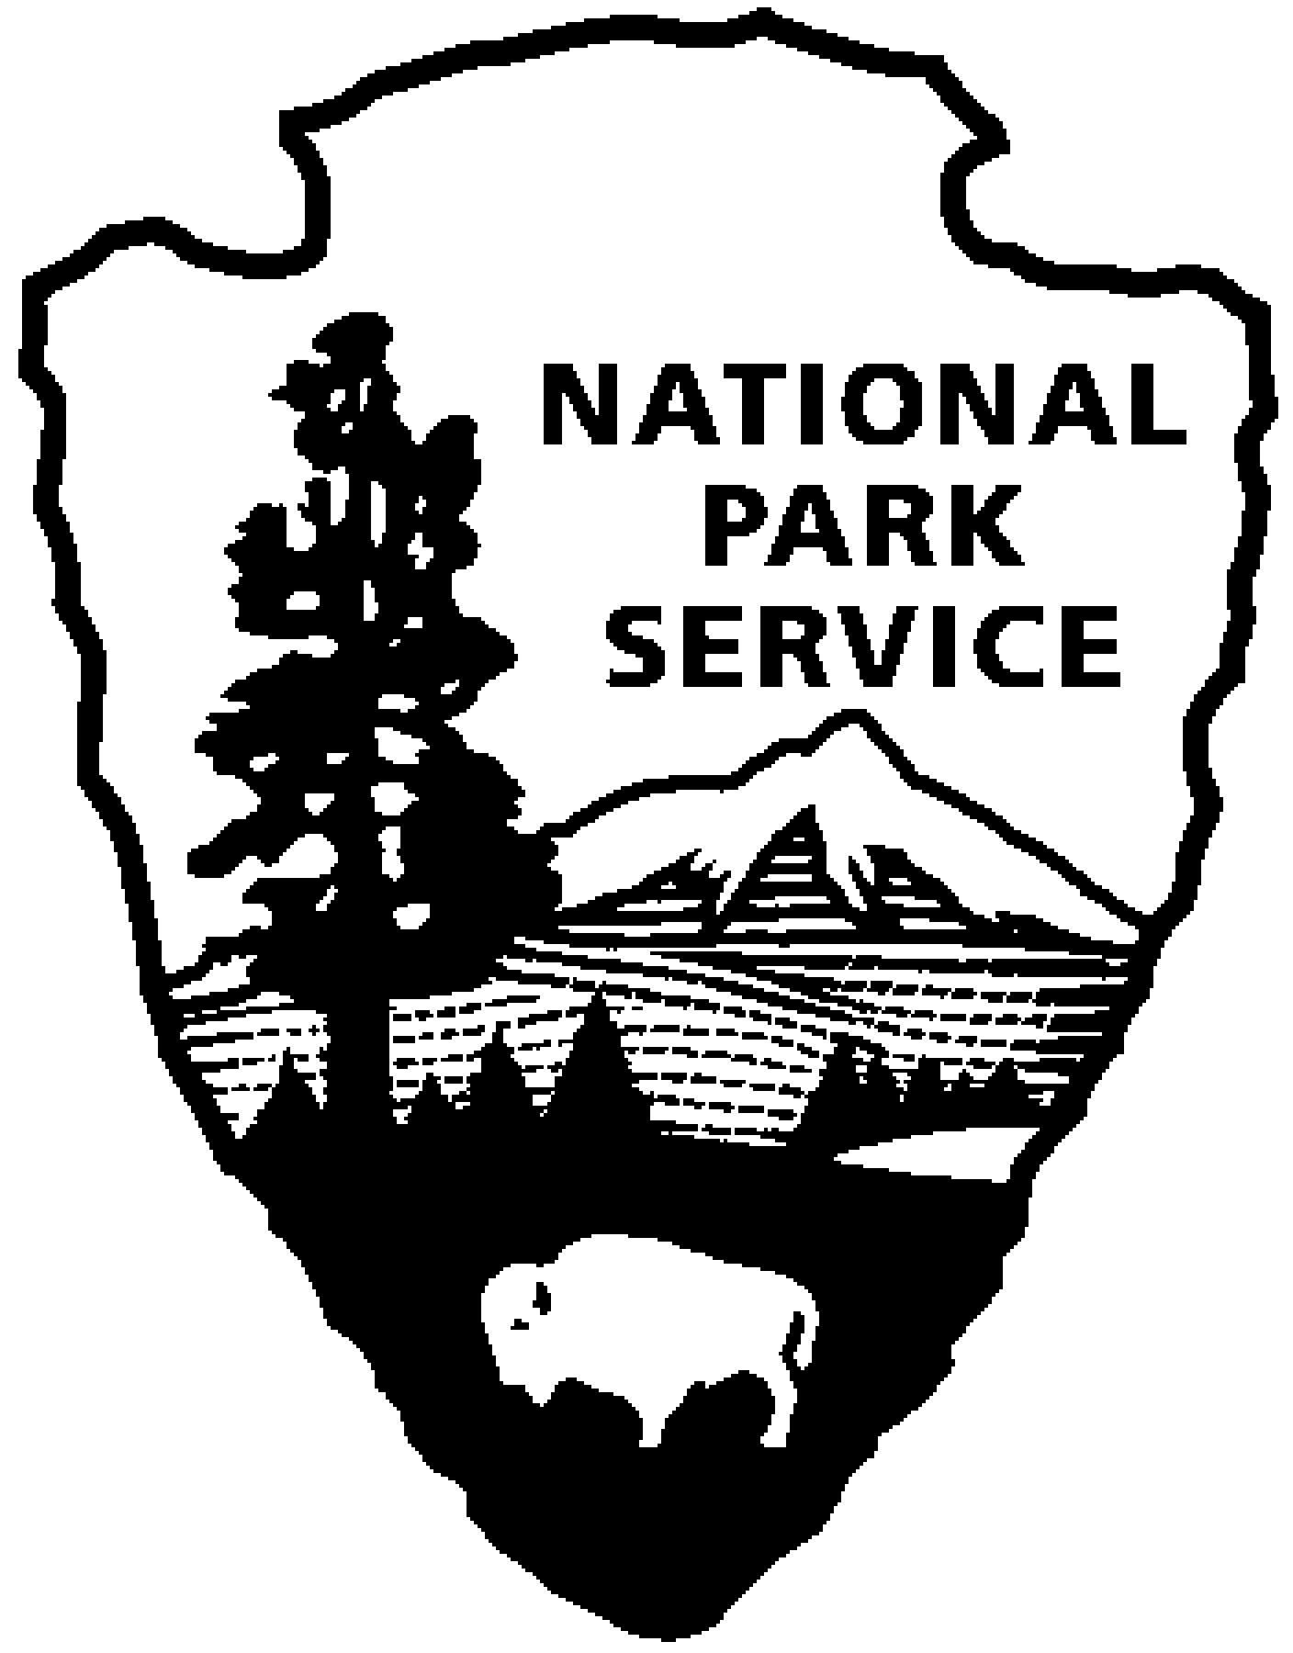National Park Service  U.S. Department of the Interior | Catoctin Mountain Park |  | 6602 Foxville Road  Thurmont, MD 21788  (301) 663-9388 phone  (301) 271-2764 fax

Catoctin Mountain Park News Release

July 1, 2014
For Immediate Release
Debra Mills

Catoctin Mountain Park Volunteer Jim Robbins Receives National Award for Volunteerism
H. H. “Jim” Robbins from Catoctin Mountain Park was honored with the George and Helen Hartzog Individual Volunteer Award for the National Park Service. Jim has been a driving force in reaching new audiences and forming partnerships that have expanded the park’s youth service and educational programs. Last year, Jim personally contributed more than 500 volunteer hours to Catoctin. He was also directly responsible for an additional 2,000 hours donated by church, school, and civic groups he recruited to help in the park.
The Hartzog Awards were presented at a ceremony in Washington, DC, hosted by the National Park Foundation on Wednesday, June 25 at the Mayflower Hotel. During their 3 day stay in the Nation’s Capital, Jim and his wife, Pam, were treated to a tour of the White House and National Park Service sites including the Lincoln Memorial, the Jefferson Memorial, and the National Mall. Mr. and Mrs. Robbins and Park Superintendent Mel Poole also met with Congressman Chris Van Hollen, Representative for Maryland’s Eighth District on Thursday, June 26 and visited the U.S. Capitol.

“Jim Robbins is an extremely dedicated volunteer who works tirelessly to get children, particularly those at risk, active in the outdoors,” said Catoctin Mountain Park Superintendent Mel Poole. “It is completely fitting that Jim’s passion to serve others was recognized with the highest NPS volunteer award. The park staff, the Catoctin Forest Alliance, and the multitudes of young people, whose lives have been made better through his programs, send their thanks and congratulations.”

The Hartzog Awards are named for former National Park Service Director George B. Hartzog, Jr. who started the Volunteers-In-Parks (VIP) Program in 1970 with 300 participants. Last year, more than 246,000 volunteers donated 6.7 million hours of time and talent to help preserve and protect national parks. Photos and additional information about the Hartzog Awards are available at: http://www.nps.gov/aboutus/hartzog-awards.htm.

Catoctin Mountain Park is one of over 400 units administered by the National Park Service, U.S. Department of the Interior. The park Visitor Center, located on State Route 77 three miles west of Thurmont, Maryland, is open daily from 9:30 a.m. until 5:00 p.m., and until 7:00 p.m. on Fridays and Saturdays. Correspondence should be addressed to: Superintendent, Catoctin Mountain Park, 6602 Foxville Road, Thurmont, MD 21788. Our website address is www.nps.gov/cato. General information can be obtained by calling the Visitor Center at (301) 663-9388.

-NPS-

EXPERIENCE YOUR AMERICA™
The National Park Service cares for special places saved by the American people so that all may experience our heritage.

