Final report

Forecasting stream habitat and Brook Trout responses to climate change in Catoctin Mountain Park
Nathaniel P. Hitt1,2 Craig D. Snyder1 Erin L. Snook1
Zachary C. Johnson1,3 Matthew J. Morgan1
1US Geological Survey Leetown Science Center
11649 Leetown Road, Kearneysville, WV 25430

2nhitt@usgs.gov
304-724-4463

3Current address:
U.S. Environmental Protection Agency
National Health and Environmental Effects Research Laboratory, Western Ecology Division, 200 SW 35th Street, Corvallis, OR 97333

Prepared for: National Park Service Catoctin Mountain Park
14707 Park Central Road, Thurmont, MD 21788 14 December 2017

Table of contents

Summary.....……………………………………………………..…………………... | 3
Introduction…………………………………………………………………………. | 6
Methods……………………………………………………………………………... | 8
Results………………………………………………………………………………. | 11
Discussion…………………………………………………………………………… | 16
Literature cited………………………………………………………………………. | 19
List of Tables and Figures…………………………………………………………... | 23
Appendix A…………………………………………………………………………. | 39
Appendix B………………………………………………………………………….. | 40

Summary

Anticipating and mitigating the effects of climate change is a fundamental challenge for natural resource conservation. In this report, we respond to research needs identified by Catoctin Mountain Park (CATO) for native Brook Trout (Salvelinus fontinalis) conservation and management as part of the US Geological Survey (USGS) Natural Resources Preservation Program in FY15-16. We addressed three overarching research questions: (1) How will anticipated changes in air temperature affect stream habitats? (2) How will changes to stream habitat affect the distribution of Brook Trout? (3) Which stream segments are most and least vulnerable to the effects of climate change?
First, we surveyed Brook Trout abundance and fish community composition using electrofishing techniques within three watersheds: Owens Creek, upper Big Hunting Creek, and Blue Blazes Creek (a tributary to Big Hunting Creek). Second, we deployed a network of stream temperature gages to assess spatial variation in stream temperature and groundwater (GW) influence. Third, we used modeling techniques to forecast future stream temperatures that account for GW influences and air temperature scenarios.
Fish sampling detected 13 species and 15,345 individual fish, the majority of which were Blacknose Dace (60%), Blue Ridge Sculpin (26%), and Brook Trout (6%). Brook Trout were not observed in Blue Blazes Creek and exhibited higher densities in Owens Creek than upper Big Hunting Creek (average densities = 19 fish/100 m and 4 fish/100 m, respectively). In contrast, Brown Trout were present in Blue Blazes Creek and exhibited greater density in Blue Blazes Creek than either Owens Creek or upper Big Hunting Creek (average densities = 3.0 fish/100 m,
  - fish/100 m, and 1.7 fish/100 m, respectively). Brown Trout occurred in sympatry with Brook

Trout in Owens Creek and upper Big Hunting Creek, but appeared to have replaced Brook Trout in Blue Blazes Creek. Our fish surveys also revealed important locations for Brook Trout reproduction and young-of-year (YOY) dispersal within the Owens Creek watershed.
Our study also revealed surprising differences in the distribution of Blue Ridge Sculpin among CATO streams. This species was abundant in Owens Creek (average density = 83 fish/100 m) but was less common in Blue Blazes Creek (average density = 12 fish/100 m) and was not detected in upper Big Hunting Creek. Histological examination of several specimens from Blue Blazes Creek by V. Blazer at the USGS Leetown Science Center revealed the presence of a novel parasite (Dermosystidium sp.) which has been linked to fish population declines elsewhere (Blazer et al. 2016). The parasite was not detected in Blue Ridge Sculpin samples from Owens Creek, and all trout appeared to be uninfected. Our survey results suggest that Blue Ridge Sculpin have been extirpated from upper Big Hunting Creek and have not recolonized from downstream source populations due to the fish passage barrier of Cunningham Falls. We recommend additional research to (1) evaluate the feasibility of reintroducing Blue Ridge Sculpin into upper Big Hunting Creek and (2) continue monitoring the distribution and potential spread of Dermocystidium in downstream waters.
Stream temperatures ranged from 9.6 – 27.6 ºC during baseflow conditions in 2015 and 2016. Sites within upper Big Hunting Creek were consistently warmer than in Owens Creek or Blue Blazes Creek, suggesting an effect of headwater ponds outside CATO on upper Big Hunting Creek temperatures. For instance, in 2016 the maximum observed temperature in upper Big Hunting Creek was 27.6 ºC whereas Owens Creek reached a maximum of 23.7 ºC that year. Stream temperature data also revealed that 2016 was warmer than 2015 throughout the study area but did not exceed thermal tolerance limits for Brook Trout in either year.

We estimated the influence of GW on stream temperatures using a statistical modeling approach based on the relationship between daily mean air temperature and stream temperature over time. Results indicated that effects of GW were generally stronger in the Owens Creek watershed than in Blue Blazes or upper Big Hunting Creek. However, we detected substantial spatial variation in GW influence among Owens Creek sites, with stream temperatures at some locations showing relatively little GW influence and others showing very strong influences (and correspondingly small influence of daily mean air temperatures). Although incoming lateral seeps were detected in upper Big Hunting Creek (D. Ferrier, Hood College, personal communication), the strongest effects of GW in the study area were due to GW upwelling within portions of the Owens Creek watershed (i.e., Tributary C in Figure 4) where we also observed high numbers of Brook Trout juveniles. Our results therefore identified potential high-priority areas for Brook Trout conservation in CATO.
Finally, we modeled future stream temperatures based on scenarios characterizing GW sensitivity to air temperature and future air temperature increases. Stream temperature forecasts revealed important differences in habitat suitability for Brook Trout within and among watersheds. Big Hunting Creek sites were generally more sensitive to air temperature increases than sites in Owens Creek or Blue Blazes Creek. For instance, an increase in mean annual air temperature of 1.5 ºC (lowest level evaluated) exceeded thermal thresholds for Brook Trout in the majority of sites within that watershed, regardless of GW influence levels. In contrast, an air temperature increase of 1.5 ºC did not exceed thermal thresholds for Brook Trout in Owens Creek. However, modeled air temperature increases of 5 ºC resulted in a loss of Brook Trout thermal suitability throughout the study area. Model results revealed spatially patchy responses

to air temperature increases that could provide an early-warning system for trout monitoring designs in CATO.

Introduction

Anticipating and mitigating the effects of climate change is a fundamental challenge for natural resource conservation. In this report, we respond to the research needs identified by the National Park Service (NPS) in Catoctin Mountain Park (CATO) for coldwater stream conservation in the context of climate change. Native Brook Trout (Salvelinus fontinalis) were identified as a high priority for research in the Natural Resources Preservation Program due to their natural and cultural importance and dependence on coldwater habitats which are threatened by climate change. Here we address three overarching research questions: (1) How will anticipated changes in air temperature affect stream habitats? (2) How will changes to stream habitat affect the distribution of Brook Trout? (3) Which stream segments are most and least vulnerable to the effects of climate change?
Climate models for the northeastern U.S. project increasing air temperatures, decreasing snowpack, and altered rainfall timing and magnitude (Hostetler et al. 2011; Rawlins et al. 2012; Kunkel et al. 2013). Several rivers in this region show significant warming trends over the last several decades (Kaushal et al. 2010), suggesting that air temperature increases may have already begun to influence freshwater fish populations. However, broad-scale predictions for Brook Trout remain highly uncertain because current inferences are mainly based on extrapolations from temperature and flow data collected from large river systems rather than the smaller streams that Brook Trout inhabit. For instance, several prior studies have assumed that Brook

Trout habitats will be highly sensitive to air temperature increases (e.g., Meisner 1990a, 1990b; Flebbe et al. 2006), as typically observed in rivers. However, small streams may be much less sensitive to atmospheric warming than rivers due to the influence of groundwater (GW) and microclimatic conditions in headwater areas (Kelleher et al. 2012; Kanno et al. 2013).
Our prior research in Shenandoah National Park demonstrates that brook trout streams may exhibit a wide range of thermal sensitivities and are often much less sensitive to atmospheric warming than observed in river ecosystems (Snyder et al. 2015). This finding has two significant implications for predicting effects of climate change on Brook Trout habitat in CATO. First, prior estimates of Brook Trout habitat loss may be overly pessimistic because they generally overestimate the sensitivity of headwater streams to atmospheric warming. Second, prior studies have failed to recognize that Brook Trout habitat loss is likely to be spatially patchy, resulting in fragmentation of habitat within stream networks. Such thermal fragmentation has been important in assessing climate change effects for other inland salmonid fishes (Rahel et al. 1996; Roberts et al. 2013). A spatially-explicit perspective of climate change is particularly important given the importance of fragmentation for Brook Trout extirpation probabilities (Letcher et al. 2007).

Study area

Catoctin Mountain Park encompasses approximately 21 km2 of forested watersheds within the northern Blue Ridge physiographic region of central Maryland (USA) (Figure 1). Prior research suggests that increasing stream temperatures will affect future Brook Trout habitat in CATO (Fredrickson 2012), but the prior research was limited by few sampling locations and a lack of consideration of groundwater-surface water interactions which can drive stream

temperature responses to atmospheric changes (Snyder et al. 2015; Johnson et al. 2017). Prior fish population and community data have been collected in CATO streams by NPS and Maryland Department of Natural Resources (MD-DNR) personnel. Brook Trout abundances in CATO appear to be decreasing over time (J. Mullican, MD-DNR, personal communication), motivating the need for the current study and associated conservation planning.

Methods

Fish community assessment

We used standard backpack electrofishing techniques to sample fish communities in 64 spatially continuous stream reaches in the study area during July 2015 (Figure 1). We sampled 46 reaches in the Owens Creek watershed and 18 total reaches were sampled in the Big Hunting Creek watershed; 6 on the main stem and 12 on Blue Blazes tributary. Each reach was approximately 100 m long and was block-netted at the upstream and downstream ends to restrict fish movement during sampling. Sample reaches were spatially continuous in the Owens Creek watershed. In the Big Hunting Creek watershed, sample reaches were spatially continuous within Blue Blazes Creek and above the “blowdown” section upstream from Cunningham Falls (i.e., section of stream influenced by a tornado in 2004; see Figure 1). We did not sample fishes within the MD-DNR sampling area downstream of the blowdown section in upper Big Hunting Creek (“hemlock bridge” site) to avoid influencing MD-DNR trend data. We refer to “upper” Big Hunting Creek as the section upstream from Cunningham Falls.
Fish sampling was conducted during baseflow conditions (i.e., avoiding storm events).

We used a Smith-Root LR-45 backpack electrofisher (typically set to 300V, 60Hz, and 20% duty

cycle) and dipnets to collect stunned fish. All fish were identified to species and tallied. Length and weight data were collected for individual trout specimens. Following sampling, fish were released into the sampling reach (with some exceptions for sculpin Dermocystidium sampling in Blue Blazes Creek). We followed approved Institutional Animal Care and Use protocols for this study (LSC Study Plan # 14-004), and we did not observe fish mortalities as a result of electrofishing.

Stream temperature and groundwater assessment

We deployed 64 ONSET ProV2 water temperature gages in Owens Creek (n=36), upper Big Hunting Creek (n=21), and Blue Blazes Creek (n=7) to collect data at stations located approximately 200 m apart (Figure 2) during summer months of 2015 and 2016. Prior research has demonstrated the necessity of stream temperature data at this spatial scale for forecasting stream thermal responses to climate change in Appalachia (Snyder et al. 2015; Johnson et al.
2017). We programmed gages to collect temperature data every 30 minutes during the sampling period. Gages were placed in drilled PVC cases and anchored to the substrate with rebar. We also used the same type of gage to collect air temperature data at a subset of sites (n=6). We calibrated all gages prior to deployment in a water bath of known temperature. Gages were removed after the study completed.
We used the stream temperature data in three ways. First, we defined current thermal habitat suitability for Brook Trout based on the maximum weekly average temperature (MWAT), which has been shown to limit Brook Trout occurrence above 23.3 ºC (Wehrly et al. 2007). Second, we modeled the effects of shallow GW on stream temperature following our prior research in Shenandoah National Park (See equation 2 in Snyder et al. 2015). These site-specific

models use parameters derived from air-water temperature regression models to estimate GW influence. Specifically, GW influence is estimated as the amount of variation in daily mean water temperature that is explained by accumulated degree-days, an air temperature parameter that describes the incremental heating over summer baseflow periods as observed in GW-dominated streams (Snyder et al. 2015). We estimated daily mean air temperatures for all water temperature sites using a multiple regression model that used the grand mean daily air temperature from measured sites for each day, and site elevation as predictor variables. Prior to GW modeling, we removed short-term spikes from air temperature gages associated with direct solar incidence. We also removed two water temperature sites (BA03 and BA04; Figure 2) that apparently dried during summer months. R code for GW modeling is presented in Appendix A.
Third, we forecasted future thermal habitat conditions for Brook Trout based on 9 scenarios combining levels of mean annual air temperature increase (1.5, 3, and 5 ºC) and GW sensitivity to air temperature change (0.5, 0.75, 1.0). We used 2016 as a baseline for evaluating future air temperature increases following methods in Snyder et al. (2015). This approach applies future mean annual air temperature increases possible over the next 50-100 years in the United States as derived from multiple general circulation models and emission scenarios (Hostetler et al. 2011; Rawlins et al. 2012). Our approach also integrates uncertainty in GW warming and thermal buffering by simulating GW sensitivity to air temperature across empirically observed levels (Kurylyk et al. 2013, 2014). The thermal sensitivity of GW to air temperature is controlled in part by the depth-to-bedrock underlying the stream (Briggs et al. in press) which is unknown in CATO, and therefore our simulations include a reasonable range of possible values for this parameter (Kurylyk et al. 2013, 2014).

Results

Fish community composition

We observed 13 fish species in CATO and detected substantial differences between fish communities in Owens Creek and upper Big Hunting Creek (Tables 1 and 2; Appendix B). Fish species richness in the Owens Creek watershed averaged 6 species/100 m (SD = 2.5) with the greatest richness of 10 species/100 m observed at several sites along the mainstem (Figure 3). In contrast, fish species richness within upper Big Hunting Creek ranged from 3-7 species/100 m and richness in Blue Blazes Creek ranged from 1-5 species/100 m. Downstream increases in fish species were observed in Owens Creek and Blue Blazes Creek (Figure 3).
Within the Owens Creek watershed, the most common fish species were Blacknose Dace (Rhinichthys atratulus; present in 100% of sites, mean abundance = 124 fish/100 m), Blue Ridge Sculpin (Cottus caeruleomentum; present in 93% of sites, mean abundance = 83 fish/100 m), and Brook Trout (Salvelinus fontinalis; present in 85% of sites, mean abundance = 19 fish/100 m) (Tables 1 and 2). Potomac Sculpin (Cottus girardi) were also observed in downstream locations within Owens Creek and co-occurred in sites with Blue Ridge Sculpin but were much less abundant (Table 2). In addition, Rosyside Dace (Clinostomus funduloides), White Sucker (Catostomus commersoni), Creek Chub (Semotilus atromaculatus), Fantail Darter (Etheostoma flabellare), Longnose Dace (Rhinichthys cataractae) and Brown Trout (Salmo trutta) were present in the Owens Creek watershed at low abundances (i.e., average abundance < 7 fish/100 m; Table 2). Observed species abundances are mapped in Appendix B (Figures B1-B11).
We observed 7 fish species in upper Big Hunting Creek and 5 fish species in Blue Blazes Creek (Tables 1 and 2). Blacknose Dace was the most abundant species in upper Big Hunting

Creek and Blue Blazes Creek with an average of 321 and 133 fish/100 m, respectively (Table 2). We also detected 2 sunfish species in upper Big Hunting Creek (Largemouth Bass, Micropterus salmoides; Bluegill, Lepomis macrochirus) which were not observed elsewhere in CATO and are not typical of headwater streams. When observed in streams, these sunfish species are typically linked to headwater pond sources as is the case in upper Big Hunting Creek upstream from the CATO boundary.
Surprisingly, Blue Ridge Sculpin was not detected in upper Big Hunting Creek despite prior records of this species occurring upstream of Cunningham Falls (J. Mullican, MD-DNR, personal communication) and the presence of apparently suitable physical habitat conditions. Moreover, sculpin densities in Blue Blazes Creek were substantially lower than in Owens Creek (83 vs. 12 fish/100 m, respectively; Table 2). We found several Blue Ridge Sculpin from Blue Blazes Creek to be infected with the parasite Dermocystidium sp. which is known to cause fish mortality in other geographic regions but previously unreported in the eastern U.S. (Blazer et al. 2016). Follow-up research by USGS revealed the presence of Dermocystidium infection in Blue Ridge Sculpin downstream from CATO in Big Hunting Creek downstream from Cunningham Falls, but not in sculpin samples from Owens Creek (V. Blazer, USGS, personal communication). We found no evidence of Dermocystidium infection on trout gills in any of our surveys.

Trout distribution and abundance

Brook Trout distribution and abundance was not uniform across CATO streams. We observed higher densities within the Owens Creek sites than in the upper Big Hunting Creek sites (19 vs. 4 fish/100 m, respectively; Table 2; Figure 4). Brook trout were not observed in

Blue Blazes Creek (Table 1; Figure 4). Differences in size class structure were also apparent between watersheds. The majority of Brook Trout observed in upper Big Hunting Creek were adult fish (i.e., total length [TL] ≥ 100 mm) whereas juvenile Brook Trout (i.e., young-of-year [YOY], defined as TL < 100 mm) constituted approximately twice the abundance of adults in Owens Creek. Moreover, YOY densities in CATO were greatest in the “Ike Smith” tributary (i.e., Tributary C in Figure 4) and within approximately 1 km downstream from its confluence with Owens Creek.
Non-native Brown Trout exhibited lower abundances and a more restricted distribution than Brook Trout in CATO. Within Owens Creek, Brown Trout were largely limited to the downstream portions of the watershed within CATO. Juvenile Brown Trout (i.e., YOY defined as TL < 100 mm) were observed in the downstream portions of Owens Creek, indicating local reproduction. Observed Brown Trout densities were highest within Blue Blazes Creek (Table 2) where Brook Trout were apparently absent. We have high confidence that Brook Trout have been replaced by Brown Trout in Blue Blazes Creek because subsequent sampling associated with Dermocystidium sp. investigations (Blazer et al. 2016) also did not detect Brook Trout in this stream.

Stream temperature and groundwater assessment

Daily mean stream temperatures in CATO averaged 18.2 ºC during summer months in 2015 and 2016 (June 30-August 10; Table 3). Observed minimum temperatures were substantially lower within the Owens Creek watershed than in upper Big Hunting Creek or Blue Blazes Creek (e.g., approximately 5 ºC difference in both years). In contrast, maximum stream temperatures were similar between Owens Creek and Blue Blazes Creek, approaching 24 ºC in

both cases. Maximum temperatures in upper Big Hunting Creek exceeded 27 ºC, consistent with expected effects of headwater pond outflows (Table 3).
All stream temperature sampling sites supported thermally-suitable habitat for Brook Trout in 2015 and 2016 (i.e., MWAT < 23.3 ºC; Figure 5). Summer stream temperatures in 2016 were somewhat warmer than in 2015 and were warmer in upper Big Hunting Creek than in other watersheds during both years (Figure 5). Sites within the Owens Creek watershed exhibited more spatial heterogeneity in stream temperature (MWAT) than other watersheds in both years (Figures 6-7) which may be due to the larger number of sampling sites in Owens Creek and the presence of GW upwelling in some locations (see below). MWAT values in upper Big Hunting Creek exceeded 19 ºC in both years, whereas some sites in the Owens Creek mainstem exceeded 19 ºC in 2016 but not 2015 (Figures 6-7).
Model results indicated that GW has a stronger effect on stream temperature within the Owens Creek watershed than within Blue Blazes Creek or upper Big Hunting Creek (Figure 8). For instance, no site within upper Big Hunting Creek exceeded GW index of 0.4 whereas the approximately half of the sites in the Owens Creek watershed exceeded this value (Figure 8).
Several tributaries within the Owens Creek watershed showed strong influences of GW on stream temperature (Figures 9-10). In tributary D, an off-channel spring in a point location provided GW flow to the stream. However, GW flow into tributary C was not associated with a single spring point source. The effect of GW within sites was fairly consistent between years (Figure 11).

Future habitat suitability for Brook Trout

Stream temperature forecasts indicated that sites in Owens Creek and Blue Blazes Creek were generally more resilient to air temperature change than sites within upper Big Hunting Creek. For instance, with a mean annual temperature increase of 1.5 ºC (i.e., lowest scenario evaluated), sites in Owens Creek and Blue Blazes Creek retained their thermal habitat suitability for Brook Trout (i.e., MWAT < 23.3 ºC) whereas most sites in upper Big Hunting Creek became unsuitable (Figure 12A-C). However, with a simulated increase in air temperature of 3 ºC, some sites within Owens Creek and Blue Blazes also became thermally unsuitable for Brook Trout (Figure 12D-F). Moreover, with an air temperature increase of 5 ºC, most sites within CATO became thermally unsuitable for Brook Trout (Figure 12G-I).
GW moderated the effects of air temperature increase to some extent, but these effects were primarily limited to within the Owens Creek watershed (Figure 12). Even if GW was perfectly sensitive to air temperature change (i.e., GW sensitivity = 1.0), some areas of high GW influence in the Owens Creek watershed remained suitable for Brook Trout given their relatively low baseline temperatures. In contrast, forecasted conditions in the Owens Creek mainstem were more dependent on the level of GW sensitivity to air temperature change. For instance, at an air temperature increase of 3 ºC, approximately half of the Owens Creek mainstem became unsuitable for Brook Trout when GW was perfectly sensitive to air temperature change, but less than half of these sites lost habitat suitability at lower levels of GW sensitivity to air temperature change (Figure 12).

Discussion

The fish community in CATO is generally consistent with other streams of the Potomac River basin in terms of species richness, abundance, and community composition (Jenkins and Burkhead 1994). However, the apparent extirpation of Blue Ridge Sculpin above Cunningham Falls and the presence of Dermocystidium sp. infection in this species in Blue Blazes Creek presents a conservation concern and an opportunity for ecological restoration. In addition, trout fishing in CATO and the adjacent Cunningham Falls State Park represents a well-known and highly-prized resource, and our results provide several new inferences for trout conservation and restoration.
First, we found that Brook Trout have been extirpated from Blue Blazes Creek, and we suggest that the interpretative sign describing Brook Trout ecology on the Blue Blazes Trail may need to be updated or removed. This change apparently has occurred within the last 15 years because Brook Trout were observed in Blue Blazes Creek in 2000 by Dr. Tim King (D. Kazyak, US Geological Survey, unpublished data). We have high confidence that Brook Trout are currently absent from Blue Blazes Creek because (a) they were not observed in subsequent sampling for Dermocystidium sp. in this stream, and (b) the small stream volume enables high capture probabilities for Brook Trout (Wagner et al. 2014). Moreover, Brown Trout are currently present and their displacement of Brook Trout has been observed elsewhere (Hoxmeier et al.
2016; Hitt et al. 2017) and Brown Trout are common in Big Hunting Creek near the Blue Blazes confluence. The perched culvert located on Blue Blazes Creek near the CATO Visitors Center appears to be a significant fish passage barrier, suggesting that an unreported stocking of Brown Trout into Blue Blazes Creek above the culvert has occurred.

Second, we demonstrated that upper Big Hunting Creek is expected to become thermally unsuitable for Brook Trout before Owens Creek given a 1.5 ºC increase in mean annual air temperature over time. However, we caution that (a) future scenarios evaluated here cannot be interpreted in units of time (i.e., years) because there is uncertainty in future emissions scenarios and downscaling processes that will control air temperature trends in the Northeastern US (Kunkel et al. 2013), and (b) our results for upper Big Hunting Creek cannot be extrapolated directly to the popular trout fishing area in lower Big Hunting Creek (i.e., downstream from Cunningham Falls) due to unmeasured effects of water discharge from Hunting Creek Lake.
Nonetheless, our results indicate that the anticipated loss of Brook Trout habitat in upper Big Hunting Creek is expected to precede such changes in Owens Creek, and therefore trout monitoring efforts in upper Big Hunting Creek (i.e., Hemlock Bridge site monitored by MD- DNR) can provide an early-warning system in this regard. Although the majority of nations worldwide have agreed to attempt to limit global temperature increases to 2 ºC above pre- industrial levels (Rose et al. 2017), some have argued that even a 1.5 ºC increase would yield significant effects in terrestrial and aquatic ecosystems (Mitchell et al. 2016).
Third, we found that GW exhibited spatially patchy effects within CATO streams, and therefore potentially mitigating effects on air temperature change will also be spatially patchy. This result is consistent with prior research in Shenandoah National Park (Snyder et al. 2015) and further provides additional spatial resolution not available to prior research because of the high density of temperature gages deployed in the current study. Moreover, our results provide empirical support for the spatially-patchy predictions of GW influence in Shenandoah National Park (Johnson et al. 2017). Although CATO comprises a small fraction of the total area of

Shenandoah National Park, the spatially-intensive inferences from the current study will be useful for guiding Brook Trout management and conservation efforts in larger NPS units.
Fourth, our study revealed the specific importance of the “Ike Smith” tributary in Owens Creek for Brook Trout management (i.e., Tributary C in Figure 4). This tributary supported strong GW influences and below-average stream temperatures, and supported abundant YOY Brook Trout indicating the suitability of spawning substrates. Moreover, we detected above- average YOY abundances in the mainstem of Owens Creek for approximately 1 km downstream from this tributary’s confluence with Owens Creek, suggesting downstream dispersal of juvenile Brook Trout. Such density-dependent dispersal is well known in Brook Trout (Petty et al. 2012; Huntsman et al. 2014) but would have been imperceptible had it not been for the spatially- continuous fish sampling design deployed in the current study. We suggest that management of the Ike Smith tributary could have a regional benefit for Brook Trout management objectives.
Moreover, management of the road culverts for connectivity between this tributary and Owens Creek mainstem could have regional benefits for long-term Brook Trout population viability in CATO.

Acknowledgements

We thank Lindsey Donaldson, Becky Loncosky, Scott Bell, Diane Pavek, Tonya Watts, Laurel Downs (NPS), Vicki Blazer, Cheyenne Simpson, Cynthia Adams, John Young, Steve Faulkner (USGS), John Mullican, Josh Henesy (MD-DNR), Mark Spurrier (Cunningham Falls State Park), Drew Ferrier and Claire Hudson (Hood College) for assistance with this research. Raw data for this report are available from ScienceBase at https://doi.org/10.5066/F7N015QC.

Funding for this research was provided by the Natural Resources Preservation Program and the USGS Leetown Science Center (LSC Study Plan # 14-004). Any use of trade, firm, or product names is for descriptive purposes only and does not imply endorsement by the U.S. Government.

Literature cited

Blazer, V.S., N.P. Hitt, C.D. Snyder, and E. Snook. 2016. Dermocystidium sp. infection in Blue Ridge Sculpin Cottus caeruleomentum captured in Maryland, USA. Journal of Aquatic Animal Health 28:143–149.
Briggs, M.A., J.W. Lane, C.D. Snyder, E.A. White, Z.C. Johnson, D.L. Nelms, and N.P. Hitt. In press. Shallow bedrock limits groundwater seepage-based headwater climate refugia.
Limnologica.

Flebbe P.A., Roghair L.D., and J.L. Bruggink. 2006. Spatial modeling to project southern Appalachian trout distribution in a warmer climate. Transactions of the American
Fisheries Society 135:1371–1382.

Fredrickson, S. 2012. Stream temperatures in Catoctin Mountain National Park: current and future suitability for brook trout (Salvelinus fontinalis). Shepherd University Biology Department, Shepherdstown WV. 19 pg.
Hitt, N.P., Snook, E.L., and D.L. Massie. 2017. Brook trout use of thermal refugia and foraging habitat influenced by brown trout. Canadian Journal of Fisheries and Aquatic Sciences 74:406–418.

Hostetler, W.W., J.R. Alder, and A.M. Allan. 2011. Dynamically downscaled climate simulations over North America: methods, evaluation and supporting documentation for users. Open-File Report 2011-1238. U.S. Geological Survey, Reston, Virginia, USA.
Hoxmeier, R.J.H., and Dieterman, D.J. 2016. Long-term population demographics of native brook trout following manipulative reduction of an invader. Biological Invasions 18:2911–2922.
Huntsman, B.M. and J.T. Petty. 2014. Density-dependent regulation of brook trout population dynamics along a core-periphery distribution gradient in a central Appalachian watershed. PLOS One 9:e91673.
Johnson, Z.C., C.D. Snyder, and N.P. Hitt. 2017. Landform features and seasonal precipitation predict shallow groundwater influence on temperature in headwater streams. Water Resources Research 53:5788–5812.
Kanno, Y., Vokoun, J.C., and B. Letcher. 2013. Paired stream-air temperature measurements reveal fine-scale thermal heterogeneity within headwater brook trout streams networks. River Research and Applications 30:745–5755.
Kaushal, S.S., G.E. Likens, N.A. Jaworski, M.L. Pace, A.M. Sides, D. Seekell, K.T. Belt, D.H. Secor, and R.L. Wingate. 2010. Rising stream and river temperatures in the United States. Frontiers in Ecology and the Environment 8:461–466.
Kelleher, C., Wagener, T., Gooseff, M., Glynn, B., McGuire, K., and L. Marshall. 2012.

Investigating controls on the thermal sensitivity of Pennsylvania streams. Hydrological Processes 26:771-785.
Kunkel, K.E., L.E. Stevens, S.E. Stevens, L. Sun, E. Janssen, D. Wuebbles, J. Rennels, A. DeGaetano, and J.G. Dobson. 2013. Regional climate trends and scenarios for the U.S.

National Climate Assessment: Part 1. Climate of the northeast. U.S. NOAA Technical Report NESDIS 142-1. National Oceanic and Atmospheric Administration, National Environmental Satellite Data, and Information Service, Washington D.C., USA.
Kurylyk, B.L., S.P.A. Bourque, and K.T.B. MacQuarrie. 2013. Potential surface temperature and shallow groundwater temperature responses to climate change: an example from a small forested catchment in east-central New Brunswick (Canada). Hydrology and Earth Systems Sciences 17:2701– 2716.
Kurylyk, B.L., K.T.B. MacQuarrie, and C.I. Voss. 2014. Climate change impacts on temperature and magnitude of groundwater discharge from shallow, unconfined aquifers. Water Resources Research 50:3253–3274.
Letcher, B.H., K.H. Nislow, J.A. Coombs, M. J. O’Donnell, T. D. Dubreuil. 2007. Population response to habitat fragmentation in a stream-dwelling brook trout population. PLOS One 2: e1139.
Meisner, J.D. 1990a. Effect of climatic warming on the southern margins of the native range of brook trout, Salvelinus fontinalis. Canadian Journal of Fisheries and Aquatic Sciences 47:1065–1070.
Meisner, J.D. 1990b. Potential loss of thermal habitat for brook trout, due to climatic warming, in two southern Ontario streams. Transactions of the American Fisheries Society 119:282–291.
Mitchell, D., R. James, P.M. Forster, R.A. Betts, H. Shiogama, and M. Allen. 2016. Realizing the impacts of a 1.5 ºC warmer world. Nature Climate Change 6:735–737.

Petty J.T., J.L. Hansbarger, B.M. Huntsman, and P.M. Mazik. 2012. Brook trout movement in response to temperature, flow, and thermal refugia within a complex Appalachian riverscape. Transactions of the American Fisheries Society 141:1060–1073.
Rahel F.J., Keleher C.J., and J.L. Anderson. 1996. Potential habitat loss and population fragmentation for cold water ﬁsh in the North Platte River drainage of the Rocky mountains: response to climate warming. Limnology and Oceanography 41:1116–1123.
Rawlins, M. A., R. S. Bradley, and H. F. Diaz. 2012. Assessment of regional climate model simulation estimates over the northeast United States. Journal of Geophysical Research 117:D23112.
Roberts, J.J., Fausch, K.D., Peterson, D.P., M.B. Hooten. 2013. Fragmentation and thermal risks from climate change interact to affect persistence of native trout in the Colorado River basin. Global Change Biology 19:1383–1398.
Snyder, C.D., Hitt, N.P., and J.A. Young. 2015. Accounting for the influence of groundwater on the thermal sensitivity of headwater streams to climate change. Ecological Applications 25:1397–1419.
Rose, S.K., R. Richels, G. Blanford, and T. Rutherford. 2017. The Paris Agreement and next steps in limited global warming. Climatic Change 142:255–270.
Wagner, T., J.T. Deweber, J. Detar, D. Kristine, and J.A. Sweka. 2014. Spatial and temporal dynamics in brook trout density: implications for population monitoring. Transactions of the American Fisheries Society 34:258–269.
Wehrly, K.E., L. Wang, and M. Mitro. 2007. Field-based estimates of thermal tolerance limits for trout: incorporating exposure time and temperature fluctuation. Transactions of the American Fisheries Society 136:365–374.

List of Tables and Figures

Tables
    - Fish species occurrence within CATO streams in 2015. Cell values give proportion of sites where the species was detected. NA indicates that the species was not detected. Young-of-year Brook Trout are indicated as YOY.
    - Fish species abundance within CATO streams in 2015. Cell values give mean relative abundance of fish per 100 m sampling unit. Standard deviations are shown in parentheses. NA indicates that the species was not detected. Young-of-year Brook Trout are indicated as YOY.
    - Stream temperature summaries. Cells show temperatures in degrees Celsius. Data were collected during 42 days (June 30 – August 10) in 2015 and 2016.

Figures
- Study area location in Catoctin Mountain Park, Maryland (USA).
- Map of stream gage sites within Owens Creek, upper Big Hunting Creek, and Blue Blazes Creek watersheds.
- Observed fish species richness within 100 m sampling areas (2015).
- Brook Trout abundance within 100 m sampling areas (2015).
- Observed maximum weekly average stream temperatures (MWAT) in 2015 and 2016. Vertical dashed lines indicate the expected thermal tolerance limit for Brook Trout.
- Observed stream temperatures in CATO: maximum weekly average temperatures in 2015.
- Observed stream temperatures in CATO: maximum weekly average temperatures in 2016.
- Estimated groundwater influence on stream temperature within CATO streams. Streams are mapped in Figure 1.
- Estimated groundwater influence on stream temperature within CATO streams. See text for modeling details.
- Estimated groundwater influence on stream temperature within CATO streams (2016). See text for modeling details.
- Relationship between estimated groundwater influence on stream temperature in 2015 and 2016. The solid line shows the fitted linear relationship (y = 0.06 + 0.74x; R2 = 0.46), and the dashed line shows the 1:1 relationship for comparison.
- Brook Trout thermal habitat suitability forecasts across 3 levels of mean annual air temperature increase (1.5, 3, and 5 ºC) and 3 levels of groundwater sensitivity to air temperature change (0.5, 0.75, 1.0).

Appendices
  - R code for modeling groundwater influence on stream temperature.
  - Fish species abundances in 2015 (excluding Brook Trout, see Figure 4).

Table 1. Fish species occurrence within CATO streams in 2015. Cell values give proportion of sites where the species was detected. NA indicates that the species was not detected. Young-of- year Brook Trout are indicated as YOY.

Family | Common name | All sites | Blue Blazes Creek | Upper Big Hunting Creek | Owens Creek
Catostomidae | White Sucker | 0.14 | NA | NA | 0.20
Centrarcidae | Bluegill | 0.05 | NA | 0.50 | NA
 | Largemouth Bass | 0.02 | NA | 0.17 | NA
Cottidae | Blue Ridge Sculpin | 0.78 | 0.58 | NA | 0.93
 | Potomac Sculpin | 0.19 | NA | NA | 0.26
Cyprinidae | Rosyside Dace | 0.41 | NA | NA | 0.57
 | Blacknose Dace | 0.98 | 0.92 | 1.00 | 1.00
 | Longnose Dace | 0.45 | 0.08 | NA | 0.61
 | Creek Chub | 0.55 | NA | 1.00 | 0.63
Ictaluridae | Yellow Bullhead | 0.02 | NA | 0.17 | NA
Percidae | Fantail Darter | 0.41 | 0.08 | NA | 0.54
Salmonidae | Brook Trout: all | 0.70 | NA | 1.00 | 0.85
 | Brook Trout: YOY | 0.69 | NA | 0.83 | 0.85
 | Brook Trout: age I+ | 0.61 | NA | 1.00 | 0.72
 | Brown Trout | 0.30 | 0.67 | 0.67 | 0.15

Table 2. Fish species abundance within CATO streams in 2015. Cell values give mean relative abundance of fish per 100 m sampling unit. Standard deviations are shown in parentheses. NA indicates that the species was not detected. Young-of-year Brook Trout are indicated as YOY.

Family | Common name | All sites | Blue Blazes Creek | Upper Big Hunting Creek | Owens Creek
Catostomidae | White Sucker | 1 (2.0) | NA | NA | 1 (2.3)
Centrarcidae | Bluegill | < 1 (0.5) | NA | 1 (1.5) | NA
 | Largemouth Bass | < 1 (0.3) | NA | < 1 (0.8) | NA
Cottidae | Blue Ridge Sculpin | 62 (59.2) | 12 (14.5) | NA | 83 (56.8)
 | Potomac Sculpin | 1 (1.7) | NA | NA | 1 (1.9)
Cyprinidae | Rosyside Dace | 4 (9.4) | NA | NA | 6 (10.7)
 | Blacknose Dace | 144 (93.3) | 133 (68.7) | 321 (58.3) | 124 (77.5)
 | Longnose Dace | 5 (7.5) | < 1 (0.3) | NA | 7 (8.1)
 | Creek Chub | 5 (9.1) | NA | 17 (23.4) | 5 (5.4)
Ictaluridae | Yellow Bullhead | < 1 (0.1) | NA | < 1 (0.4) | NA
Percidae | Fantail Darter | 4 (7.3) | < 1 (NA) | NA | 5 (8.3)
Salmonidae | Brook Trout: all | 14 (20.3) | NA | 4 (1.9) | 19 (22.0)
 | Brook Trout: YOY | 10 (15.8) | NA | 1 (1.0) | 13 (17.4)
 | Brook Trout: age I+ | 4 (6.0) | NA | 2 (1.5) | 6 (6.5)
 | Brown Trout | 1 (2.3) | 3 (4.1) | 2 (1.9) | < 1 (1.1)

Table 3. Stream temperature summaries. Cells show temperatures in degrees Celsius. Data were collected during 42 days (June 30 – August 10) in 2015 and 2016.

Stream temperature summary | Year | All sites | Blue Blazes Creek | Upper Big Hunting Creek | Owens Creek
Minimum | 2015 | 9.6 | 14.8 | 15.3 | 9.6
 | 2016 | 10.0 | 15.4 | 15.2 | 10.0
Maximum | 2015 | 23.4 | 21.2 | 23.4 | 20.9
 | 2016 | 27.6 | 23.6 | 27.6 | 23.7
Average daily mean | 2015 | 17.3 | 17.6 | 19.0 | 16.8
 | 2016 | 19.0 | 19.5 | 20.8 | 18.3

Figure 1. Study area location in Catoctin Mountain Park, Maryland (USA).
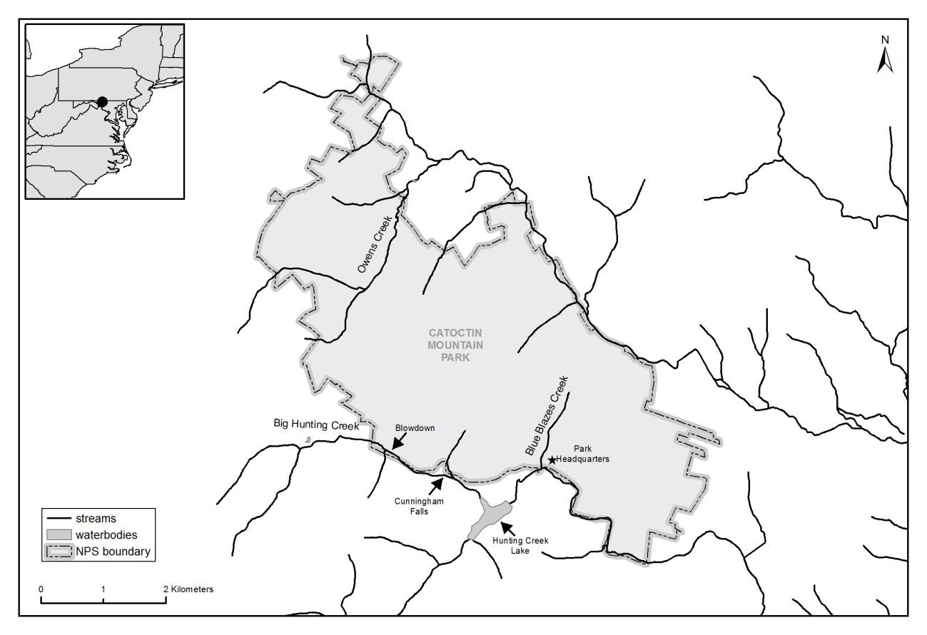

Figure 2. Map of stream gage sites within Owens Creek and upper Big Hunting Creek watersheds.
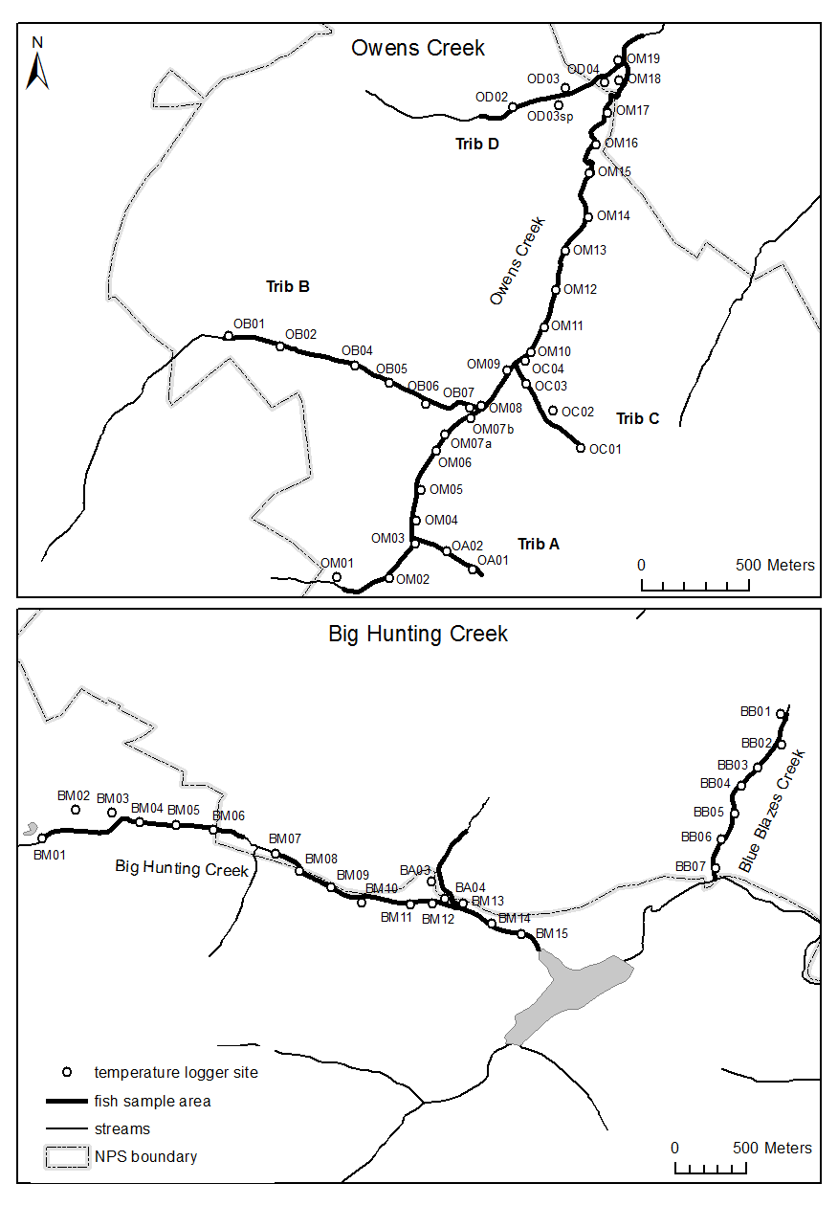

Figure 3. Observed fish species richness within 100 m sampling areas (2015).
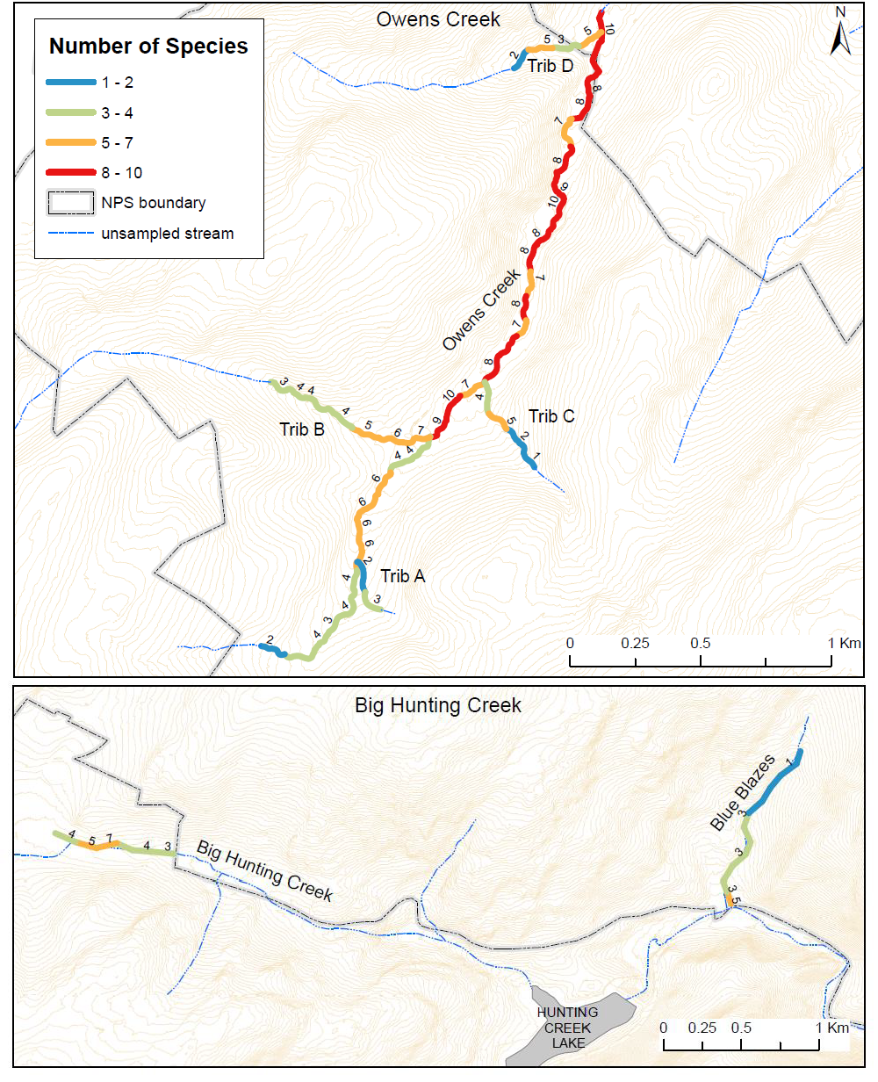

Figure 4. Brook Trout abundances within 100 m sampling areas (2015).
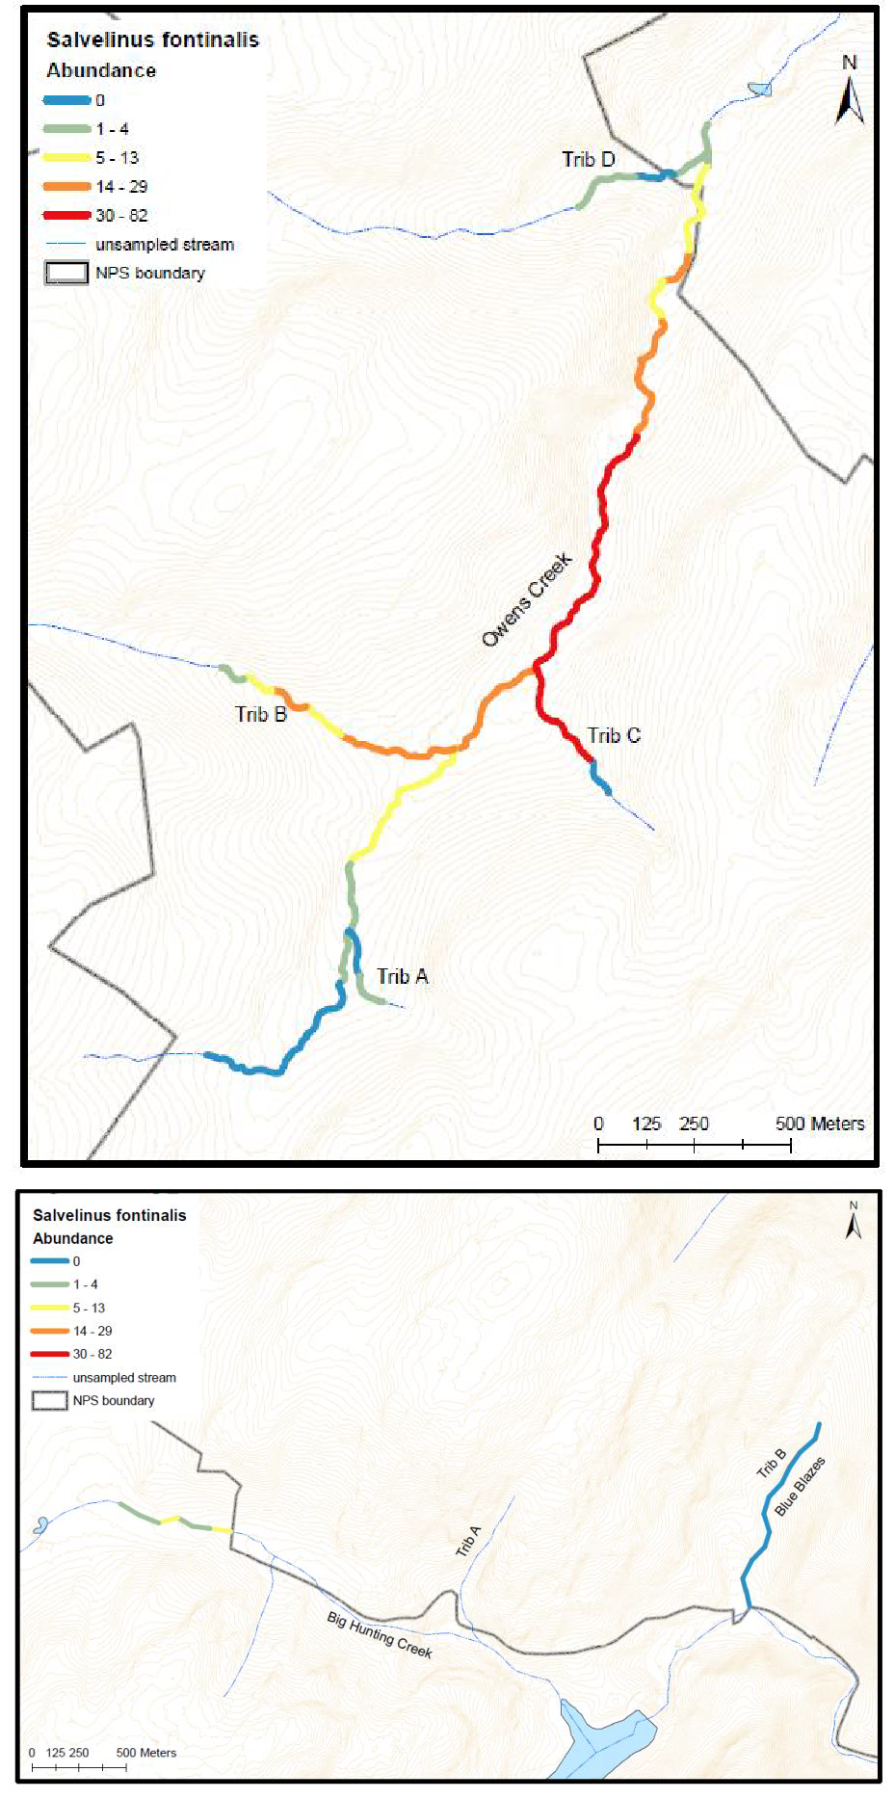

Figure 5. Observed maximum weekly average stream temperatures (MWAT) in 2015 and 2016. Vertical dashed lines indicate the expected thermal tolerance limit for Brook Trout.

Blue Blazes Creek - 2015
4
Blue Blazes Creek - 2016
4

3 3

2 2

1 1

0 0

10 12 14 16 18 20 22 24 10 12 14 16 18 20 22 24

Upper Big Hunting Creek - 2015
5
Frequency

4

3

2

1

0

10 12 14 16 18 20 22 24
Upper Big Hunting Creek - 2016
7
6
5
4
3
2
1
0

10 12 14 16 18 20 22 24

Owens Creek - 2015
14 20
12
10 15
8
6 10
4 5
2
0 0
Owens - 2016

10 12 14 16 18 20 22 24 10 12 14 16 18 20 22 24

Maximum weekly average temperature (MWAT) in Celsius

Figure 6. Observed stream temperatures in CATO: maximum weekly average temperatures in 2015.
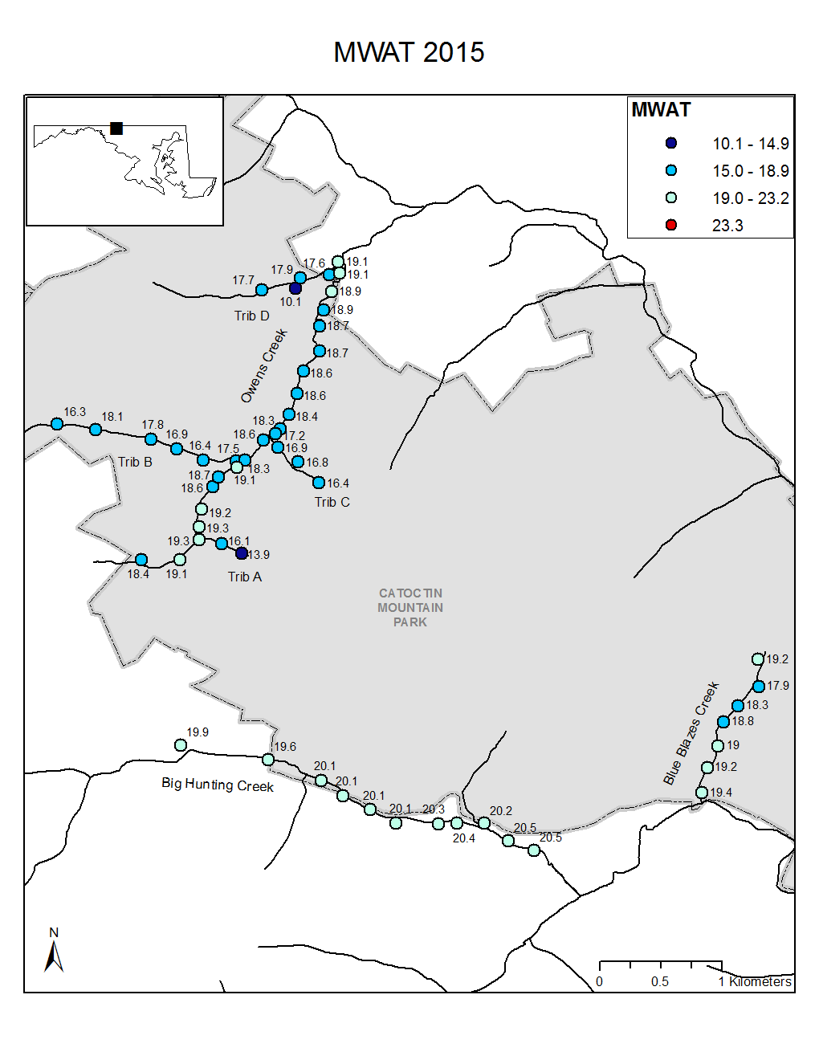

Figure 7. Observed stream temperatures in CATO: maximum weekly average temperatures in 2016.
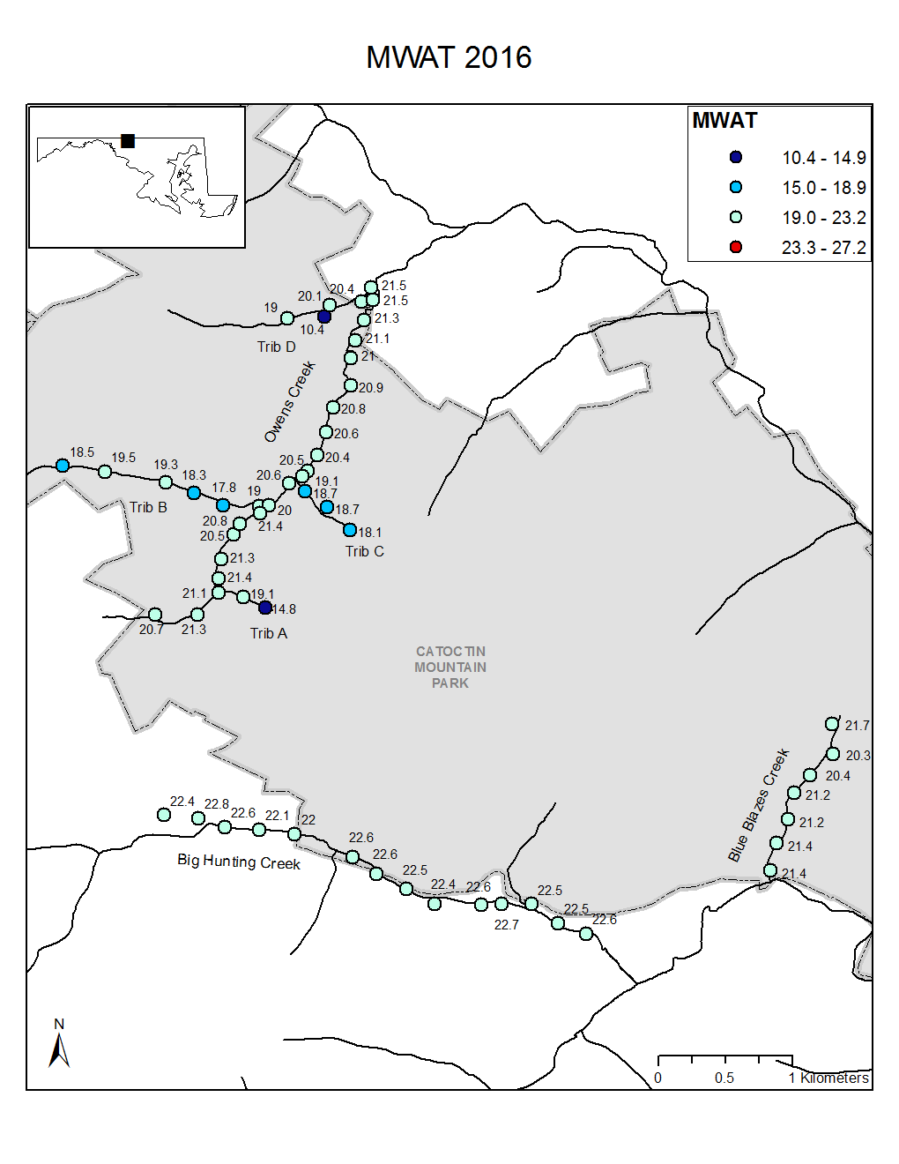

Figure 8. Estimated groundwater influence on stream temperature within CATO streams. Streams are mapped in Figure 1. The groundwater index was calculated following Snyder et al. (2015).

3.0

2.5

2.0
1.5

1.0

0.5

0.0
Blue Blazes Creek - 2015

2.0

1.5

1.0

0.5

0.0
Blue Blazes Creek - 2016

0.0 0.2 0.4 0.6 0.8 1.0 0.0 0.2 0.4 0.6 0.8 1.0

Upper Big Hunting Creek - 2015
7
Frequency
6
5
4
3
2
1
0

0.0 0.2 0.4 0.6 0.8 1.0
Upper Big Hunting Creek - 2016
5

4

3

2

1

0

0.0 0.2 0.4 0.6 0.8 1.0

Owens Creek - 2015 Owens Creek - 2016

10
15
8

10 6
4
5
2

0 0

0.0 0.2 0.4 0.6 0.8 1.0 0.0 0.2 0.4 0.6 0.8 1.0

Groundwater influence index

Figure 9. Estimated groundwater influence on stream temperature within CATO streams in 2015. See text for modeling details.
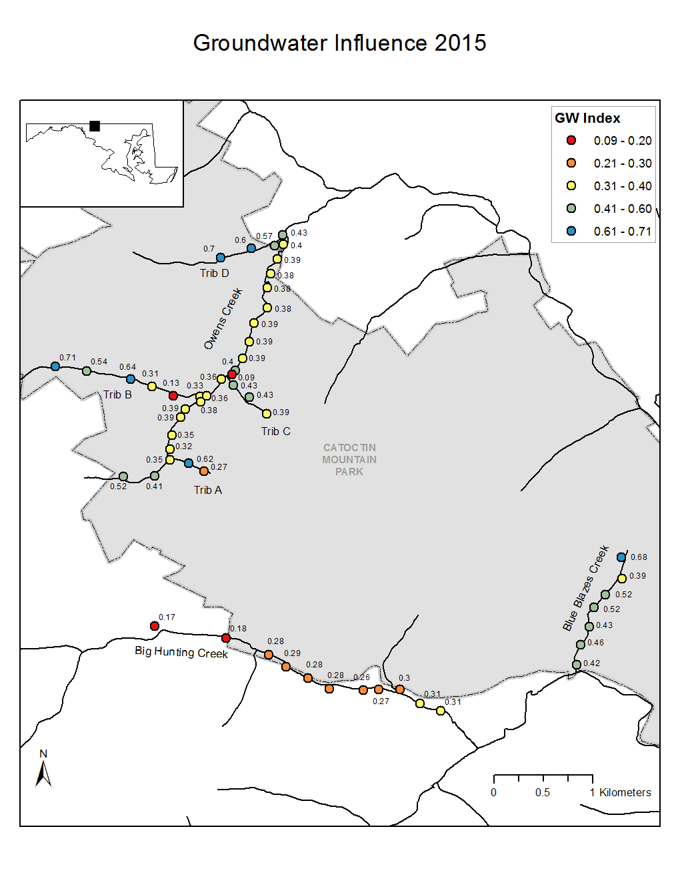

Figure 10. Estimated groundwater influence on stream temperature within CATO streams in 2016. See text for modeling details.
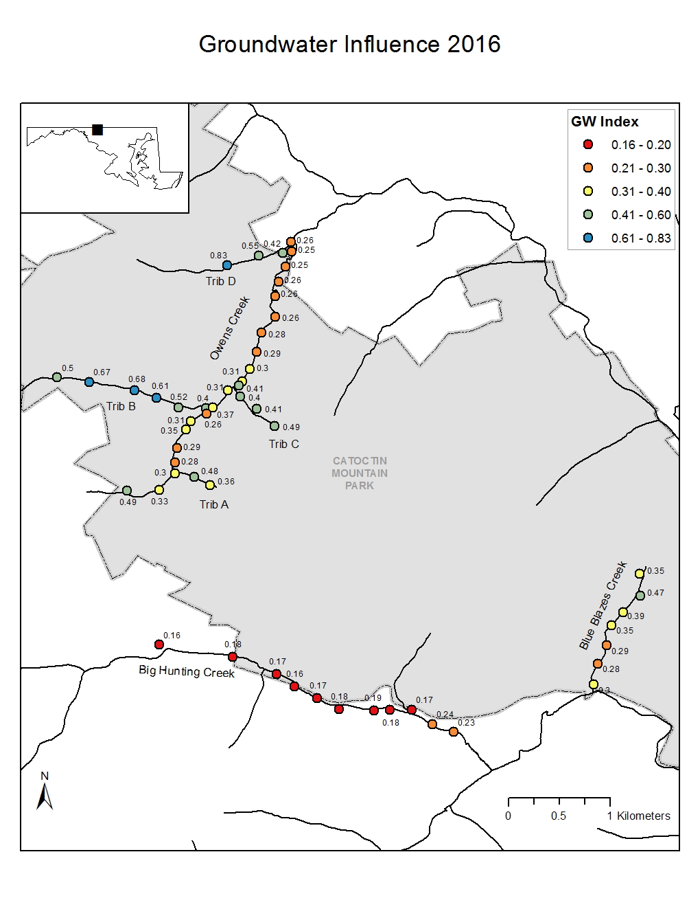

Figure 11. Relationship between estimated groundwater influence on stream temperature in 2015 and 2016. The solid line shows the fitted linear relationship (y = 0.06 + 0.74x; R2 = 0.46), and the dashed line shows the 1:1 relationship for comparison.

0.8
Blue Blazes Creek upper Big Hunting Creek Owens Creek

0.6
GW influence: 2016

0.2

0.2 0.4 0.6 0.8

GW influence: 2015

Figure 12. Brook Trout thermal habitat suitability forecasts across 3 levels of mean annual air temperature increase (1.5, 3, and 5 ºC) and 3 levels of groundwater sensitivity to air temperature change (0.5, 0.75, 1.0) in Catoctin Mountain Park. Red circles indicate thermal unsuitability for Brook Trout based on maximum weekly average temperature (MWAT > 23.3 ºC).
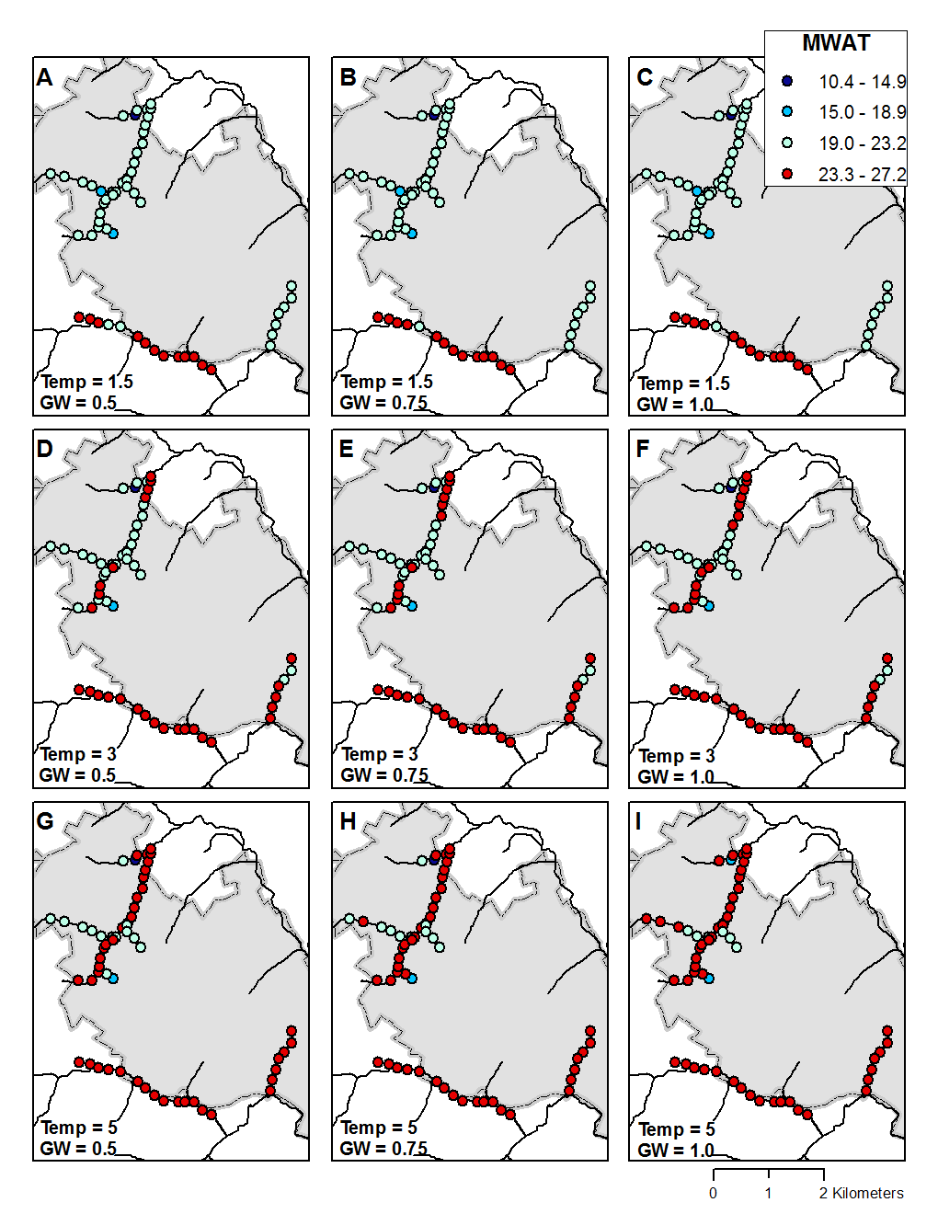

Appendix A. R code for groundwater influence model.

# Authors: Zachary C. Johnson and Erin L. Snook (7 December 2016)
# Input: dataframe named “AirWater_daily” with columns Site, Date, Year, Mean Daily Water
# Temp, Mean Daily Air Temp, Accumulated Degree Days
library(dplyr); library(relaimpo) # load required packages d <- subset(AirWater_daily, Year == 2015) # assign year for analysis
sites <- unique(d$SiteName) # define object that includes all sites
res <- matrix(nrow=length(sites), ncol = 8) # matrix: rows=sites and columns=outputs colnames(res) <- c("SiteName", "ADDSlp", "RelImpAir", "RelImpADD", "YInt", "AirSlp", "AdjRsqr", "RMSE")

for (i in 1:length(sites)){
dat <- subset(d, SiteName == sites[i]) # subset the data frame for one site res[i, "SiteName"] <- paste(sites[i]) # puts SiteName in column 1
m <- lm(WaterDaily.mean ~ AirDaily.mean + ADD, data = dat)
# 2-term linear model
if (coef(m)["ADD"] < 0 ){ # if ADD slope is negative: m2 <- lm(WaterDaily.mean ~ AirDaily.mean, data = dat)
# run another model with no ADD term
res[i, "ADDSlp"] <- 0 # assign 0 to slope value
res[i, "RelImpAir"] <- summary(m2)$r.squared # get R2 for relative importance of air res[i, "RelImpADD"] <- 0 # assign 0 to relative importance of ADD
}else{ # if ADD slope is positive:
res[i, "ADDSlp"] <- coef(m)[3] # extract slope of original model res[i, "RelImpAir"] <- calc.relimp(m,type="lmg")$lmg[1]
# calculate relative importance of air res[i, "RelImpADD"] <- calc.relimp(m,type="lmg")$lmg[2]
# calculate relative importance of ADD
}
res[i, "YInt"] <- coef(m)["(Intercept)"] # extract y-intercept
res[i, "AirSlp"] <- coef(m)["AirDaily.mean"] # extract slope of air effect res[i, "AdjRsqr"] <- summary(m)$adj.r.squared # extract model adjusted R2 res[i, "RMSE"] <- sqrt(mean(resid(m)^2,na.rm=TRUE))
# calculate root mean-squared error
}
GWI <- data.frame(lapply(data.frame(res, stringsAsFactors = FALSE), type.convert))
# convert results into a dataframe

Appendix B. Fish species abundance in 2015 (excluding Brook Trout, see Figure 4).

Figure B1. Creek chub (Semotilus atromaculatus)
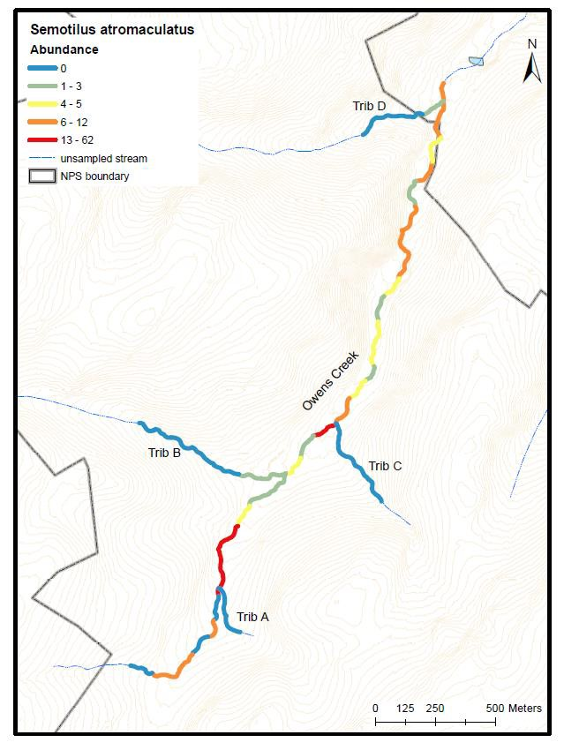
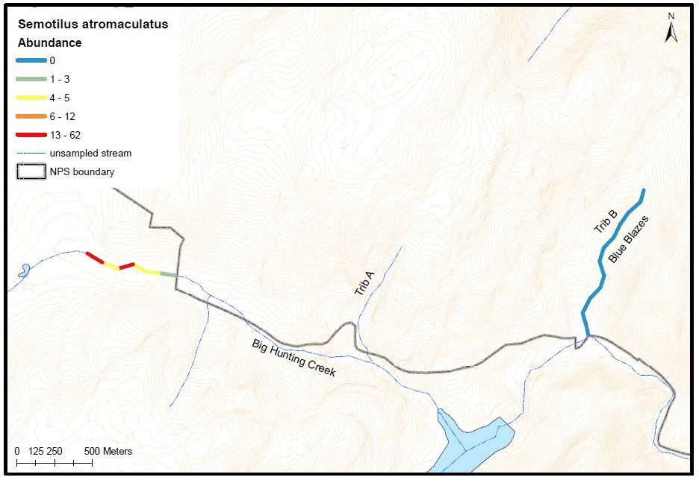

Figure B2. Brown Trout (Salmo trutta)
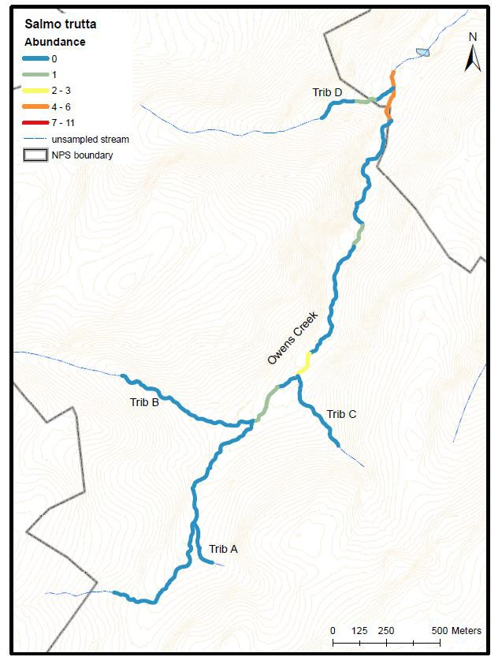
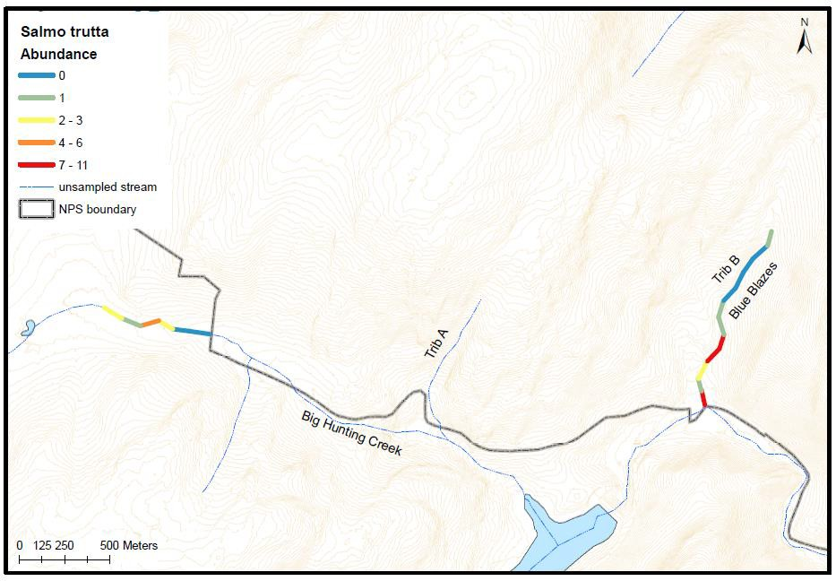

Figure B3. Longnose Dace (Rhinichthys cataractae)
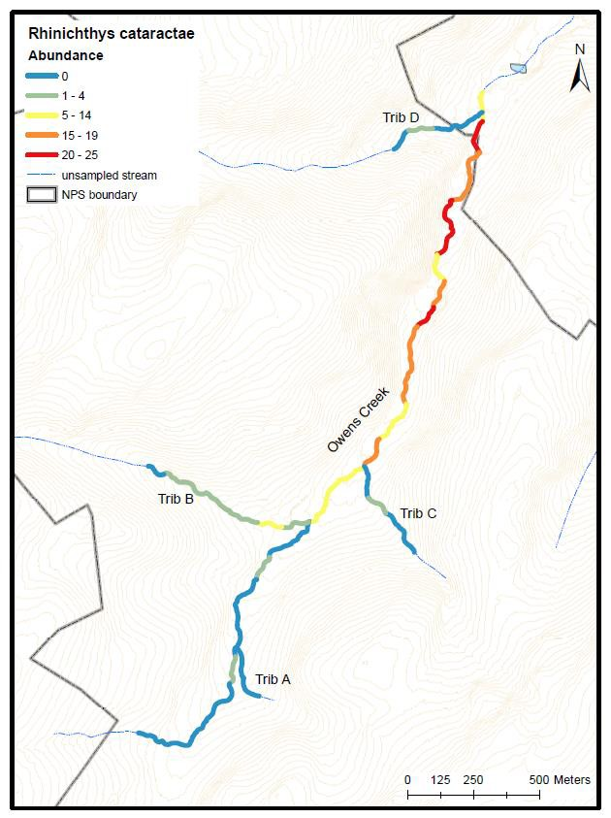
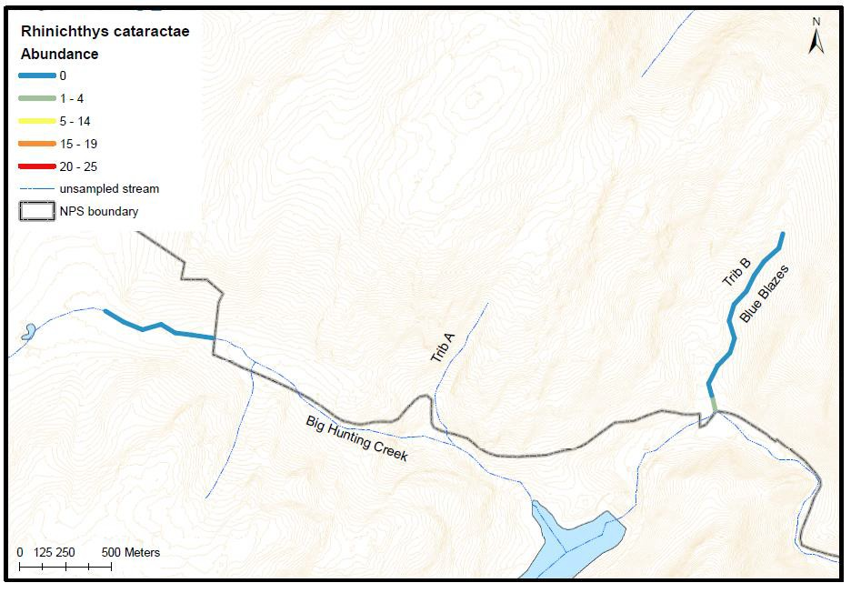

Figure B4. Blacknose Dace (Rhinichthys atratulus)
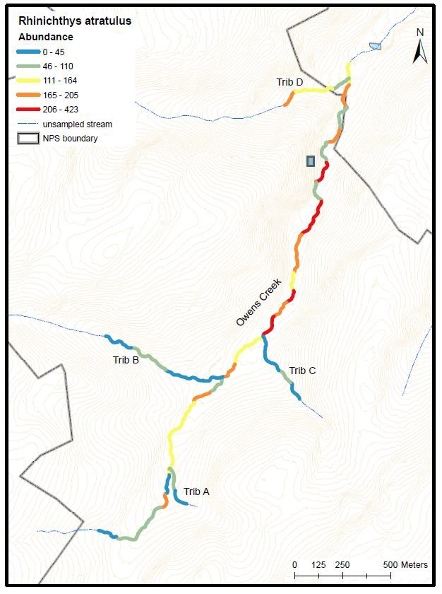
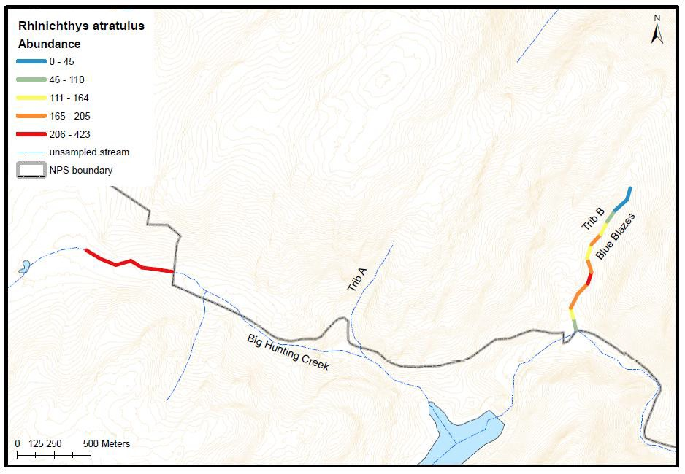

Figure B5. Largemouth Bass (Micropterus salmoides)
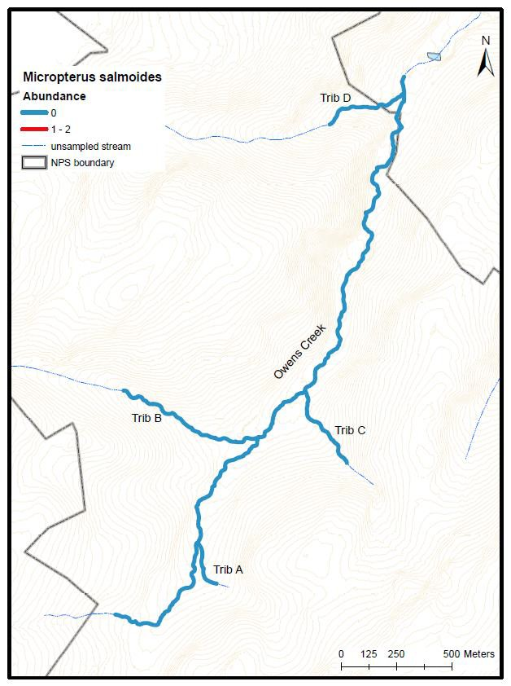
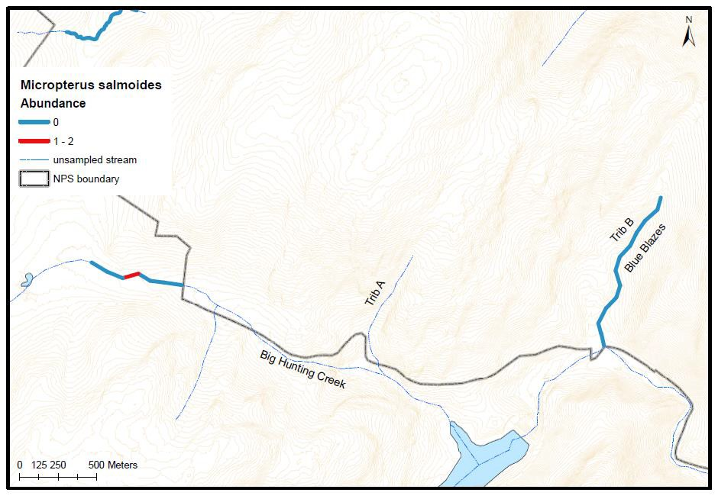

Figure B6. Bluegill (Lepomis macrochirus)
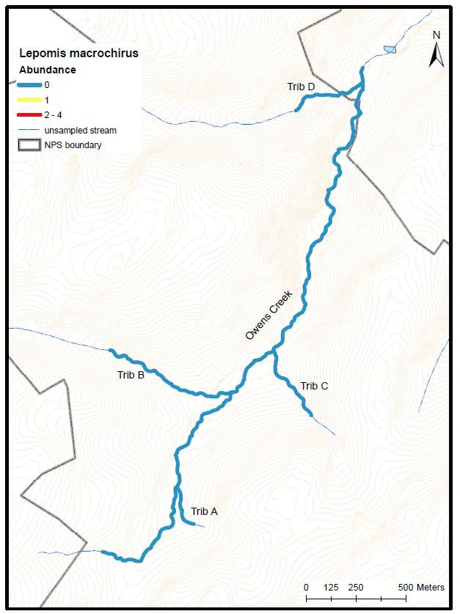
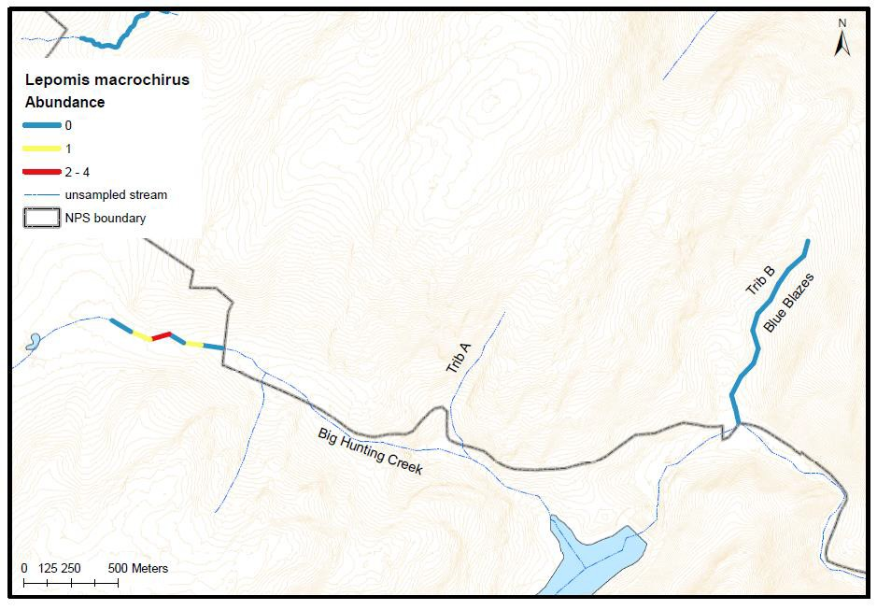

Figure B7. Yellow Bullhead (Ameiurus natalis)
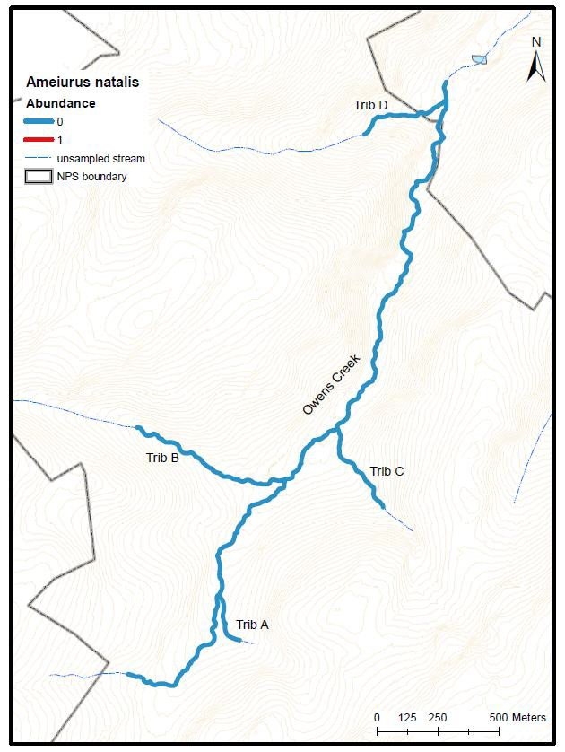
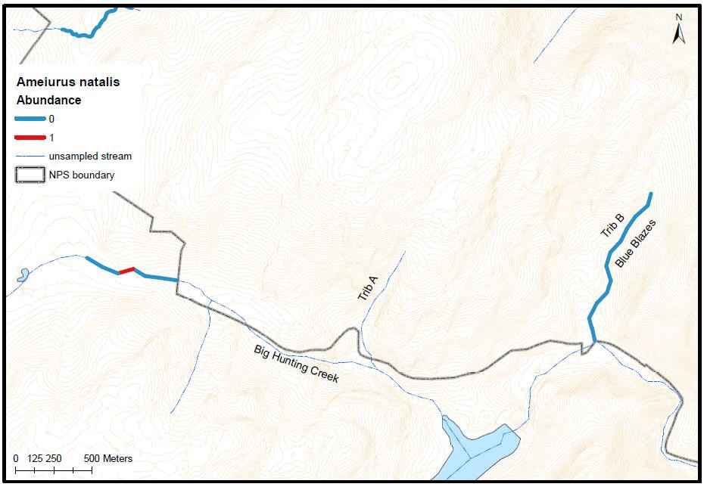

Figure B8. White Sucker (Catosomus comersonii)
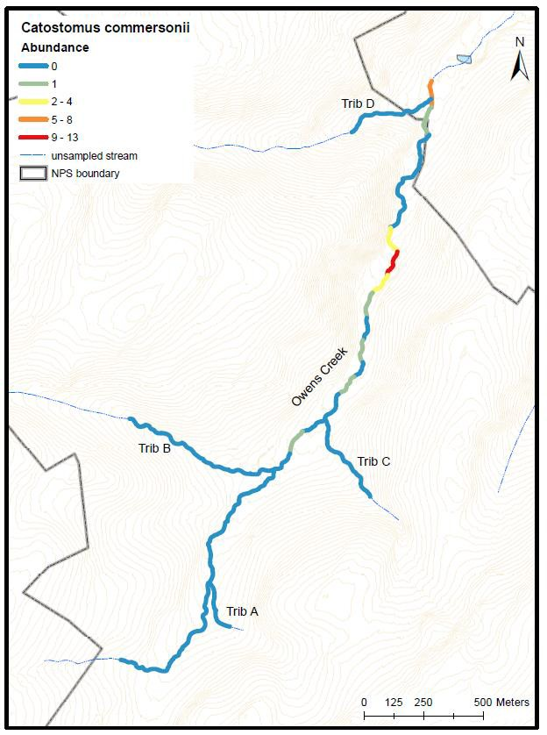
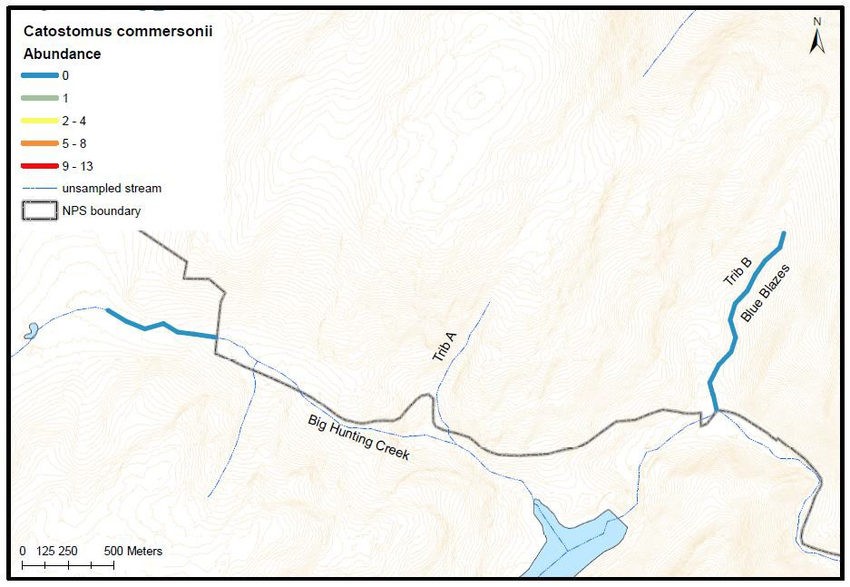

Figure B9. Rosyside Dace (Clinostomus funduloides)
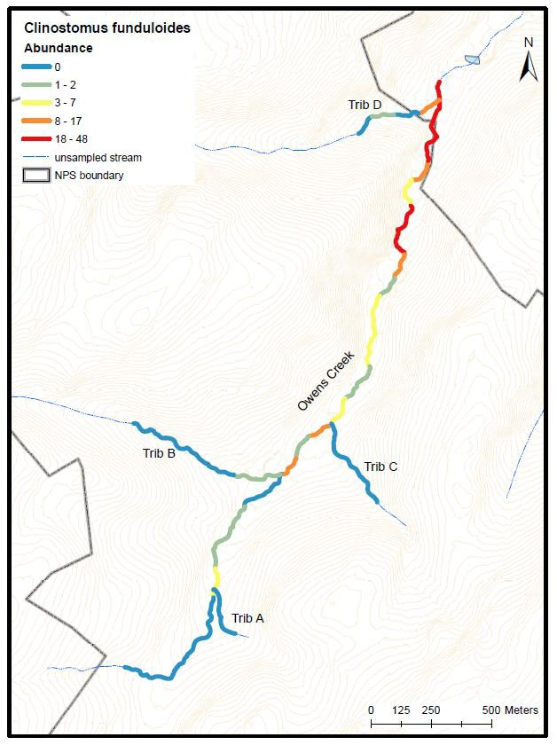
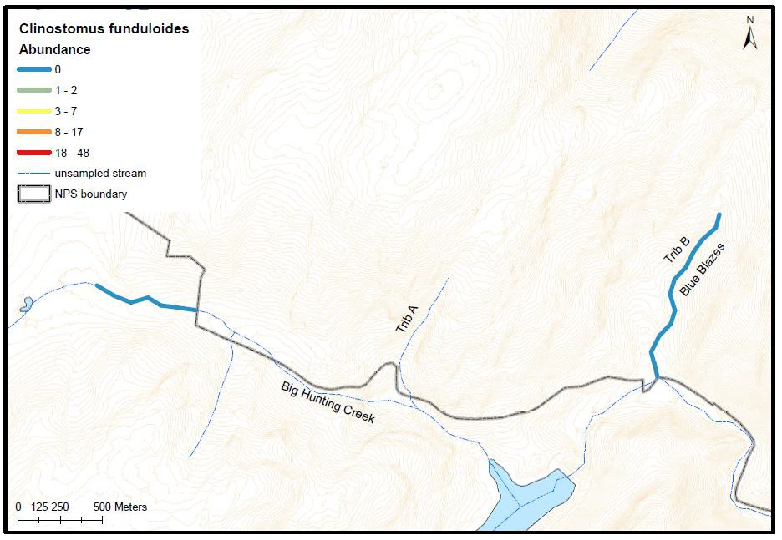

Figure B10. Blue Ridge Sculpin (Cottus caeruleomentum)
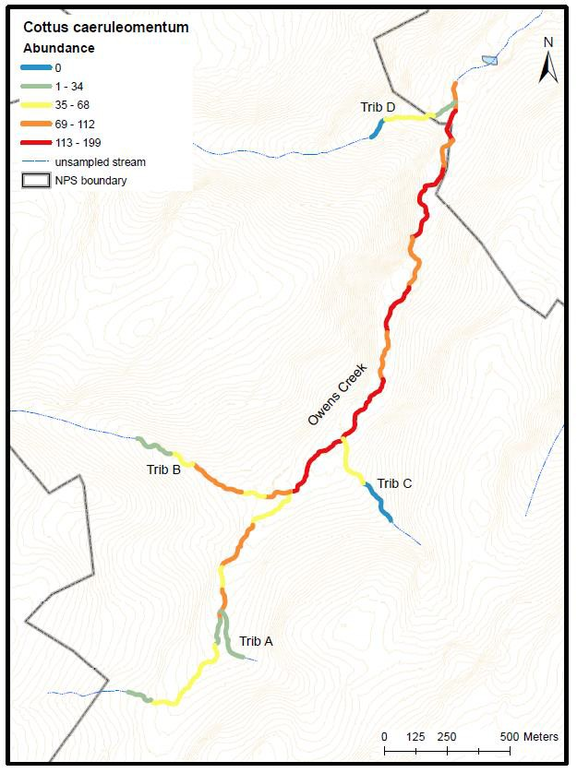
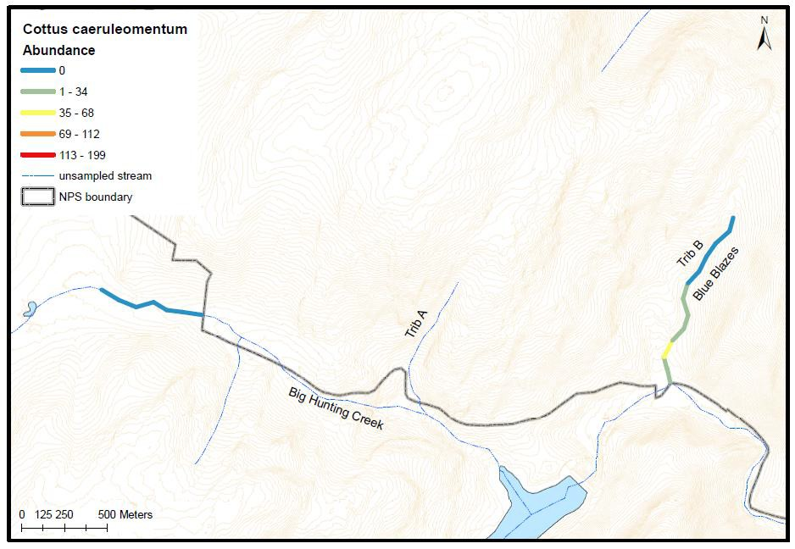

Figure B11. Potomac Sculpin (Cottus girardi)
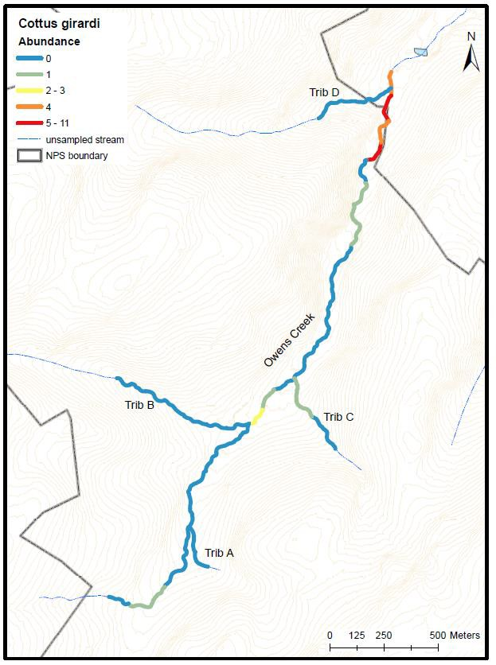
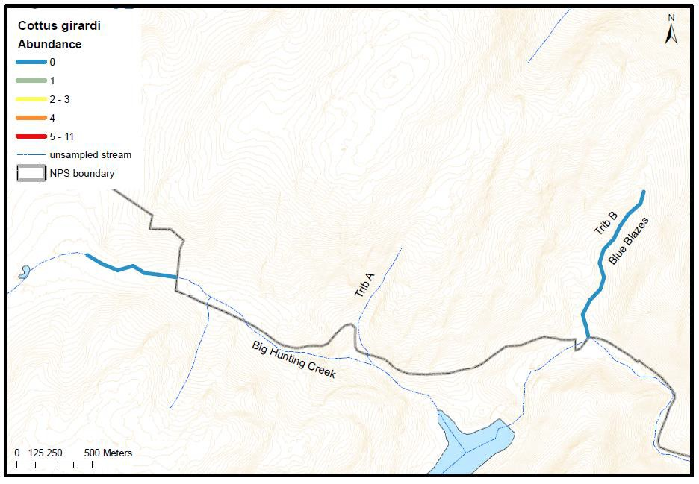

Figure B11. Fantail Darter (Etheostoma flabellare)
