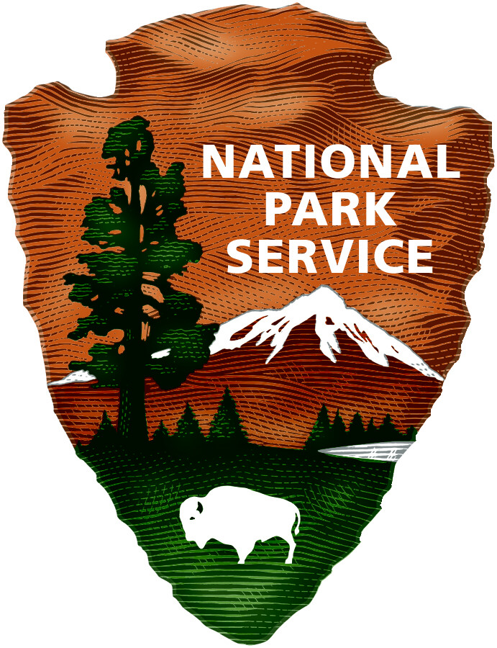
Catoctin Mountain
National Park Service
U.S. Department of the Interior

Catoctin Mountain Park

Catoctin Mountain Park White-tailed Deer Management Plan
Frequently Asked Questions

Why manage deer at Catoctin Mountain Park?

Since Catoctin Mountain Park was established in 1936, deer populations throughout the country have rebounded and are now higher than at any other time in their known history. By the 1970s, problems related to an overabundance of deer in the Park were suspected. The National Park Service and other researchers conducted multiple studies to document the size of the park’s deer population, as well as plant growth in the understory of the mature forest canopy. In areas where deer were excluded, plant species richness and abundance were significantly higher. Data indicated that by 2009, forest regeneration was nearly absent within the majority of the park, due in large part to high deer numbers.

What is the purpose of the Deer Management Plan?

Catoctin Mountain Park developed a Deer Management Plan/Final Environmental Impact Statement (EIS) to provide an effective strategy that supports forest regeneration and provides for long-term protection, conservation, and restoration of native species and cultural landscapes. The Plan/EIS was completed in 2009 with a preferred alternative to use qualified federal employees to conduct sharpshooting to reduce the deer population. Deer management operations have successfully taken place for seven consecutive seasons between 2010 and 2016.

Will the National Park Service donate the meat to charity?

Yes. The Thurmont Food Bank, the Lunch Place, and the Help Hotline will receive donations of meat. More than 30,800 pounds of meat have been donated to local food banks since the program began in 2010.

How do I get a copy of the White-tailed Deer Management Plan / Environmental Impact Statement (EIS)?

The plan can be accessed via the National Park Service Planning, Environment and Public Comment (PEPC) website at http://parkplanning.nps.gov/CATO

Will the National Park Service allow public hunting?

No. A public hunting alternative was considered but dismissed for further analysis because it would be in conflict with existing laws, policies, regulations, and case law regarding public hunts in units of the National Park System. For a more detailed explanation on this topic, please refer to Page 86-88 and Appendix H, Page 388-394 of the White-tailed Deer Management Plan / EIS.

-more-

How many deer are in the park and what is the deer density goal?

Deer density spotlight surveys have been conducted in the park since 1989. The highest deer density recorded was 193 deer per square mile in 2003. Before the first season of deer management began in February 2010, there were approximately 123 deer per square mile in the park. The initial deer density goal set forth in the EIS is 15-20 deer per square mile. This was achieved for the first time in January 2016. This goal is based on recent research conducted in eastern deciduous forests similar to Catoctin’s forest and may change based on the results of annual vegetation monitoring. Deer reduction will take place annually or as needed to maintain the target density.

Is deer management working?

Yes. A total of 1,163 deer have been removed from the park in 7 years. As of 2009, there were 255 seedlings per acre in the park, compared to 2,547 per acre in forests of other national parks in the National Capital Region. As of 2016, the average tree seedling level at Catoctin is now 3,078 per acre. This 10-fold increase in seedling density in just 7 years demonstrates that deer management can be an effective tool in promoting seedling regeneration.​

Many visitors come to the Park to see the deer. Will they still be able to see deer?

Yes. The management plan is not designed to eliminate deer from Catoctin Mountain Park. Rather, it is designed to bring the deer population to a level that allows the park’s forests to regenerate. White-tailed deer are part of the ecosystem and future generations of park visitors will continue to have the opportunity to see deer in the park.

When will deer be removed and will it be safe to visit the Park during this time?

The 8th season of deer management will occur from November 2016 – March 2017. The safety of park visitors and staff has always been the primary concern during deer reduction activities. Deer herd reduction will be conducted during the colder months when park visitation is typically low. To assure visitor safety, certain areas of the park will be closed during reduction activities. Closure maps are available on the Park website and closed areas will be clearly posted.

Are there other National Park Service areas that are doing deer management?

Yes. In the eastern half of the United States there are a number of National Park Service areas that are actively performing deer management: Gettysburg National Military Park, Indiana Dunes National Lakeshore, Rock Creek Park, and Valley Forge National Historical Park. Antietam National Battlefield and Monocacy National Battlefield plan to implement deer management in the fall and winter of 2016-2017.

What if I have a question that is not addressed here?
Please feel free to email us at: CATO_Superintendent@nps.gov

