Campsite Forensics

The family was on their first camping trip. They set up their tent, enjoyed dinner and left the site to participate in a campfire program. When they returned, their campsite was a mess!
Investigate the clues left behind so you can discuss what might have happened here.

(Write observations here)

Track Identification Key
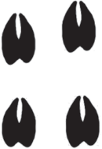
White-tailed deer:
1.5-3” long1.1-2.6” wide
Front and hind tracks similar
2 hoofed toes form heart-shaped track
Opossum:
Front track: 1-1.6” long, 1-2.5” wide
Hind track: 1.5-2.2” long, 1.2-2.3” wide
Hind feet have opposable thumbs
Claws sometimes visible
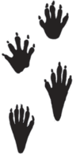
Raccoon:
Front track: 1.5-3.2” long and 1.4-2.9” wide
Hind track: 1.4-4.1” long and 1.3-3” wide
Small, sharp claws
Hind track may have long “heel”
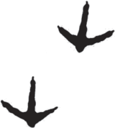
Turkey:
3.5-4.5” long
3.7-4.3” wide
Three toes, claws sometimes visible
Wing marks or pecks/scratches sometimes visible
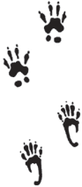
Gray Squirrel:
Front track: 0.5”long and 0.5” wide (four toes)
Hind track: 1” long and 0.5” wide (five toes)
Hind track may have long “heel”

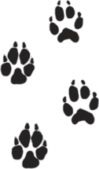Red Fox:
1.5-2” wide
1.7-2.5” long
Front and hind tracks similar
Four toes with claws

Planted for Survival

While on your discovery walk your leader will point out many of the adaptations plants have developed to reproduce and survive. Sketch or describe the adaptations as you see them.

Thorns
Sharp, pointy thorns can puncture your skin or the soft mouth tissue of animals that consider these plants for food. Thorns protect plants.
Nuts
Some trees, including oaks and hickories produce a hard, dry fruit with a seed we call nuts. The nuts provide food for forest animals. New trees sprout from uneaten nuts.
Plant Galls
Some insects lay their eggs on plants that will provide food for their young. The plant reacts to the invasion by producing this growth known as a gall.
Flowers
The bright colors or special scents attract insects, bats or birds seeking the pollen within their special structures. Once pollinated, the flowers produce seeds.
Fungus
Green plants can produce their own food using sunlight, water and chlorophyll. Fungi do not have this ability and get their food from another plant. Fungi speed the process of decomposition.
Anything Else?
Draw an adaptation you see but is not listed- remember to label it!

Tree Factory

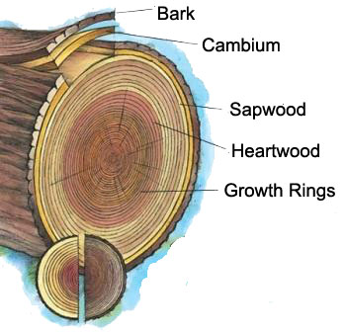
Lateral Roots

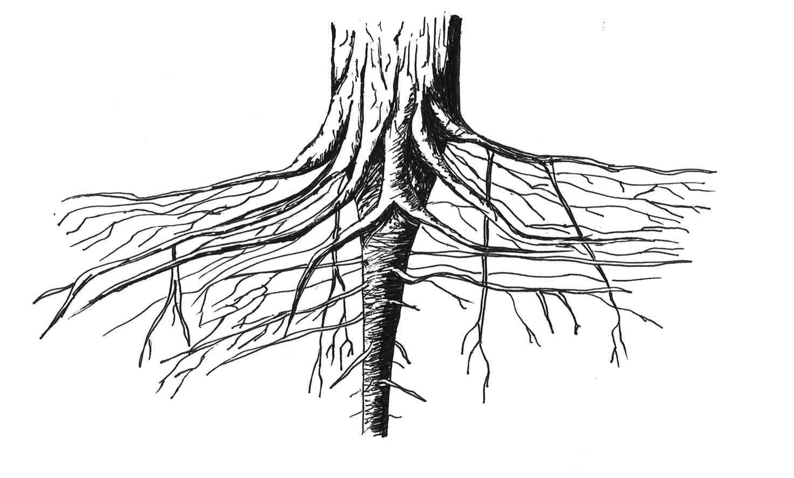
Taproot

Vocabulary
Adaptation– (verb) The act or process of changing to better suit a situation. (noun) A body part, feature, or behavior that helps a living thing survive and function better in its environment.

Bark – The outer covering of a woody plant. It protects the plant from insects, disease, fire and injury.

Biodiversity– The variety of life, variety of living things in a given place. Biodiversity is important for the health of our ecosystems.

Cambium – The growing part of a tree, adding a layer each year that is seen as a ring when the tree is cut down. The tubes that take the food from the leaves to the roots and the rest of the tree are to the outside of the cambium.

Canopy (Overstory) – The top layer of the forest. This is where trees’ highest branches find the sunlight that they need.

Deciduous – Plants that shed their leaves and go through a period of rest. Most of the trees in the Catoctin forest are deciduous. The leaves become brightly colored before shedding in the autumn.

Evergreen – Plants that keep their leaves all year long. Most leaves are thin with a waxy surface. Many people associate evergreens with Christmas trees.

External structure – Usually include skin, bark, tails, claws, fur, or other features you see on the outside of an animal or plant.

Habitat – The natural home or environment that contains the food, water and conditions that a plant or animal needs to survive.

Heartwood – A tree’s woody center. When alive, the vessels in the heartwood carried water and food, but they no longer function. The heartwood provides the strength that supports the tree.

Internal structure – The parts that keep organisms alive, help them grow, and help them reproduce (located on the inside). Could include bones, organs, etc.
Invasive – Plants or animals with few or no natural predators in the area. They often crowd out other plants or animals. See also “Non-native species.”

Invertebrate – An animal that does not have a backbone or skeleton inside its body. Insects, spiders, worms, snails, clams, crabs, and squids are some kinds of invertebrates.

Leaf – Structure that plants use to capture sunlight. The chlorophyll (green pigment) within the leaf allows the plant to use the energy from the sun to produce food.

Lichen – A unique organism that is part algae and part fungus.

Nut – The hard, dry seed within the fruit that is produced by certain trees like oaks and hickories.

Non-native species - Plants and animals from other parts of the world or other parts of our country. Also referred to as an exotic species. Not all are invasive, but some are.

Nutrients – Water, food, and minerals that plants and animals need to grow.

Roots – The underground portion of a plant that provides support and seeks water and nutrients. Roots also store food created by leaves. The large, deep root that anchors a tree is the taproot. The smaller roots that deliver water and nutrients are lateral roots.

Sapwood (xylem) – The layer of wood between the heartwood and the bark, sapwood is a network of living cells that bring water and nutrients up from the roots to the branches, twigs and leaves. It is the youngest wood of the tree - eventually, the inner layers of sapwood die and become heartwood.

Shrub – Any woody plant that grows to less than 6 feet tall and has multiple stems.
Conclusions: Survive and Thrive
If you were an animal or plant living at Catoctin, what adaptations and features would you need to survive? Draw your creation and label the adaptations.

