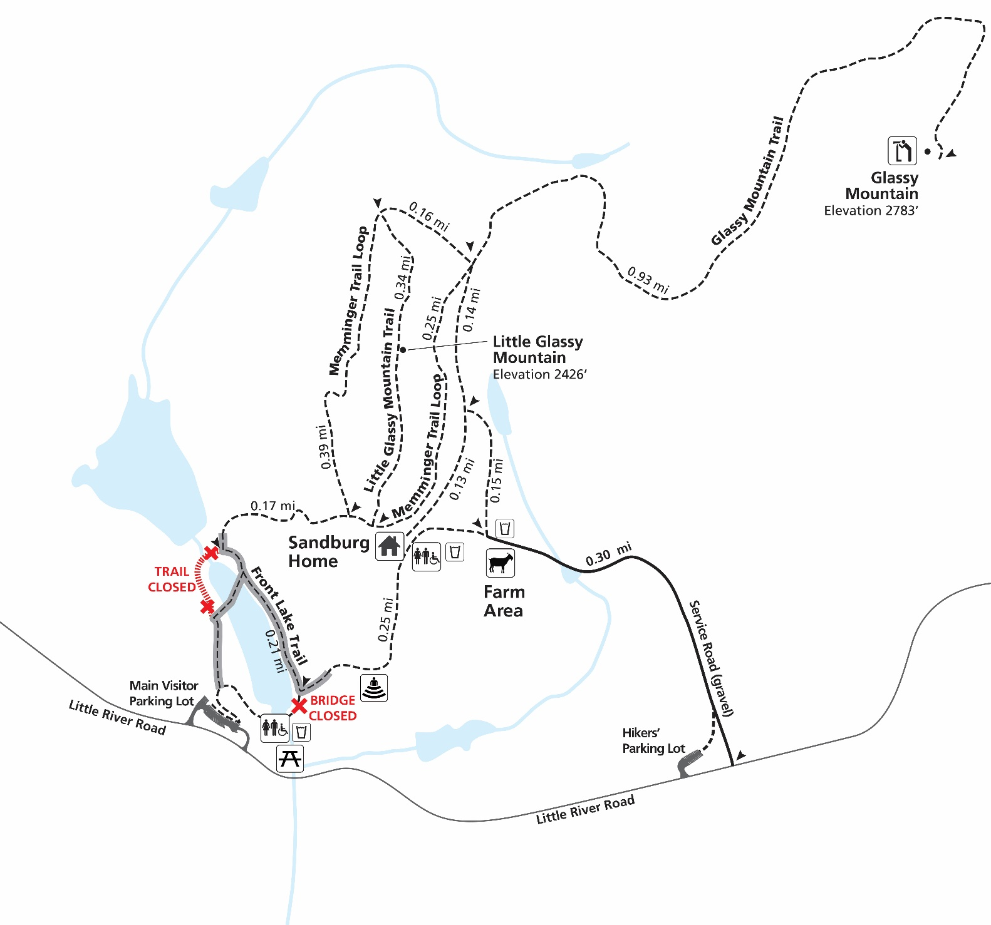
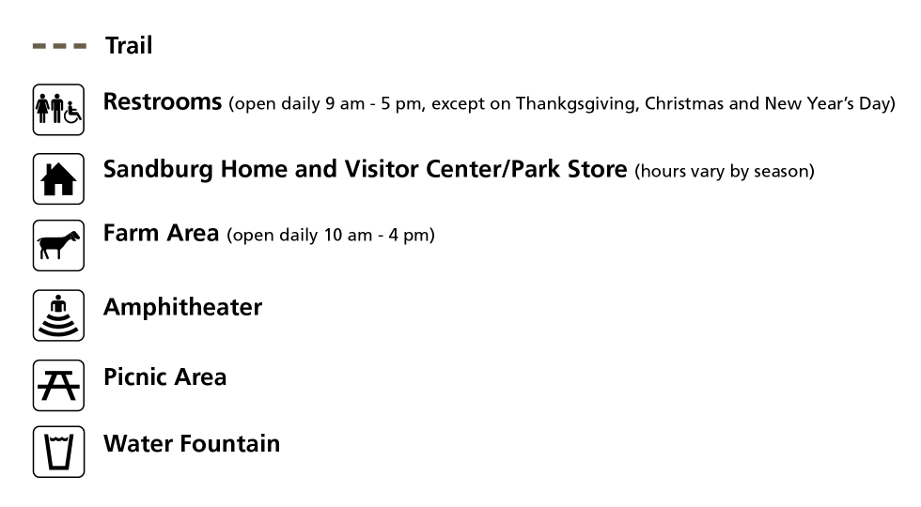

The Pedestrian bridge at the main entrance is closed. Follow detour signs (on left) to walk around the lake bed and across the temporary bridge to access park facilities.

DETOUR
Trail Map
Carl Sandburg Home
National Historic Site
Plan your visit:
- Grounds, trails, and parking lots are open daily from sunrise to sunset.
- For information call 828-693-4178 or email carl_administration@nps.gov.
For your safety:
- In case of emergency call 911.
- Stay on established trails.
- Be alert for rough terrain and nature’s hazards.
- Dogs must be leashed at all times, no longer than 6 foot. Please clean up after your pet.
- No smoking in the park.

Distances
Main Parking Lot to Home 0.70 mi with
detour. (110 ft. elevation climb)
Main Parking Lot to Glassy Mtn. 1.5 mi.
(623 ft. elevation climb)
Sandburg Home to Glassy Mtn 1.2 mi.
(513 ft. elevation climb)
Front Lake Loop 0.40 mi.
(5 times around = 2 mi.)
Hikers’ Parking Lot to Barn 0.30 mi.
(walk on gravel road)
Hikers’ Parking Lot to Home 0.40 mi.
(walk on gravel road)
Visit www.nps.gov/carl
for current operating hours, calendar of events, trail map, self-guided tours and more!

