FILMING & PHOTOGRAPHY
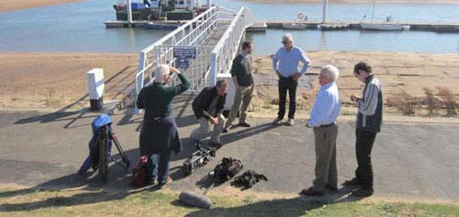

General

A permit will not be required for a visitor’s personal, noncommercial filming and photography activities within normal visitation areas and hours. (Outside normal visitation areas and hours, a permit may be required).

Commercial Filming

All commercial filming activities require a permit. Commercial filming means filming that involves the digital or film recording of a visual image or sound recording by a person, business, or other entity for a market audience. This includes recordings such as those used for a documentary, television or feature film, advertisement, or similar project.

Still Photography

In accordance with Public Law 106-206, still photography (whether commercial or noncommercial) will not require a permit unless;

- it takes place at a location(s) where or when members of the public are generally not allowed, or
- it uses model(s) or prop(s) that are not a part of the location’s natural or cultural resources or administrative facilities, or
- the Park Service would need to provide management and oversight to prevent unacceptable impacts.

If none of the conditions identified above exist, then a permit is not required.

Public Law 106-206

In Public Law 106-206, Congress acknowledged the importance of resource protection

and provided that a permit request should be denied if:

- There is the likelihood that resource damage would occur that cannot be mitigated or restored under the terms and conditions of the permit;
- There is the likelihood of unreasonable disruption or of conflict with the public’s use and enjoyment of the park;
- There is the likelihood that the activity poses health or safety risks to the public;
- There is the likelihood that the activity would result in impairment of park resources or values;
- The requested activity will violate any other applicable Federal, State, or local law or regulation

News Coverage

News coverage does not require a permit, for either filming or still photography, but is subject to time, place, and manner restrictions, when warranted, to maintain order and ensure the safety of the public and the media, and to protect natural and cultural resources.

Permit Fees

Commercial filming permits and still photography permits (when applicable) are statutorily subject to cost recovery and a location fee, neither of which may be waived. The location fee is determined by the type of activity (commercial filming versus still photography). It is based on the current schedule, the number of permitted days, and the number of people on park lands associated with the permitted activity. There is no deviation from the schedule.

Location Fee Schedule

Commercial Filming/Videos |  | Still Photography
1 – 2 people camera & tripod only | $0/day
1 - 10 people | $150/day | 1 - 10 people | $50/day
11 - 30 people | $250/day | 11 - 30 people | $150/day
31 - 49 people | $500/day | Over 30 people | $250/day
Over 50 people | $750/day

Nature Films

To address the needs of videographers and cinematographers who produce nature films highlighting the wonders of national parks, the following provision is in effect:

Commercial videographers, cinematographers, or sound recording crews of up to two people with only minimal equipment consisting of a camera and a tripod, working in areas open to the public are required to obtain a commercial filming permit and are subject to appropriate permit terms, conditions and cost recovery charges, but are not subject to location fees.

Additional Information

- When a filming permit is required, liability insurance naming U.S. Federal Government/Canaveral National Seashore as additionally insured is also required. The minimum amount of the liability coverage is $1,000.000.00
- All vehicles must be parked in a designated parking area.
- The Commercial Film/Photography application with proof of insurance must be submitted at least seven business days prior to filming. Once all aspects of the filming project have been approved, a Commercial Filming Permit will be issued.
- The use of all props and equipment other than photographic equipment must be specified in your application and approved in the Commercial Filming Permit.
- Film crews must not interfere with the enjoyment of visitors or force visitors to leave a certain area of the park in order to conduct the filming.
- Commercial film permittees and associated support personnel identified in the permit will not be charged an entrance fee.

