National Park Service News Release

Canaveral National Seashore
212 S. Washington Ave.
Titusville, FL 32796
321-267-1110 office
321-264-2906 fax
www.nps.gov/cana
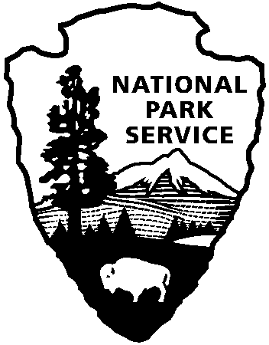
National Park Service
U.S. Department of the Interior

Release Date: Immediately
Contacts: Laura Henning
321-267-1110 Ext. 25

PLAYALINDA DISTRICT INTERPRETIVE
PROGRAMS
SEPTEMBER 2019

PLEASE NOTE: all programs are subject to cancellation and/or rescheduling due to staff limitations, weather conditions, or other factors. Some programs require reservations, a minimum age, or a cost recovery fee. Call 321-403-9334 or 386-428-3384 ext. 0 for program information during operating hours (9:00 AM to 5:00 PM). Visit our website at www.nps.gov/cana. Entrance fees apply to all interpretive program participants. All programs meet the requirements for the Canaveral National Seashore Junior Ranger Program.
SATURDAY, September 28th – FEE FREE DAY – Come out and celebrate National Public Lands Day!
SATURDAY, SEPTEMBER 21ST – 8:00 – 12:00 PM, “INTERNATIONAL COASTAL CLEANUP” – Join us for this annual world-wide coastal cleanup! Once a year all over the world, millions of volunteers, who love the ocean and want to protect it, take this day to make a difference. The seashore provides important habitat for many species who will benefit from clean-up efforts such as sea turtles and sea birds. Bring water in a reusable container, gloves, and water. Also bring gloves and sun protection. Meet at parking area # 1.

SATURDAY, SEPTEMBER 28TH – 10:00 AM “NATIONAL PUBLIC LANDS DAY – ISLAND CLEANUP”- Join in the nation’s biggest celebration of the great outdoors on National Public Lands Day! All national parks will have free admission and many will host volunteer service projects open to all. Canaveral National Seashore is hosting a volunteer cleanup paddling Mosquito Lagoon. Some paddling experience is required. Participants must be at least 8 years old, able to swim. Bring water, gloves, sunscreen, & sturdy water shoes. Dress to get wet. Reservations begin: one week in advance. There is no charge for program. To reserve a spot and if you need a kayak, call (321) 403-9334. OR bring your own kayak. Kayak availability is limited. Reserve a spot and meet at the Eddy Creek boat ramp. (2 hours)

THURSDAY, SEPTEMBER 5th, 12TH & 26TH – 9:00 AM, “MANATEE VIEWING” – Observe manatee in their natural environment and learn about their unique characteristics from park staff. Meet at the Eddy Creek dock. (1 Hour)
THURSDAY, SEPTEMBER 19TH – 9:00 AM, “BEACH PHOTO WALK” – Explore the seashore through the view finder. Discover the diversity and beauty of the various plants and animals within the seashore. Bring your camera, water, sunscreen and repellent. Meet at parking Area #1. (45 Minutes)

