National Park Service News Release

Canaveral National Seashore
212 S. Washington Ave.
Titusville, FL 32796
321-267-1110 office
321-264-2906 fax
www.nps.gov/cana
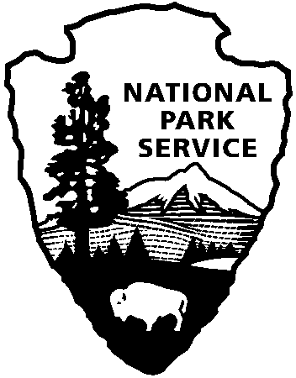
National Park Service
U.S. Department of the Interior

Release Date: Immediately
Contacts: Laura Henning
321-267-1110 Ext. 25

PLAYALINDA DISTRICT INTERPRETIVE
PROGRAMS
DECEMBER 2019

PLEASE NOTE: all programs are subject to cancellation and/or rescheduling due to staff limitations, weather conditions, or other factors. Some programs require reservations, a minimum age, or a cost recovery fee. Call 321-403-9334 or 386-428-3384 ext. 0 for program information during operating hours (9:00a.m. to 5:00 p.m.). Visit our website at www.nps.gov/cana. Entrance fees apply to all interpretive program participants. All programs meet the requirements for the Canaveral National Seashore Junior Ranger Program.

TUESDAY, 3RD & 10TH – 10:00 AM “SEASHELL & SEABEAN WALK” – Explore the beach wrack line for treasured seashell or sea bean. Bring water and sunscreen. Meet at parking area #3. (1 hour)
THURSDAY 5TH – 10:00 AM “BARTRAM NATURE WALK” – Walk the historic Bartram Trail hiked by one of the nation’s earliest botanists. Discover the diversity and beauty of the various plants and animals within the seashore. Bring your camera, water, and sunscreen. Meet at the Eddy Creek parking area. (1 hour)
TUESDAY, 11TH – 10:00 AM “BEACH CLEANUP” – Explore the beach wrack line for trash or treasure depending on what the tide brings in that day. Bring gloves, water and sunscreen. Meet at parking area #1. (1 hour)
SATURDAY, 14TH – 12:00 – 4:00 PM “SEMINOLE REST OPEN HOUSE” – You are cordially invited to celebrate the holiday season. Take a stroll back in time. Explore the ancient Timucuan mounds and turn of the century homes. There will be a live band, refreshments and crafts for the kids. See you then! Seminole Rest: 207 River Rd. Oak Hill FL, 32759.
THURSDAY, 19TH – 9:00 AM “CAST NETTING AT SEMINOLE REST” – Try your hand at cast netting. Enjoy the lagoon and see what you can catch. We have a few cast nets, bring your own if you wish. Meet at Seminole Rest parking area (207 River Road Oak Hill, FL 32759).

SATURDAY, 21ST – 6:00 – 11:00 PM “NIGHT SKY EXPLORATION”- Explore the celestial sky with area astronomers. Telescopes will be available for viewing stars, planets and more. Bring bug repellent, water/snacks, and maybe a lawn chair for your comfort. REQUIRED RESERVATIONS begin a week in advance of the event date: SPACE IS LIMITED. Call 321-403-9334 to reserve. Meet at Eddy Creek. (5 hours)
WEDNESDAY, 18TH – 10:00 AM “PADDLE SEMINOLE REST Cleanup”- Bring your canoe or kayak and paddle Mosquito Lagoon. Some experience is required and be at least 10 years old and able to paddle and swim. Bring water, sunscreen, & sturdy water shoes. Dress to get wet. Reservations begin: one week in advance. REQUIRED RESERVATIONS. There is no charge for program. Please bring your own kayak, or canoe, paddles, and vest. Call (321) 403-9334, to reserve a spot. Meet at the Seminole Rest: 207 River Rd. Oak Hill FL, 32759. (2 hours)

