National Park Service News Release

Canaveral National Seashore
212 S. Washington Ave.
Titusville, FL 32796
321-267-1110 office
321-264-2906 fax
www.nps.gov/cana
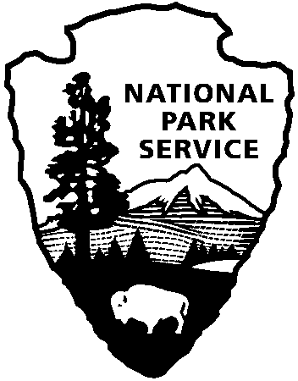
National Park Service
U.S. Department of the Interior

Release Date: Immediately
Contacts: Laura Henning
383-428-3384

PLAYALINDA DISTRICT INTERPRETIVE
PROGRAMS
MARCH 2019

PLEASE NOTE: all programs are subject to cancellation and/or rescheduling due to staff limitations, weather conditions, or other factors. Some programs require reservations, a minimum age, or a cost recovery fee. Call 321-403-9334 or 386-428-3384 ext. 0 for program information during operating hours (9:00 AM to 5:00 PM). Visit our website at www.nps.gov/cana. Entrance fees apply to all interpretive program participants. All programs meet the requirements for the Canaveral National Seashore Junior Ranger Program.

THURSDAY, 7TH – 10:00 AM “NATURE WALK” – Explore the seashore. Discover the diversity and beauty of the various plants and animals within the seashore. Bring your camera, water, sunscreen and repellent. Meet at parking area # 3. (1 hour)
THURSDAY, 14TH & 28TH – 10:00 AM “TRASH-or-TREASURE” – Explore the beach wrack line for treasures such as sea beans and shells. We will bring trash bags if on this day the oceans washes up more trash than treasure. Bring water and sunscreen. Meet at parking area #8. (1 hour)
TUESDAY, 12TH & 26TH – 10:00 AM “MANATEE VIEWING” – Observe manatee in their natural environment and learn about their unique characteristics from park staff. Meet at the Eddy Creek dock. (1 hour)

