National Park Service News Release

Canaveral National Seashore
212 S. Washington Ave.
Titusville, FL 32796
321-267-1110 office
321-264-2906 fax
www.nps.gov/cana
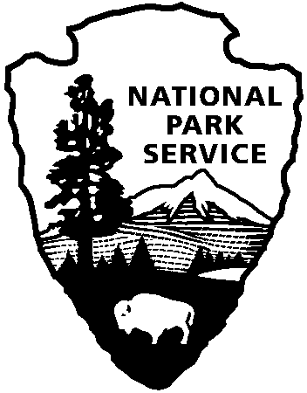
National Park Service
U.S. Department of the Interior

Release Date: Immediately
Contacts: Laura Henning
321-267-1110 Ext. 25

PLAYALINDA DISTRICT INTERPRETIVE
PROGRAMS
APRIL 2019

PLEASE NOTE: all programs are subject to cancellation and/or rescheduling due to staff limitations, weather conditions, or other factors. Some programs require reservations, a minimum age, or a cost recovery fee. Call 321-403-9334 or 386-428-3384 ext. 0 for program information during operating hours (9:00 AM to 5:00 PM). Visit our website at www.nps.gov/cana. Entrance fees apply to all interpretive program participants. All programs meet the requirements for the Canaveral National Seashore Junior Ranger Program.

SATURDAY, April 20th – FEE FREE DAY – Come out and celebrate National Park Week!
TUESDAY, April 9th, 16th, 23rd & 30TH – 10:00 AM “MANATEE VIEWING” – Observe manatee in their natural environment and learn about their unique characteristics from park staff. Meet at the Eddy Creek dock. (1 hour)
SATURDAY, April 6th – 8:00 – 12:00 PM “TRASH BASH” - It’s that time of year again! Keep Brevard Beautiful annual Trash Bash is here again, and we need your help to make it a huge success. As part of the Great American Cleanup, KBB’s Trash Bash partners each year with local cities to help organize volunteers and remove trash from their areas. Join us at Playalinda Beach parking area #1. (4 hours)
THURSDAY, April 25TH – 10:00 AM “TRASH-or-TREASURE” – Explore the beach wrack line for treasures such as sea beans and shells. We will bring trash bags if on this day the oceans washes up more trash than treasure. Bring water and sunscreen. Meet at parking area #3. (1 hour)

