National Park Service News Release

Canaveral National Seashore
212 S. Washington Ave.
Titusville, FL 32796
321-267-1110
321-264-2906 fax
www.nps.gov
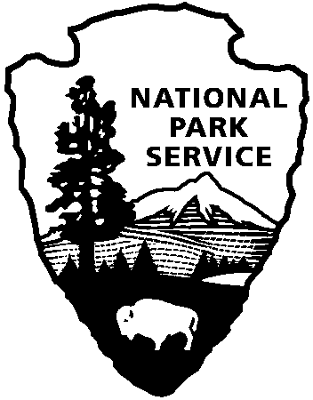
National Park Service
U.S. Department of the Interior

Release Date: Immediately
June 30, 2016
Contacts: Laura Henning – 386-428-3384

PLAYALINDA DISTRICT
JR RANGER PROGRAMS
JUNE 2016

PLEASE NOTE: all programs are subject to cancellation and/or rescheduling due to staff limitations, weather conditions, or other factors. Some programs require reservations, a minimum age, or a cost-recovery fee. Call 386-428-3384 ext. 0 or
321-403-9334 for program information during operating hours (9:00 a.m. to 5:00 p.m.). Visit our website at www.nps.gov/cana . Entrance fees apply to all interpretive program participants. All programs meet the requirements for the Canaveral National Seashore Junior Ranger program.

“JUNIOR RANGER PROGRAM”
Please join us on these days for the programs listed below. Completing one set of programs that are held each Tuesday in June. Picking up a bag of litter as well will allow you to complete Canaveral National Seashore’s Junior Ranger Program. Junior Ranger patch and certificate will be awarded when the assigned activities are completed.

Tuesday, July 5th – 10:00 AM- “LAGOON DISCOVERY”
Use a seine net with the help of a ranger and see what young sea life is spawning on the edge of Mosquito Lagoon. (1 hour)

Tuesday, July 12th – 10:00 AM – “JR LAGOON FISHING”
Experience fishing on the dock of Mosquito Lagoon with a ranger. Let’s see what we can catch. Bring a rod if you have one, we will provide some as well. (1 hour)

Tuesday, July 26th - 10:00 AM – “JR TURTLER”
Learn about the sea turtles that nest on Canaveral National Seashore and how we protect them. Walk the beach to see the nests. (1 hour)

****All activities will be at Eddy Creek. Bring water, sunscreen, and repellent. A parent or guardian must also stay for the program.

About the National Park Service. More than 20,000 National Park Service employees care for America’s 408 national parks and work with communities across the nation to help preserve local history and create close-to-home recreational opportunities. Learn more at www.nps.gov.

