National Park Service News Release

Canaveral National Seashore
7611 S. Atlantic Ave.
New Smyrna Beach, FL 32169
386-428-3384 phone
386-426-7973 fax www.nps.gov

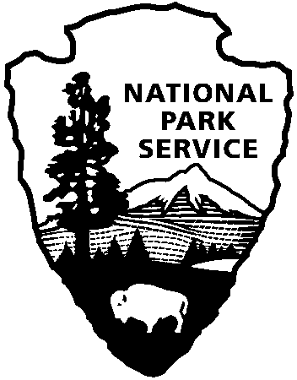
National Park Service
U.S. Department of the Interior

Release Date: Immediately
Contacts: Laura Henning – 321-267-1110 Ext. 25

APOLLO DISTRICT INTERPRETIVE
PROGRAMS
SEPTEMBER 2019

PLEASE NOTE: all programs are subject to cancellation and/or rescheduling due to staff limitations, weather conditions, or other factors. Some programs require reservations, a minimum age, or a cost-recovery fee. Call 386-428-3384 ext. 0 for program information during operating hours (9:00 a.m. to 5:00 p.m.), www.nps.gov/cana. Entrance fees apply to all interpretive program participants. All programs meet the requirements for the Canaveral National Seashore Junior Ranger program. Apollo Beach Visitor Information Center Address: 7611 S. Atlantic Ave. NSB, 32169.

2019 INTERNATIONAL COAST CLEANUP
SEPTEMBER 21ST, 8:00AM – 12:00PM

Canaveral National Seashore invites the public to join the International Coastal Cleanup. Once a year all over the world, millions of volunteers, who love the ocean and want to protect it, take this day to really make a difference. Come join Canaveral National Seashore and its many visitors in the Annual International Event to help cleanup marine debris that washes ashore with the tides. The first 100 Visitors will receive a T-Shirt, Bring Water in a reusable container, Work Gloves, Sunscreen, and a hat for protection from the sun. Meet at the Visitors Information Center at the address provided in the top portion of this page.

TUESDAY 10th - 10:00 AM “ENDANGERED SPECIES” Learn about the endangered animals who call Canaveral National Shore home. The diversity includes mice, birds, reptiles, and aquatic mammals. Explore why this barrier island is vital to their survival and how you can help. Meet at the Visitor Center.

WEDNESDAY 4th, 11th, 18th, 25th – 10:00 AM “CANOE MOSQUITO LAGOON” Reservations will be accepted a week before the canoe date. Join a guide as you explore this rich and diverse estuary up close. Some experience is preferred. You must be at least 8 years old and able to paddle. You must wear covered shoes (no sandals or flip-flops). Bring water, sunscreen and a hat. Dress to get wet. Individuals with their own kayaks or canoes are welcome to join in. There is no charge for the program. However, if you need to rent a canoe, there is rental charge of $25/canoe Meet at the Visitors Information Center at 8:45 am. We will leave promptly at 9:00 a.m. (2 hours)

FRIDAY 13th – 1:00 PM “SEA TURTLE NESTING SEASON 2019” Join us for a discussion on nesting sea turtles in general and specifically how the 2019 nesting season is progressing. Meet at the Visitor Information Center at 12:45 PM (1 hour)

SATURDAY 28 – 8:00 AM FEE FREE DAY-Come out and celebrate National Public Lands Day’’
Join us as we ride through your national park with a stop at Eldora house with tour through the house. Bring your own bike meet at the fee booth

