National Park Service News Release

Canaveral National Seashore
7611 S. Atlantic Ave.
New Smyrna Beach, FL 32169
386-428-3384 phone
386-426-7973 fax www.nps.gov

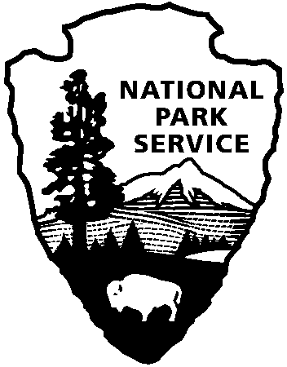
National Park Service
U.S. Department of the Interior

Release Date: Immediately, Oct 29, 2018
Contacts: Laura Henning – 321-267-1110 Ext. 25

APOLLO DISTRICT INTERPRETIVE
PROGRAMS
November 2018

PLEASE NOTE: all programs are subject to cancellation and/or rescheduling due to staff limitations, weather conditions, or other factors. Some programs require reservations, a minimum age, or a cost-recovery fee. Call 386-428-3384 ext. 0 for program information during operating hours (9:00 a.m. to 5:00 p.m.), www.nps.gov/cana. Entrance fees apply to all interpretive program participants. All programs meet the requirements for the Canaveral National Seashore Junior Ranger program.

WEDNESDAY 7TH, 14TH AND 28TH – 9:45 AM - “CANOE MOSQUITO LAGOON” Reservation will be accepted a week before the canoe date. Join a guide as you explore this rich and diverse estuary up close. Some experience is preferred. You must be at least 8 years old and able to paddle. You must wear covered shoes (no sandals or flip-flops). Bring water, sunscreen and a hat. Dress to get wet. There is no charge for the program if you bring your own canoe or kayak. Or rent a canoe for $25. Call (386) 428-3384 ext. 0 to reserve your spot. Meet at the Visitor Information Center at 9:45 a.m. We will leave promptly at 10:00 a.m. (2 hours)

SUNDAY 11TH -- 11:00 AM “BEACH TREASURE HUNT” Join an experienced leader to walk the beach and see what treasures the tides have provided. Bring a hat, sunscreen, insect repellent and water. Meet at Parking Lot #1B. (1 hour)

SUNDAY 25TH - 11:00 AM - “ELDORA WALK” Take a stroll through time down to the Eldora State House and learn what it would have been like to live in an agricultural village around the turn-of-the-century. Meet at parking lot #8. (1 hour)

